Shetland Wildflooer Plant walk

Picture | Name | In Shetland | Whar did you see it?
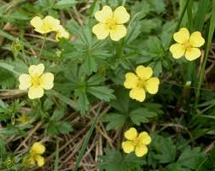 | tormentil | Eart-bark
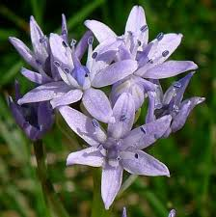 | Wild squill | Grice ingan
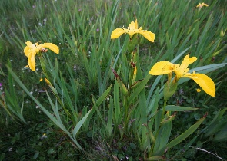 | Wild Iris | Seggie
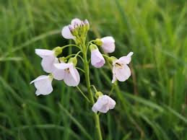 | Lady Smock | Cuckooflower
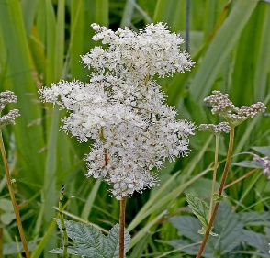 | Meadowsweet | Yule girss
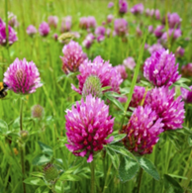 | Red Clover | Smora

Shetland Wildflooer Plant walk

 | Plant name | In Shetland | Whar did you see it?
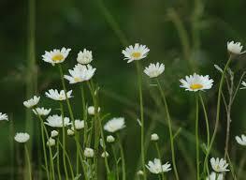 | Daisies | Kokkiluries
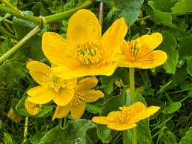 | Marsh marigold | Blugga
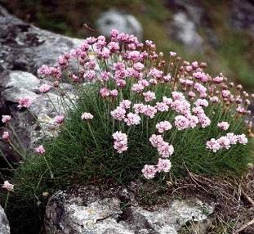 | Thrift | Sea pinks
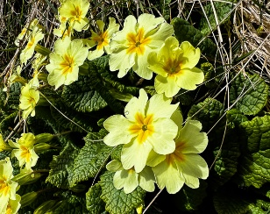 | Primrose | Mey-flooer
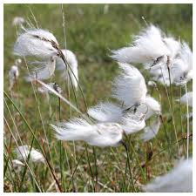 | Wild cotton | Luckiminnies oo
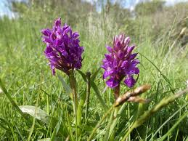 | Northern Marsh Orchid | Curly Dodie

Shetland Wildflooer Plant walk

 | Plant name | In Shetland | Whar did you see it?
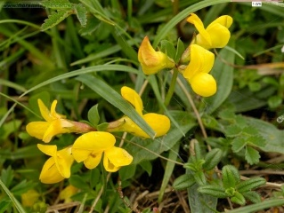 | Birds foot Trefoil | Da cock an da hen
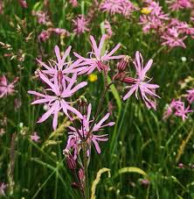 | Ragged Robin | Raggiewillie

