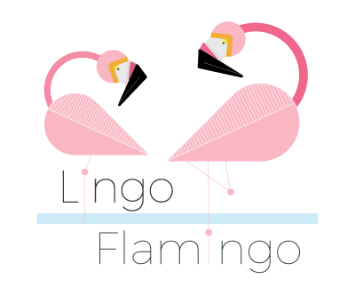
Bienvenue! Welcome!

Firstly, a very warm welcome to Lingo Flamingo!
We are a not-for-profit organisation that uses language learning as a platform to give the brain a good workout!
There is some fascinating research showing that language learning can make the brain more resilient and can even increase our attention, communication and concentration skills. We gain all of these great benefits because language learning serves as an amazing mental workout for the mind.
So, now you know who we are and why we do what we do! We hope you enjoy this French taster session.

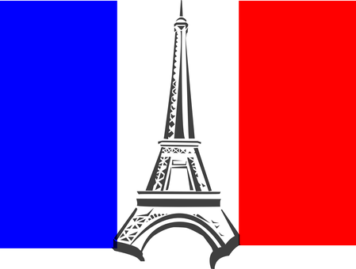

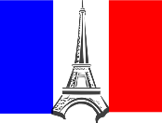
1. French Greetings

Did you know?
- French is not only spoken in France, but is an official language in 29 other countries including Belgium, Luxembourg, Switzerland, Canada and many African nations.
- There are around 220 million French speakers worldwide
- French is the 6th most widely-spoken language in the world

With that in mind, let’s have a look at the top 6 words for French survival (remember the words in red are your pronunciation guide!)

- Bonjour (baw-joor) - Hello
- Au revoir (oh-riv-wa) - Goodbye
- Oui (wee) - Yes
- Non (naw) - No
- S’il vous plait (seel-voo-pleh) - Please
- Merci (mer-see) - Thank you

A. Take turns and have a go at saying the above words and phrases out loud.
B. How do you say ‘yes’ is French?
C. How do you say ‘please’ in French?

Fantastique! Now, let’s move on and learn how to introduce ourselves.

2. Introductions
To introduce yourself in French, you would use the following phrase:

- Je m’appelle (jih-ma-pell) - My name is

So, if your name was John, you’d say:
- Je m’appelle John (jih-ma-pell John)

A. Try introducing yourself, using the phrase ‘Je m’appelle.’
B. Now you can have a go at introducing yourself as someone famous! Take the cards out of envelope 1 and place them in a pile face down. Take it in turns to pick a card and, using the Je ma’appelle phrase, introduce yourself as that famous celebrity! Keep going until there are no cards left.
C. So, now you know a few handy French words and phrases. Can you think of any other French words that we already use in our everyday language? Write down any French words that spring to mind! (Clue: think of some tasty French food or different types of French cheese). Here are a few to get you started:
- Baguette (bah-gett)
- Mousse (mooss)
- Café (ca-fay)

D. You may already be using lots of French words in your everyday language – you just might not realise it! Look at the pictures on the next page and try to work out what they are. You can fill in the blanks or just have a chat about it!
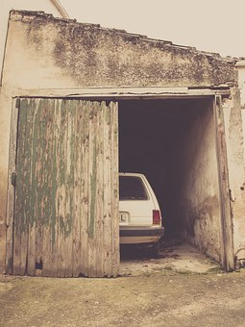  A  G_ _ _ _ _ |   B  B _ _ _ _ _
  C  B _ _ _ _ _ _ _ | 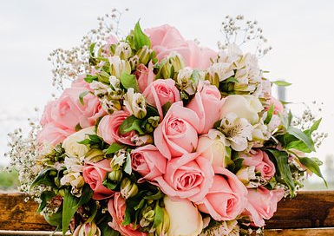  D  B _ _ _ _ _ _
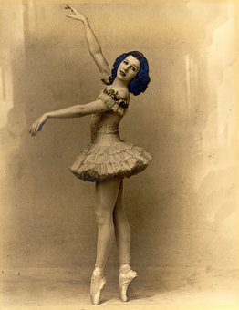  E  B _ _ _ _ _ | 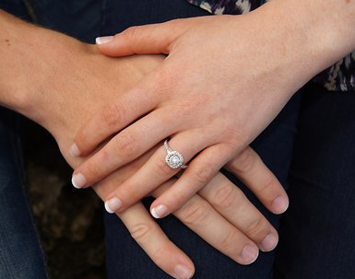  F  F _ _ _ _ _ _
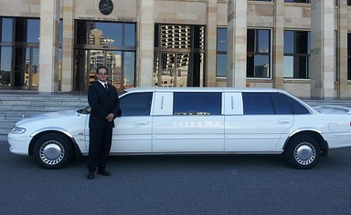  G  C _ _ _ _ _ _ _ _ | 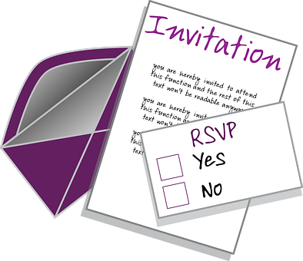  H  R _ _ _ _ _ _ _ S’_ _ V _ _ _ P _ _ _ _

Excellent! (Ek-say-law!) Let’s move on and familiarise ourselves with some more French phrases. For example, how do you say ‘How are you?’ in French and how would you reply to this type of question? Let’s find out….

- Ça va? (Sa va?) – How are you?
- Ça va bien (Sa va bee-ah) – I’m well
- Ça va mal (Sa va mal) – I’m not too good
- Comme ci comme ça (com-see-com-sa) – So so

E. Practise saying the above phrases. Take turns at asking each other ‘Ça va?’ and then give an answer depending on how you’re feeling today!

F. Draw a line to pair the phrase with its matching picture



Comme ci comme ça
Ça va bien
Ça va mal
G. Do you know that the English and French languages have a lot in common?
Can you work out what the following words mean, using your prior knowledge of English and Scots? It’s not easy but look at the spelling and how the words are pronounced and if you’re not sure….it’s worth a guess!
Write your answers in the spaces provided.

1. Abolir (ah-boh-leer) ……………………………………………………………
2. Avancer (ah-von-say) …………………………………………………………..
3. Délai (dih-lay) ………………………………………………………………………
4. Douter (doo-tay) ………………………………………………………………….
5. Obligatoire (oh-blee-ga-twar) ……………………………………………….
6. Palais (pah-lay) ……………………………………………………………………..
7. Répondre (ray-pon-drih) ………………………………………………………
8. Souffrir (soof-reer) ……………………………………………………………….

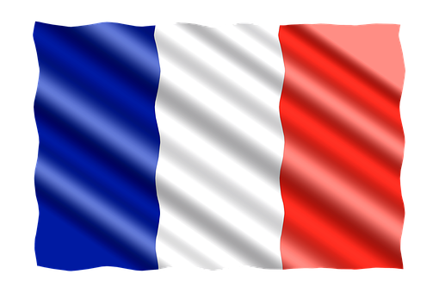
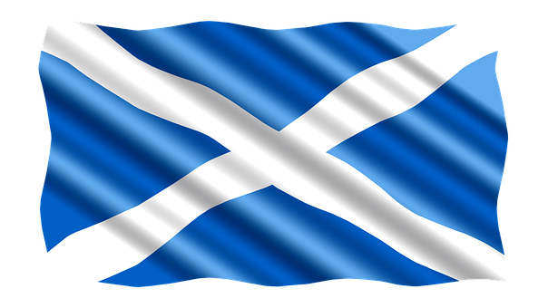

Note: It works both ways - and the French language has adopted many English words too. For example, French people often use the following words:
Le weekend; le sandwich; le jogging; le football; le rugby; le T-shirt and of course…..le whisky!
ANSWERS
2. Introductions
Page 3
C. Some examples of other French words we use: camembert; restaurant; boutique; chic; petite; souvenir; aperitif; croissant; déja-vu; à la carte
Page 4
D A. Garage B. Blonde C. Brunette D. Bouquet E. Ballet
F. Fiancée G. Chauffeur H. Répondez s’il vous plaît (Meaning ‘please reply.’ In the U.K. we often say ‘Respondez s’il vous plait, adding an extra ‘s’)

Page 5
F. Draw a line between the matching phrase and picture
Comme ci comme ça
Ça va bien
Ça va mal
ANSWERS
2. Introductions

Page 6
1. Abolir (ah-boh-leer) ….. Abolish
2. Avancer (ah-von-say) ….. Advance
3. Délai (dih-lay) ….. Delay
4. Douter (doo-tay) ….. Doubt
5. Obligatoire (oh-blee-ga-twar) ….. Obligatory
6. Palais (pah-lay) ….. Palace
7. Répondre (ray-pon-drih) ….. Respond/ Reply
8. Souffrir (soof-reer) ….. Suffer

