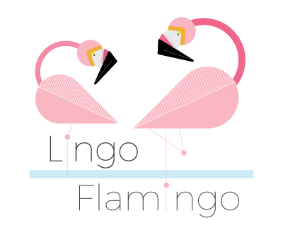
Benvenuti! Welcome!

Firstly, a very warm welcome to Lingo Flamingo!
We are a not-for-profit organisation that uses language learning as a platform to give the brain a good workout!
There is some fascinating research showing that language learning can make the brain more resilient and can even increase our attention, communication and concentration skills. We gain all of these great benefits because language learning serves as an amazing mental workout for the mind.
So, now you know who we are and why we do what we do! We hope you enjoy this Italian taster session.



1. Italian Greetings

Did you know?
- Italian is not only spoken in Italy but is an official language in 5 other countries: San Marino, Vatican City, Switzerland, Croatia, and Slovenia!
- There are around 64 million Italian speakers worldwide.
- Italian is also one of the official languages of the European union and the 21st most widely spoken language in the world.

With that in mind, let’s have a look at the top 6 words for Italian survival (remember the words in red are your pronunciation guide!)

- Buongiorno (boo-on-jour-no) - Hello
- Arrivederci (ah-ree-vae-daer-chee) - Goodbye
- Sì (see) - Yes
- No (no) - No
- Per Favore (par fa-vo-raeh) - Please
- Grazie (gra-zee-aeh) - Thank you

A. Take turns and have a go at saying the above words and phrases out loud.
B. How do you say ‘yes’ is Italian?
C. How do you say ‘please’ in Italian?

Fantastico! Now, let’s move on and learn how to introduce ourselves.

2. Introductions
To introduce yourself in Italian, you would use the following phrase:

- Mi chiamo (mee-key-a-mo) - My name is

So, if your name was John, you’d say:
- Mi chiamo John (mee-key-a-mo John)

A. Try introducing yourself, using the phrase ‘Mi chiamo .’
B. Now you can have a go at introducing yourself as someone famous! Take the cards out of envelope 1 and place them in a pile face down. Take it in turns to pick a card and, using the Mi chiamo phrase, introduce yourself as that famous celebrity! Keep going until there are no cards left.
C. So, now you know a few handy Italian words and phrases. Can you think of any other Italian words that we already use in our everyday language? Write down any Italian words that spring to mind! (Clue: think of some tasty Italian food). Here are a few to get you started:
- Pizza (pee-tzah)
- Spaghetti (spa-gae-ttee)
- Caffé (ca-ffay)

D. You may already be using lots of Italian words in your everyday language – you just might not realise it! Look at the pictures on the next page and try to work out what they are. You can fill in the blanks or just have a chat about it!
  A  C_ _ _ _ _ _ _ | 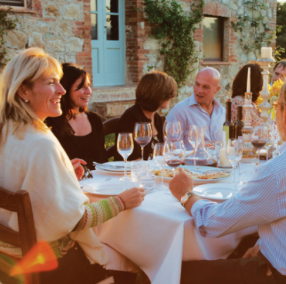  B  A _ F_ _ _ _ _
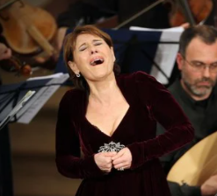  C  S_ _ _ _ _ __ |   D  C_ _ _ _ _ _ _
  E  B _ _ _ _ _ _ _ _ |   F  C _ _ _ _ _
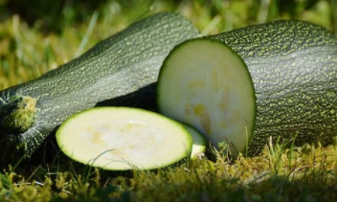  G  Z _ _ _ _ _ _ _ | H  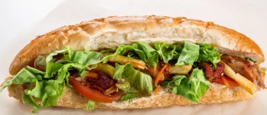  P _ _ _ _ _

Excellente! (Etchae-laen-tae!) Let’s move on and familiarise ourselves with some more Italian phrases. For example, how do you say, ‘How are you?’ in Italian and how would you reply to this type of question? Let’s find out….

- Come va? (Ko-mae va?) – How are you?
- Va bene (va bee-ah) – I’m well
- Va male (Va va mal) – I’m not too good
- Così così (co-sey- co-sey) – So so

E. Practise saying the above phrases. Take turns at asking each other ‘Come va?’ and then give an answer depending on how you’re feeling today!

F. Draw a line to pair the phrase with its matching picture



Va così così
Va bene
Va male
G. Do you know that the English and Italian languages have a lot in common?
Can you work out what the following words mean, using your prior knowledge of English and Scots? It’s not easy but look at the spelling and how the words are pronounced and if you’re not sure….it’s worth a guess!
Write your answers in the spaces provided.

1. Abolire (ah-boh-lee-rae) …………………………………………………………….
2. Avanzare (ah-van-tsa-ray) ………………………………………………………….
3. Dormire (dor-mee-ray) ……………………………………….………………………
4. Decorare (dae-co-ra-ray) …………………………………………………………….
5. Obbligatorio (oh-blee-ga-to-ree-oh) ……………………………………………
6. Palazzo (pah-la-tzo) ……………………………………………………………………
7. Rispondere (ree-spon-dae-raeh) ………………………………………………….
8. Soffrire (sof-free-rae) ………………………………………………………………….




Note: It works both ways - and the Italian language has adopted many English words too. For example, Italian people often use the following words:
Il weekend; Il sandwich; Il jogging; Il football; Il rugby; la T-shirt and of course….il whisky!
ANSWERS
2. Introductions
Page 3
C. Some examples of other Italian words we use: pamigiano; ristorante; camera; vendetta; panini; latte; Aperitivo; pizza; Tiramisù.
Page 4
D A. Casanova B. Al fresco C. Soprano D. Confetti E. Ballerina
F. Camera G. Zucchini H. Panini

Page 5
F. Draw a line between the matching phrase and picture
Va così così
Va bene
Va male

ANSWERS
2. Introductions

Page 6

1. Abolire (ah-boh-lee-rae) … Abolish
2. Avanzare (ah-van-tsa-ray) … Advance
3. Dormire (dor-mee-ray) ………Sleep
4. Decorare (dae-co-ra-ray) … Decorate
5. Obbligatorio (oh-blee-ga-to-ree-oh) … Obligatory
6. Palazzo (pah-la-tzo) …… Palace
7. Rispondere (ree-spon-dae-raeh) ………… Respond/ Reply
8. Soffrire (sof-free-rae) ………………… Suffer

