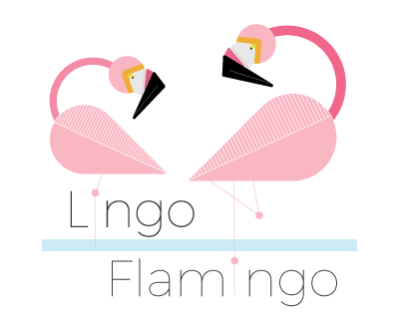
Benvenuti! Welcome!

Firstly, a very warm welcome to Lingo Flamingo!
We are a not-for-profit organisation that uses language learning as a platform to give the brain a good workout!
There is some fascinating research showing that language learning can make the brain more resilient and can even increase our attention, communication, and concentration skills. We gain all of these great benefits because language learning serves as an amazing mental workout for the mind.
So, now you know who we are and why we do what we do! We hope you enjoy this Spanish taster session.

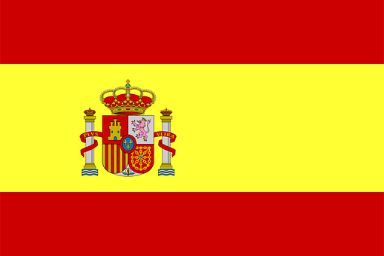

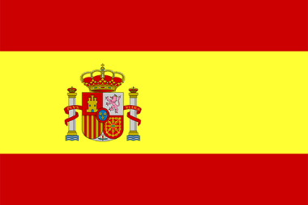
1. Spanish Greetings

Did you know?
- Spanish is not only spoken in Italy but is an official language in 15 other countries across Europe and the Americas such as Mexico, Argentina, Peru, Ecuador, and Colombia!
- There are almost 460 million Spanish speakers worldwide.
- Spanish is also one of the official languages of the European union and the 4th most spoken language in the world.

With that in mind, let’s have a look at the top 6 words for Spanish survival (remember the words in red are your pronunciation guide!)

- Buenos días (boo-aen-os dee-as) - Hello
- Adios (ah-dee- os) - Goodbye
- Sì (see) - Yes
- No (no) - No
- Por Favor (por fa-vo-r) - Please
- Gracias (gra-see-as) - Thank you

A. Take turns and have a go at saying the above words and phrases out loud.
B. How do you say ‘yes’ is Spanish?
C. How do you say ‘please’ in Spanish?

Fantastico! Now, let’s move on and learn how to introduce ourselves.
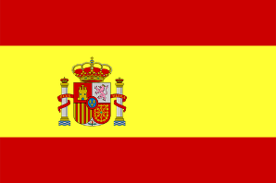
2. Introductions
To introduce yourself in Spanish, you would use the following phrase:

- Me llamo (mae ya-mo) - My name is

So, if your name was John, you’d say:
- Me llamo John (mae ya-mo John)

A. Try introducing yourself, using the phrase ‘Me llamo .’
B. Now you can have a go at introducing yourself as someone famous! Take the cards out of envelope 1 and place them in a pile face down. Take it in turns to pick a card and, using the Me llamo phrase, introduce yourself as that famous celebrity! Keep going until there are no cards left.
C. So, now you know a few handy Spanish words and phrases. Can you think of any other Spanish words that we already use in our everyday language? Write down any Spanish words that spring to mind! (Clue: think of some tasty Spanish food). Here are a few to get you started:
- Sombrero (som-brae-ro)
- Macho (ma-cho)
- Matador (ma-ta-dor)

D. You may already be using lots of Spanish words in your everyday language – you just might not realise it! Look at the pictures on the next page and try to work out what they are. You can fill in the blanks or just have a chat about it!
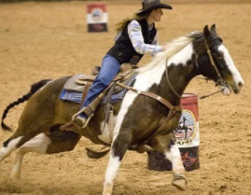  A  R_ _ _ _ | 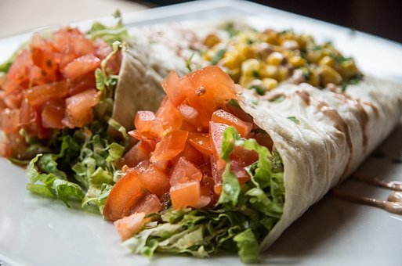  B  T_ _ _ _ _ _ _
C    C_ _ _ _ _ | 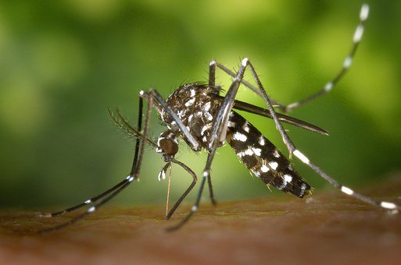  D  M_ _ _ _ _ _ _
  E  T _ _ _ _ _ _ |   F  T _ _ _ _
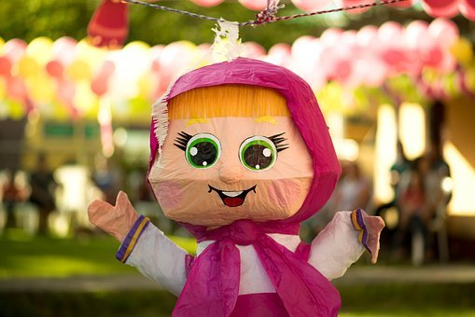  G  P _ _ _ _ _ | 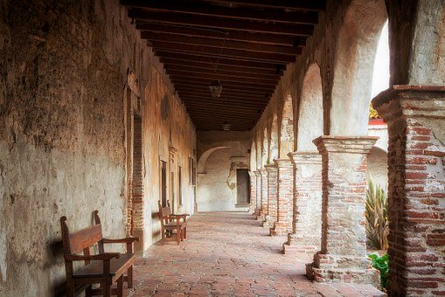  H  P _ _ _ _

¡Excelente! (Ex-sae-laen-tae!) Let’s move on and familiarise ourselves with some more Spanish phrases. For example, how do you say, ‘How are you?’ in Spanish and how would you reply to this type of question? Let’s find out….

- ¿Como estas? (Ko-mo aes-tas?) – How are you?
- Estoy bien (aes-toy bee-aen) – I’m well
- Estoy mal (aes-toy mal) – I’m not too good
- Estoy asì asì (aes-toy a-sey- a-sey) – So so

E. Practise saying the above phrases. Take turns at asking each other ‘¿Como estas?’ and then give an answer depending on how you’re feeling today!

F. Draw a line to pair the phrase with its matching picture



Estoy asì asì
Estoy bien
Estoy mal
G. Do you know that the English and Spanish languages have a lot in common?
Can you work out what the following words mean, using your prior knowledge of English and Scots? It’s not easy but look at the spelling and how the words are pronounced and if you’re not sure….it’s worth a guess!
Write your answers in the spaces provided.

1. Abolir (ah-boh-lee-r) …………………………………………………………….
2. Avanzar (ah-van-sar) ………………………………………………………….
3. Dormir (dor-mee-r) ……………………………………………………………
4. Decorar (dae-co-rar) …………………………………………………………….
5. Obligatorio (oh-blee-ga-to-ree-oh) ……………………………………………
6. Palacioo (pah-la-cee-oh) ……………………………………………………………
7. Responder (ree-spon-daer) ………………………………………………….
8. Sufrir (souf-freer) ………………………………………………………………….



Note: It works both ways - and the Spanish language has adopted many English words too. For example, Spanish people often use the following words:
El weekend; El selfie; El cocktail; El football; El rugby; la T-shirt and of course….el whisky!
ANSWERS
2. Introductions
Page 3
C. Some examples of other Spanish words we use fiesta, matador, bodega, rumba, telenovela, Arizona, California, guerrilla, paella, nacho etc.
Page 4
D A. Rodeo B. Tortilla C. Canyon D. Mosquito E. Tornado
F. Tango G. Piñata H. Patio

Page 5
F. Draw a line between the matching phrase and picture
Va così così
Va bene
Va male

ANSWERS
2. Introductions

Page 6

1. Abolir (ah-boh-lee-r) Abolish
2. Avanzar (ah-van-sar) Advance
3. Dormir (dor-mee-r) Sleep
4. Decorar (dae-co-rar) Decorate
5. Obligatorio (oh-blee-ga-to-ree-oh) Obligatory
6. Palacioo (pah-la-cee-oh) Palace
7. Responder (ree-spon-daer) Respond/ Reply
8. Sufrir (souf-freer) Suffer

