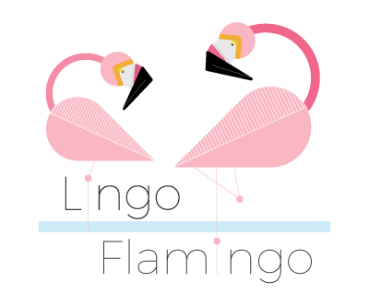
Lingo Flamingo: Helper’s Guide
We very much hope that you enjoy learning a new language with the people you care for. For many family members, staff members and carers learning a foreign language together with their residents, relatives or friends has proved to be a positive, rewarding experience and one that they will look back on fondly in years to come. The following information will help you get the most from your language lessons:
What is my role as a helper?
- The helper’s main role is to encourage the student and help them work through the range of weekly language exercises.
- You don’t need any prior knowledge of French, Italian, Spanish or the new language you are working on.
- You and your loved one will be learning the language together

What are the main things to take into consideration?
The most important things that you can do are as follows:
- Be positive
- Be patient (learning a new language can take time)
- Offer lots of praise and encouragement (it really helps!)
- Be relaxed about making mistakes (it is all part of the learning process)

How do I use the materials?
Our language lessons are specifically designed to help you work through each exercise with ease and include:
- A useful pronunciation guide (in red ink)
- Clear instructions for when and how to play the included games
- An answer sheet at the end of each section
We would recommend that you:
- Read each page out loud
- Allow the student to try and answer first
- Give clues to help the student find the right answer (such as what letter the word begins with or what sound/syllable it begins with)

Anything else I should know?
- Practise makes perfect - so try and use the vocabulary you have learned in your day-to-day life!
- You can revise the lessons again throughout the week – this helps to reinforce what’s been learned
- Relax and have fun – you’re doing a great job!

