Clean Energy for Households
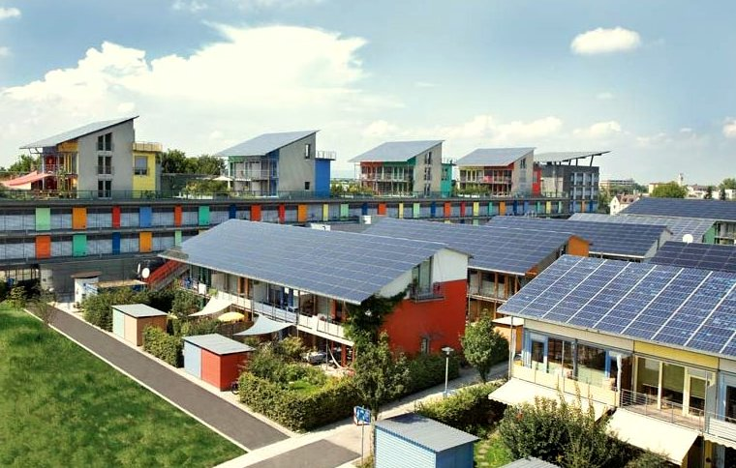
Clean Energy for Households 1
How this course works 1
Learning outcomes 2
Introduction 2
Clean Energy Pathway: Energy Efficiency 3
Clean Energy Pathway: Electrification 4
Clean Energy Pathway: Production 4
Conclusion 5
Additional Resources 6
Acknowledgements 6
Image Attributions 6

How this course works
This short, 30-minute course gives an overview of different types of clean energy and how clean energy is produced. The course also provides a range of different ways you can make your energy use cleaner and greener. You might be:
- Thinking about making your energy use cleaner and greener, but unsure of what to do next.
- Interested in exploring different ways to maximise your use of clean energy.
- Interested in developing a better understanding of the connection between digitalisation and clean energy technologies.
This course will deepen your understanding of the digital energy transition and support your own digital energy journey! It is part of the suite of 12 courses called Digital Energy Essentials, developed by the Every1 project, which aims to enable and empower everyone’s engagement in the energy transition. You can find out more about the project by going to: https://every1.energy
At the end of the course, we suggest some further learning materials for you to explore. This includes the course What is the Digital Energy Transition? which explores what digital energy is and the reasons behind moving towards digitalising our production and consumption of energy.
This is a Word version of the original English language version of the course, which includes an opportunity to complete a short quiz and earn an Every1 digital badge.
This project has received funding from the European Union’s Horizon Programme for Research and Innovation (2021-2027) under grant agreement No 101075596. The sole responsibility for the content of this course lies with the Every1 project and does not necessarily reflect the opinion of the European Union.

Learning outcomes
After studying this short course, you should be able to:
- Describe the context and key legislation which underpins the European Union’s clean energy ambitions.
- Describe three approaches to maximising our use of clean energy.
- Make cleaner and greener choices about your energy consumption.

Introduction
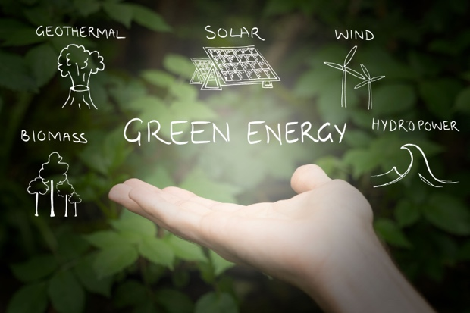
The European Union (EU) aims to be climate-neutral by 2050, achieving an economy with net-zero greenhouse gas emissions. This ambitious goal is central to the European Green Deal and has been established as a legally binding target under the European Climate Law.
The Fit for 55 policy package aims for a 55% reduction in greenhouse gas emissions by 2030 compared to the 1990 baseline, which is to be extended to 90% by 2040 and net-zero by 2050. These efforts are aligned with the EU's commitment to global climate action under the Paris Agreement and its long-term strategy submitted to the United Nations Framework Convention on Climate Change (UNFCCC) in 2020.
The transition to a climate-neutral society presents an opportunity to build a more sustainable and equitable future, ensuring that no one is excluded.
In 2022, households in the EU accounted for 25.8% of final energy consumption, with renewables and wastes comprising 22.6% of energy source for households. Whilst 63.5% of household energy use is dedicated to heating (Eurostat, 2024), renewables play a significant role, representing about one-third (31.4%) of the energy used for space heating in EU households. However, there remains ultimate dependency on fossil fuels as primary energy sources as around 40% of the EU electricity is produced from fossil fuels.
To support the move to net-zero and climate-neutrality, in this course we take a closer look at three ways we can maximise our use of clean energy: energy efficiency, electrification and green energy production.

Clean Energy Pathway: Energy Efficiency
Improving the efficiency of energy refers to the process of reducing the amount of energy required to provide products and services.
Examples of energy efficiency include technological upgrades, process optimisation, or changing behaviour so that the performance of devices or systems is enhanced. The goal of energy efficiency improvement is to minimise energy waste, reduce costs, and lessen environmental impact by making better use of available energy resources. Energy efficiency should not result in a reduction or reduced quality of output or service.
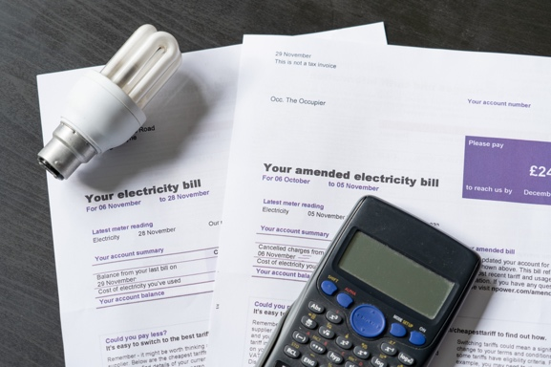
Energy-efficient appliances, lighting, and heating systems consume less energy without compromising our comfort and can result in cost savings over time. These cumulative cost savings offset the cost of upgrading devices.
There may be government incentives, such as rebates and tax credits, that can also reduce the upfront costs of energy-efficient upgrades.
Additionally, reducing energy consumption directly or indirectly decreases the demand for fossil fuels, leading to lower greenhouse gas emissions and reduced air pollution.
Embracing digital technologies and artificial intelligence driven smart appliances can further improve energy efficiencies over traditional ones along with offering greater convenience and control. You can find out more about the role of digital technologies and energy digitalisation in the course Smart devices and digital energy technologies.
Homes with energy-efficient features can be more attractive to buyers or renters, as they can reduce costs. Energy-efficient homes are also less affected by energy price fluctuations and supply disruptions due to lowering of net energy consumption. If you own your own home, you may find that it also yields a higher market price!
Overall, prioritising energy efficiency is a smart, sustainable choice that helps households save money and supports a cleaner, greener future.
Energy efficiency is an important way for households to adopt cleaner energy practices and is the most accessible clean energy pathway discussed in this course.

Clean Energy Pathway: Electrification
Within the European and Global North context, electrification refers to the process of replacing technologies that rely on burning fossil fuels or even sustainable fuels directly with those that use electricity as the energy source. For example, you may have considered:
- Buying or renting an electric vehicle (EV) to replace your petrol or diesel car.
- Replacing natural gas or oil-based heating systems with electric heat pumps.
- Adopting electrical resistance or induction-based cooking ranges instead of traditional natural gas stoves and ovens.
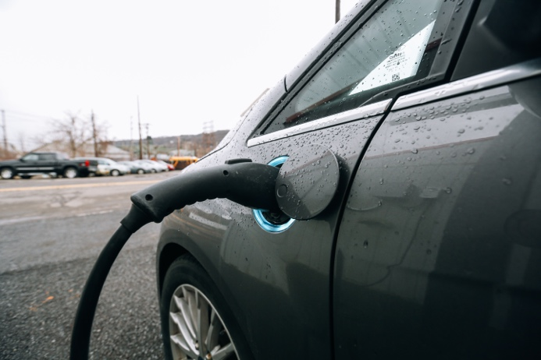
As we saw in the last section, electric counterparts are more energy efficient compared to conventional appliances and offer a range of benefits.
Wherever you live in the world electrification is a crucial strategy for reducing dependence on fossil fuels, enhancing energy efficiency, and achieving climate goals by enabling the use of cleaner and renewable sources of energy. However, it requires installing new or significantly upgrading the electricity grid infrastructure to support increased demand and integration of renewable energy sources. This requires significant investment and is a formidable fiscal barrier in most parts of the world, including in Europe.
Electrification is also an equity issue. Improving access to electricity as a reliable and affordable energy source is critical to greater inclusion and addressing energy poverty. If you are concerned about energy poverty you can find out more in the course Energy Anxiety.

Clean Energy Pathway: Production
As people seek ways to reduce their carbon footprint and lower energy bills, localised clean energy production and consumption at the household level is becoming more popular. This movement has been supported by regulations both at the EU and Members State level in the form of subsidies and tax-breaks. As a result, the European electricity system is shifting from centralised to distributed energy systems.
A key aspect of distributed energy systems is the establishment of energy communities under the Clean Energy for All Europeans Package of 2019. Successive EU directives are gradually empowering these communities to bring them into the mainstream. These efforts, in turn, have further popularised household level electricity production. As a result, it’s estimated that 83% of EU households will both consume and produce electricity (i.e. be ‘prosumers’) by 2050. You can find out more about this type of local-level collective actions in our course Energy Communities.
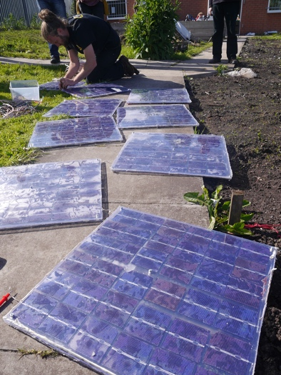
Solar photovoltaic panels, which convert sunlight directly into electricity, typically mounted on rooftops, are by far the most common means of electricity generation at the household level. Small-scale residential wind turbines are also gaining popularity in areas with consistent wind speeds. Though uncommon, micro-hydro systems may be considered exclusively for homes near flowing water sources.
These types of decentralised household energy production offer significant benefits, including reduced grid dependence and enhanced energy security. By generating their own energy, households improve resource efficiency and system resilience, while fostering greater community involvement in decarbonisation efforts.
Apart from green electricity generation, households may harness geothermal energy through heat pumps designed to exploit the stable temperatures underground to heat and cool homes. Solar water heating systems are also an effective means to reduce energy consumption from the grid.
As we move towards a more distributed energy system with a larger number of households generating their own electricity, home batteries will play an increasingly important role. Home batteries will support the gap between electricity generation and consumption and are anticipated to become an integral part of the household energy system.
If you are not able to explore these options, or become involved in an energy community, you could consider switching to a green electricity tariff. Contact your energy supplier to find out what options are available. Tariff regulations typically vary significantly from Member State to Member State and the tariff may also be energy supplier dependent.

Conclusion
Everyone has a role to play in the digital energy transition and transition to net-zero or climate-neutrality. In this course we explored three different ways to maximise our use of clean energy: energy efficiency, electrification and green energy production. Even making what might seem like small changes in your behaviour or choices can have a big impact.

Additional Resources
- Read more about EC support for energy communities:
https://energy.ec.europa.eu/topics/markets-and-consumers/energy-consumers-and-prosumers/energy-communities_en
- Find out more about how the EC supports energy efficiency: https://energy.ec.europa.eu/topics/energy-efficiency_en

Acknowledgements
Clean Energy for Households was created by the Every1 project and is licensed CC BY-SA 4.0, unless otherwise stated.

Image Attributions
Main course image: Clean energy at work for earthday! by naturalflow is licensed CC BY-SA 2.0.
Introduction: Green energy sources – renewable energy by Uswitch.com images is licensed CC BY 2.0.
Clean Energy Pathway: Energy Efficiency: Electricity bills with lightbulb and calculator by USwitch.com Images is licensed CC BY 2.0.
Clean Energy Pathway: Electrification: Triple Cities Makerspace, Inc. by 100% Campaign is licensed CC BY 2.0.
Clean Energy Pathway: Clean Energy Production: Moss Community Energy Launch by 10 10 is licensed CC BY 2.0.

