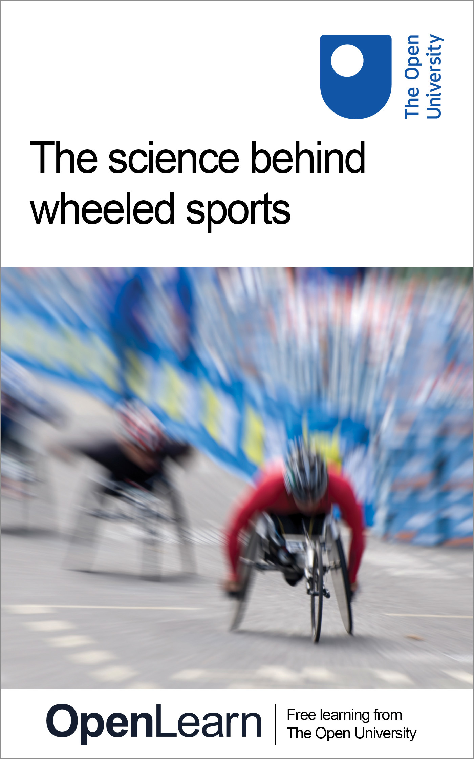

S172_1

The science behind wheeled sports
About this free course
This free course provides a sample of level 1 study in Science http://www.open.ac.uk/courses/find/science
This version of the content may include video, images and interactive content that may not be optimised for your device.
You can experience this free course as it was originally designed on OpenLearn, the home of free learning from The Open University: http://www.open.edu/openlearn/health-sports-psychology/health/sport-and-fitness/the-science-behind-wheeled-sports/content-section-0.
There you'll also be able to track your progress via your activity record, which you can use to demonstrate your learning.
Copyright © 2016 The Open University
Intellectual property
Unless otherwise stated, this resource is released under the terms of the Creative Commons Licence v4.0 http://creativecommons.org/licenses/by-nc-sa/4.0/deed.en_GB. Within that The Open University interprets this licence in the following way: www.open.edu/openlearn/about-openlearn/frequently-asked-questions-on-openlearn. Copyright and rights falling outside the terms of the Creative Commons Licence are retained or controlled by The Open University. Please read the full text before using any of the content.
We believe the primary barrier to accessing high-quality educational experiences is cost, which is why we aim to publish as much free content as possible under an open licence. If it proves difficult to release content under our preferred Creative Commons licence (e.g. because we can't afford or gain the clearances or find suitable alternatives), we will still release the materials for free under a personal end-user licence.
This is because the learning experience will always be the same high quality offering and that should always be seen as positive - even if at times the licensing is different to Creative Commons.
When using the content you must attribute us (The Open University) (the OU) and any identified author in accordance with the terms of the Creative Commons Licence.
The Acknowledgements section is used to list, amongst other things, third party (Proprietary), licensed content which is not subject to Creative Commons licensing. Proprietary content must be used (retained) intact and in context to the content at all times.
The Acknowledgements section is also used to bring to your attention any other Special Restrictions which may apply to the content. For example there may be times when the Creative Commons Non-Commercial Sharealike licence does not apply to any of the content even if owned by us (The Open University). In these instances, unless stated otherwise, the content may be used for personal and non-commercial use.
We have also identified as Proprietary other material included in the content which is not subject to Creative Commons Licence. These are OU logos, trading names and may extend to certain photographic and video images and sound recordings and any other material as may be brought to your attention.
Unauthorised use of any of the content may constitute a breach of the terms and conditions and/or intellectual property laws.
We reserve the right to alter, amend or bring to an end any terms and conditions provided here without notice.
All rights falling outside the terms of the Creative Commons licence are retained or controlled by The Open University.
Head of Intellectual Property, The Open University
978-1-4730-1962-1 (.kdl)
978-1-4730-1194-6 (.epub)

Contents
- Introduction
- Learning outcomes
- Rolling fast: the science behind wheeled sports
  - 1 Cycling events at the Olympic Games
  - 2 Aerodynamics and wheeled sports
  - 3 Materials technology and wheeled sports
  - 4 Effects of new technology
  - Conclusion
- Keep on learning
- Acknowledgements

Introduction
This course is about cycling and wheelchair racing: what we might collectively call 'wheeled sports'.
The scientific concepts of force, acceleration and speed are useful for understanding these sports. However, technology more obviously plays an important role in cycling and wheelchair racing. In this course, we will concentrate mainly on this aspect of these sports.
The structure of this course is as follows:
- Section 1 describes different types of cycling and wheelchair events and gives a short history of these sports throughout the Olympic Games.
- Section 2, 'Aerodynamics and wheeled sports', describes the way that air flows around a moving cyclist and the influence of aerodynamics on tactics in competitive races.
- Section 3, 'Materials technology and wheeled sports', explains the properties of carbon fibre and how it is constructed, and looks at its effect on the development of cycles.
- Section 4, 'Effects of new technology', considers the overall effect of aerodynamics and new materials on cycling and wheelchair racing.
- Section 5, 'Summary and reflection', contains a brief summary of the course and asks you to reflect on how effectively you use the internet for studying.
This course is an adapted extract from the Open University course SG072 Learn about sport: the science behind the medals.
This OpenLearn course provides a sample of level 1 study in Science

Learning outcomes
After studying this course, you should be able to:
- understand forces and their role in determining performance in sport
- understand the science behind new technologies, and their impact on sport
- apply this knowledge and understanding to familiar and unfamiliar situations
- express course concepts in an objective and factually correct way
- make sense of a variety of information sources, including textual, numerical, graphical and video material.

Rolling fast: the science behind wheeled sports
Before starting your study of this course, watch this introductory film.

Video content is not available in this format.
Video 1
View transcript - Video 1

1 Cycling events at the Olympic Games
Four different types of cycling event are now part of the Olympic Games; BMX and mountain biking having recently been added to the more traditional disciplines of track cycling and road cycling.
The bicycles used in the four events fall into two broad categories: those with large wheels and frames, used in track and road cycling, and those with small wheels and sturdier, smaller frames, used in mountain biking and BMX.
The four separate cycling disciplines shared a combined total of 18 gold medals at the 2008 Games.

Track cycling
These events are held in a cycling stadium called a velodrome (Figure 1), which has an oval-shaped track that is banked very steeply. Cyclists ride around this track in a variety of different events that include both individual and team races.

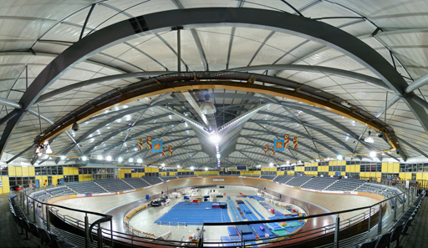
Grateful acknowledgement is made to Adam J.W.C. Used under a Creative Commons Licence.
Figure 1 The Dunc Gray Velodrome in Sydney, site of the Olympic track cycling events in the 2000 Olympic Games.

Road cycling
In these events, cyclists ride on a temporary course laid out in the streets of a town, city or district. The race distance is not fixed exactly, although modern races are usually about 120 km long and take more than two hours to complete.
There are two events in road cycling: the road race, in which all cyclists compete at the same time as each other (as runners do in a marathon); and the time trial, in which cyclists ride individually and try to set the fastest time possible over the course.

Mountain biking
This sport developed first as a recreation in California in the 1950s, when enthusiasts began cycling on rough terrain rather than on roads. It then developed into the cycling equivalent of cross-country running or cross-country skiing.
In Olympic competitions, there is one event each for men and for women. The cyclists start the race as a group and usually complete the course in about two hours.

BMX
BMX, which stands for 'bicycle moto-cross', is the newest cycling discipline. It was added to the Olympic programme in 2008. Cyclists race each other around laps of an unpaved, uneven track, and events are structured with heats, semi-finals and finals, as in sports such as sprinting and swimming.

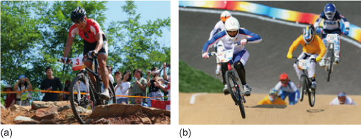
Grateful acknowledgement is made to Getty Images (Figure 2a and Figure 2b).
Figure 2 Cycling events at the 2008 Olympic Games: (a) Germany's Sabine Spitz competing in the women's mountain biking event; (b) Great Britain's Shanaze Reade racing in the women's BMX event.

1.1 History of cycling at the Olympic Games
Cycling has quite a long history compared with many modern sports. As bicycles became relatively cheap in the mid-1800s, cycling developed first as a recreational pastime and then very shortly afterwards as a sport. It is one of the few sports that have been in every modern Olympic Games.
Although cycling is a long-established Olympic sport, there has never really been a consistent Olympic programme, with events changing from Games to Games. Races have been held over various distances and in a variety of formats: in 1896 there was a 12 hour race; in 1908 there was a 600 yard sprint; while from 1908 right up to 1972 there was even a track event for tandems (i.e. single bicycles made for two riders).
Figure 3 shows some of the major milestones in the history of cycling events at the Olympic Games.

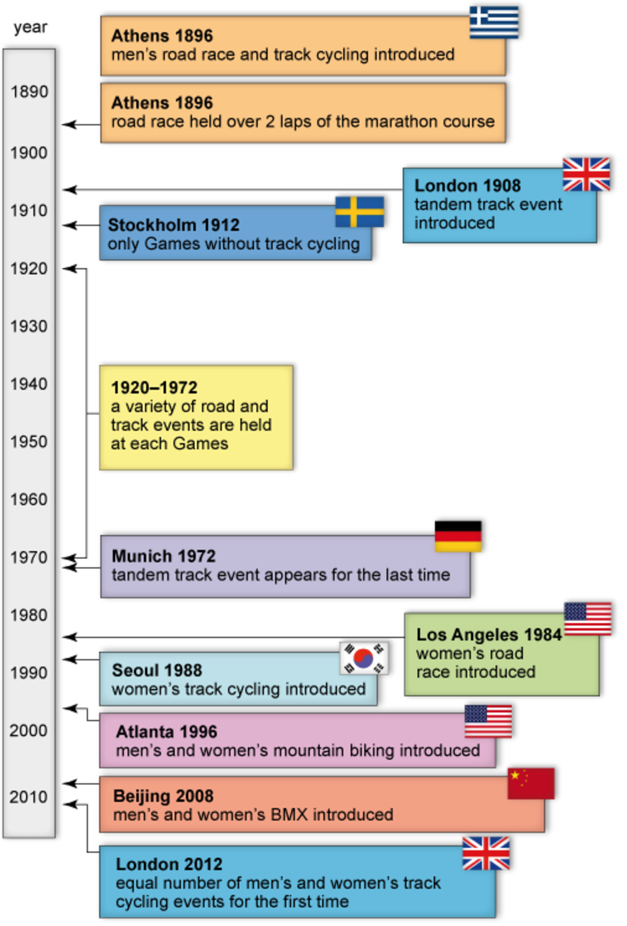
Figure 3 Notable events in the history of cycling events at the Olympic Games.

Track cycling is also notable because, until recently, it was one of the few remaining Olympic sports where men and women did not compete in an equal number of events. In fact, since the relatively late introduction of women's events in 1984, new events for men were added to the track cycling programme even though women's events remained few in number.
However, this situation changed in 2009 when it was announced that the Olympic track cycling programme would be changed significantly for the 2012 Olympic Games. Some traditional races in the men's programme have been discontinued to make space for new women's races, and there will now be a total of ten events: five for men and five for women.

1.2 Wheelchair sports at the Paralympic Games
The two sports at the Paralympic Games that have most similarities with cycling in the Summer Olympics are, rather obviously, cycling, and wheelchair racing.
Athletes at the Paralympics compete in a variety of cycling events, some of which are exactly the same as those discussed in the previous section and some, like the tandem event for visually impaired cyclists shown in Figure 4a, are particular to the Paralympics.
Wheelchair sports, especially wheelchair racing (Figure 4b), share many similarities with cycling. The concepts of force, speed, acceleration and centre-of-mass are all important in understanding what happens in wheelchair racing, and similar technology is involved in both sports. The science that we introduce in this course - aerodynamics, properties of materials and carbon-fibre construction - are just as relevant to wheelchair racing as to cycling.

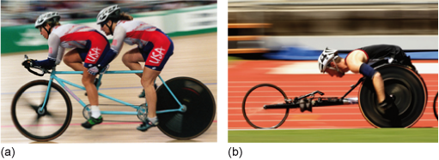
Grateful acknowledgement is made to Getty Images (Figure 4a and Figure 4b).
Figure 4 (a) Two US cyclists competing in a tandem track event for visually impaired athletes, in which the front rider is sighted and the rear rider is visually impaired. (b) A wheelchair athlete competing in a track race.

1.3 Study skill: effective internet use
The study skill we focus on in this course concerns using the internet effectively.
As suggested in other units, the internet contains a lot of useful information and is an invaluable study aid, but there is so much information available that finding useful material can sometimes be difficult and time consuming.
There are various techniques that you can use to help you locate useful information effectively, including:
- searching with a range of keywords
- choosing more descriptive keywords
- using search engine commands to control the range of your search.
Activity 1 asks you to use the third technique to search the internet for information about mountain biking.

Activity 1 Searching for information on the internet
(The estimated time needed to complete this activity is 20 minutes.)

Imagine that you are trying to research the success of British athletes in mountain biking at the Olympics.
Use the following steps to search the internet for information about this topic. For each step, make sure that you write down the answer to the question(s) asked before moving on.
- Open a new internet browser window or tab on your computer and go to the home page of your preferred search engine.
- Search for information using the term 'mountain + biking', without quotation marks. This will find all websites that include both the words 'mountain' and 'biking'.
  - How many websites does your search engine find?
  - View the list of websites. (Note that you should only view the descriptions in the search engine results, not access the actual websites.) Do the first three websites listed appear useful - in other words, do you think they might contain information about British mountain biking at the Olympics?
- Now search for information using the term 'mountain + biking + Britain + Olympics', without quotation marks. This will find websites that include all of these terms.
  - How many sites does your search engine find?
  - Once again, view the list of websites. Do the first three sites from this search appear useful?
- Now search for information using the term '“mountain biking” + Britain + Olympics', including the double quotation marks. This will find websites that include 'Britain', 'Olympics' and the specific phrase 'mountain biking'.
  - How many websites does your search engine find?
  - Do the first three sites listed appear useful?
- Finally, search for information using the term '“mountain biking” + Britain + Olympics + results', including the double quotation marks.
  - How many websites does your search engine find?
  - Once again, look at the first three sites. Do they look useful?

View comment - Activity 1 Searching for information on the internet

As you work through this course, you will be asked to find information about various topics on the internet. Choosing suitable keywords is one of the most effective ways of reducing the time you spend doing this.

1.5 Summary
In this section we introduced different types of cycling events and briefly described the history of the sport. We also outlined the similarities between cycling and wheelchair racing. The following sections explain scientific concepts that help us understand the role of science and technology in these sports.
We also introduced the study skill of effectively searching the internet. Although most people search the internet regularly for a variety of purposes, there are specific guidelines that can help you do this more effectively and save you time and effort. You will practise this skill in several activities later in this course.
The next section introduces aerodynamic flow and examines how this phenomenon affects athletes' performance in cycling.

2 Aerodynamics and wheeled sports
Cyclists can travel at very high speeds: up to 60 km hr⁻¹ on the track and even faster going downhill in a road race. At such speeds, we have to go beyond the idea of simple air resistance caused by the athlete pushing through the atoms and molecules in the air, and consider how the air flows past the cyclist as well. This leads us to the topic of aerodynamics.
In this section of the course, we introduce aerodynamics and then consider how it affects athletes' performance in cycling.

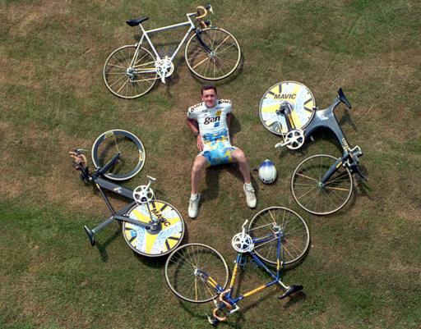
Grateful acknowledgement is made to Getty Images.
Figure 5 Chris Boardman, one of Britain's most successful Olympic cyclists, posing with four of his racing cycles. They are all lightweight in construction but there is a great difference in bicycle design because aerodynamics is very important in some events and less significant in others.

2.1 Aerodynamics
Aerodynamics is the scientific study of the flow of air past an object. To understand the effect of aerodynamics in cycling you need to understand the way that airflow is described scientifically, the different types of airflow and their effects.
The next activity introduces these topics.

Activity 2 Introducing aerodynamics
(The estimated time needed to complete this activity is 40 minutes.)

Aerodynamics
Please note: this activity may take a few seconds to download.

View comment - Activity 2 Introducing aerodynamics

Activity 2 concentrated on explaining the scientific aspects of aerodynamics. The next section examines the effect of aerodynamics on performance in cycling events.

2.2 The effect of aerodynamics
The importance of aerodynamics in some cycling events can be judged, to a certain extent, by seeing how much emphasis athletes place on this aspect of the sport.
For instance, in long-distance road races cyclists compete in teams of three or more riders. There are usually very large numbers of cyclists involved, and the competitors tend to ride in one large group, called the peloton (Figure 6). The tactics of each team are based on minimising the effect of air resistance on their best rider. In these large groups, the junior members of each team ride near the front of the group, feeling the full effects of air resistance and consequently becoming very tired during the race, while the most senior member of each team stays behind the front riders, gaining the advantage of reduced air resistance and consequently using less energy. The final stages of a road race are thus usually dominated by the senior members of each team, as they have conserved their energy throughout the race and so have more left for an intense burst of sprinting at the race finish.

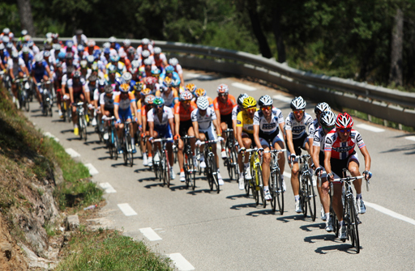
Grateful acknowledgement is made to Getty Images.
Figure 6 An example of a peloton - the large group of lead riders - in a road race. Cyclists ride behind each other to reduce the effect of air resistance, and hence avoid having to put in as much effort as the rider in front.

The tactics of riders in teams gives some indication of the qualitative importance of air resistance and aerodynamics in cycling, but can this effect be measured? How much advantage is really gained by riding behind another cyclist?
Although aerodynamic effects can be estimated using theory and calculation, the best way to obtain quantitative information is to carry out scientific tests in devices called wind tunnels. Inside these devices, giant fans generate a strong wind in one direction, which enables the air resistance of an object placed in the tunnel to be measured. The airflow around the object can be observed by using smoke or a sensing device placed on the object's surface. Figure 7 shows a speed-skier testing different body positions in one such device.

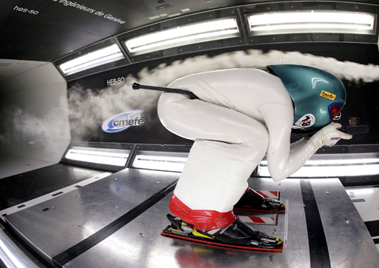
Grateful acknowledgement is made to Martial Trezzini/epa/Corbis.
Figure 7 A speed-skier inside a wind tunnel. The white smoke shows the flow of air over the speed-skier's body.

Measurements of cyclists have shown that riding directly behind another rider can reduce air resistance by as much as 40 per cent! This explains why cyclists in many different events pay so much attention to this aspect of the sport.

2.3 Technological developments in track cycling
Improved scientific understanding and technological development have greatly affected the design of bicycles used in competitive cycling. The principles of aerodynamics are one influence on bicycle design while the development of new materials, to be explored later in this course, also has a large effect.
Throughout this course we ask you to carry out a series of activities in which you will use the internet to research different aspects of the history of bicycle design. The following activity is the first in this series.

Activity 3 Finding images of track cycles
(The estimated time needed to complete this activity is 30 minutes.)

Search the internet to find images of bicycles used in track cycling events from the 1960s to the present. These images might be photographs or drawings. Try to find at least one image from each decade. Use the following step-by-step process to guide your search.
- Think of keywords to use in your internet search, and write down a list of at least five terms. (Note: as you are looking for images rather than text, using 'images' as one of your keywords might be helpful.)
- Open a new browser window and go to your favourite search engine website.
- Choose at least three keywords from your list and use them to search for useful websites.
- View the list of websites suggested by your search engine, and choose the three that seem likely to have useful images. (These might not be the first three listed.)
- Visit these three websites and spend a maximum of five minutes viewing the images on each site.
- Record in your study diary the website addresses (URLs) of the three sites you looked at and write down (using bullet points), comments about their usefulness for your search.

View comment - Activity 3 Finding images of track cycles

SAQ 1

Roughly when did aerodynamics become prominent in track cycling? To answer this question, consider the websites that you found in the previous activity and our set of images, shown in the discussion for that activity.

View answer - SAQ 1

2.4 Summary
In this section you were introduced to fundamental aspects of aerodynamics, including phenomena such as bow waves, wakes and boundary layers. You also saw how these phenomena affect tactics and performance in track and road racing. Finally, you did some research into the history of cycling by carrying out an internet search to find images.
In the next section we will introduce some concepts of materials science, and one of the most important new materials - carbon fibre.

3 Materials technology and wheeled sports
More so than in many sports, success in competitive cycling and wheelchair racing depends on technology.
One aspect of the technology involved in cycling is the development of materials used in manufacturing the bicycle itself. Many years ago bike frames were made from steel, which was then replaced by aluminium, resulting in lighter cycle frames. Modern cycle frames, at least at professional level, are made from a relatively new material called carbon fibre, which is lighter than aluminium but still strong enough to be used for this purpose.
The following short film is an excerpt from a BBC television programme about technology in sport. It describes how a new bicycle frame was developed for the British national cycling team. Watch this film now. Note both the high-level of technology involved, and the effect of this technology on the cyclists' performance.

Video content is not available in this format.
Video 2
View transcript - Video 2

The development of carbon fibre has had an enormous impact on performance in many sports other than cycling. It is used for a wide range of sporting equipment, from tennis racquets to bobsleighs, including almost anything for which a strong, lightweight material is required.
In this section we will introduce more detail about the structure of carbon fibre, and explain why it has the particular properties that it does.

3.1 The structure of carbon fibre
There is a reason that a material like carbon fibre can be strong and lightweight at the same time. It is related to the atoms that make up these materials, and the way that these atoms bond together.
The next activity introduces some ideas about the physical structure of material, using the example of carbon fibre.

Activity 4 Properties of materials
(The estimated time needed to complete this activity is 40 minutes.)

Material structure
Please note: this activity may take a few seconds to download.

View comment - Activity 4 Properties of materials

3.2 Carbon fibre and composite materials
The term 'carbon fibre' is commonly used to refer to several materials that, although related, are not the same.
Strictly speaking, carbon fibres are the long, thread-like structures of linked carbon atoms that were discussed in Activity 4. When the fibres are woven into a cloth-like material (Figure 9), the resulting material is also referred to as carbon fibre.

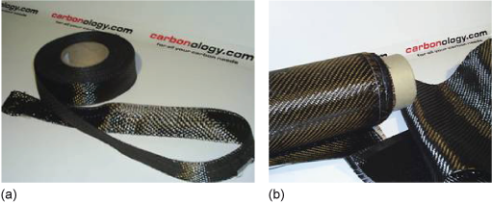
Grateful acknowledgement is made to Carbonology.com.
Examples of carbon-fibre cloth, a material made from carbon fibres woven together: (a) tape; (b) fabric.

However, the material most commonly associated with the term 'carbon fibre' is a plastic-like rigid material in which carbon-fibre cloth is used to reinforce a particular type of plastic. The technical term for this material is 'carbon-fibre-reinforced plastic', or CFRP. On its own, plastic has rigidity but lacks strength, but in CFRP the carbon-fibre cloth inside the plastic adds the necessary strength. This material is then used in sporting equipment such as bicycle frames, tennis racquets and hockey sticks. Carbon-fibre materials are so strong that they are even used to make many of the components in aircrafts, including parts of the wings.
Carbon-fibre reinforced plastic is an example of a class of substances called composite materials, in which two or more substances are combined to make a material with different properties from either of the individual components. Another example of a composite material is glass-fibre reinforced plastic, also known as fibreglass, in which thread-like structures of glass are used to reinforce plastic materials. Fibreglass has been used since the 1950s to make lightweight structures, ranging from household furniture to yachts and leisure craft. Both carbon fibre materials and fibreglass can be moulded into complex shapes, which is another reason why these materials are often preferred to the conventional, heavier alternatives of wood and steel.

3.3 The effect of new materials on cycling
In Section 2.3, we asked you to use the internet to find images of bicycles that reflect the technological development of the equipment used in track cycling. The next activity asks you to continue your research into bike design by finding information about the use of carbon fibre in track cycling.

Activity 5 Development of bike design
(The estimated time needed to complete this activity is 30 minutes.)

When was carbon fibre first used in cycling at the Olympic Games? Search for relevant websites that will help answer this question by following the step-by-step procedure below.
- Think of at least five keywords that you could use to search for information about this topic.
- Choose at least three keywords from your list, and use them to search the internet for useful websites.
- View the list of websites suggested by your search engine. Choose two of the websites that look most useful.
- Visit both of these websites, spending a maximum of five minutes viewing each site. (Note that the aim of this activity is to find useful websites, not to use the information there. You don't have to read all of the material on each website but just enough to judge whether it might help you answer the question.)
- Record the addresses of these two websites in your study diary and write down, as bullet points, comments about their usefulness for your search.

View comment - Activity 5 Development of bike design

3.4 Summary
In this section you were introduced to some basic materials science, including the internal structure of solids. You saw that the way in which atoms are bound to each other in a solid affects the overall properties of that material. You also saw how the structure of carbon fibre gives the composite material its lightweight and strong properties. You then carried out further research into the history of cycling by searching the internet to find out when carbon fibre became commonly used in track cycling.
In the next section, we ask you to use the results of your internet searches to analyse the impact of new techniques and new technology on performance in cycling.

4 Effects of new technology
In both cycling and wheelchair racing factors such as wider participation, better training methods and new technology have led to continually improved performances over the years. As in all sports, it is often hard to identify which factor is most important in enabling improved performance. However, given the large impact of technology on wheeled sports, you might wonder if we could identify the effect of technological advances in, for example, improvements in world record times.
In this section we ask you to consider the effect of changing technologies on wheelchair racing and track cycling. As well as gaining a better appreciation of the role of technology in these sports, you should also gain a better understanding of the benefits and limitations of using the internet as a study resource.

4.1 Aerodynamics and technology in wheelchair racing
Athletes in wheelchair events can reach high speeds, so you might expect aerodynamics to play an important role in this sport. To a large extent, this is true. There are no team races involving wheelchair athletes, so you don't see teams of wheelchair athletes lined up in the same way as happens in the team events in track cycling. However, the effect of air resistance and aerodynamics does impact on individual wheelchair athletes.

Activity 6 Wheelchair racing
(The estimated time needed to complete this activity is 5 minutes.)

Go to the BBC Motion Gallery website and search for terms involving wheelchair racing to find a few clips, like this example. This clip shows several wheelchair athletes in a marathon race. Note how they ride directly behind each other, just as cyclists do in a race.

Materials technology has also affected wheelchair design. Wheelchairs have become lighter as new materials become available, and carbon-fibre chairs are now standard in racing events.
The next activity asks you to use the internet to research the extent of the effect of new technology on racing wheelchairs. This activity is very similar to Activity 3, in which you searched for images of bicycles. However, wheelchair racing is less prominent than cycling and has a shorter history, so it is harder to find images showing these design changes. You may have to think more carefully about how you search for images in this case.

Activity 7 Finding images of racing wheelchairs
(The estimated time needed to complete this activity is 30 minutes.)

Has wheelchair design changed significantly in the last 30 years?
To answer this question, use internet image banks to find depictions of wheelchairs used in wheelchair racing over the last 30 years. (Remember, you read about image bank websites such as Google or Yahoo! Images, Flickr and Getty Images in Activity 3.)
Use the images that you find to answer the question, noting down your answers in your study diary.

View comment - Activity 7 Finding images of racing wheelchairs

In this course we have asked you to use the internet to find information about cycling and wheelchair events. The internet is an incredibly useful source of information but it does have some drawbacks. The following activity asks you to think about one such aspect.

Activity 8 Limitations of the internet
(The estimated time needed to complete this activity is 10 minutes.)

Consider your experience of using the internet in this course. What problems did you encounter while searching for information? Note up to three problems in your study diary, then see our comments in the 'Reveal discussion' section below.

View comment - Activity 8 Limitations of the internet

4.2 World records in track cycling
To examine the effect of aerodynamics and technology on cycling, and other wheeled sports, it might seem natural to consider the progression in world records.
Figure 11 shows the progression in the women's world record for the individual pursuit event, in which two cyclists compete in a velodrome over a distance of 3 km. Look carefully at the graph and then answer the questions that follow.

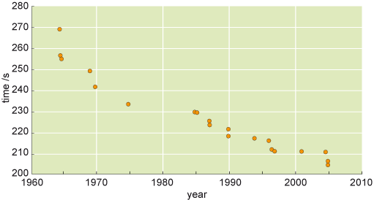
Figure 11 World records in the women's 3km individual pursuit event (1965-2005).

SAQ 2

Earlier in this course (in SAQ 1), you saw that aerodynamics began to affect the design of cycles in the mid-1980s. Study the data in Figure 11. Is the development in cycle design reflected in the progression in world record times for the women's individual pursuit event?

View answer - SAQ 2

SAQ 3

You also saw (in Activity 5) that carbon fibre began to be used in track cycling from the early 1980s onwards. Is this particular development in cycle design reflected in Figure 11?

View answer - SAQ 3

So, one conclusion from analysing this graph is that it is hard to identify clearly the effect of technology on cycling performance simply by looking at the progression in world records. There are so many factors that lead to better performance (e.g. improved equipment, better training, more-professional athletes) that the effect of one particular technology is hard to see.

4.3 Removing the technology
Although the effect of individual technologies can be hard to see, there is, fortunately, a way to observe the effect of technological improvements on cycling.
For this, we need to look at the so-called 'hour record' event, in which an individual cyclist rides for exactly one hour on a track attempting to ride as far as possible. While this is not an Olympic or a World Championship event, the hour record in cycling is quite prestigious and dates back to 1893, when it was set by Henri Desgrange (the man responsible for organising the first Tour de France long-distance road race).
Figure 12 shows the progression of the men's record from 1950 to 2000. Like the women's individual pursuit record in Figure 11 this graph shows continuous improvement, though there is a clear, sharp increase in the 1990s. Is this increase due to better trained, more professional athletes, or is it due to technological improvements?

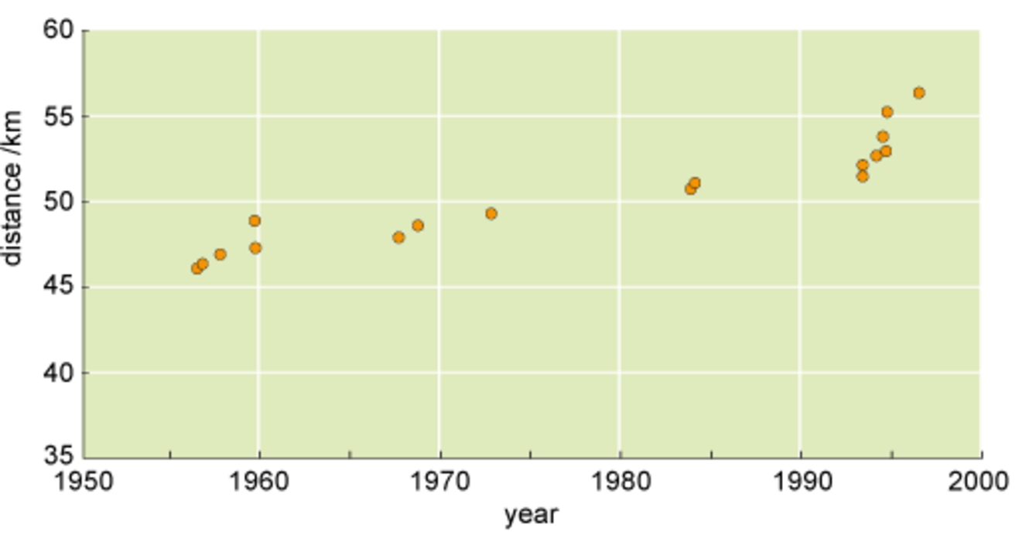
Figure 12 Progression of the hour distance record in track cycling (1950-2000).

In the late 1990s the organisations that govern international cycling felt that reliance on technology was affecting international cycling by preventing proper comparison of cyclists from different eras. So, while they allowed technology to be part of competitive races such as the Olympics, the cycling authorities decided, in 2000, that the hour record will now only be valid if the cyclist uses technology available in 1972, when the celebrated Belgian cyclist Eddy Merckx set the record. Hence, the hour record now must be attempted using a bicycle with 1970s technology.
This decision gives us the opportunity to see the true effect of technological advances on this record. In 1996, before the rule change, the British cyclist Chris Boardman set a new record using modern equipment, riding slightly more than 56 km in the one-hour period. Then, in 2000, he set it again under the new rules using 1970s equipment, this time riding only slightly more than 49 km. The difference in technology can be seen in the photographs in Figure 13, and the difference in performance was about 10 per cent! In fact, Boardman's one-hour distance in 2000 was only 10 m further than that set by Eddy Merckx almost 30 years earlier.

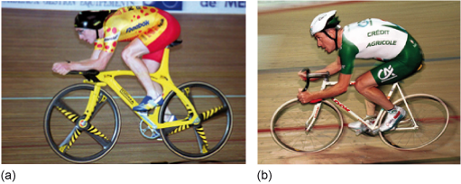
Grateful acknowledgement is made to AFP/Getty Images (Figure 13a) and Getty Images (Figure 13b).
Figure 13 Chris Boardman setting the hour-distance record: (a) in 1996, using all available technology; (b) in 2000, using technology available in 1972.

Hence, you can conclude that although the effect of individual technologies on cycling cannot always be seen in world records, overall advances in modern technology affect performance greatly, especially in long-distance races.

4.4 Summary
In this section you saw how the aerodynamics and materials technology that was introduced earlier in the course affects the design and performance of both wheelchairs and bicycles. You also saw that, despite seemingly major advances in technology, it is hard to identify the impact of any single technology on the progression of world record performances. However, the change in rules for the hour record in cycling gives us, almost uniquely in sport, an effective way to see the great effect of technology on performance in technology-intensive sports such as cycling.
This section also contained a number of internet-focused activities that enabled you to see some of the advantages and limitations of using the internet as a study aid.

Conclusion
This course introduced some of the science that lies behind performance in cycling. In this final section we will:
- review the main scientific points that were introduced in the course
- review the way that this science helps your understanding of wheeled sports
- ask you to think again about how you use the internet to search for information.

5.1 What science have you seen in this course?
The science introduced in this course focused on two main areas.
In Section 2, you were introduced to some fundamental aspects of aerodynamics. You saw that airflow around an object is characterised by its bow wave and its wake, and that the nature of this flow is determined by the layer of air right next to the object's surface, called the boundary layer. Overall, you saw how air resistance and aerodynamics are linked.
In Section 3, you were introduced to ideas about materials structure. You saw how the density, strength and other properties of a material are determined by the way atoms inside the material bind to each other. You also saw that the strength of carbon-fibre structures partially arises from the fact that the substance is a composite material.

5.2 How does this science help us understand wheeled sports?
The science that we introduced in previous units (force, acceleration, speed, etc.) can be used to understand many aspects of wheeled sports. You could, for example, use that science to analyse the speed of a wheelchair athlete in a race, the changes in speed as cyclists pass each other on a track, and even the influence of gravity and reaction forces on cyclists riding on the banked track of a velodrome.
The science introduced in this course enables us to understand several specific aspects of wheeled sports.
You saw that in track races, cyclists exploit aerodynamics to reduce air resistance by riding directly behind each other. In road races involving large groups of cyclists, the tactics of individual riders and teams are strongly affected by the advantage that is gained by competitors who don't ride at the front of the group. You also saw that aerodynamics also affects the posture of wheelchair athletes and the design of their wheelchairs.
Understanding the structure of materials, and their resulting properties, allows us to appreciate the improvements in bicycle and wheelchair design and the effect of this on athletes' performance in events. The explanation of carbon-fibre materials helps us understand more about cycling and also more about other sports where equipment made from carbon fibre plays an important role.

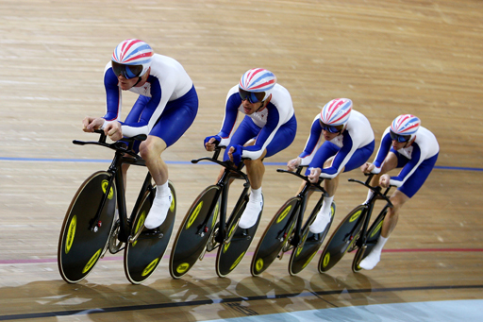
Grateful acknowledgement is made to Getty Images.
Figure 14 The British men's pursuit team competes at the 2008 Beijing Olympics. The aerodynamic benefit of riding close together and the technological benefit of advanced cycles helped them make the most of their skill and enabled them to win the gold medal.

5.3 Science and wheeled sports: a few final words
In this course, we examined the effect of technology on cycling and wheelchair sports by introducing aerodynamics and some basic aspects of material science. We used mainly qualitative arguments in this course to introduce these ideas, but this approach was sufficient to highlight some important ways in which the topics affect performance.
In addition to this new science, a significant part of the course was devoted to activities that enabled you to practise your internet skills, focusing on effective ways to search for information.

Keep on learning



Study another free course
There are more than 800 courses on OpenLearn for you to choose from on a range of subjects.
Find out more about all our free courses.

Take your studies further
Find out more about studying with The Open University by visiting our online prospectus.
If you are new to university study, you may be interested in our Access Courses or Certificates.

What's new from OpenLearn?
Sign up to our newsletter or view a sample.

For reference, full URLs to pages listed above:
OpenLearn - www.open.edu/openlearn/free-courses
Visiting our online prospectus - www.open.ac.uk/courses
Access Courses - www.open.ac.uk/courses/do-it/access
Certificates - www.open.ac.uk/courses/certificates-he
Newsletter - www.open.edu/openlearn/about-openlearn/subscribe-the-openlearn-newsletter

Acknowledgements
Course image: SuperCar-RoadTrip.fr in Flickr made available under Creative Commons Attribution-NonCommercial-ShareAlike 2.0 Licence.
Don't miss out:
If reading this text has inspired you to learn more, you may be interested in joining the millions of people who discover our free learning resources and qualifications by visiting The Open University - www.open.edu/openlearn/free-courses

SAQ 1

Answer
From the set of images in Figure 8, and hopefully from the websites you found yourself, you should be able to see that aerodynamics began to be an important part of cycling in the 1980s. Photographs from any major championships after 1985, such as the one shown in Figure 8c, will show this.
Back to Session 1 SAQ 1

SAQ 2

Answer
While the graph shows that record times have improved significantly, it is hard to see any sudden change in the mid-1980s, when the aerodynamic improvements were introduced.
You can see some change, but no greater than the change in the 1960s.
Back to Session 1 SAQ 2

SAQ 3

Answer
Once again, it is hard to see any sharp improvement in world records at this time. The improvement in the record is fairly continuous.
Back to Session 1 SAQ 3

Activity 1 Searching for information on the internet

Comment
The number of websites on the internet changes continually, so each person doing these searches might find a different number of search results in each case, and the first three sites listed by the search engine might also change over time. Using a variety of search engines will also give different results.
At the time of writing (2010), one search engine gave the following results for part (a) of each search:
- 'mountain + biking' = more than 12 million results
- 'mountain + biking + Britain + Olympics' = about 130 000 results
- '“mountain biking” + Britain + Olympics' = about 88 000 results
- '“mountain biking” + Britain + Olympics + results' = about 4000 results.
Although your results may differ from ours you probably found the same trend. The more keywords you search for, the fewer sites you find. Even so, you can see that the number of results for all four cases is still so high that you couldn't possibly view all of those websites. However, better-chosen keywords will also help determine which websites appear near the top of the list.
You might also have noted that searching for the specific phrase 'mountain biking' was better than looking for the two words separately.
In terms of the usefulness of the websites your searches found, the first three sites listed will vary depending on when you did your search. (If you try this exercise again tomorrow, you could get different results.) However, once again, the trend should be the same. The better your chosen keywords, the more relevant websites you will find. It is therefore worth spending a little time choosing your search terms carefully.
Incidentally, so far, Britain has never won a medal in mountain biking at the Olympics. We asked you not to look at the websites returned by your searches, just their description. Do you think you would have found this information by searching with this set of keywords?
Back to Session 1 Activity 1

Activity 2 Introducing aerodynamics

Comment
The main points from the activity were:
- Aerodynamics is the scientific field that studies the flow of air around an object.
- Air resistance produces a force on a moving object, in the opposite direction to the object's velocity. Aerodynamics can affect the amount of air resistance (i.e. the magnitude of that force.)
- The flow of air around an object can be characterised by:
  - the bow wave, a region of higher density in front of the object
  - the wake, a turbulent region that trails out behind the object
  - the boundary layer, a thin layer of air that lies between the object's surface and the moving air around it.
- The shape of an object has a major influence on the way that air flows around it. Athletes in sports such as cycling can benefit from maintaining a smooth shape.
Back to Session 1 Activity 2

Activity 3 Finding images of track cycles

Comment
Figure 8 shows photographs of track cyclists that we found on the internet. Your set of images will be different but you should be able to see clearly that cycling technology has changed greatly over the years.

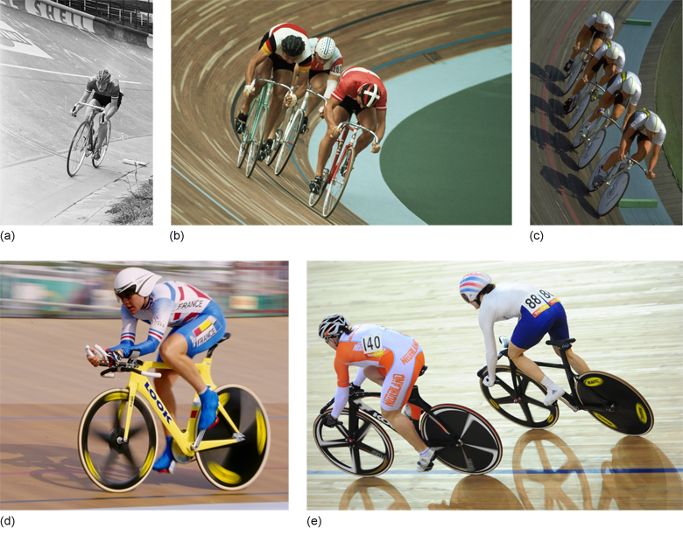
Grateful acknowledgement is made to Getty Images (Figure 8a, Figure 8c, Figure 8d), Wally McNamee/Corbis (Figure 8b) and AFP/Getty Images (Figure 8e).
Figure 8 (a) Britain's Beryl Burton practising for the 1967 World Championships; (b) the USA competing in the team pursuit event at the 1976 Olympics in Montreal; (c) Australia competing in the team pursuit event at the 1988 Olympics in Seoul; (d) Marion Clignet of France competing in the women's individual pursuit event at the 1996 Olympics in Atlanta; (e) Britain's Victoria Pendleton competing in the women's sprint event at the 2008 Olympics in Beijing.

How did you fare in your own search?
If you used 'images' as one of your keywords, you might have found at least one of the large collections of images available on the internet. These sites are sometimes called image banks and they include:
- Search engines such as Yahoo! and Google have their own image banks, made up of images that the search engine finds on various websites. These image banks might appear as a listed item on the search results page, or they might appear as a separate link on the search engine home page.
- Flickr, a website that allows users to store their own photographs. This is a huge collection, containing images by both professional and amateur photographers. Many of these images will appear in the search engine image banks described above.
- Getty Images, a website run by a commercial organisation that sells photographs to media organisations such as newspapers and magazines. It has a large collection of sporting photographs that anyone can view.
Back to Session 1 Activity 3

Activity 4 Properties of materials

Comment
The main points from the activity were:
- The number of atoms that any individual atom can bind to depends on the type of atom
  - hydrogen atoms can bind to, at most, one other atom, oxygen to two atoms and carbon to four atoms.
- Atoms in molecules bind to each other to make a self-contained individual particle.
- Atoms in solid materials bind to each other to make a continuous three-dimensional structure.
- The properties of solid materials depend on the type of atoms in the material and its internal structure: i.e. the way that atoms are bound inside the material.
- Important material properties include density, strength, flexibility and hardness.
- Graphite, diamond and carbon fibre are three different types of solid carbon material. The difference in their properties arises because of the difference in the carbon bonds within each material.
Back to Session 1 Activity 4

Activity 5 Development of bike design

Comment
Carbon fibre began to be used in bicycle components in the early 1980s, first appearing at the 1984 Games. Fully carbon-fibre frames first appeared a few years later. (The short film at the start of this section describes the fabrication of such a frame.)
It is not very straightforward to find this information, and you may not have found it with just a brief search, but did you discover any useful websites? Did your choice of keywords help your search?
As you were asked to find something about the history of cycling, 'history' would have been a good choice for a keyword. Other useful keywords include 'carbon fibre', 'Olympics' and 'track cycling', while 'cycle design' and 'cycle frame' might also have helped.
Your search engine may have found a Wikipedia page on the history of either cycling or carbon fibre. This sort of page would contain useful information but, as we noted earlier in the course, you need to verify information from encyclopedic websites of this kind. These web pages are useful as the starting point of an information search but they should not be used on their own.
You might have also found the websites of sporting organisations such as British Cycling or the International Olympic Committee. These sites may mention technological developments such as the introduction of carbon fibre but they might not have detailed histories of its use in the sport.
Back to Session 1 Activity 5

Activity 7 Finding images of racing wheelchairs

Comment
Figure 10 shows some images of wheelchair racing from different decades.

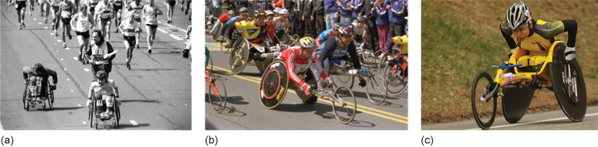
Grateful acknowledgement is made to Getty Images (Figure 10a and Figure 10c) and AFP/Getty Images (Figure 10b).
Figure 10 (a) Wheelchair athletes competing in the London marathon in 1986. (b) A group of athletes starting the wheelchair division of the Boston marathon in 1996. (c) A Japanese athlete competing in the Boston marathon in 2008.

You probably had some difficulty finding a good set of images from the last 30 years, mainly because wheelchair sport has only become well-known and well-funded in the last 10-15 years, and hence there are fewer photographs from before this time. We found our images on the Getty Images website, by searching for terms such as 'wheelchair', 'racing' and 'marathon'.
The images in Figure 10 show that wheelchair design has changed greatly. Even in the 1980s, wheelchair athletes competed using relatively ordinary wheelchairs that had been only slightly modified but, as Paralympic sport has become more prominent, increased time, effort and money has been spent to develop specialist wheelchairs.
Back to Session 1 Activity 7

Activity 8 Limitations of the internet

Comment
Despite its undoubted usefulness, the list of problems that you might encounter while using the internet is potentially very long. Here, we list three of the most common issues.
- Too much information. If you search for quite general information, you might come across so many websites that you simply cannot decide what is useful and what is not. We gave some guidelines in Section 1.4 that will help you, but this is a recurring problem.
- Too little information. While the internet contains a great deal of information, it doesn't contain everything. In Activity 7, we asked you to find images of wheelchairs, and you probably found that task quite difficult. To get a detailed view of the history of wheelchair racing you might have to go to a library and find a book on this topic, or even contact a sporting association to get some advice on where to find this information. In this course we will not ask you questions that require this type of extended search, but if you use the internet repeatedly you are almost certain to find instances where you simply cannot find the information you need.
- Too time-consuming. This is a common problem, and one that we have mentioned several times throughout the course. We have given advice at various points of the course and we strongly recommend that you keep those tips in mind when searching for information on the Web.
Back to Session 1 Activity 8

Video 1

Transcript
Narrator
These cyclists are among the best in the world.
The competitors that train here include several Olympic medallists and a handful of World Champions - standards are incredibly high.
But how did the cycling squad go from being spare wheels on the circuit to being all conquering international heroes? Well - yes and you're probably just a little bit ahead of me here - they took advantage of science…
It's not enough to be able to pedal quickly - you need to pedal powerfully… You need to perform tactically - and hey - even fly through the air if you're brave enough to take on the BMX circuit…
Cyclists need to understand aerodynamics - and speed and acceleration.
Track cyclists take advantage of gravity as they use the banked corners in races - BMX competitors are also using the basic laws of physics to power their way round a circuit.
Cycling IS about the athlete - but it's also about the apparatus. The cycle is as important as the cyclist.
The bike itself can be the single biggest deciding factor. What materials is it made of - how does the design, the weight and the balance of the frame affect how fast it will go?
In this part of the course we'll look at some of the science of cycling - and the way that the same science affects wheelchair sports. Like in other sports - specialised training has become the norm - but here it's also technology that can really make a difference.
Back to Session 1 MediaContent 1

Video 2

Transcript
Kate Knapman
When he does a standing start, Scottish cyclist Chris Hoy can produce up to 250 kg of effective mass on his bike. When you have athletes this powerful and highly trained, you want to give them a machine to match. He's got the body, now all he needs is the bike.
The bike is made from this. It's carbon fibre with an epoxy resin. It's put into a mould, and then it's headed under pressure in the autoclave behind me. When it comes out, it looks like this. This is the new bike frame. Now it may just look like an ordinary bike frame, but actually it's very very light. It only weighs just over one kilo and considering it's that light it's also very very strong for its weight.
The technology used to create the bike is the same for Formula 1 cars and fighter jets. British cyclists are pinning their ambitions to be the best in the World on this set of wheels. Remarkably, no prototype has ever been built. Instead, the bikes performance can be determined whilst it's still just a computer design. The weak points in the frame can be identified before they result in a potentially dangerous crash.
Peter Keen (Performance Director, British Cycling)
We've looked at where the strain and the forces are going to occur in the bicycle using the computer analysis. And we're therefore able to look at how we can apply the right carbon fibres in the right orientation to give the frame its maximum stiffness and strength for the weight that it is, so the cyclist gets more for the power that they put into the bicycle.
Kate Knapman
The aim is to produce a lightweight frame that is super-strong, making it faster than its competitors.
And what is the most important thing for the people that are going to ride that bike?
Dimitris Katsanis (Design Engineer)
How they feel about it. When we are going to have the first test, he's going come out of the ride, step off the bike and you're going to be there, you're going to say 'What do you think about it? Is it good?' If he says yes, then that's the most satisfactory thing for me. If he says no, then I'll go away.
Kate Knapman
You'll go and cry? Fingers crossed then that he likes it!
Dimitris Katsanis
Fingers crossed then. Definitely.
Kate Knapman
With six weeks to go the bike arrives in Manchester for the first track test. It's too late to make any big changes before the Commonwealth Games.
Chris Hoy is keen to test it out. And then delivers his verdict.
Chris Hoy
It just feels really really impressive. Very good. Nicest bike I have ever ridden by far.
Dimitris Katsanis
Very good. Very good.
Peter Keen
I think its performed as well as we could ever have hoped. It gives us confidence that Dimitris has got it pretty much right.
Kate Knapman
And then in what should be a routine 200 meter time trial, something extraordinary happens as Chris pushes the bike to its limits. The current track record is 9.98 seconds, but not for long.
[Trainer]
If I tell you that's the fastest we have ever had for that effort, 9.75. Nice one 9 7 5!
Kate Knapman
Within just a few hours of getting on the bike, Chris has smashed the track record. Those legs pushing the speed up to 75 kilometres per hour. The team were hoping the bike would be fast, but no one had expected this.
Chris Hoy
I'm pretty surprised actually, it felt very good. It didn't feel like I was having to put that much effort in, so it bodes well for the bike you-know. As soon as I got on it I could tell it was something special. I just don't want to tell people about it, you-know, keep it a secret, so that they don't want to use the bike as well.
Back to Session 1 MediaContent 2

