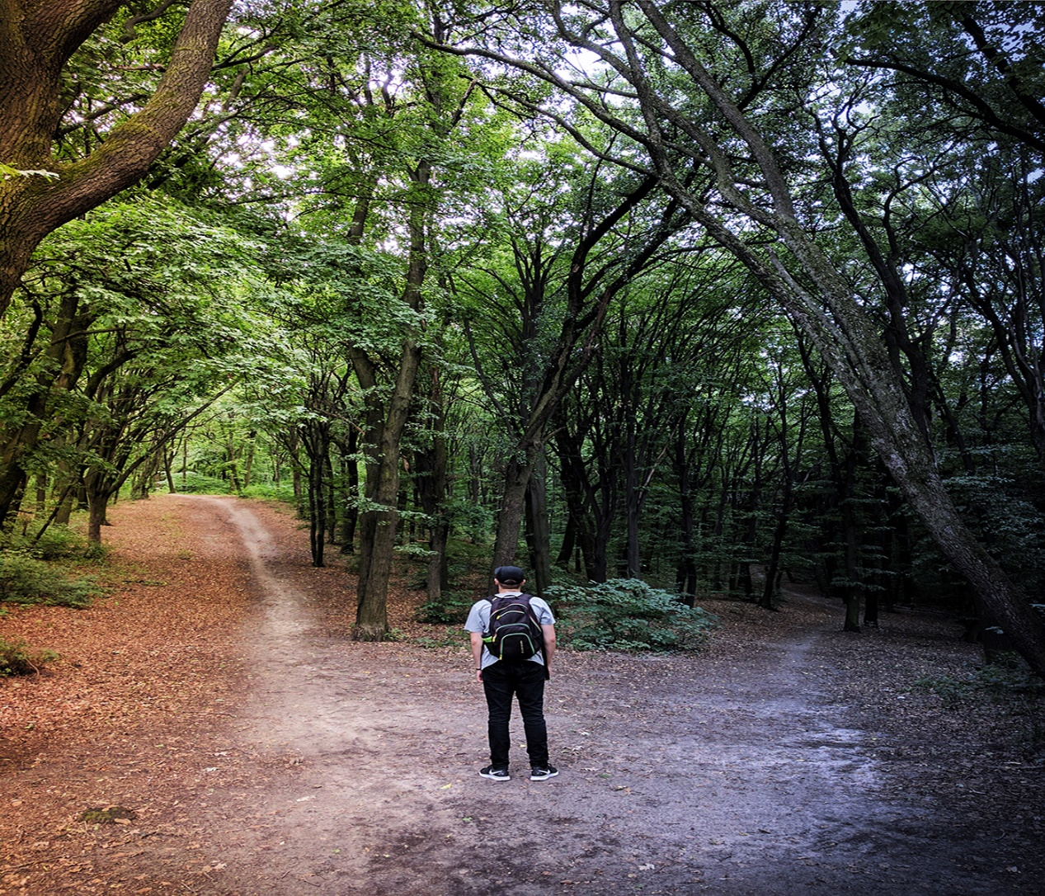

B874_1

Decision trees and dealing with uncertainty

About this free course
This free course is an adapted extract from the Open University course B874 Finance for strategic decision-making - www.open.ac.uk/postgraduate/modules/b874.
This version of the content may include video, images and interactive content that may not be optimised for your device.
You can experience this free course as it was originally designed on OpenLearn, the home of free learning from The Open University –
Decision trees and dealing with uncertainty
There you’ll also be able to track your progress via your activity record, which you can use to demonstrate your learning.
Copyright © 2020 The Open University
Intellectual property
Unless otherwise stated, this resource is released under the terms of the Creative Commons Licence v4.0 http://creativecommons.org/licenses/by-nc-sa/4.0/deed.en_GB. Within that The Open University interprets this licence in the following way: www.open.edu/openlearn/about-openlearn/frequently-asked-questions-on-openlearn. Copyright and rights falling outside the terms of the Creative Commons Licence are retained or controlled by The Open University. Please read the full text before using any of the content.
We believe the primary barrier to accessing high-quality educational experiences is cost, which is why we aim to publish as much free content as possible under an open licence. If it proves difficult to release content under our preferred Creative Commons licence (e.g. because we can’t afford or gain the clearances or find suitable alternatives), we will still release the materials for free under a personal end-user licence.
This is because the learning experience will always be the same high quality offering and that should always be seen as positive – even if at times the licensing is different to Creative Commons.
When using the content you must attribute us (The Open University) (the OU) and any identified author in accordance with the terms of the Creative Commons Licence.
The Acknowledgements section is used to list, amongst other things, third party (Proprietary), licensed content which is not subject to Creative Commons licensing. Proprietary content must be used (retained) intact and in context to the content at all times.
The Acknowledgements section is also used to bring to your attention any other Special Restrictions which may apply to the content. For example there may be times when the Creative Commons Non-Commercial Sharealike licence does not apply to any of the content even if owned by us (The Open University). In these instances, unless stated otherwise, the content may be used for personal and non-commercial use.
We have also identified as Proprietary other material included in the content which is not subject to Creative Commons Licence. These are OU logos, trading names and may extend to certain photographic and video images and sound recordings and any other material as may be brought to your attention.
Unauthorised use of any of the content may constitute a breach of the terms and conditions and/or intellectual property laws.
We reserve the right to alter, amend or bring to an end any terms and conditions provided here without notice.
All rights falling outside the terms of the Creative Commons licence are retained or controlled by The Open University.
Head of Intellectual Property, The Open University
978-1-4730-3181-4 (.kdl)
978-1-4730-3182-1 (.epub)

Contents
- Introduction
- Learning outcomes
- 1 Dealing with uncertainty: an introduction to probability
- 2 Check your understanding of probability
- 3 Expected values
- 4 Decision trees
  - 4.1 Decision trees and expected value
  - 4.2 A complex decision tree – deciding whether or not to launch a product early
  - 4.3 A complex decision tree – developing a new pharmaceutical drug
- Conclusion
- References
- Acknowledgements
- Solutions

Introduction
This course is concerned with using decision trees to simplify and formulate business decisions, typically using financial information. As decisions affect the future well-being of an organisation, they almost always rely on some form of forecast information. In this course, you will consider the subject of uncertainty in a financial context and meet a few ways of dealing with it, including a basic introduction to probability. This will help you to understand a common approach to dealing with financial information known as an ‘expected value’.
Once you have a basic understanding of probability, you will then use that knowledge in the context of a powerful and sophisticated technique referred to as a ‘decision tree’. This technique allows you to consider, simultaneously, a variety of possible outcomes and to find the optimal decision for the organisation.

This OpenLearn course is an adapted extract from the Open University course B874 Finance for strategic decision-making.

Learning outcomes
After studying this course, you should be able to:
- deal with basic uncertainty in a decision-making context
- understand the basic ideas of probability
- calculate expected values
- produce and analyse a decision tree.

1 Dealing with uncertainty: an introduction to probability

Allow approximately 1 hour 30 minutes to complete this section.

Decision-making is often undertaken in an uncertain world. That is, you might have some doubts about the reliability of the data you have been provided with, as well as the future environment in which you will be operating. In business, uncertainty regarding the future can cover a very wide range of scenarios, including:
- political – who will be running the country in five years’ time? What will be their view on, for example, tax, regulation, etc.?
- economic – will the country be in recession, or booming? What will interest rates be?
- market – how will your product market develop? Will there be new entrants, leavers or substitutes?
As decision-makers, you need to find strategies to deal with uncertainty and so, in this section, you will be introduced to the topic of probability.
A knowledge of probability enables you to assess the likelihood of something happening. For example, what is the chance that a 55-year-old person will buy a new car in the next 12 months?
You might subdivide the data – what is the probability that a 55-year-old man will buy a car within the next 12 months?
You can then go further by attaching conditions. For example, what is the probability that a 55-year-old man, who bought his last car three years ago, will buy a new car within the next 12 months?
Or even, if a 55-year-old man has purchased a new car within the last three years, how long will it be before he buys a new car?
Unfortunately, probability theory is quite a complex subject and so in this course you will only consider the most basic ideas. These ought to suffice for the kinds of decisions that managers need to make most of the time. In the next activity you will be introduced to those basic ideas.

Activity 1 What is probability?
Allow approximately 20 minutes to complete this activity

In Videos 1 and 2, you will be introduced to the basic ideas of probability. An understanding of probability allows you to quantify uncertainty.
You will build on your understanding of probability, especially later on in this course when you learn about decision trees. So you may need to watch Videos 1 and 2 a few times until you feel comfortable with how probability starts to address the question of how to deal with uncertainty in decision-making.

Part 1

Watch Video 1. You may like to make notes in the text box below.

Video content is not available in this format.
Video 1 An introduction to probability: part 1
View transcript - Video 1 An introduction to probability: part 1

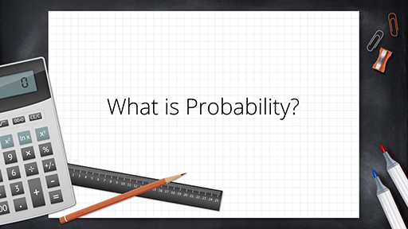

Provide your answer...

Part 2

Watch Video 2. You may like to make notes in the text box below.

Video content is not available in this format.
Video 2 An introduction to probability: part 2
View transcript - Video 2 An introduction to probability: part 2

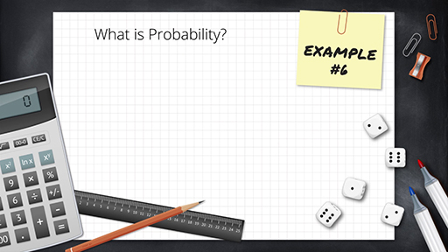

Provide your answer...
View discussion - Part 2

Most people will have an instinctive feel for what probability is. Probability is a measure of how likely it is that something will occur. How might you assess that likelihood?

Probability: first principles
To begin, you might be able to derive a number from first principles.
For example, it is hopefully obvious that if someone throws a ‘normal’ six-sided die, the number ‘3’ is likely to land face up 1 in 6 times. You might say that the probability of throwing a ‘3’ is , or one sixth.
Of course, if someone throws a die six times then they might get ‘3’ more than once or even no ‘3’s. It is only if the die is thrown thousands of times that the person will notice that roughly one sixth of the throws result in a ‘3’ landing face up.

Probability: considering past behaviour
Another way of arriving at a probability might be to observe past behaviour. For example, the Eurovision song contest has, as of April 2019, had 66 winners (some years there have been joint winners). The Republic of Ireland has won it seven times. So you might conclude that the Republic of Ireland has a probability of winning the next contest. Coming to such a conclusion is, of course, rather simplistic. You would need to consider how much past success indicates the chance of future success, given that the performers are usually different.

Probability: subjective opinion
One last way you might assign a probability is through simply expressing a subjective opinion. For example, if you watch the Eurovision performers prior to voting, you might arrive at a view of which act is most likely to appeal to the voters (nowadays, a combination of the public and appointed judges). Of course, this probability might be very different to that assigned by another watcher.
The concept of probability could also be used to consider how the gambling industry functions and the interplay between odds and subjective probabilities, but this will not be covered in this course.

In business scenarios, it is not often that you can rely on the first approach of deriving a number from first principles of probability only. More often, you have to arrive at a probability based on a combination of some data (via a market survey, for example) and experience.

Before proceeding, the definition and mathematical rules for probability need to be explained. From the die example earlier, a reasonable definition of a probability can be concluded as follows:

- Probability is expressed as a ratio whose value is positive. You cannot have negative probabilities.
- A probability is less than or equal to 1. This means that a probability cannot exceed 1.
- The total of all probability outcomes must equal 1.
For example, if the probability of something happening is 0.45, the probability of it not happening must be .

In the next section you will have the opportunity to check your understanding of probability.

2 Check your understanding of probability

Allow approximately 30 minutes to complete this section.

In this section, you will attempt some questions and work through examples to test and embed your understanding of basic probability, as used in decision-making. First, try some simple questions on probability in Activity 2.

Activity 2 Probability quiz
Allow approximately 5 minutes to complete this activity

Select the response that best answers each question.

1. What does a probability of 1 mean?

This means that the event is certain to occur.
There is a 1 in 100 chance of the event occurring.
The event can only occur once.
There is a 1 in 10 chance of the event occurring.
View answer - Part

2. What must all the probabilities of all outcomes total to?

They must total to 1.
The total value of all outcomes.
0.50.
It depends on the event.
View answer - Part

Now study the following worked example in Box 1.

Box 1 Worked example on probability
What is the probability of throwing three heads and one tail, when throwing four coins at the same time?
To answer this, you need to explore the total number of possible outcomes. Here are two approaches to this problem.

Approach 1
Each coin will fall independently. The possible combinations are as follows. (Note that the scenarios of ‘three heads and one tail’ are in bold and italics below.)
HHHH
HHHT
HHTH
HHTT
HTHH
HTHT
HTTH
HTTT
THHH
THHT
THTH
THTT
TTHH
TTHT
TTTH
TTTT
From the list of possible combinations, you can conclude that there are 16 combinations, four of which (in italics) are three heads and one tail. This can be shown as:

Approach 2
The number of combinations could also have been found as follows:
- each coin has two possible outcomes
If the first coin has two possible outcomes and the second also has two, then between them there are four combinations (i.e. 2 × 2 = 2² = 4)
- adding a third coin (which has two outcomes) doubles the combinations (i.e. 2 × 2 × 2 = 2³ = 8)
- finally, the last coin makes it 16 (i.e. 2⁴) as there are 4 coins, each of which may be heads or tails, then there are 4 combinations with 3 heads and one tail, so, the probability is: .

In Activity 3, you will apply your understanding of probabilities in considering a different scenario.

Activity 3 Probability of ribbons in a box
Allow approximately 10 minutes to complete this activity

You place five ribbons in a box. They are coloured, black, blue, red, yellow and green. If you pull out two ribbons and the first is black, what is the probability that the second you select is blue?

Provide your answer...
View answer - Activity 3 Probability of ribbons in a box

You have now covered the basic ideas of probability and for the rest of this course you will learn how to apply these ideas in the context of making business decisions.

3 Expected values

Allow approximately 1 hour to complete this section.

You can use probability to arrive at a weighted average of the value of an outcome, reflecting the various levels of likelihood. This weighted average can be called the expected value. Work through the following example to see how this idea is used in financial forecasting.

Box 2 Worked example on forecasting interest rates
Economic forecasters are unsure what interest rates will be next year. However, combining the various contributing economic scenarios, they believe the outcomes shown in Table 1 are possible.

Table 1 Probability of different possible interest rates
Possible interest rate % | Probability
1.50 | 0.29
2.75 | 0.54
3.90 | 0.17

Note that there are only three possible outcomes.
Their probabilities must total one.
So, .
The ‘expected value’ of interest rates can be calculated as follows:

As a common sense test, note that the expected value is close to the overwhelmingly most probable (2.75%, with a probability of 0.54).
Also, the expected value, being an average, must lie within the range of possible outcomes (that is, between 1.5% and 3.9%).

In the next activity you will use the idea of expected value to estimate stock returns. Although this approach may seem simplistic, it lies at the heart of modern-day corporate finance.

Activity 4 Calculating the expected value of stock returns
Allow approximately 15 minutes to complete this activity

In this activity, you will calculate the expected value of stock returns. You will assume that the rates of return on the stock market over the last 120 years are as summarised in Table 2. The frequency tells you how many of those years a particular return was made.

Table 2 Frequency of stock returns
Return % | Frequency
3.00 | 4
3.25 | 12
4.00 | 19
4.50 | 23
5.12 | 28
6.00 | 18
6.50 | 12
7.00 | 4
 | 120

Part 1 Calculating the probability of stock returns

Before you calculate the expected value of stock returns, you will first need to find the probabilities and record them in Table 3.
Hint: if something occurs 4 times out of 120, what is its probability?

Table 3 Calculating the probability of stock returns
Return % | Frequency | Probability
3.00 | 4 | Provide your answer...
3.25 | 12 | Provide your answer...
4.00 | 19 | Provide your answer...
4.50 | 23 | Provide your answer...
5.12 | 28 | Provide your answer...
6.00 | 18 | Provide your answer...
6.50 | 12 | Provide your answer...
7.00 | 4 | Provide your answer...
 | 120 | Provide your answer...

Tip: do not forget to check that all of the probabilities add up to a total of one.

View answer - Part 1 Calculating the probability of stock returns

Part 2 Calculating the expected value of stock returns

You can now calculate the expected value of stock returns and complete Table 5.

Table 5 Calculating the expected value of stock returns
Return % | Frequency | Probability | Expected value
3.00 | 4 | 0.0333 | Provide your answer...
3.25 | 12 | 0.1000 | Provide your answer...
4.00 | 19 | 0.1583 | Provide your answer...
4.50 | 23 | 0.1917 | Provide your answer...
5.12 | 28 | 0.2333 | Provide your answer...
6.00 | 18 | 0.1500 | Provide your answer...
6.50 | 12 | 0.1000 | Provide your answer...
7.00 | 4 | 0.0333 | Provide your answer...
 | 120 | 1.000 | Provide your answer...

View answer - Part 2 Calculating the expected value of stock returns

You will use expected value in the next section on decision trees.

4 Decision trees

Allow approximately 2 hours to complete this section.

Sometimes decisions can be complex and require a number of stages to arrive at a final outcome. Such a final outcome may be dependent on earlier, intermediate decisions. Alternatively, the final decision may be dependent on a series of uncertain, intermediate outcomes. Dealing with these types of decisions may appear, on the face of it, quite difficult. However, the technique of decision trees that you are going to explore in this section will help to simplify this process.
The best way to illustrate the technique is by a worked example in Activity 5. Before doing so, it is important to point out the meaning of two symbols that will be used in the decision trees.
Where a branch appears on your tree, this point will be called a node. A node may appear for one of two reasons. The first is that a decision is required. In other words, the node represents a series of choices. This type of node will be called a decision node and a square will be used to denote it. The second type of node is a chance node. Here, there is a range of possible events or outcomes of varying probabilities. Such nodes are denoted with a circle.

Activity 5 Introduction to decision trees
Allow approximately 30 minutes to complete this activity

In Videos 3 and 4, you will be introduced to the powerful technique of decision trees. This technique allows you to incorporate probabilities into a range of potential outcomes, which may themselves be conditional on other outcomes.
You may wish to watch the videos a few times and make notes in the text boxes to ensure that you understand the concept of decision trees, as well as to answer the questions.

Part 1

A company (MKOU) is assessing two outsourcing bids, A and B. Company A is more expensive but is reckoned to have a higher probability of delivering a high quality good than B. This is important as the higher the quality the more MKOU can charge and the less it will need to refund to dissatisfied customers. The data may be summarised as shown in Table 7.

Table 7 Possible financial benefits of using companies A and B
Company | Probability of acceptable service level | Net financial benefit if acceptable £M | Net financial cost if not acceptable £M
A | 80% | 120 | -30
B | 55% | 160 | -10

Video content is not available in this format.
Video 3 A worked example on decision trees
View transcript - Video 3 A worked example on decision trees

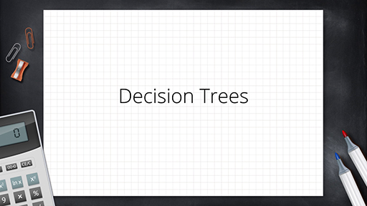

Provide your answer...

Part 2

A company is considering launching a new product. It can either launch immediately or in one year’s time. If it launches immediately there is a 0.75 chance of the launch being successful. If it is unsuccessful then the launch will be halted at a cost of £1M and relaunched in a year’s time. If the company launches immediately it may opt to also have a promotion, which has a 0.6 chance of success. If the promotion is successful the financial benefit is £10M, if not £2M. If the company does not do the promotion the benefit is £5M. If the company launches in a year’s time the benefit is £6M. What should the company do?

Video content is not available in this format.
Video 4 A second worked example on decision trees
View transcript - Video 4 A second worked example on decision trees

Provide your answer...
View discussion - Part 2

Now that you have watched the videos on decision trees, you will consider potential decisions faced by businesses. In the next section you will see some more applied examples of how decision trees are used in making business decisions.

4.1 Decision trees and expected value
You are now at a stage to see how an understanding of expected values and probability can be combined to simplify complex business problems.

Example: decision tree for a business considering a new office location
You are considering opening a new office somewhere in the UK and you have shortlisted two town councils: A and B. However, a key factor is the impact of local taxes, also called business rates.
Local elections are coming up with two main parties in the running: J and K. Each party has a different view on how business should be treated; however, there is uncertainty as to whether they will increase or decrease business rates.
Table 8 shows the probabilities of each party winning, their possible views towards business and the impact of each.

Table 8 Probabilities of each party
Council | Party | Probability of winning | Probability of being business friendly | Estimated impact of being business friendly/ £M | Estimated impact of being business unfriendly/ £M
A | J | 0.55 | 0.7 | 3.0 | -0.50
 | K | 0.45 | 0.4 | 0.5 | -2.00
B | J | 0.30 | 0.6 | 2.5 | -0.25
 | K | 0.70 | 0.35 | 1.0 | -1.00

The probabilities of winning might be based, for example, on the odds currently being offered by a betting website, predicting the chances of that party winning.
The probabilities of being business friendly would be based on past experience and any announcements being made by the parties.
The final two columns show the estimated monetary impact, positive or negative, in £ millions.
In the fifth column, ‘Estimated impact of being business friendly/£M’, if, for example, in the first row, in council A, party J has a 0.7 probability of being business friendly, then it must have a probability of 0.3 of being unfriendly towards business. This is because the total probabilities must total to 1.
Table 8 includes estimates of the financial impact. So, for example, in the first row, it has been estimated that in council A, if party J were business friendly, the company would benefit financially by £3M. On the other hand, if the party were not business friendly, the company would suffer financially by £0.5M.
The data shown in Table 8 can be mapped in a decision tree as follows.

Creating a decision tree
- Put in the main decision and choice nodes (Figure 1).

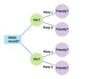
Figure 1 Decision tree for which council
View description - Figure 1 Decision tree for which council

- Add the final column (Figure 2). This column leads to the final value for each particular path. In other words, you will add the top branch of the decision tree – the impact if council A wins and it is business friendly.

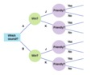
Figure 2 Decision tree for which council, with 'yes'/'no' chance nodes
View description - Figure 2 Decision tree for which council, with 'yes'/'no' chance nodes

- Put in the impact values (Figure 3).

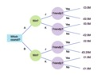
Figure 3 Decision tree for which council, with terminal values added
View description - Figure 3 Decision tree for which council, with terminal values added

- Then add their probabilities. Note that if party J in council A has a 0.7 probability of being business friendly, then it must have a 0.3 (1 – 0.7) probability of being business unfriendly.
As the only possibilities are being friendly or unfriendly, the probabilities of these must equal 1 – it is definitely either friendly or unfriendly (Figure 4).
This example only has one decision node: which town to move to. There are then two sets of chance nodes. The ‘chances’ being those actions outside of the decision-maker’s control. They are: Which party will win? (So you can create a branch for each of the two possibilities) and, is that winning party business-friendly or not?
Again, you create a branch for each answer. If there were more decisions, at each decision node you would insert a branch for each option open to the decision-maker.

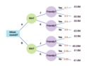
Figure 4 Decision tree for which council, with probabilities added
View description - Figure 4 Decision tree for which council, with probabilities added

Calculating the expected value
Now you can find the expected value of the financial impact for each party in each council.

- What is the expected value of the financial impact if party J won in council A?
- There is a 0.7 probability of it being business friendly and 0.3 of it being unfriendly. If party J won council A, the expected financial impact would be:
(0.7 × £3M) + (0.3 × -£0.5M) = £1.95M.
The expected values can be added to the decision tree (Figure 5).

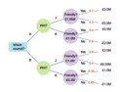
Figure 5 Decision tree for which council, with expected values added to ‘Friendly’ nodes
View description - Figure 5 Decision tree for which council, with expected values added to ‘Friendly’ ...

- What is the financial impact if the company moved to council B?
- There is a 0.3 probability of J winning (with an expected financial impact of £1.4M) and 0.7 of K winning (with an expected impact of -£0.3M). So the expected financial impact of moving to B is:
(0.3 × £1.4M) + (0.7 × -£0.3M) = £0.21M.
The probabilities can be added to the decision tree (Figure 6).

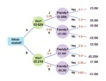
Figure 6 Decision tree for which council, with win probabilities and win node expected values added
View description - Figure 6 Decision tree for which council, with win probabilities and win node expected ...

For example, for council A, the expected value is:
(0.55 × £1.95M) + ( 0.45 × -£1M) = £0.62M

So now you can step back and see that council A has the higher expected value (£0.62M compared with £0.21M in B) and so, on the grounds of economic impact (there may be other factors), you would select to relocate to A.
This general approach to solving the problem, by analysing from the last stage back to the first, is a process called dynamic programming. The content of this course will not go beyond decision trees.
In the next subsection you will consider an example of a complex decision tree related to the launch of a product.

4.2 A complex decision tree – deciding whether or not to launch a product early
From the last worked example, you should now have a good understanding of the basics of how decision trees work. In this next example in Activity 6 you will meet a more complex decision tree with more than just the initial decision node. In other words, more than one decision will be needed. Thus, as well as providing an initial decision (what to do now), the decision tree will also provide a strategy for future decisions depending on the outcomes of various chance events.

Activity 6 Example of a complex decision tree: considering early launch of a product
Allow approximately 45 minutes to complete this activity

A company is planning on launching a new product. It was thinking of launching in June of next year but it believes that a rival is also considering launching a similar product around that time. The company is considering bringing the launch forward to the end of this year. This will cost an extra €3M to carry out and the company believes it will have a 0.8 probability of beating the rival to the market. If, however, they wait until June, the probability of beating the rival falls to 0.2.
To make the decision easier, the company assumes that sales will be either high, medium or low. If the company launches before its rival, the probability of high sales is 0.6 and the probability of medium sales is 0.25. If it launches after its rival, the probability of high sales falls to 0.35 and medium sales rises to 0.45. If the rival launches first, the company could undertake a sales promotion, costing €1.5M, but would change the probabilities of high sales to 0.5 and medium to 0.4.
The financial impacts are that high sales would be worth €9M, medium would be worth €5M and low, €1M.
Using a decision tree analysis, calculate what the company’s investment strategy should be. You can use pen and paper, an Excel spreadsheet, or record your calculations in the text box below.
Once you have arrived at a solution, watch Video 5 for the feedback of this activity.

Provide your answer...
View discussion - Part

In the next subsection you will consider another example of a complex decision tree, this time related to the launch of a new pharmaceutical drug.

4.3 A complex decision tree – developing a new pharmaceutical drug
Now that you have watched Video 5 that presents a more complex example of using decision trees, the next activity will give you an opportunity to practise the skill of building and evaluating a decision tree.

Activity 7 Example of a complex decision tree: considering the development of a new pharmaceutical drug
Allow approximately 30 minutes to complete this activity

A pharmaceutical company is considering developing a new drug. The key decision criteria is the development time, which the company would like to minimise. There are two approaches to developing the drug. The first is to base it on stem cell research (‘stem’). There is a 0.4 probability that this approach would lead to a drug within 5 years, otherwise it will take up to 7 years (0.6 probability). Note, these times are from the start of the use of this approach.
An alternative approach is based on a method called targeted delivery (‘TD’). This has a 0.3 probability of delivering a drug within 3 years. However, if at the end of 3 years there is no drug, the company would have to choose between switching to stem or carrying on with TD. At that point, the TD will have a 0.8 probability of delivering the drug within a further 2 years.
Although, if the drug has still not been delivered after a further 2 years, the company can still switch to the stem approach. Alternatively, persevering at this stage with TD will definitely yield a drug after a further 7 years.
Given the objective is to minimise development time, use a decision tree to determine what the company’s strategy should be.
You can use pen and paper, an Excel spreadsheet, or record your calculations in the text box below.

Provide your answer...
View discussion - Activity 7 Example of a complex decision tree: considering the development of a new ...

Conclusion
In this course, you learned how to use probability to quantify uncertainty. Probability enables the decision-maker to calculate a quantity called the expected value, which gives you a quantity that takes account of the differing probabilities of the potential outcomes of an event.
Finally, you learned how to use these ideas in situations where there is a range of possible outcomes, some of which may be dependent on earlier outcomes. The technique used was that of a decision tree.
This OpenLearn course is an adapted extract from the Open University course B874 Finance for strategic decision-making.

References
The Yale Tribune (2020) Mergers are on the Rise: Is it Good for the Economy?. Available at: https://campuspress.yale.edu/tribune/mergers-are-on-the-rise-is-it-a-good-thing-for-the-economy/ (Accessed: 2 September 2020).

Acknowledgements
This free course was written by Kevin Amor. It was first published in December 2020.
Except for third party materials and otherwise stated (see terms and conditions), this content is made available under a Creative Commons Attribution-NonCommercial-ShareAlike 4.0 Licence.
The material acknowledged below and within the course is Proprietary and used under licence (not subject to Creative Commons Licence). Grateful acknowledgement is made to the following sources for permission to reproduce material in this free course:

Images/Tables
Course/ Introduction image: Making decision: Photo by Vladislav Babienko on Unsplash.

Audio/Video
Every effort has been made to contact copyright owners. If any have been inadvertently overlooked, the publishers will be pleased to make the necessary arrangements at the first opportunity.
Don't miss out
If reading this text has inspired you to learn more, you may be interested in joining the millions of people who discover our free learning resources and qualifications by visiting The Open University – www.open.edu/openlearn/free-courses.

Solutions

Activity 1 What is probability?

Part 2

Discussion
From Video 2 you learnt that probability is a way of measuring uncertainty. The probability of an event may be taken as the proportion of times that an event can occur out of the total possible events. The video provided some simple examples of how you might estimate a probability.
Back to - Part 2

Activity 2 Probability quiz

Part

Answer
Right:
This means that the event is certain to occur.
Wrong:
There is a 1 in 100 chance of the event occurring.
The event can only occur once.
There is a 1 in 10 chance of the event occurring.
Back to - Part

Part

Answer
Right:
They must total to 1.
Wrong:
The total value of all outcomes.
0.50.
It depends on the event.
Back to - Part

Activity 3 Probability of ribbons in a box

Answer
The probability of the second ribbon selection being blue is then:

Back to - Activity 3 Probability of ribbons in a box

Activity 4 Calculating the expected value of stock returns

Part 1 Calculating the probability of stock returns

Answer
So, taking 3.00% as an example from Table 2, you can see that it has occurred four out of a possible total 120 times. This gives it a probability as follows: .
If you then calculate the probability for all of the stock returns, you should get the results shown in Table 4.

Table 4 The probability of stock returns
Return % | Frequency | Probability
3.00 | 4 | 0.0333
3.25 | 12 | 0.1000
4.00 | 19 | 0.1583
4.50 | 23 | 0.1917
5.12 | 28 | 0.2333
6.00 | 18 | 0.1500
6.50 | 12 | 0.1000
7.00 | 4 | 0.0333
 | 120 | 1.0000

Back to - Part 1 Calculating the probability of stock returns

Part 2 Calculating the expected value of stock returns

Answer
To get the expected value of stock returns, you multiply each stock return by its probability and then sum the result, as shown in Table 6 below.

Table 6 Expected value of stock returns
Return % | Frequency | Probability | Expected value
3.00 | 4 | 0.0333 | 0.100
3.25 | 12 | 0.1000 | 0.325
4.00 | 19 | 0.1583 | 0.633
4.50 | 23 | 0.1917 | 0.863
5.12 | 28 | 0.2333 | 1.195
6.00 | 18 | 0.1500 | 0.900
6.50 | 12 | 0.1000 | 0.650
7.00 | 4 | 0.0333 | 0.233
 | 120 | 1.000 | 4.899

So the expected value of stock returns is 4.899%, which you could round up to 4.9%.
Back to - Part 2 Calculating the expected value of stock returns

Activity 5 Introduction to decision trees

Part 2

Discussion
To summarise, you can use decision trees to break down a decision into a series of events that involve the decision-maker making a sub-decision (‘decision node’) or there being a chance event outside of the decision-maker’s control (‘chance node’). (Note that ‘sub-decision’ means a decision taken after the first, main, decision.)
By allocating probabilities to the chance nodes you can evaluate the expected value from the various combinations of sub-decisions and chance events.
This then informs which initial decision and then subsequent sub-decisions should be taken.
Back to - Part 2

Activity 6 Example of a complex decision tree: considering early launch of a product

Part

Discussion
Now watch Video 5.

Video content is not available in this format.
Video 5 Solution for considering the early launch of a product
View transcript - Video 5 Solution for considering the early launch of a product

You may find it useful to work through the written solution below too. In this more complex decision tree you had to make some subsequent decisions based on the final outcomes of each branch. Thus you not only arrived at an initial decision (what action to take now) but also what actions to take at future points based on future chance events.

Written solution
You can also read the solution below.
The decision tree is shown in Figure 7.

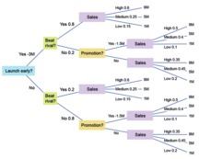
Figure 7 Decision tree: a company deciding on when to launch a new product
View description - Figure 7 Decision tree: a company deciding on when to launch a new product

The calculations for each node are as shown in Table 9 (remember that you will need to work from right to left).

Expected sales

Table 9 Expected sales
Sales’ node number (from top to bottom of decision tree) | Expected sales – calculation €M | Expected sales – value €M
1 | (0.6 × 9) + (0.25 × 5) + (0.15 × 1) | 6.8
2 | (0.5 × 9) + (0.4 × 5) + (0.1 × 1) | 6.6
3 | (0.35 × 9) + (0.45 × 5) + (0.2 × 1) | 5.6
4 | (0.6 × 9) + (0.25 × 5) + (0.15 × 1) | 6.8
5 | (0.5 × 9) + (0.4 × 5) + (0.1 × 1) | 6.6
6 | (0.35 × 9) + (0.45 × 5) + (0.2 × 1) | 5.6

Expected sales after promotion
There are two promotion decision nodes, as summarised in Table 10.

Table 10 Expected sales after promotion
Promotion node number (from top to bottom of decision tree) | Expected sales after promotion – calculation €M | Expected sales after promotion – value €M
1 – Yes | 6.6 – 1.5 | 5.1
1 – No | 5.6 | 5.6
2 – Yes | 6.6 – 1.5 | 5.1
2 – No | 5.6 | 5.6

At both decision nodes, the expected value of sales is higher without the promotion than with it. The company will, therefore, never promote if launching after its rival. The higher figure of expected sales (€5.6m) is now carried forward.

Table 11 Expected sales at 'Beat rival?' chance node
‘Beat rival’ node number (from top to bottom of decision tree) | Expected sales – calculation €M | Expected sales – value €M
1 | [(0.8 × 6.8) + (0.2 × 5.6)] − 3 | 3.56
2 | (0.2 × 6.8) + (0.8 × 5.6) | 5.84

You can see from Table 11 that the value of launching early is €3.56M, whereas the value of not launching early is €5.84M.
Thus, the decision is two-fold: the company should not launch early. If it then finds that it has not beaten its rival, it should not undertake a promotion.
Back to - Part

Activity 7 Example of a complex decision tree: considering the development of a new pharmaceutical drug

Discussion
First, you should draw the decision tree. Your decision tree should look something like Figure 8 below.

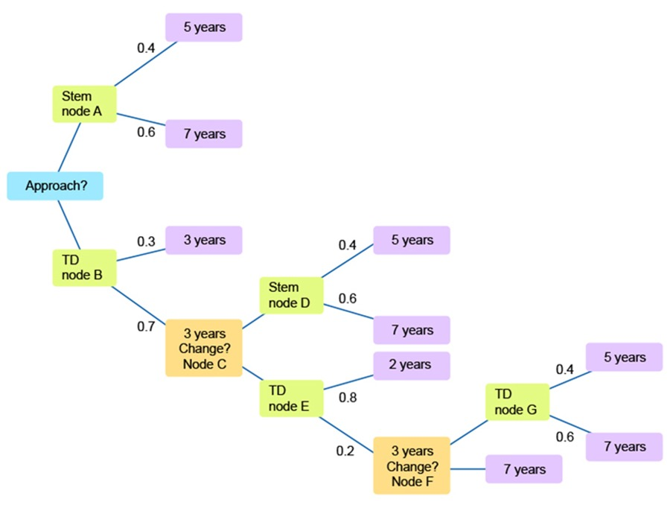
Figure 8 Decision tree: a company deciding on the development of a new pharmaceutical drug
View description - Figure 8 Decision tree: a company deciding on the development of a new pharmaceutical ...

As before, you start from the right-hand side and work back towards the start.
At node G, the expected development time from that point is (0.4 × 5) + (0.6 × 7) = 6.2 years. Note that this is the development time for stem, so you can use this calculation again.
As this is shorter than the alternative (7 years), at decision node F you would choose to start the stem approach, taking 6.2 years from that point. However, you have already waited 2 years before making that choice. From node E, there are 8.2 years (6.2 + 2) if you follow the lower branch (leading to node F).
So from node E you have an expected development time of (0.8 × 2) + (0.2 × 8.2) = 3.24 years.
You know that node D has an expected development time of 6.2 years (the stem time). At node C you would choose to carry on with TD as the expected time is lower (3.24 years). However, it has taken you 3 years to arrive at node C, so the development time is 6.24 years.
At node B, then, the expected development time is (0.3 × 3) + (0.7 × 6.24) = 5.27 years.
Now you have the strategy. As the first decision stem has an expected development time of 6.2 years, whereas the first decision TD has an expected development time of 5.27 years.
Thus, you would start on TD. If after three years you had not developed the drug (now at node C), you would choose to carry on with TD as the expected time at that point of 3.24 years is less than stem (6.2 years).
If after a further two years you still had not developed the drug (at node F), you would switch and start the stem approach, as 6.2 expected years for the stem approach is less than the definite 7 years it would take to complete the TD approach.
Back to - Activity 7 Example of a complex decision tree: considering the development of a new pharmaceutical drug

Figure 1 Decision tree for which council

Description
Decision tree: two branches, the top is for A and bottom is for B.
Following the top branch (for A) you come to a chance node called ‘win’ which then splits into two further branches, for the party, called J and K. Each of these branches arrives at another chance node called ‘friendly’. This is repeated in the lower branch for B.
Back to - Figure 1 Decision tree for which council

Figure 2 Decision tree for which council, with 'yes'/'no' chance nodes

Description
From the previous diagram (Figure 1), the decision tree has two branches, the top is for A and bottom is for B.
Following the top branch (for A) you come to a chance node called ‘win’ which then splits into two further branches, for the party, called J and K.
Each of these branches arrives at another chance node called ‘friendly’.
Each of these has two further branches form each node, called ‘yes’ or ‘no’.This is repeated in the lower branch for B.
Back to - Figure 2 Decision tree for which council, with 'yes'/'no' chance nodes

Figure 3 Decision tree for which council, with terminal values added

Description
To the previous diagram (Figure 2) you now add the expected financial benefits.
Starting at the top and working down they are £3 million, -£0.5 million, £0.5 million, -£2 million, £2.5 million, -£0.25 million, £1 million and -£1 million.
So in total the decision tree has two branches, the top is for A and bottom is for B.
Following the top branch (for A), you come to a chance node called ‘win’, which then splits into two further branches, for the party, called J and K. Each of these branches arrives at another chance node called ‘friendly’. Each of these has two further branches form each node, called ‘yes’ or ‘no’. This is repeated in the lower branch for B.
You now add the expected financial benefits. Starting at the top and working down they are: £3 million, -£0.5 million, £0.5 million, -£2 million, £2.5 million, -£0.25 million, £1 million and -£1 million.
Back to - Figure 3 Decision tree for which council, with terminal values added

Figure 4 Decision tree for which council, with probabilities added

Description
To the previous decision tree diagram (Figure 3) you now add the probabilities for each financial benefits.
Starting at the top and working down they are 0.7, 0.3 , 0.4, 0.6, 0.6, 0.4, 0.35 and 0.65.
So in total the decision tree has two branches, the top is for A and bottom is for B.
Following the top branch (for A) you come to a chance node called ‘win’, which then splits into two further branches, for the party, called J and K.
Each of these branches arrives at another chance node called ‘friendly’. Each f these has two further branches form each node, called ‘yes’ or ‘no’. This is repeated in the lower branch for B.
Now add the expected financial benefits. Starting at the top and working down they are £3 million, -£0.5 million, £0.5 million, -£2 million, £2.5 million, -£0.25 million, £1 million and -£1 million.
Now add the probabilities for each financial benefits. Starting at the top and working down they are 0.7, 0.3 , 0.4, 0.6, 0.6, 0.4, 0.35 and 0.65.
Back to - Figure 4 Decision tree for which council, with probabilities added

Figure 5 Decision tree for which council, with expected values added to ‘Friendly’ nodes

Description
To the previous decision tree diagram (Figure 4) you now add the probabilities for each financial benefits.
Starting at the top and working down they are 0.7, 0.3 , 0.4, 0.6, 0.6, 0.4, 0.35 and 0.65.
So in total the decision tree has two branches, the top is for A and bottom is for B.
Following the top branch (for A) you come to a chance node called ‘win’, which then splits into two further branches, for the party, called J and K.
Each of these branches arrives at another chance node called ‘friendly’. Each f these has two further branches form each node, called ‘yes’ or ‘no’. This is repeated in the lower branch for B.
Now add the expected financial benefits. Starting at the top and working down they are £3 million, -£0.5 million, £0.5 million, -£2 million, £2.5 million, -£0.25 million, £1 million and -£1 million.
Now add the probabilities for each financial benefits. Starting at the top and working down they are 0.7, 0.3 , 0.4, 0.6, 0.6, 0.4, 0.35 and 0.65.
Now add the expected values at each of the four ‘friendly?’ chance nodes. Starting at the top they are £1.95 million, -£1 million, £1.4 million and -£0.3 million.
Back to - Figure 5 Decision tree for which council, with expected values added to ‘Friendly’ nodes

Figure 6 Decision tree for which council, with win probabilities and win node expected values added

Description
To the previous decision tree diagram (Figure 5) you now add the probabilities for each financial benefits.
Starting at the top and working down they are 0.7, 0.3 , 0.4, 0.6, 0.6, 0.4, 0.35 and 0.65.
So in total the decision tree has two branches, the top is for A and bottom is for B.
Following the top branch (for A) you come to a chance node called ‘win’, which then splits into two further branches, for the party, called J and K.
Each of these branches arrives at another chance node called ‘friendly’. Each f these has two further branches form each node, called ‘yes’ or ‘no’. This is repeated in the lower branch for B.
Now add the expected financial benefits. Starting at the top and working down they are £3 million, -£0.5 million, £0.5 million, -£2 million, £2.5 million, -£0.25 million, £1 million and -£1 million.
Now add the probabilities for each financial benefits. Starting at the top and working down they are 0.7, 0.3 , 0.4, 0.6, 0.6, 0.4, 0.35 and 0.65.
Now add the expected values at each of the four ‘friendly?’ chance nodes. Starting at the top they are £1.95 million, -£1 million, £1.4 million and -£0.3 million.
Now add the probabilities of each party winning (branching out of the two ‘win?’ chance nodes). From the top they are 0.55, 0.45, 0.3 and 0.7.
Then you add the expected values in the two ‘win?’ nodes, form the top they are £0.62 million and £0.21 million.
Back to - Figure 6 Decision tree for which council, with win probabilities and win node expected values added

Figure 7 Decision tree: a company deciding on when to launch a new product

Description
The first decision node asks ‘launch early?’
The top branch is for ‘yes’ which has a cost of 3m. Next on that branch is a chance node called ‘beat rival?’. This splits into two branches. The top brach is for ‘yes’ and has a 0.8 probability. This leads to a chance node called ‘sales’ which has three branches for high , medium and low. The respective probabilities are 0.6, 0.25 and 0.15. Finally there are the three respective final values starting with high sales 9 million, medium, 5 million And low 1 million.
Returning to the ‘beat rival?’ chance node the second branch is for ‘no’ and has a 0.2 probability. This leads to a decision node ‘promotion?’ which has two branches. The top branch is for ‘yes’ and costs -1.5 million and leads to a ‘sales’ chance node. This node has three branches for levels of sale, high , probability 0.5 and value 9 million, medium 0.4 probability and value 5 million and low, 0.1 probability 1 million.
Returning to the promotion node, the second branch is for ‘no’ and leads to a chance node ‘sales’ with three branches high, probability 0.35 value 9 million, medium 0.45 value 5 million and low 0.2 and 1 million.
Returning to the ‘launch early? Node the bottom branch is for no. Next on that branch is a chance node called ‘beat rival?’. This splits into two branches. The top branch is for ‘yes’ and has a 0.2 probability. This leads to a chance node called ‘sales’ which has three branches for high , medium and low. The respective probabilities are 0.6, 0.25 and 0.15. Finally there are the three respective final values starting with high sales 9 million, medium, 5 million And low 1 million. Returning to the ‘beat rival?’ chance node the second branch is for ‘no’ and has a 0.8 probability. This leads to a decision node ‘promotion?’ which has two branches. The top branch is for ‘yes’ and costs 1.5 million and leads to a ‘sales’ chance node. This node has three branches for levels of sale, high , probability 0.5 and value 9 million, medium 0.4 probability and value 5 million and low, 0.1 probability 1 million.
Returning to the promotion node, the second branch is for ‘no’ and leads to a chance node ‘sales’ with three branches high, probability 0.35 value 9 million, medium 0.45 value 5 million and low 0.2 and 1 million.
Back to - Figure 7 Decision tree: a company deciding on when to launch a new product

Figure 8 Decision tree: a company deciding on the development of a new pharmaceutical drug

Description
The image starts with a square choice node labelled ‘approach’. The upper branch leads to a chance node labelled ‘stem node A’. From this leads a terminal node ‘5 years’ with probability 0.4 and ‘7 years’ with probability 0.6. The lower branch from ‘approach’ leads to a chance node labelled ’TD node B’. This has an upper branch leading to a terminal node 3 years with probability 0.3. The lower branch leads to a chance node labelled ‘3 years change? Node c’. This has an upper branch leading to chance node labelled ‘stem node d’. From this node there are two terminal nodes one for 5 years with probability 0.4 and 7 years with probability 0.6. The lower branch leads to a chance node ‘td node e’. This has an upper branch leading to a terminal node 2 years with probability 0.2. The lower branch leads to a chance node,with probability 0.2, labelled ‘3 years change? Node f’. The upper branch from here leads to a chance node ‘td node g’ which itself leads to 2 terminal nodes , 5 years with probability 0.4 and 7 years with probability 0.6. The lower node leads to a terminal node of 7 years.
Back to - Figure 8 Decision tree: a company deciding on the development of a new pharmaceutical drug

Video 1 An introduction to probability: part 1

Transcript
NARRATOR:
What is probability? Probability gives us a way of measuring or assessing uncertainty. It measures the likelihood of certain random events. We're going to go through some examples.
Take a 6-sided dice. What's the probability that we'll throw a 3? We know that there are 6 possible outcomes: 1, 2, 3, 4, 5, and 6. But there's only one 3. And so there's a 1 in 6 chance, or a 1 in 6 probability, of rolling number 3. We would express that probability as 1 divided by 6, which is 0.167.
Taking the same 6-sided dice, what's the probability that we'll throw an even number? Well, there's 3 even numbers on a dice: 2, 4, and 6, and there's 6 possible outcomes, so we'd express this as 3 over 6, which is a half, or 0.5.
What's the probability that we'll throw an even number greater than 3? There are 2 even numbers greater than 3: 4 and 6. So there's 2 numbers and 6 possible outcomes. So the probability here is 2 out of 6, which is one third, or 0.33. We can see that probability compares the number of times the desired outcome happens with the total number of possible outcomes.
What's the probability that you'll throw an odd number greater than 3? The answer here is 1 in 6 because there's only 1 odd number greater than 3 - that's 5. And so we say there's a 1 out of 6 probability.
What's the probability that we'll throw a number greater than 3? Well, there are 3 numbers greater than 3: 4, 5, and 6. So we would immediately think it's 3 out of 6, which is 0.5.
But another way of doing this is to say, what's the probability of throwing even numbers greater than 3, and adding that to the probability of throwing odd numbers greater than 3. And so the probability of throwing a number greater than 3 should equal the probability of throwing the even numbers plus the probability of throwing the odd numbers.
Here, we've got the probability of throwing an even number greater than 3 as 0.333 and the probability of throwing an odd number greater than 3 as 0.167. If you add them together, it's 0.5. This only works because they're what we call mutually exclusive events. A number greater than 3 cannot be both odd and even.
So each of the numbers: 4, 5, and 6 can only be an even number or an odd number. And when you have mutually exclusive events, you can do this adding up calculation. So one way of calculating the probability of an outcome is to compare the number of ways that outcome may occur with the total number of possible outcomes.
Back to - Video 1 An introduction to probability: part 1

Video 2 An introduction to probability: part 2

Transcript
NARRATOR:
Let's throw 2 6-sided die. What's the probability that you'll throw a total equal to 7? Remember what we need to do. We're going to compare the number of times it could happen with the total number of complete possibilities.
Here's all the complete possibilities. There are 36 ways that the two die could fall. Out of these, how many ways are there of getting 7? I've put them all in red. There's 6 possible ways or 6 combinations. So 6 over 36, which is the same as one sixth, which is 0.167.
What's the probability of throwing first a 2 and then an even number greater than 3? Well, let's start with the first die. Throwing a 2, we know happens 1 out of 6 times. There's only one 2, and there's 6 outcomes. This means that anything which comes after, whatever that probability, is only going to happen one sixth of the time. So it's going to be whatever this probability is times one sixth.
The second throw, throwing an even number greater than 3, is going to happen 2 out of 6 times. But the first row is only happening one sixth of the time. Therefore, the second throw can only happen one sixth of its normal probability. And so we multiply two sixths, which is actually one third, by one sixth to get two thirty-sixths, or one eighteenth. So events that follow each other can be multiplied by the individual probabilities.
Here's some overall rules about probability. The probability of all possible outcomes has to equal 1. What's the probability of throwing an odd number? 3 over 6. What's the probability of throwing an even number? 3 out of 6. In other words, the probability of everything happening is 1.
For combined mutually exclusive events, we can add probabilities. We looked at mutually exclusive events in example 5. Combined events - one dice, then another - can be found by multiplying their probabilities. And of course, if something doesn't have a possibility of it happening, we can still use the rule of how often it happens compared to the total. So if the number of times it happens is 0, then the probability must be 0.
And finally, before we leave the intrinsic approach, we can also use history, studies, or market research to come up with probabilities. Here's something from a medical piece of research. 2619 men were found to have certain risk factors to do with coronary heart disease. Of those men, at the end of the 8-year study, 246 of them had suffered with heart disease.
So if the total possible men that could have coronary heart disease with a risk factor is 2619 but only 246 went on to actually get it, then the probability of getting it is this figure here. The number of those who did over the total number who could have. So 246 over 2619. In other words, a probability of 0.094.
Back to - Video 2 An introduction to probability: part 2

Video 3 A worked example on decision trees

Transcript
NARRATOR:
In this video, we're going to introduce decision trees. A decision tree is a really useful tool for visualising and solving problems where there are various choices involved and we don't know which choices to make. So we're going to bring in probabilities with this.
Decision trees consist of nodes. These are where the branches of the decision tree split. And there are two types of nodes. A square node is where a decision is being taken, something that is our choice. And the other type of node we show is a circle, where there is some kind of chance element. This is where we apply probabilities, where things happen outside our control.
A company, MKOU, is assessing two outsourcing bids: A and B. Company A is more expensive but is reckoned to have a higher probability of delivering a high-quality good than B. This is important, as the higher the quality, the more MKOU can charge and the less it will need to refund dissatisfied customers.
So we need to assess two bids to make a decision between A or B. Let's set up a branch for A and a branch for B. There's a chance on each of them - will they deliver a good service or not? So let's look at A's first. It's a chance. So it's a circle node. Will the service of A be acceptable? And that's a 'Yes' or a 'No' branch. There's an 80% probability, or 0.8, of it being 'Yes'. So, therefore, there must be 0.2 of it being 'No'.
You'll recall from the beginning of this section that all probability must total 1. So if it's 'Yes', it has a final value of 120 million pounds, whereas if it's a 'No', it's minus 30 million pounds. And we're going to have to give refunds, and there's going to be costs incurred.
Coming down to B, is it acceptable? 'Yes' or 'No'? There is a 0.55 probability, or 55% chance of it being 'Yes'. So the 'No' must be 0.45 because probabilities have to equal 1. And the values here are 160 million pounds and minus 10 million pounds.
And what we do now is we just work out which of these two nodes - 1 or 2 - have the highest expected value. The expected value of 1 is going to be 0.8 times 120 plus 0.2 times minus 30, which is 90 million pounds. And the value of node 2 is going to be 0.55 times 160 plus 0.45 times minus 10. And that works out to be 83.5 million pounds. 90 million pounds goes here, and 83.5 million pounds goes here.
In this fairly simple decision tree, the root with the highest expected value is A. We would expect, on average, A to get 90 million pounds, whereas B only 83.5 million pounds. Therefore, on this basis, we would go with A.
Notice that although this is a simple decision tree, we can already see the technique. When we're setting up the model, we work from left to right, going through putting down what each of the various branches will do. And then we work backwards to get the expected value of each node.
Back to - Video 3 A worked example on decision trees

Video 4 A second worked example on decision trees

Transcript
NARRATOR:
Let's look at a more complicated example. A company is considering launching a new product. It can either launch immediately or in 1 year's time. If it launches immediately, there's a 0.75 chance of the launch being successful. If it's unsuccessful, then the launch will be halted at a cost of 1 million pounds and re-launch in a year's time.
If the company launches immediately, it may also opt to have a promotion. If the promotion is successful, the financial benefit is 10 million pounds. If not, it's 2 million pounds. If the company doesn't do the promotion, the benefit is 5 million pounds. If the company launches in a year's time, the benefit is 6 million pounds.
So we're considering launching a product. It can launch immediately or in one year's time. We put our two branches down. At the end, we'll go with the one with the highest expected value. If the product launches immediately, there's a 0.75 chance of the launch being successful.
This is something outside our control, so we write successful with a question mark. Yes, it will be successful, is a 0.75 chance, and therefore, no, it won't be successful, has a 0.25 chance. If it's unsuccessful, the launch will be halted at a cost of 1 million pounds. So let's write that here. -1 million pounds and re-launched in a year's time. So it'll come down here to 1 year, and we'll join those lined up in a minute.
If the company launches immediately, it may also opt to have a promotion. Well, we'll only do the promotion if it's successful. So we had another choice. Do we launch a promo? Yes or no? If we do a promotion, will it be successful? Yes or no?
The promotion has a 0.6 probability of being successful and, therefore, 0.4 probability of not being successful. If the promotion is successful, the benefit is 10 million pounds after all costs. And if it's not successful, it's 2 million after all costs.
If the company doesn't do the promotion, the benefit is 5 million pounds. Here's this line. And if the company launches in a year's time, the benefit is 6 million pounds, so these two lines join up. So we now work from right to left. We'll label this node number 1.
The expected value here is 0.6 times 10 plus 0.4 times 2, which is 6.8 million pounds. We'll write that on node 1. On node 2, where we have a choice, 'Yes' is worth 6.8 in expected value terms, whereas 'No' is worth 5. So we'd pick 'Yes' and with an expected value of 6.8.
Coming now to node 3, the expected value at this point is 0.75 times 6.8 because that's the expected value at node 2 plus 0.25. Now will launch in a year's time, but now the expected value of coming down this route is -1 plus 6, which is 5. Node 3 is therefore worth 6.35 million pounds.
The value of this route is simply 6. Nothing else happened in between. So what we can conclude, based on our diagram, is that launching a new product now has an expected value of 6.35 million pounds, whereas launching a new product in a year's time has an expected value of 6. Therefore, on this basis, we would go with the 6.35 million pounds, so we would launch now.
If we were to launch now and it was successful, we then have another choice to make at node 2. And here, we would choose 'Yes', we would promote. So our strategy is the launch now, and then, if it's successful, to launch a promotion.
Just to recap. Decision nodes are shown as squares. Chance nodes are shown as circles. Terminal nodes are the ones where their values go right at the end, and we show them as rectangles. Probabilities coming out of a chance node must total 1 because they must cover every single eventuality.
We calculated expected values moving from right to left and then carried back the expected values which formed later decisions. We saw this in the example question, do we promote? The expected value of promoting was higher than not promoting, so that node no longer becomes a decision node because we made the decision now. And then, coming right back to the beginning, you can see which initial branch gives you the highest expected value.
Back to - Video 4 A second worked example on decision trees

Video 5 Solution for considering the early launch of a product

Transcript
NARRATOR:
A company is planning on launching a new product. It was thinking of launching in June next year but believes that a rival is also considering launching a similar product. The company is considering bringing the launch forward to the end of this year. This will cost an extra 3 million euros to do, and the company believes it will have a 0.8 probability of beating the rival to the market. If, however, they wait until June, the probability of beating the rival falls to 0.2.
To make the decision easier, the company assumes that sales will be high, medium, or low. If the company launches before its rival, the probability of high sales is 0.6, and medium, 0.25. If it launches after, the probability of high sales falls to 0.35 and medium rises to 0.45. If the rival launches first, then the company could undertake a sales promotion costing 1.5 million euros but would change the probabilities of high sales to 0.5 and medium to 0.4.
The financial impacts are that high sales would be worth 9 million euros, medium, 5 million euros, and low, 1 million euros. So should the company launch this year or next? That's the big decision-- this or next. It'll cost an extra 3 million to launch this year. We'll note that for when we work out the expected value.
If we go up this branch, we need to take 3 million euros of the expected value. The company believes it will have a 0.8 probability of beating the rival to the market if it launches this year. So beat rival, yes or no, 0.8 here, therefore, this must be 0.2. If, however, the company waits until June next year, the probability of beating the rival falls to 0.2. So here we also put beat rival, yes or no branches, and it's 0.2 for yes and 0.8 for no.
So now we go to what type of sales we've got. We have three types-- high, medium, and low-- and the probabilities from this particular branch are 0.6, 0.25, and therefore, because they must all equal 1, 0.15. And then the values here are 9 million euros, 5 million euros, and 1 million euros.
If the company doesn't beat the rival to the market, then it has the opportunity to undertake a sales promotion. So this is a decision node. If it does the promotion, it will cost 1.5 million euros. And the sales will now have different probabilities; 0.5 for high, 0.4 for medium, and, therefore, 0.1 for low, but the end values will stay the same. If the company doesn't undertake a sales promotion, the probabilities are 0.35 for high, 0.45 for medium, and 0.2 for low. And again, the end values stay the same.
Now we move to launching the product next year. The sale nodes here are identical to the three at the top. They've all come after the "beating the rival" node. It's just the probabilities of getting there have changed. So this node here, with the one beside it, is the same as this node in terms of its expected value. It's just this one has 0.8 chance of it happening, whereas this one has a 0.2 chance. So whatever this expected value is, we put the same down here and the same with these.
Now let's work out the expected value at node one, which is 0.6 times 9 plus 0.25 times 5 plus 0.15 times 1, which is 6.8 million euros. We can also do the second node, 0.5 times 9 plus 0.4 times 5 plus 0.1 times 1 minus the 1.5 million to undertake the promotion. So we see that the expected value of undertaking a promotion is 5.1 million euros.
We'll put 6.8 on node one, and this will also be 6.8. Node two is 5.1, and so this is 5.1 as well. Now, we can work out the third sales node, where we didn't undertake a promotion. To work out this expected value, it's 0.35 times 9 plus 0.45 times 5 plus 0.2 times 1. There's no cost to deduct for this one, so the expected value is 5.6 million euros.
Node three's expected value can go here and also here. The company needs to decide whether to undertake a sales promotion. If they do, the expected value is 5.1 million euros. And if they don't, the expected value is 5.6 million euros. So based on these figures, the decision will be to not do a promotion.
Now we can go to node four. Remember, we're going right to left, and the expected value here is 0.8 times 6.8 plus 0.2 times 5.6, which is 6.56 million euros. And then node five is 0.2 times 6.8 plus 0.8 times 5.6. So node five is 5.84 million euros, and node four is 6.56 million euros.
Now, the only problem with node four is to get there, the company had to spend 3 million euros. So, in fact, the true cost here is the 6.56 minus the 3, which is 3.56 million euros. So the expected value of this route is 3.56 million euros, and the expected value of this route is 5.84 million euros.
So the company's strategy will be, first of all, not to bring the launch forward-- to launch the product next year. And if a rival beats the company to the market, it will not do the sales promotion.
Back to - Video 5 Solution for considering the early launch of a product

