

ALT_1 Citizen science and global biodiversity

Citizen science and global biodiversity
About this free course
This version of the content may include video, images and interactive content that may not be optimised for your device.
You can experience this free course as it was originally designed on OpenLearn, the home of free learning from The Open University – https://www.open.edu/openlearn/science-maths-technology/citizen-science-and-global-biodiversity/content-section-overview
There you’ll also be able to track your progress via your activity record, which you can use to demonstrate your learning.
Copyright © 2019 The Open University
Intellectual property
Unless otherwise stated, this resource is released under the terms of the Creative Commons Licence v4.0 http://creativecommons.org/licenses/by-nc-sa/4.0/deed.en_GB. Within that The Open University interprets this licence in the following way: www.open.edu/openlearn/about-openlearn/frequently-asked-questions-on-openlearn. Copyright and rights falling outside the terms of the Creative Commons Licence are retained or controlled by The Open University. Please read the full text before using any of the content.
We believe the primary barrier to accessing high-quality educational experiences is cost, which is why we aim to publish as much free content as possible under an open licence. If it proves difficult to release content under our preferred Creative Commons licence (e.g. because we can’t afford or gain the clearances or find suitable alternatives), we will still release the materials for free under a personal end-user licence.
This is because the learning experience will always be the same high quality offering and that should always be seen as positive – even if at times the licensing is different to Creative Commons.
When using the content you must attribute us (The Open University) (the OU) and any identified author in accordance with the terms of the Creative Commons Licence.
The Acknowledgements section is used to list, amongst other things, third party (Proprietary), licensed content which is not subject to Creative Commons licensing. Proprietary content must be used (retained) intact and in context to the content at all times.
The Acknowledgements section is also used to bring to your attention any other Special Restrictions which may apply to the content. For example there may be times when the Creative Commons Non-Commercial Sharealike licence does not apply to any of the content even if owned by us (The Open University). In these instances, unless stated otherwise, the content may be used for personal and non-commercial use.
We have also identified as Proprietary other material included in the content which is not subject to Creative Commons Licence. These are OU logos, trading names and may extend to certain photographic and video images and sound recordings and any other material as may be brought to your attention.
Unauthorised use of any of the content may constitute a breach of the terms and conditions and/or intellectual property laws.
We reserve the right to alter, amend or bring to an end any terms and conditions provided here without notice.
All rights falling outside the terms of the Creative Commons licence are retained or controlled by The Open University.
Head of Intellectual Property, The Open University
978-1-4730-2944-6 (.kdl) 978-1-4730-2945-3 (.epub)
1.0

Contents
- Introduction and guidance
  - Introduction and guidance
  - What is a badged open course?
  - How to get a badge
- Week 1: What is citizen science?
  - Introduction
  - 1 What is citizen science?
  - 2 Defining citizen science
  - 3 Who is a citizen scientist?
  - 4 Why citizen science?
  - 5 Motivation: understanding why people do citizen science
  - 6 Can citizens contribute to science?
  - 7 How do we do it? Approaches to citizen science
  - 8 Citizen science in action – the growth of citizen science
  - 9 Creating a support structure for citizen science
  - 10 This week’s quiz
  - 11 Summary of Week 1
- Week 2: Global biodiversity
  - Introduction
  - 1 Identity
    - 1.1 Why use Latin?
  - 2 Diversity
  - 3 Measuring biodiversity
  - 4 Biodiversity patterns
    - 4.1 Spatial scale
    - 4.2 Time-scale
  - 5 Biodiversity drivers
    - 5.1 Climate
    - 5.2 Geological drivers
    - 5.3 Human drivers
  - 6 Interaction of spatial and temporal scales
  - 7 Contemporary global biodiversity challenges
    - 7.1 The sixth mass extinction?
    - 7.2 The Red List
    - 7.3 A catastrophic decline?
  - 8 This week’s quiz
  - 9 Summary of Week 2
- Week 3: Using biological keys for species identification
  - Introduction
  - 1 Why is species identification important?
  - 2 Identifying species
    - 2.1 Example 2
    - 2.2 Example 3
  - 3 Current estimates of the total number of species
  - 4 Types of biological key
  - 5 Comparing biological keys
  - 6 Using a biological key
  - 7 Limitations of biological keys
    - 7.1 Other issues using biological keys
  - 8 This week’s quiz
  - 9 Summary of Week 3
- Week 4: Biodiversity recording
  - Introduction
  - 1 A large-scale project
    - 1.1 Case study on monitoring monarch butterflies
  - 2 Plant surveying
  - 3 Collecting insects
    - 3.1 Sampling on the soil surface
    - 3.2 Sampling flying insects
    - 3.3 Light traps in the Grand Canyon
  - 4 This week’s quiz
  - 5 Summary of Week 4
- Week 5: Advanced species ID techniques
  - Introduction
  - 1 Small details are important
  - 2 Using microscopes
    - 2.1 USB microscopes
  - 3 Examining specimens with a microscope
  - 4 Using DNA sampling
  - 5 Automated species identification from images and sounds
  - 6 This week’s quiz
  - 7 Summary of Week 5
- Week 6: Using web resources
  - Introduction
  - 1 Online resources supporting species identification
    - 1.1 Identifying Katie’s moth
    - 1.2 Searching for species information
  - 2 Further research post-identification of the stinging nettle
  - 3 Finding out basic information
  - 4 Researching further information about a species
    - 4.1 More examples
  - 5 Time for reflection
    - 5.1 What if there isn’t an answer to my question?
  - 6 This week’s quiz
  - 7 Summary of Week 6
- Week 7: Joining an online citizen science community
  - Introduction
  - 1 Overview of iSpot
  - 2 Using iSpot
  - 3 Browsing iSpot
  - 4 Registering on iSpot
  - 5 Adding an observation
  - 6 Adding species names to identifications
    - 6.1 Using the Species Browser
    - 6.2 The Species Browser and taxonomy
    - 6.3 Using iSpot keys
    - 6.4 Using the taxonomic hierarchy (‘tree of life’)
  - 7 Personalising and customising iSpot
    - 7.1 Customising your activity – iSpot Projects
    - 7.2 Customising your view of iSpot – community filters
  - 8 This week’s quiz
  - 9 Summary of Week 7
- Week 8: Citizen science community
  - Introduction
  - 1 Ecosystems
  - 2 Image analysis
  - 3 Big data
  - 4 Technology provides opportunities
    - 4.1 Satellites – the next big advance in citizen science?
  - 5 Reflections
    - 5.1 The scope of citizen science projects
    - 5.2 The development of skills required for identifying and using online resources
    - 5.3 The contribution of citizen science projects to assessing biodiversity and the state of the planet
  - 6 This week’s quiz
  - Where next?
  - Tell us what you think
- References
- Acknowledgements

Introduction and guidance

Introduction and guidance
This free course deals with the importance of biodiversity and explores how anyone can contribute to and be involved in identifying and recording wildlife, as a citizen scientist. It looks at what citizen science is, who can be a citizen scientist and how citizen science facilitates public involvement in scientific research activities as individuals learn and build skills.
After completing this course, you will be able to:
- observe, record and analyse biodiversity
- join the iSpot community and learn from real examples how organisms are identified
- undertake observations and post these to the iSpot website
- use identification keys and other online aids to identification
- understand the use of a microscope as a tool to aid identification.
Moving around the course
In the ‘Summary’ at the end of each week, you will find a link to the next week. If at any time you want to return to the start of the course, click on ‘Course content’. From here you can navigate to any part of the course. Alternatively, use the week links at the top of every page of the course.
It’s also good practice, if you access a link from within a course page (including links to the quizzes), to open it in a new window or tab. That way you can easily return to where you’ve come from without having to use the back button on your browser.
The Open University would really appreciate a few minutes of your time to tell us about yourself and your expectations for the course before you begin, in our optional start-of-course survey. Participation will be completely confidential and we will not pass on your details to others.

What is a badged open course?
While studying Citizen science and global biodiversity you have the option to work towards gaining a digital badge.
Badged courses are a key part of The Open University’s mission to promote the educational well-being of the community. The courses also provide another way of helping you to progress from informal to formal learning.
To complete a course you need to be able to find about 24 hours of study time, over a period of about 8 weeks. However, it is possible to study them at any time, and at a pace to suit you.
Badged courses are all available on The Open University's OpenLearn website and do not cost anything to study. They differ from Open University courses because you do not receive support from a tutor. But you do get useful feedback from the interactive quizzes.
What is a badge?
Digital badges are a new way of demonstrating online that you have gained a skill. Schools, colleges and universities are working with employers and other organisations to develop open badges that help learners gain recognition for their skills, and support employers to identify the right candidate for a job.
Badges demonstrate your work and achievement on the course. You can share your achievement with friends, family and employers, and on social media. Badges are a great motivation, helping you to reach the end of the course. Gaining a badge often boosts confidence in the skills and abilities that underpin successful study. So, completing this course should encourage you to think about taking other courses.



How to get a badge
Getting a badge is straightforward! Here’s what you have to do:
- read each week of the course
- score 50% or more in the two badge quizzes in week 4 and week 8.
For all the quizzes, you can have three attempts at most of the questions (for ‘true or false?’ type questions you usually only get one attempt). If you get the answer right first time you will get more marks than for a correct answer the second or third time. Therefore, please be aware that it is possible to get all the questions right but not score 50% and be eligible for the badge on that attempt. If one of your answers is incorrect you will often receive helpful feedback and suggestions about how to work out the correct answer.
For the badge quizzes, if you're not successful in getting 50% the first time, after 24 hours you can attempt the whole quiz, and come back as many times as you like.
We hope that as many people as possible will gain an Open University badge – so you should see getting a badge as an opportunity to reflect on what you have learned rather than as a test.
If you need more guidance on getting a badge and what you can do with it, take a look at the OpenLearn FAQs. When you gain your badge you will receive an email to notify you and you will be able to view and manage all your badges in My OpenLearn within 24 hours of completing the criteria to gain a badge.
Get started with Week 1

Week 1: What is citizen science?

Introduction
In this week you will be introduced to citizen science projects and activities, which will give you an opportunity to appreciate the benefits of becoming a citizen scientist and joining citizen science communities.

Video content is not available in this format.
View transcript - Uncaptioned interactive content

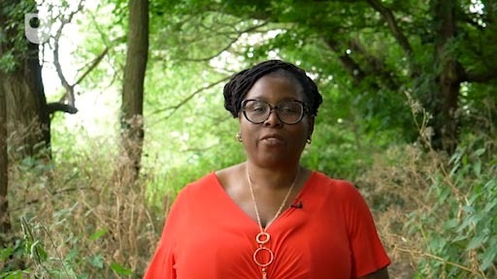

By the end of this week, you should be able to:
- understand the role of citizen science as a tool for scientific investigation (enquiry) and research
- describe the practice, growth and development of citizen science
- recognise how citizen science engages the public with science
- understand how, when and why citizen science supports biological recording (environmental monitoring).
The Open University would really appreciate a few minutes of your time to tell us about yourself and your expectations for the course before you begin, in our optional start-of-course survey. Participation will be completely confidential and we will not pass on your details to others.

1 What is citizen science?
In June 2009, six-year-old Katie Dobbins who lives just outside London, England, saw an unusual furry moth on her windowsill (Figure 1). Curious to find out what it was, she showed it to her dad, who helped her to take a photo and posted the observation on the then-new citizen science platform www.iSpotnature.org. Within 24 hours, the iSpot online community confirmed it to be the euonymous leaf notcher, a species never previously seen in the UK.

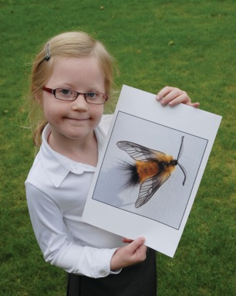
©Get Reading
Figure 1 Katie and the moth

This example of citizen science demonstrates its power. It enables anyone to participate, make discoveries and contribute to scientific knowledge, while at the same time being able to engage with and learn about science. The story of Katie and the moth will be revisited later in this week as we discuss the concept of citizen science and how to become a citizen scientist.
This first week of the course examines the growth of citizen science and how it contributes to scientific knowledge. You will learn about its historical context – how amateur scientists have long been contributing to scientific research and biological recording. You will also learn how, with the support of new communications technology, citizen science has recently grown a much wider audience, engaging volunteers in the collection and processing of data on a huge scale. This first week briefly examines what motivates and engages people to participate in citizen science and explores the impact and benefits of this participation. Finally, you will be introduced to examples of citizen science projects and activities along with the process of becoming a citizen scientist and joining a community such as www.iSpotnature.org.

2 Defining citizen science


Figure 2 School children involved in a citizen science survey

Volunteers have a long history of making significant contributions to science as collectors of data that can be useful and valuable in a wide range of fields including archaeology, astronomy and natural history (Figure 2). Charles Darwin is widely regarded to have been one of the earliest contributors in the UK (Figure 3). While in the USA lighthouse keepers started collecting data on birds as far back as 1880.

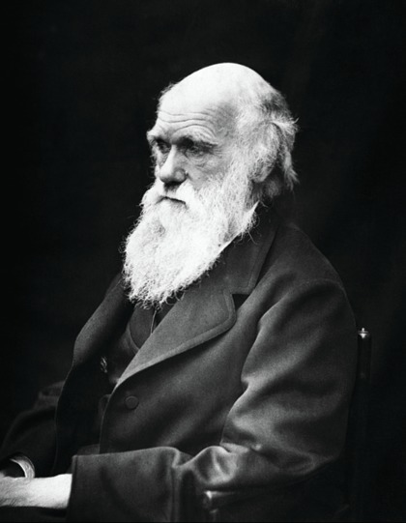
Figure 3 The English naturalist Charles Darwin (1809–1882)

The Oxford English Dictionary defines citizen science as the ‘collection and analysis of data relating to the natural world by members of the general public, typically as part of a collaborative project with professional scientists’, although there are other perspectives. In practice, citizen science has emerged under a wide range of terms including public participation in scientific research (PPSR), public engagement with science, informal science education, community science, crowd-based or crowd-sourced science and volunteer monitoring, to name a few. The term citizen science was first used in the 1990s in both the UK and the USA and came from two different frameworks. In his book Citizen Science, Alan Irwin considers the role that scientific expertise can play in bringing the public and science together and building a more scientifically active citizenry, empowering individuals to contribute to scientific development (Irwin, 1995).
Rick Bonney also used the term citizen science in 1995 to describe the growing number of research projects at the US-based Cornell Lab of Ornithology (CLO). This involved volunteers collecting large quantities of bird-related data (or ‘scientific information’, as he called it) across a range of habitats and locations over different timelines (Bonney et al., 2009).

3 Who is a citizen scientist?
Participants in citizen science – i.e. citizen scientists – are involved in a wide range of research projects in subjects such as astronomy, medicine, climate change, invasive species, conservation, ecological restoration, monitoring water quality and studying population ecology, to name just a few. (There are more examples at the end of this week and in Week 8.) There has been a rapid growth in the range, diversity, scale and scope of these types of initiative, particularly over the past ten years. There is also an increased appreciation of the role they play in providing a range of assets, including volunteer labour and skills (see Figures 4 to 8). The impact they have had on research and engagement around science has been significant.

Interactive content is not available in this format.
Figure 4–8

Public participation in science can engage non-professionals in scientific investigation through initiatives that mainly involve a collaboration between amateurs (people with no or some expertise) and scientists. A citizen scientist is anyone who volunteers their time contributing to wildlife observation, collection and analysis of data, and interpretation and reporting of results. An important factor is that citizen science provides opportunities for non-professional people to work with scientists and participate in authentic scientific research, as illustrated in this video which talks about the ‘big butterfly count’.

Video content is not available in this format.
Video of citizen science activity
View transcript - Video of citizen science activity

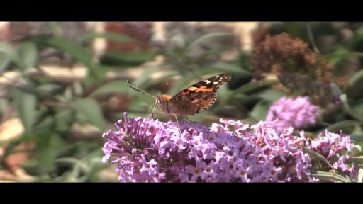

However, we should not overlook that citizen science also facilitates and inspires public action to tackle core global environmental problems, e.g. climate change. Its participatory nature means that, while facilitating understanding, it also engages and empowers those affected by the issues and their outcomes. Through enabling public action, including researching and collecting data, citizen science can also benefit those who become involved by facilitating the development and transfer of skills, providing a platform for education and learning, and cultivating a sense of personal fulfilment and enjoyment in participants. These motivations are discussed further in the next section, where you will consider why people become citizen scientists.

Activity 1 Understanding citizen science
Allow about 10 minutes

Have you ever seen a plant or an animal and wondered what it was called, or seen something important you’d like to share? iSpot was developed to help people get involved and provide answers to these types of query.
Take a look at the website and view the post about Katie’s moth, mentioned in Section 1. You can see this in the images below or find it on the iSpot website
Familiarise yourself with the features on the first part of the page:
- Look at the image in the observation posted, and the Description and Notes added.

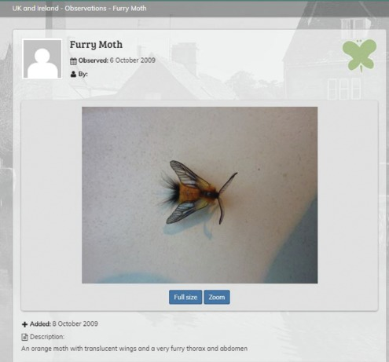

- Look at the observations and comments that were left, leading to an identification:

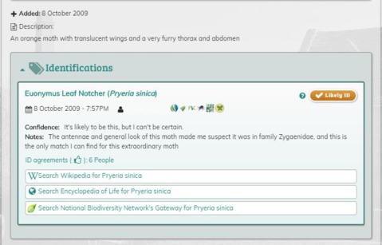

- Now consider your own interests. How can an online resource like iSpot assist you to participate in studying, understanding and learning about biodiversity?

Provide your answer...

The word cloud below displays some of the most popular words from comments made by iSpot users on the website. Thinking about your response in Activity 1, how many of these reflect your own interest in citizen science?

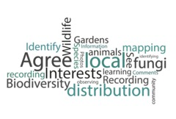
Figure 9 Word cloud

You will have other opportunities to explore iSpot and learn more about the website and how it works as the course progresses. So you can leave it for now and move on to the next section.

4 Why citizen science?
Science provides an important way of viewing the world and is a key part of everyday life. The relationship between citizens and science can be viewed within the context of how we relate and engage with it, both as individuals and collectively. Citizen science is an enabling force, making it possible to carry out science-based investigations that may not be possible without the contribution of volunteers. It is increasingly being recognised as a mechanism for scientific discovery and a means of acquiring knowledge while at the same time enabling better understanding of and engagement with science.
Citizen science is also evolving in the way it mobilises people’s involvement in recording information, social action and wide-ranging data gathering. Supported by technology, it can involve much wider audiences, enabling the mass-scale involvement of anyone with an interest in collecting, reporting and processing data. This is facilitated by easily available online technical tools such as mobile apps, websites and web-based platforms, as well as increased access to these tools via mobile phones, tablets, cameras etc. Citizen science also provides opportunities for participants to get involved in the process of scientific investigation or enquiry – enabling them to work with scientists and experts, which might not have otherwise been possible. This helps to advance understanding of science as well as facilitate skills building and learning (i.e. scientific literacy). These are significant outcomes of citizen science that will be discussed in greater depth later in the course.

Activity 2 Are you a citizen scientist?
Allow about 5 minutes

Take a few minutes to think about your own interest in and experience of science, reflecting on the definitions and discussion of citizen science explored so far. What would you say sparked that interest? How have you explored it further?
Below is a list of possible factors that might motivate you to get involved in citizen science. Thinking of your own interests and experience, answer the following questions:
- Select yes or no (Y/N) to indicate which options express your interest to be involved in citizen science.
- Looking at your yes options, how would you rank them, with 1 as the highest?
(The one/s with more influence should be ranked highest.)

Table 1 Motivating factors for participating in citizen science
Motivating factor: | Yes / No | Rank (based on your choices)
Spending time outdoors | Provide your answer... | Provide your answer...
Helping at a specific place, site or area | Provide your answer... | Provide your answer...
Contributing to scientific knowledge | Provide your answer... | Provide your answer...
Helping wildlife | Provide your answer... | Provide your answer...
Sharing my knowledge / expertise | Provide your answer... | Provide your answer...
Learning new things | Provide your answer... | Provide your answer...
Meeting people / for fun | Provide your answer... | Provide your answer...
Getting exercise | Provide your answer... | Provide your answer...
Developing new skills | Provide your answer... | Provide your answer...
Furthering my career | Provide your answer... | Provide your answer...
Being with others who wanted to do it (family, friends, teacher, etc.) | Provide your answer... | Provide your answer...
Other reasons | Provide your answer... | Provide your answer...
(Source: adapted from results of surveys on motivations for citizen science and environmental monitoring; Geoghegan et al., 2016)

Summary of survey results illustrating participants’ responses to questions about their motivations for getting involved in citizen science:

Motivating factor
Helping wildlife | 52%
Contributing to scientific knowledge | 29%
Helping at a specific place, site or area | 6%
Learning new things | 3%
Being with others who wanted to do it (family, friends, teacher, etc.) | 3%
Spending time outdoors | 2%
Sharing my knowledge or expertise | 2%
Other reasons | 2%
Furthering my career | 1%
Getting exercise | 1%
Meeting people or for fun | 0
Developing new skills | 0
(Source: Adapted from results of surveys on motivations for citizen science and environmental monitoring. Geoghegan et al., 2016.)

5 Motivation: understanding why people do citizen science
When asking the question ‘Why do citizen science?’, it is important to consider the driving factors behind it. For example what might motivate participants to become involved, giving their free time to scientific research, as well as why scientists and other people might seek to initiate and deliver projects.
Individual motivation: A review of motivations behind environmental volunteering suggests that people participate for reasons that are either intrinsic (e.g. they find the activity satisfying) or extrinsic (e.g. it confers other benefits such as helping to promote career advancement). The driving motivations behind participation in citizen science are similar but vary, based on the type of project, with intrinsic and extrinsic factors ranging from personal growth and gain to being of benefit to others and core to individual values. Digital technology can expand these motivating factors through the integration of games, competition, rewards or reputation building (Geoghegan et al., 2016).
For many people who do citizen science as part of their jobs, it is more than that. As individuals, they can be personally motivated or involved in their work projects or sometimes as participants in other initiatives of interest.
While out at about at citizen science meetings and events in the UK and abroad, Janice Ansine, Senior Project Manager – Citizen Science in the Open University’s STEM Faculty and author of this week, captured the views of a few people involved in citizen science as part of their work from a range of projects, organisations and institutions, asking what drew them to citizen science.

Video content is not available in this format.
Video 1 Why citizen science?
View transcript - Video 1 Why citizen science?



Video content is not available in this format.
Video 2 Why citizen science?
View transcript - Video 2 Why citizen science?



Video 1 participants: Kate Lewthwaite, The Woodland Trust; Jake Morris, Department for Environment, Food and Rural Affairs; Dr. Michael Pocock, Centre for Ecology and Hydrology.
Video 2 participants: Jack Sewell, Marine Biological Association; Tania Jenkins, Evolutionary Knowledge for Everyone (EvoKE) project, and consultant for Swiss Academy of Natural Sciences; Dr. David Slawson, Open Air Laboratories, Imperial College London.
People may also be motivated to give their time based on possible personal benefits, such as – what they can learn. For example, the US-based Cornell Lab of Ornithology (CLO) states that their citizen science projects strive to help participants learn about the birds they observe, and as they provide vast quantities of data about species occurrence and distribution around the world, they also experience a process of scientific investigation. (Bonney et al., 2009). Many citizen scientists also develop and enhance their skills and expertise. For example, a review of participants on iSpot demonstrates that, by the time they made their 50th observation, more than 60% of contributors were able to identify the species themselves. This was significantly higher than the 40% accuracy of first-time contributors. (Silvertown et al., 2015).
Organisational motivation: So far we have discussed why people get involved with citizen science, but why do organisations choose to launch citizen science initiatives? For some, it is a means of conducting scientific investigations – biological recording or monitoring. (Engaging volunteers is an effective way to implement environmental surveys, wildlife recording or biodiversity monitoring, which are the main type of projects initiated. At the same time, this encourages the wider adoption of citizen science. For example, in the UK records of bird sightings have been submitted by the public to the British Trust for Ornithology since the 1930s and continue to this day. Scientists are increasingly appreciating the role of citizen scientists in providing a source of labour and skills. Citizen science is viewed as a means of answering difficult questions about scientific and environmental research, with the additional ability to collect data on a large scale.
Citizen science is also regarded as a platform from which to inform the public of matters connected to science, policy, conservation and land-management practices, as well as a way of raising awareness and engaging people’s interest in a particular topic. For some scientists, advancing scientific knowledge is the most important motivator for launching a citizen science project, while for others involved in the planning, development and implementation of citizen science initiatives, key motivators include the benefits to their organisation (e.g. publicity, new approaches to public engagement, etc.) as well implementing an activity that the participants themselves indicate the benefits of (i.e. the personal satisfaction, enjoyment and fulfilment from being involved).
Here is a list of factors that could motivate scientists to get involved in citizen science:.

Table 2 Why do scientists get involved with citizen science projects?
1 | To contribute to science
2 | To inform policy
3 | To inform people about conservation and land management
4 | To educate
5 | To gain or improve buy-in for decision making
6 | To raise awareness and engage people
7 | To build partnerships and improve communication
8 | Other stakeholder motivations (e.g. personal satisfaction)
(Source: adapted from results of surveys on motivations for citizen science and environmental monitoring. Geoghegan et al., 2016)

Consider your top motivational factors from Activity 2. Do any of those mentioned in Table 2 reflect your own individual interest in citizen science?

6 Can citizens contribute to science?
Scientists study and propose hypotheses, exploring the natural world around us by way of scientific enquiry. When applied to learning, an enquiry-based approach can help learners to develop their own knowledge, coming to understand scientific ideas and the process of investigation. Citizen science can provide a way for people to learn about science through participation in authentic scientific research: observing and monitoring species, collecting data, tackling environmental issues, etc.
One way of seeing how citizen science can contribute to scientific research is by looking at how initiatives are designed to meet science-based objectives. It has been suggested that an important consideration for those involved in citizen science is whether it is the best approach for the research question. If it is, projects should be driven by a research question (hypothesis) or monitoring agenda that fits within a specific science or conservation mission, considering also the participants’ skills levels in order to determine the need for additional training or other support needed. Second, it’s important for a research team to include a professional scientist for any project to have scientific validity and, perhaps, to provide support for the non-professional participants and to communicate the project’s findings. Statistical and technical expertise for data analysis and evaluation can be useful for setting and reporting on measurable objectives.
The design of data-collection methods is another step towards developing, testing and refining data forms and other resources. Recruiting and training participants is also important and should be approached with the project goals in mind, in a way that can facilitate analysis for interpreting and drawing conclusions. Disseminating conclusions and results, ensuring that the data are useful and accessible to a wide audience, is crucial.
Nature’s Calendar is a citizen science project run by the Woodland Trust and the Centre for Ecology and Hydrology. Members of the public are invited to contribute their records of plant and animal annual events e.g. leaf buds bursting, blackberries ripening or the arrival and departure of migratory birds. This populates a database through time and space of these phenological events – the seasonal changes observed in wildlife each year (see Figures 10 and 11). Since these are often determined by meteorological conditions, such as temperature, scientists can use this database to investigate the effects of weather and climate on wildlife.

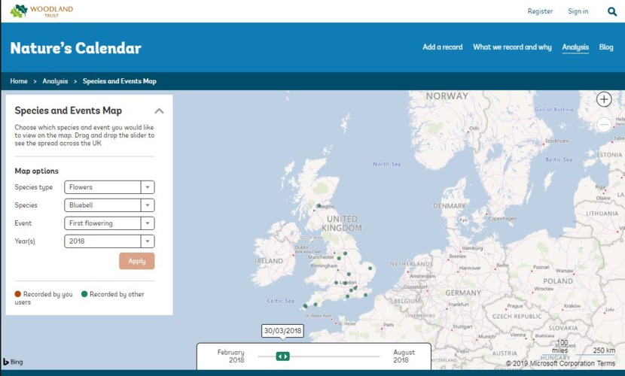
Figure 10 First flowering of bluebells in March 2018

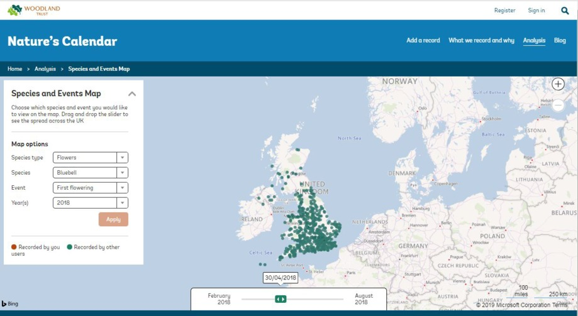
Figure 11 First flowering of Bluebells in April 2018

Citizen scientists select a subject in an area which they visit regularly, (e.g. an oak tree near where they work or butterflies in their garden), and monitor it several times a week for a significant event (e.g. bud burst or first sighting). Participants can then upload their observation to the website, where they can see a map and a time slider showing how the event develops through the months across the country. As participants enter a new record for the same spot every year, they can see whether this has happened earlier or later than in previous years, and compare this with other people’s observations throughout the rest of the country.
It would be impossible for a researcher to record the timing of a wildlife event over such a large geographical area, even if they were able to make accurate predictions about when it might happen. However, when citizen scientists can use a simple guide for identifying species and their associated events they are able to provide a large quantity of good quality data. Nature’s Calendar has been set up to include common and easily recognisable species that already have an existing historical record, in order to make their records comparable and consistent. Citizen scientists are contributing to this database which already contains over 2.7 million records and can be compared with previous records dating as far back as 1736.

Activity 3 Colecting data in Nature’s Calendar
Allow about 15 minutes

Scientists have used the data collected by the public in Nature’s Calendar to assess how these phenological events have been changing. Their results are suggesting that spring events are coming earlier while autumn events are getting later. This can be linked to rising temperature providing a longer growing season. By covering many different groups of species- amphibians, birds, fungi, insects and plants, researchers are also able to understand how the interactions and interdependencies between these species could change in the future. Changing phenology provides the first indication of how a species is responding to long-term climatic changes, and can help researchers establish which species will suffer and which will benefit under new conditions. These results have been published in scientific journals and shared with the public in articles.
Questions to consider (you can write your response in the box below):
- What kind of data is being recorded?
- How were the public engaged and involved?
- How was data collected?
- Why are citizen scientists so important?
- What are some of the conclusions or results?
- How was this shared or disseminated?
Not available in this format.

7 How do we do it? Approaches to citizen science
Public involvement in science has moved on from being mostly about volunteers assisting with data collection. Today, citizen science helps people to understand and learn about science, providing a way for them to get involved in collecting and sometimes analysing data. It can also provide ongoing engagement and learning possibilities with a subject of interest. The ways in which citizen science projects involve participants, as well as their outputs, are key classification methods that can provide valuable information to determine how such initiatives can be implemented.
The three main approaches used to describe participation in citizen science are known as contributory, collaborative and co-created. In contributory projects, scientists take the lead in setting the research questions, designing the survey procedures and data-collection framework, and analysing and communicating the results. Participants submit data to follow these requirements. Collaborative projects are also designed by scientists, but participants have the opportunity to be involved in more than one stage. For example, contributing or analysing data, helping to define the research questions or communicating and disseminating results. Co-created projects may be developed by scientists and a community group working together to monitor a local nature reserve in response to an environmental issue, for example. The participants and other stakeholders are involved as closely as possible in defining goals, shaping approaches and collecting and analysing data.
The integration of new and emerging technologies in citizen science over recent years has expanded the possibilities for participation and scope for scientific research, facilitating wider data collection and expanding capacity for the management and collation of data. This often involves crowdsourcing, defined as the practice of executing a task or seeking the solution to a problem by inviting anyone to respond or participate (Silvertown et al., 2015). A proposed typology for crowdsourcing citizen science projectssuggests that they can use a wide range of defining characteristics to engage and involve people.These include initiatives that are action-focused, with volunteers addressing local concerns; those with an emphasis on conservation activities; those with an emphasis on investigation methods that are conducted mainly online; and those focusing on educational goals. For example, iSpotnature.org can be described as a platform that classifies wildlife data and also crowdsources the identification of a wide range of species (you will learn about this in more detail as the course progresses). While, Zooniverse.org, is a platform that hosts a variety of projects in different science disciplines as well as the social sciences and the arts that require volunteers to help with research tasks such as classifying images, etc.
Technology can also support citizen science through the use of sensors: volunteers can be asked to collect automated data on weather, air quality, noise pollution, etc. Smartphones have revolutionised this area, particularly in biodiversity-monitoring projects, providing participants with easy access to apps and other tools that facilitate instant data entry. This is then collected or collated with the simultaneous recording of GPS location information and easy uploading of photos for further verification. This helps to convert the public from being mere observers to becoming recorders of scientific data. See the example projects led by the Extreme Citizen Science (ExCiteS) Research Group at University College London (www.ucl.ac.uk/excites). ‘Gamification’ is another useful approach, integrating a challenge-based environment to provide a fun element for participants when doing scientific tasks that may seem repetitive.
In reality, projects adapt a combination of approaches and, in doing so, they are able to achieve goals of participant recruitment, research, conservation and education – all at the same time. They also have other positive impacts such as developing understanding and knowledge, enhancing engagement or interest, improving skills, and changing attitudes and behaviour.

Activity 4 Approaches to citizen science
Allow about 10 minutes

Citizen science projects can be categorised based on the method used for participation – how it is developed and implemented. Now complete Table 3 by doing the following, based on the descriptions outlined above:
- Consider your own involvement and interest in citizen science. How would you describe the activities you have been involved in?
- If you have not yet participated as a citizen scientist, what are your interests and how would you like to be involved? Or, using the introductory video to Butterfly Conservation’s ‘big butterfly count’ in Section 3, or the Nature’s Calendar project example from Activity 3, think about the research behind it – the tasks, purpose and goal, or aim of the project.

Interactive content is not available in this format.
Table 3 Defining approaches to citizen science

8 Citizen science in action – the growth of citizen science
The number of citizen science initiatives has grown rapidly around the world over the years. Factors contributing to this increase include people becoming more aware of opportunities by which they can get involved in science, as well as a realisation and an appreciation in the scientific community that members of the public are a useful resource, volunteering their time and many useful skills.
However, other resources are needed to support citizen science. Recognising this as a public need, while acknowledging the role the public can play, various national public funding bodies, research funders and policy makers are creating opportunities for the public to engage with science on different scales, including citizen science. For example, the Big Lottery Fund (BLF) has supported the OPen Air Laboratories (OPAL) network.
This UK-wide citizen science initiative that has enabled anyone to get hands-on with nature, whatever their age, background or level of ability, facilitated by a group of partners (including The Open University) and other institutions.
Through various types of grants, funders have also been challenging researchers to deliver scientific research incorporating the public, allocating funding for delivering impact cases and strands such as public engagement and informal science learning. Citizen science is being supported by this allocation of resources. For example, in 2017-18 the Natural Environment Research Council (NERC) in the UK funded the first stage of a Engaging Environments programme which included a national scoping project to create a vision for citizen science and public engagement with environmental research (see Opening up Science for all! project).
In April 2019 this programme was expanded with further NERC funding of £1.3 million over three years, to engage the UK public on big issues in environmental science. Another example is Observatree, an initiative which focusses on monitoring tree health, aimed to protect the UK’s trees, woods and forests from pests and diseases through surveillance and monitoring carried out by a team of volunteer citizen scientists.
While internationally LEARN CitSci is a collaborative initiative (including The Natural History Museum and The Open University in the UK) that seeks to answer how citizen science can be used to educate, enable and empower youth in science, supported by The Wellcome Trust, the Economic and Social Research Council (ESRC) and the US National Science Foundation via a Science Learning+ grant. Meanwhile, in Europe a citizen science green paper was published in 2013.
Meanwhile, in Europe a citizen science green paper was published in 2013, and European Commission policy directives have included citizen science as one of five strategic areas with funding allocated to support initiatives through the ‘Science With and For Society (SwafS)’ strand of the Horizon 2020 programme. This includes significant awards such as the EU-Citizen Science project, which is creating a hub for knowledge sharing, coordination, and action.

9 Creating a support structure for citizen science
Citizen science projects and activities have been initiated by a range of organisations, including scientific bodies, schools, universities and volunteer groups, with a view to involving both beginners and experienced citizen scientists in activities contributing to scientific and other areas of research, from local to global issues (see Wikipedia’s growing list) The increase in accessibility of communications technology, particularly over the past ten years, has matched the growth in the scale of citizen science, seeing the development of websites and online platforms that seek input from even larger audiences through crowdsourcing. Efforts to share best practice and formalise thinking about leading citizen science initiatives have also been happening through the development of associations, groups and networks formed through professional affiliation, common interests and geographical location. A few examples are listed below.
UK: The British Ecological Society (BES) citizen science special interest group provides a forum for sharing details of current citizen science in ecology. It also fosters and supports creativity in research via citizen science as part of a community.
The UK’s Tree Health Citizen Science Network was formed by a group of organisations working across a range of projects and activities that engage the public around trees.
Europe: The European Citizen Science Association (ECSA) was set up to encourage the growth of citizen science across Europe, to increase public participation in scientific processes, mainly by initiating and supporting citizen science projects as well as conducting research on citizen science. ECSA has a membership of over 200 individual and organisational members from over 28 countries across the European Union and beyond. Below is a video from the 2018 conference, the next ECSA conference will be held in Trieste, Italy in May 2020.

Video content is not available in this format.
Video from the ECSA’s second International Citizen Science Conference, Geneva, 3–5 June 2018.
View transcript - Video from the ECSA’s second International Citizen Science Conference, Geneva, 3–5 ...



USA: The US-based Citizen Science Association (CSA) brings together a diverse range of practitioners working in this field, around the world, to share their expertise, resources and best practices in conducting various types of citizen science project.
Australia: The Australian Citizen Science Association is a membership community supporting the development of citizen science in Australia. It was formed to help advance citizen science through the sharing of knowledge, collaboration, capacity building and advocacy.

10 This week’s quiz
Check what you’ve learned this week by taking the end-of-week quiz.
Week 1 practice quiz
Open the quiz in a new tab or window (by holding ctrl [or cmd on a Mac] when you click the link) and come back here when you are done.

11 Summary of Week 1
Science provides an important way of viewing the world and is a key part of everyday life. The relationship between citizens and science can be viewed within the context of how they relate and engage with it, both as individuals and collectively. Citizen science is increasingly recognised as a mechanism for scientific discovery and a means of acquiring knowledge while at the same time enabling better understanding of, and engagement with, science. It can provide a way for non-professional people to learn about science and participate in authentic scientific research, based on investigations.
Citizen science has been defined as the collection and analysis of data relating to the natural world by the public, as part of a collaborative project with scientists. While these activities have a long history and emerged within the context of a number of related terms and phrases, the term ‘citizen science’ didn’t emerge until the mid-1990s. A citizen scientist can be defined as someone who volunteers their time contributing to the observation, collection and analysis of data, and the interpretation and reporting of results. An important factor is that citizen science provides opportunities for non-professionals to work with scientists and participate in authentic scientific research.
Public involvement in science has moved on from being mostly about volunteers assisting with data collection. Today, citizen science helps people to understand and learn about science, providing a way for them to get involved in collecting and sometimes analysing data, and it can provide ongoing engagement and learning possibilities with a subject of interest. The ways in which citizen science projects involve participants, as well as their outputs, are key classification methods that can provide valuable information to determine how such initiatives can be implemented.
So far, this course has introduced you to iSpotnature and as it progresses, you will continue to build your understanding of the link between citizen science and global biodiversity. Although somewhat dominated by studies concerned with biodiversity monitoring and environment issues, opportunities to participate in citizen science are very diverse. There are a number of initiatives that can pique interest, spanning a range of diverse fields and interests in the sciences as well as other disciplines. For example the arts and history, from ecology to astronomy, medicine, computer science, climate change, conservation biology and other areas incorporating monitoring or identification activities. This list on Wikipedia details many citizen science projects.In Week 8 you will be encouraged to continue your citizen science experience and will be introduced to a range of projects and platforms covering many of these areas.
You can now go to Week 2.

Week 2: Global biodiversity

Introduction
There is a rich diversity of life around us. Wherever you are in the world, be it in a tropical rainforest or deceptively quiet tundra, there will be various types of species, whether they are towering trees or microscopic fungi. However, appreciating this diversity would require not only keen observation skills but also the ability to identify them.

Video content is not available in this format.
View transcript - Uncaptioned interactive content

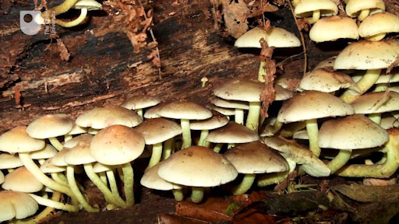

By the end of this week, you should be able to:
- recognise a working definition of the term ‘species’
- recognise and understand terminology that is relevant to biodiversity
- understand the role of biodiversity drivers and how they influence biodiversity
- give examples of threats to biodiversity and limitations of the state of knowledge of biodiversity.

1 Identity

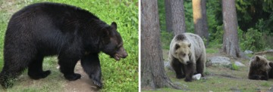
Figure 1 (left) Black bear in North America. Figure 2 (right) Brown bears on the Russia–Finland border

The bears in Figures 1 and 2 look similar even though they are from different continents. Their common names refer to their colour. But that can be misleading as the fur colour of black bears (Latin name Ursus americanus) can be brown and similarly, brown bears (Ursus arctos) can have fur that is almost black. Both black and brown bears occur together in parts of North America. They are classified as separate species because, although hybrids have occasionally been found, the hybrids themselves do not appear to be fertile.
The term species is surprisingly difficult to define. A commonly used definition is the biological species concept, which defines a species as a reproductively isolated group of individuals that are able to breed together to form offspring that can in turn breed successfully. In later weeks you will come to realise the deficiencies of this definition, even though it is widely used.
Every species has a two-part scientific name – called a binomial – that identifies it uniquely. The first name indicates the genus (plural genera) to which the species belongs – i.e. the group of closely related species that are similar in appearance. For example, polar bears, are in the genus Ursus but pandas aren’t. The species name is the name given to the species when it was first discovered and described, and that name cannot be changed except in special circumstances. However, genus names are occasionally altered as more information on how species are related to each other becomes available. It sometimes happens that an organism is described and named by two people independently, in which case it’s the one that’s published first that is universally adopted. The name of a new species is published with a description of a specimen, giving the key features that define the species, so that other people can make a correct identification. That specimen is known as the type specimen and should be stored for future reference, preferably in a national collection.

1.1 Why use Latin?
The use of Latin for the scientific names of species started in the eighteenth century. The advantages of using Latin, at that time, were:
- it was familiar to scientists
- it wasn’t a language that was evolving
- it could be used across the boundaries that existed between people speaking different languages.
Common species names aren’t universal, after all, and the same common name may in fact be used to refer to several related species – for example, pill bugs are also called slaters or woodlice, amongst other local names, and the term refers to several species. For example, pill bugs are also called a slaters or woodlice, among other local names, and the term refers to several species (Figures 3 and 4).

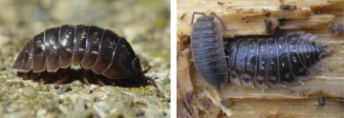
Figures 3–4 The binomial indentifies the animal (in Figure 3) as Armadillidium vulgare and distinguishes it from others that are similar in appearance, such as Oniscus asellus (Figure 4, left) and Porcellio scaber (Figure 4, right).

The binomial also tells you something about interspecies relationships, which common names generally do not. Sharing a generic name means that two species are closely related. There also are higher order groupings that express broader relationships. For example, related genera are grouped into a family and then related families are grouped into orders, orders into classes and classes into phyla.

2 Diversity
The variety of life on Earth is described by the term biodiversity, a shortened form of biological diversity, but the term doesn’t just refer to the number of species or individuals that can be found in a particular habitat. Biodiversity can be described at three major levels, the highest of which is ecosystem diversity.
An ecosystem can be small, like a rock pool, or immense, like a tropical rainforest. The set of organisms and non-biological components that are all linked by energy transfer and the cycling of components constitute the ecosystem.

Activity 1 Energy sources
Allow about 5 minutes

What sources of energy would be available to plants and animals in a small ecosystem such as a small wood? Suggest two examples for each.

View answer - Activity 1 Energy sources

There are of course other sources of energy within ecosystems, and as you read on others may occur to you. Taking the wood as an example, make a diagram showing routes of energy flow within the wood ecosystem.
Below the top level is the species diversity level, which describes the variety of species within an ecosystem. This is the level that you will be familiar with from its use in news and current affairs, whereby the loss of species through extinction reduces species diversity.
The lowest of the three levels is genetic diversity, which applies to diversity within a species. Within a population of organisms of a particular species, the genome of each individual organism is different. It is these differences that provide the possibility of evolutionary change, giving the species the potential to adapt to changing conditions in the future.

Activity 2 Genetic diversity
Allow about 5 minutes

In addition to genetic variation between individuals, there is a second component of genetic diversity. Suggest what this component might be. (Hint: think globally.)

View answer - Activity 2 Genetic diversity

The study of diversity is dependent up knowing which organisms are present and how they are linked. You should now be able to appreciate how the identification of organisms is of paramount importance in studying biodiversity. It is impossible to make an accurate assessment of the state of an ecosystem or the vulnerability of a species without accurate species identification.

3 Measuring biodiversity
This section looks at how to assess and rank biodiversity.

Interactive content is not available in this format.
Figures 5–8 Three different types of woodland: Figure 5 European mixed woodland; Figures 6 and 7 Daintree tropical rain forest, Australia; Figure 8 Canadian pine forest, Banff National Park.

Activity 3 Woodland comparisons
Allow about 5 minutes

Look at the three different woodlands in Figures 5–8 and rank them in order of increasing species diversity.

View answer - Activity 3 Woodland comparisons

Activity 4 Woodland comparison and numerical comparison
Allow about 5 minutes

It is relatively easy to make a judgement about biodiversity, as you were asked to do in Activity 3, but is such a judgement accurate? Consider how you could quantify diversity and thus have a numerical comparison.

Provide your answer...
View answer - Activity 4 Woodland comparison and numerical comparison

Consider two of the woodlands shown at the start of this section – the mixed woodland and the pine forest. Suppose you counted the number of species of tree present and found that there were equal numbers of species in each woodland. Would that mean the two types had the same species diversity? Think about this question before moving on.

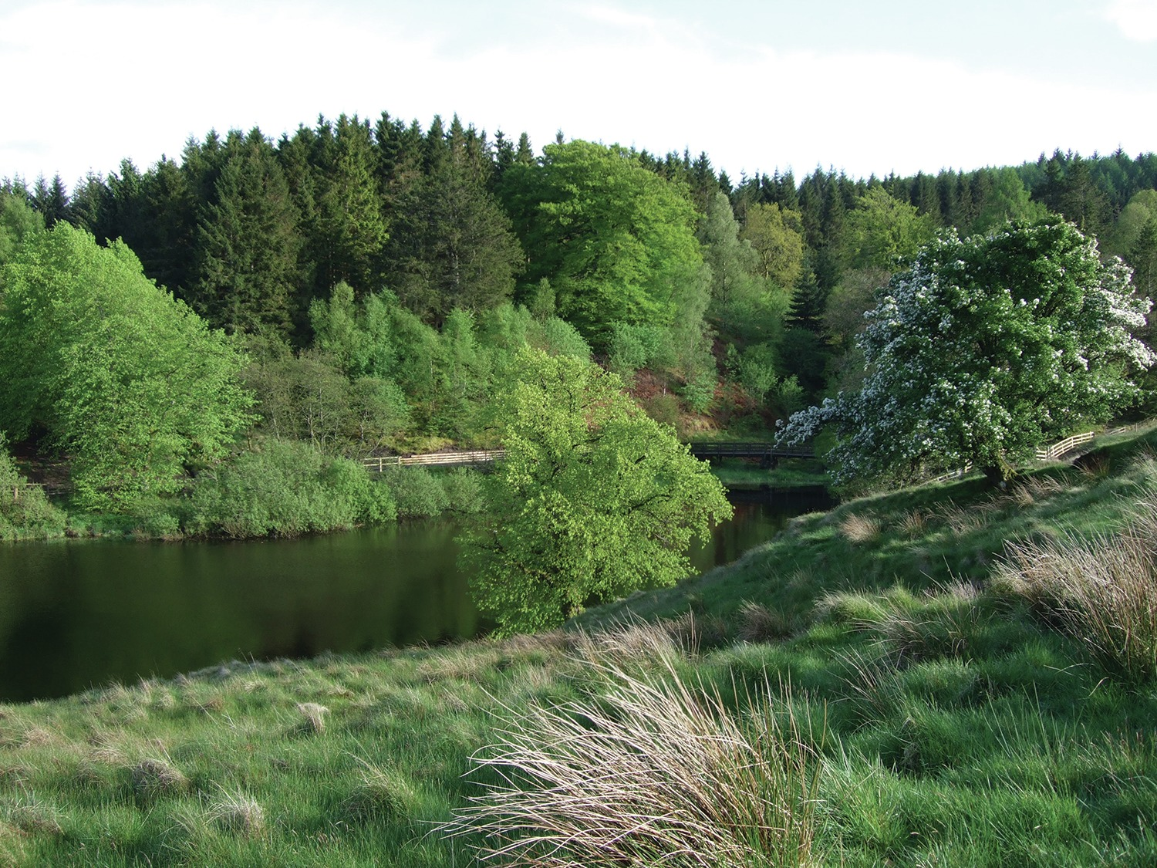
Figure 9 Mixed woodland

The fact that the two woodlands had the same number of tree species would not necessarily mean they had the same species diversity, because the number of individuals of each species might be different. A pine forest might be dominated by only one or two species with the other species being present in very small numbers. By contrast, the mixed woodland (Figure 9) might have roughly equal numbers of each species of tree. Each of these woodlands would have the same number for species richness but very different figures for the relative abundance of each species.
Imagine two woods. Wood 1 has 5 species of tree of equal abundance, so the relative abundance for each species would be 20%. Wood 2 also has 5 species of tree but one is dominant; the relative abundance here might be 90% for the dominant species and 2.5% for each of the other four species.
It is possible to combine the relative abundances for the species in each wood to obtain an index of species diversity. A number of methods for achieving this have been devised – for example, the Shannon index and the Simpson index. As long as the same index is used for each wood, a direct comparison of species diversity is possible, and there are equations for the calculation of the index of species diversity. All you need to know at this stage, however, is that an index can in fact be calculated. The explanation below is for interest only. (Note also that this woodland example relates only to diversity of trees, but there are likely to be plenty of other species of plants and animals present even if the trees are all of the same species.)

The Shannon index, H, is calculated by adding together terms for the relative abundance of each species in the area being surveyed. The term for relative abundance is calculated from the percentage of abundance, as a proportion, multiplied by the natural log of the percentage. In Wood 2, the index would be:
H = -[(0.90 x ln0.90) + 4(0.025 x ln0.025) = -(-0.095) + 4(-0.092) = -(-0.095) + (-0.368) = 0.463.
For Wood 1, the index would be 1.609. So, the larger the index, the greater the diversity.

Now imagine what you would need to do to get the information required to calculate species diversity in woods and forests. You would need to identify and list all of the species present within a sample area and, for each, an estimate of the number of individuals present. This is not a small task, and you can probably see a role for citizen scientists in such surveys.

4 Biodiversity patterns
The rich diversity of life on Earth has fascinated humans for thousands of years, and new species are still being discovered and named. But how many species are there in the world? This section attempts to explore this diversity, starting with this video news item from the BBC
Estimating the number of species on our planet is a tough challenge with contentious estimates ranging from 10 million to well over a trillion. However, one thing scientists agree on is the fact that the pattern of biodiversity distribution in the world is not even, both in space (for example, think of geographical distribution, e.g. Figure 10) and time (for example, the various levels of biodiversity during Earth’s geological ages shown in Figure 11). You may notice in Figure 10 that, at this point in time, the highest biodiversity of Earth’s vascular plants lies in the tropics and the lowest is in the higher latitudes. Figure 11, however, shows that Earth’s biodiversity hasn’t always been the same. There have been times, for example, when biodiversity declined (called periods of mass extinction – e.g, when the dinosaurs died out). The map also shows a rapid increase in the biodiversity of flowering plants.

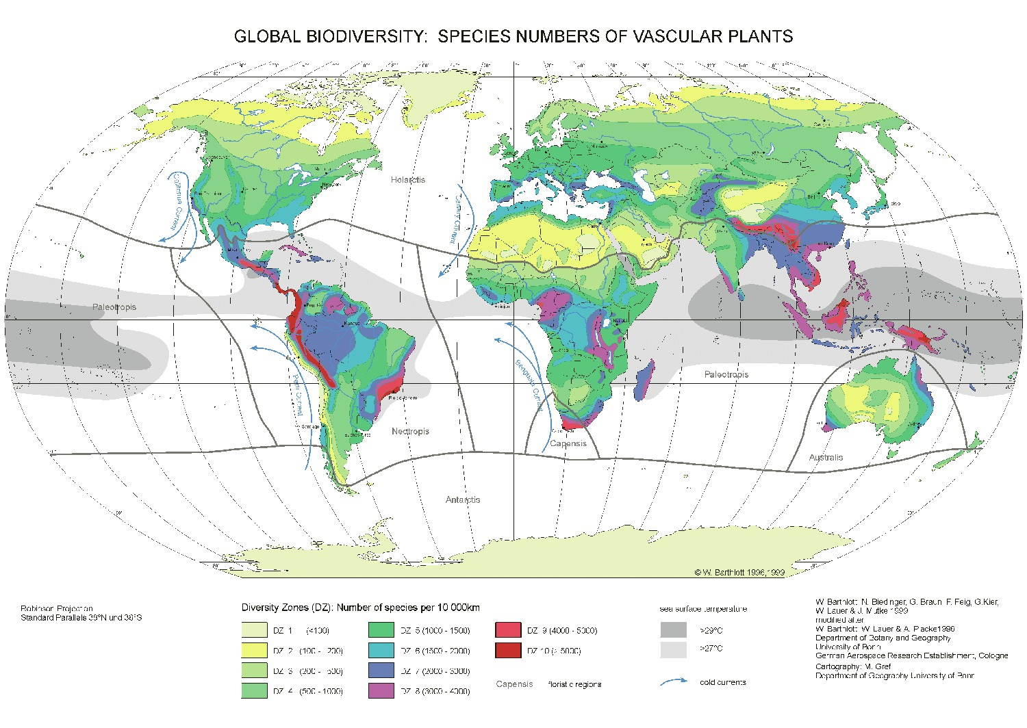
Figure 10 Pattern of global biodiversity of vascular plants.

In Figure 10, there is a distinct pattern of high biodiversity in the tropics and other localities (shown in red), some of which have even higher biodiversity. These localities are called biodiversity hotspots in recognition of their high diversity and the particular threat of destruction in their region.

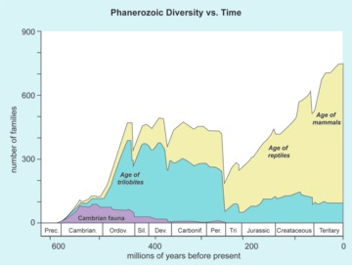
Source: The Washington Post
Figure 11 Biodiversity recorded in terms of number of families throughout geological time.

Activity 5 Diversity through time
Allow about 10 minutes

Considering the change in biodiversity (i.e. number of families) through time shown in Figure 11, can you spot and name instances of rapid biodiversity decline (i.e. mass extinctions)?

View answer - Activity 5 Diversity through time

After completing Activity 5, you should recognise that, in any discussion of biodiversity, the framework of geographic and time scales must first be considered. For example, imagine you were noting the prevalence of the Canary laurel (Laurus novocanariensis) in the uplands of Tenerife (the largest island in the Canary Islands archipelago). While it might be correct to state that this plant is on the increase, it might also be the case that the species has only recently been able to spread up to the formerly cool higher altitudes of the same island due to a warming climate. Or one might observe that the Canary Islands stonechat (Saxicola dacotiae) has disappeared from Lanzarote (formed 15 million years ago) only to be found on the more recently formed island of El Hierro (formed 1.2 million years ago), thus showing a change in the bird’s distribution over time. However, as with the previous example, it is worth noting that spatial and temporal patterns sometimes overlap and the picture might not be always clear. Nevertheless, such patterns are abundant in nature and follow either or both of the two scales. These patterns will be explored in detail in the following sections.

4.1 Spatial scale
As hinted at in Section 2, considering biodiversity on a spatial scale requires a more specific boundary to be set. For example, when looking at a global level, the pattern of biodiversity demonstrates that more than half of all plant species live in the moist tropical rain forests – an area that covers just 6% of the world’s land surface – while Earth’s desert biome has low biodiversity. However, at a local level, an oasis in the middle of a desert (e.g. the Cuatro Ciéngas Basin in Mexico) could have a higher biodiversity than a plantation forest in the middle of a rainforest biome. This example demonstrates the need to understand spatial scale in terms of hierarchy, from local to landscape, then on to regional, continental and global scales. (See Figure 12 for a diagrammatic description of this arrangement.) It should be noted, however, that these scales are arbitrary and often follow an accepted organisational level.
An analogous example is the way human societies are organised in tiered arrangements of administrative levels.They range from municipalities up to countries, and then to regional organisations – for example, the European Union – and, at a global level, the United Nations.
When it comes to biodiversity, the reason for such organisation is often related to levels of environmental drivers, be they climate or geological. This is covered in more detail in Section 5.

Interactive content is not available in this format.
Figure 12 Spatial demonstration of biodiversity scale: local (<1000 m), landscape (<100 km), regional (< 1000 km), continental (<5000 km), global (<20,000 km)

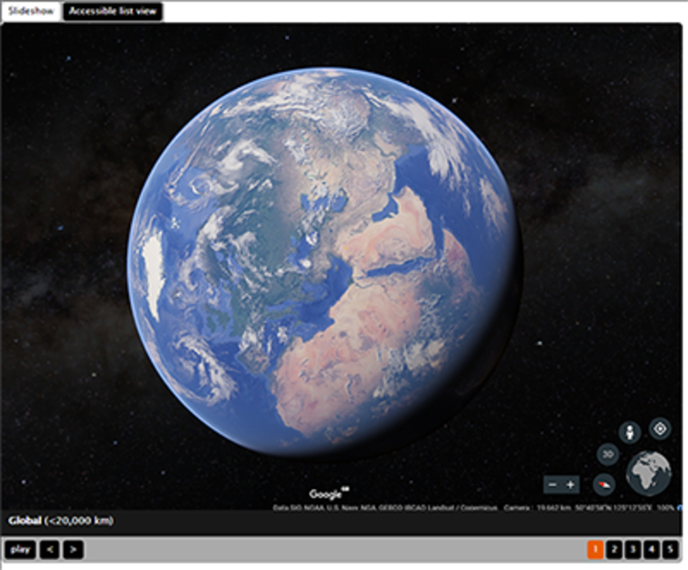

Activity 6 Species distribution
Allow about 10 minutes

Think of a species that is common in your locality. Try to find its distribution map on iSpot or another resource such as Map of Life. Comment on its prevalence at the local, landscape, regional, continental and global scale.

View answer - Activity 6 Species distribution

4.2 Time-scale
Changes in the natural environment occur over a wide range of time scales. Many systems are thus best considered to be in dynamic equilibrium – that is, they appear to be stable, but only over a certain duration of time. For example, Earth’s temperature over the last million or so years appears to be relatively constant. But since the Industrial Revolution of the 1850s – a relatively short timespan of 150 years – there has been a consistent rise in temperature. So it is important to realise that the time scale we adopt for the study of natural events can affect our understanding of them.
Nevertheless, despite some time scales being long in the past and appearing to be not so relevant today, they do have an influence in creating the world as we know it now. For example, Pangaea – the global supercontinent from Earth’s early age – fragmented about 140 million years ago, and the separated land masses began their long journey to become the continents as we know them today. The animals and plants that were on it had to then evolve on separate continents with different environments and climates, resulting in distinctly adapted species. An example of such evolution is that of marsupials like kangaroos, which are now uniquely found only in Australia. Another, more recent example is the evolution of the camel. (see Figure 13.)

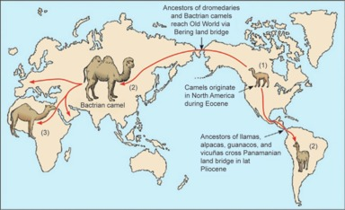
Figure 13 The evolution of the camel

The earliest known camel, called Protylopus, lived in North America (see 1 on the map in Figure 13) 40–50 million years ago. It migrated into South America, Asia (2) and then Africa (3), where it continued to evolve, resulting in the present day’s New World camelids such as llamas (South America), bactrian (Central Asia) and dromedary camels (Africa and Middle East).
After looking at all those patterns of biodiversity in time and space, you might be tempted to ask, what actually drives this variation and hence biodiversity? The answer(s) to this could be discussed by considering the drivers behind these developments. They could be environmental factors (e.g. climate), geological events (e.g. mountain building) or human activity (e.g. hunting or even climate change). These drivers are discussed in detail in the next section.

5 Biodiversity drivers
By now you should be able to identify patterns of biodiversity at varying local, regional and global scales, and you might be tempted to think about what actually determines or drives biodiversity. Broadly, these causative factors, or drivers, can be categorised as climatic, geologic or anthropogenic (i.e. of human origin). These will be discussed shortly, but first you can examine an example of drivers from the Teign Valley in the southwest of the UK.

Video content is not available in this format.
Video 1 An example of environmental drivers and diversity, using the Teign Valley, South West UK.
View transcript - Video 1 An example of environmental drivers and diversity, using the Teign Valley, ...

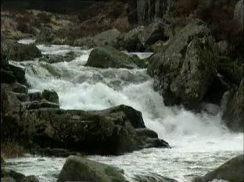

As you saw in the video, just as the patterns of biodiversity are scale-dependent, so too are the drivers. Spatially speaking, if you are looking at biodiversity on the local scale, the drivers might be differences in soil fertility in a patch of land, while at the landscape level you might consider altitude. At the regional and continental scales, varying levels of solar radiation available in different latitudes might drive biodiversity.
The same scale aspect also applies when considering time, where the impacts of, for example, human interventions such as eutrophication (excessive fertilisation), become apparent in a relatively short time frame of just a few weeks, while evolutionary processes require millions of years to be realised.

5.1 Climate
Climate is a critical environmental factor that often dominantly determines biodiversity patterns. It does this mainly through its variability in time and space, acting as a limit for the survival and success of different species. Climatic variation is often fuelled by differences in latitude (at the global scale) or availability of water or solar radiation (at local and regional levels). A prominent global example of climate’s role is the various types of biomes in the world.These are a direct reflection of temperature and availability of water, which ultimately determine the local flora and fauna (see Figure 14).

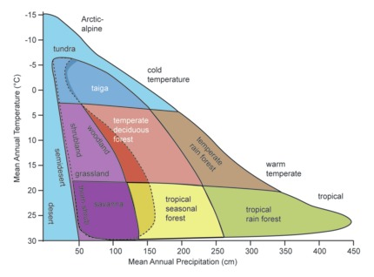
Figure 14 Biome distribution with respect to temperature and precipitation. Each biome occurs in special zones limited by availability of water and temperature.

Activity 7 Biome characteristics
Allow about 15 minutes

Examine Figure 14, in which different biomes are shown, depending on the prevalent temperature and precipitation. Then complete the following table.

Biome | Temperature | Precipitation | Expected biodiversity
tropical rainforest | hot | Provide your answer... | Provide your answer...
Provide your answer... | cold | medium wet | low
Provide your answer... | very cold | very dry | very low
temperate deciduous forest | Provide your answer... | Provide your answer... | medium

View answer - Activity 7 Biome characteristics

5.2 Geological drivers
Earth is constantly being modified under the influence of its deep-lying geology. These geological drivers often manifest themselves in the forms of moving continental plates, earthquakes, volcanoes or soil-erosion processes. These which in turn often occur as geological events, such as glacial cycles and mountain-building episodes, with impacts that can be seen at the local scale up to regional and global scales. Such modifications in the landscape allow the potential for new species to arise and succeed in the newly modified environment.
At this juncture, it is worth noting that, as instability creates opportunities for biodiversity to arise or make space for others, so a long period of comparative stability could provide an environment in which evolution can operate at will. This may result in a high diversity of endemic species (i.e. species not found anywhere else other than where they originated). A well-known example of this principle is South Africa’s Cape Floristic Region, a biodiversity hotspot where over 9000 species of plants, over 70% of which are endemic, live in area of just 90,000 square kilometres – roughly the size of Ireland. In contrast, Ireland has just a quarter of this number, checking in at 2300 species.

5.3 Human drivers
A potent driver of biodiversity, although a recent one, is humankind. That said, however, humans have had an impact on the environment throughout history – for example, as hunters and farmers. The leading naturalist and broadcaster Sir David Attenborough summarises the impact these roles have had in the following video.

Video content is not available in this format.
Video 2 David Attenborough introduction on human impact
View transcript - Video 2 David Attenborough introduction on human impact

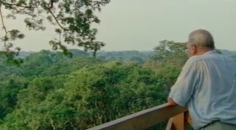

This impact has recently been exacerbated indirectly via human’s increasing influence on global nutrient cycling and climate change. Moreover, activities like pollution, deforestation and over-exploitation have had a far-reaching impact on all types of ecosystems (see Figures 15–18). These human drivers can change biodiversity by influencing species composition or, at the other extreme, making some species go extinct (i.e. disappear) from a region. For example, consider the European bison, (Bison bonasus), which was hunted to extinction in Europe, or species-rich meadows that have seen a decline in their biodiversity due to over-fertilisation, which has the consequence of destabilising plant-species composition. Overall, the loss of species has accelerated drastically over the last 10,000 years, since the development of human culture and society.

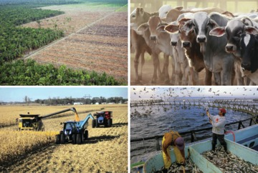
Figures 15–18 Human induced biodiversity drivers. Figure 15 Deforestation of habitats for crop production (top left). Figure 16 Increased greenhouse-gas emission from intensive livestock farming (top right). Figure 17 Commercial agriculture and excessive use of pesticides (bottom left). Figure 18 Nutrient enrichment of water bodies from aquaculture (bottom right).

6 Interaction of spatial and temporal scales
To have a full understanding of global biodiversity, we need to knit the roles of drivers with their impact across scales of time and space, as they often operate at the same time. Consider for example the impact of lightning causing a forest fire and decimating a rich diversity of reptiles. The fire event could happen within hours, but its impact could destroy the biodiversity of a large area at the landscape level, measured in tens of square kilometres.
In another context, climatic shift may occur gradually, perhaps over decades, to change the local forest biome to a desert and hence impacting an area encompassing tens of thousands of square kilometres – i.e. at the regional scale.
The key message here is the need to understand the time and space scales of environmental drivers and their impacts so that, when investigating environmental issues, cause and effect are considered at the appropriate scale. A hierarchical summary of drivers and impacts across scales of time and space is given in Table 1.

Table 1 Hierarchical framework of temporal and spatial processes influencing species diversity (after Middleton, 2013)
Spatial scale | Dominant environmental variables | Temporal scale
Local: within communities, within habitat patches  ~0.1–10 km | Fine-scale biotic and abiotic interactions (e.g. habitat structure, disturbance by fires, storms) | ~1–100 years
Landscape: between communities; turnover of species within a landscape  ~10 km–100 km | Soils, altitude, peninsula effect | ~100–1000 years
Regional: large geographical areas within continents  ~100 km–1000 km | Radiation budget and water availability, area, latitude | Previous 10,000 years (i.e. since end of last glacial period)
Continental: differences in species lineages and richness across continents  ~1000–5000 km | Aridification events, Quaternary glaciation, interglacial cycles, mountain-building episodes (e.g. Tertiary uplift of the Andes) | Previous 1–10 million years
Global: differences reflected in the biogeographical realms (e.g. distribution of mammal families between continents)  ~5000–10000 km | Continental plate movements, sea-level change | Previous 10–100 million years

7 Contemporary global biodiversity challenges
The natural world is not static and unchanging. In the past, there have been changes resulting from long-term processes such as continental drift and short-term events like volcanic eruptions or meteorite strikes. Some changes have caused extinctions, not just of individual species but of whole groups of organisms.

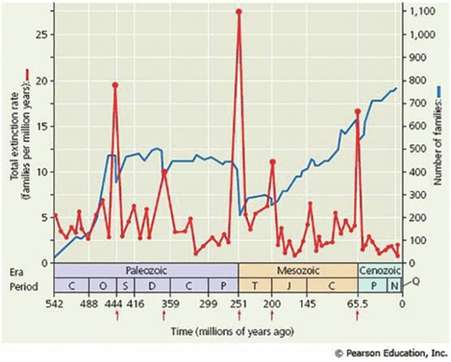
Figure 19 Impact of five major extinction events on the numbers of marine families over time. The geological periods are shown with their initial letter only but the full names can be seen below.

Cambrian, Ordovician, Silurian, Devonian, Carboniferous, Permian, Triassic, Cretaceous, Paleogene, Neogene and Quaternary Periods.

As you know from Activity 5, there have been five major extinction events in the past. These are marked on the time scale in Figure 19 by red arrows. The blue line shows the number of families of marine organisms and the decline in numbers at each extinction event. The red line shows the rate of extinction in families of marine organisms, with a peak value at the end of the Permian Period (P). In this particular mass extinction, 96% of species disappeared and all of the current species are descended from the surviving 4%.

Activity 8 Mass extinctions
Allow about 10 minutes

Consider the consequences of mass extinction. From the graph shown in Figure 19, how long did it take for the marine organisms to recover their diversity (measured by the number of families) after the Permian mass extinction 248 million years ago?

View answer - Activity 8 Mass extinctions

The question that arises from a consideration of the past is, what does the future hold? Are we now in the period of a sixth mass extinction?

7.1 The sixth mass extinction?

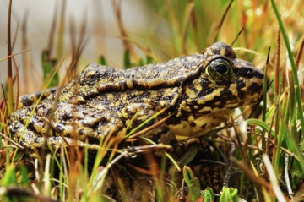
Figure 20 The critically endangered Nevada yellow-legged frog

In the last 400 years, around 1000 species are known to have become extinct. Of course, extinction is a natural phenomenon and there is a baseline rate of extinction estimated at 1–5 species per year. However, the rate of extinction now is estimated to be around 1000 times the base rate. This dramatic increase is one piece of evidence suggesting that Earth is entering a sixth period of mass extinction (Pimm et al., 2014).

Activity 9 Extinction rates
Allow about 5 minutes

Estimate how many organisms have become extinct in the last 400 years. Type your answer in the box below.

Provide your answer...
View answer - Activity 9 Extinction rates

The fact that organisms can become extinct before they have been described and named highlights the need to survey and quantify the occupants of the natural world. For example, consider just one group of animals – amphibians. New species of amphibian are still being discovered. In February 2017, researchers in India described seven new species from the Western Ghats (Figure 21), one of 36 biodiversity hotspots around the world (Garg et al., 2017). A biodiversity hotspot is rich in diversity but contains an ecosystem that is highly endangered.

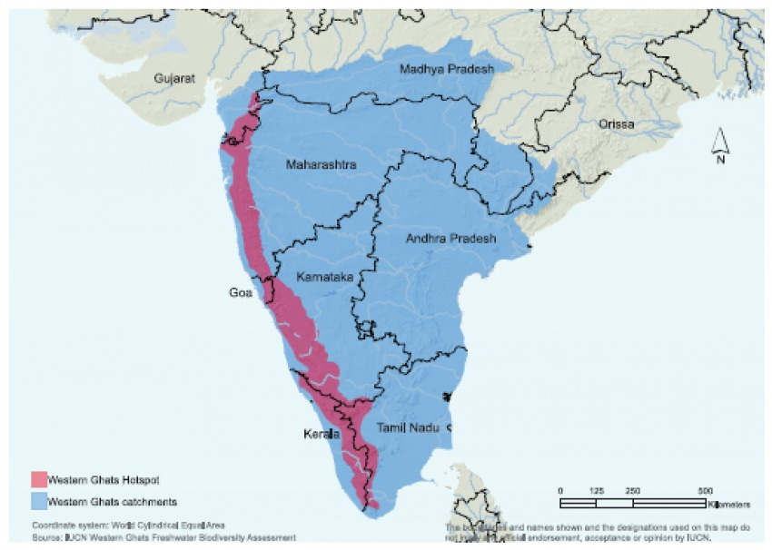
Figure 21 Map of the Western Ghats, a mountain range in India

Populations of the new species have yet to be surveyed, so it isn’t possible yet to determine the status of each of these new species. (Source: www.iucn.org)

7.2 The Red List
The Red List, produced by the International Union for Conservation of Nature (IUCN), gives the global conservation status of organisms. Species at risk are categorised using standard criteria (Figure 22). Applying these criteria gives each species’ Red List status and the list can be used to quantify the biodiversity on the planet.

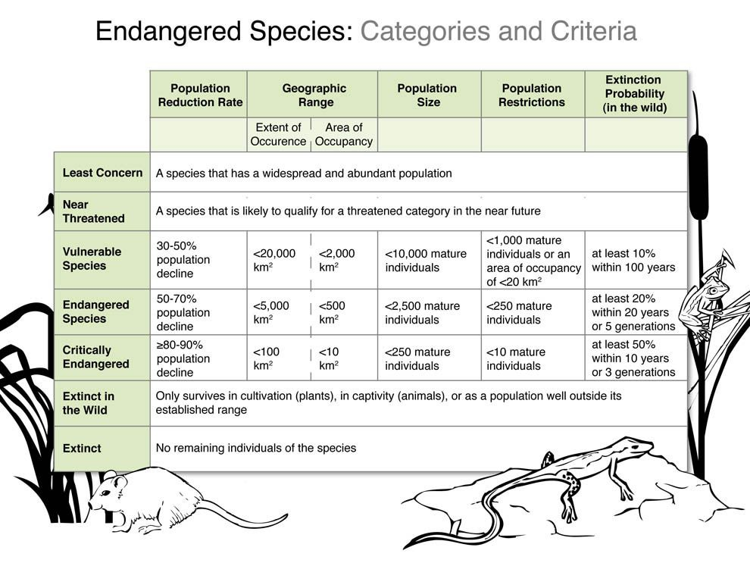
Figure 22 The categories and criteria used to describe the status of endangered species (Source: National Geographic)

The IUCN Red List index measures overall trends in extinction risk for groups of species based on observed changes in their Red List status over time. At present, index values have been calculated for only four groups of organism (Figure 23). In order to establish a trend, at least two sets of observations are required, so there is much more work to do.

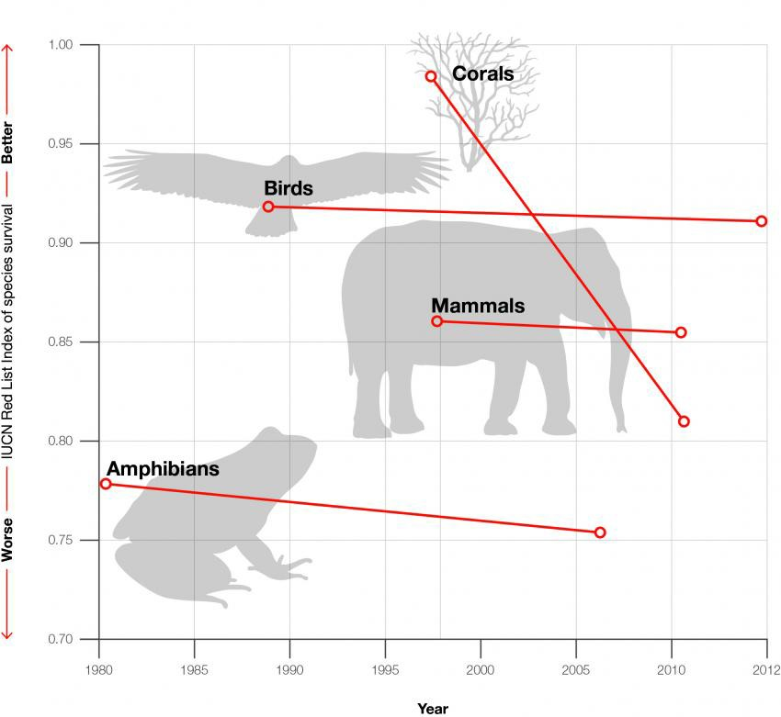
(Source: IUCN)
Figure 23 The Red List index of species survival for four groups of animals. The higher the index number, the lower the risk faced by the group.

As you can be see, with just two measures of the Red List index for each of the four groups, a decline in status is apparent for all of them. This is powerful evidence that there is a rapid decline in biodiversity in some major groups. Does this mean we really are heading towards a sixth extinction event?

7.3 A catastrophic decline?
Amphibians provide evidence that we might be on the verge of a sixth extinction event. The following extract is the abstract of a paper in the journal Proceedings of the National Academy of Sciences. As you read it, make notes of the separate factors that are having an impact on species diversity in amphibians.

Many scientists argue that we are either entering or in the midst of the sixth great mass extinction. Intense human pressure, both direct and indirect, is having profound effects on natural environments. The amphibians – frogs, salamanders, and caecilians – may be the only major group currently at risk globally. A detailed worldwide assessment and subsequent updates show that one-third or more of the 6,300 species are threatened with extinction. This trend is likely to accelerate because most amphibians occur in the tropics and have small geographic ranges that make them susceptible to extinction. The increasing pressure from habitat destruction and climate change is likely to have major impacts on narrowly adapted and distributed species. We show that salamanders on tropical mountains are particularly at risk. A new and significant threat to amphibians is a virulent, emerging infectious disease, chytridiomycosis, which appears to be globally distributed, and its effects may be exacerbated by global warming. This disease, which is caused by a fungal pathogen and implicated in serious declines and extinctions of >200 species of amphibians, poses the greatest threat to biodiversity of any known disease. Our data for frogs in the Sierra Nevada of California show that the fungus is having a devastating impact on native species, already weakened by the effects of pollution and introduced predators. A general message from amphibians is that we may have little time to stave off a potential mass extinction.
(Source: Wake and Vredenburg, 2008)

Activity 10 Amphibian diversity
Allow about 5 minutes

List the factors that are having an impact on species diversity in amphibians.

Provide your answer...
View answer - Activity 10 Amphibian diversity

Even if the planet is not heading for a sixth extinction, there is evidence to suggest that major changes in biodiversity are occurring. If the decline in species is to be halted, we need to not only take active measures, such as habitat protection, restrictions on trade and reduced carbon emissions, but also achieve a much better understanding among decision makers of the value of biodiversity. Above all, we need to maintain the constant monitoring of ecosystems and their populations of organisms so that biodiversity action plans are based on a firm evidential base. Here is the call to action for citizen scientists.

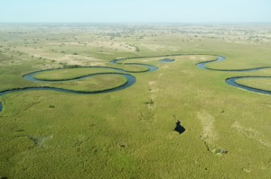
Figure 24 The Okavango Delta in Botswana, Africa, is a wetland ecosystem of international importance.

8 This week’s quiz
Check what you’ve learned this week by taking the end-of-week quiz.
Week 2 practice quiz.
Open the quiz in a new tab or window (by holding ctrl [or cmd on a Mac] when you click the link) and come back here when you are done.

9 Summary of Week 2
Biodiversity is a term broadly used to refer to the number, variety and variability of living things on our planet. Although it is often used in terms of species, it can also refer to ecosystems and even genes.
Globally, such a depiction of biodiversity is often discussed in relation to the scale being considered. If the scale is local, we one might consider biodiversity as variation within a species or habitat types in a patch of land. While at regional and continental scales we would consider variations as a result of latitude and differences in solar radiation, which are often a result of glacial cycles or mountain-building episodes, for example. At a global scale, however, such variation could be between biomes and also be a result of continental plate movements. We could envisage local variations occurring within tens of years while regional and continental variations could be considered to develop in millions of years.
One thing that is commonly observed is that the geographical pattern of biodiversity is not even. Often the highest biodiversity on Earth lies in the tropics while at other times it occurs in areas of high spatial or environmental variability.
Having appreciated the scale of biodiversity across space and time, it is time to investigate how to identify species as accurately as possible. This is an essential task but fraught with challenges. You will explore this week using a methodical approach and some useful tools.
You can now go to Week 3.

Week 3: Using biological keys for species identification

Introduction
It is important to know how many species there are, but it can be difficult to determine this number as species can be tricky to identify. Accurate identification is a necessary prerequisite for biodiversity observations. Without knowing what has been found, an observation is of little value.

Video content is not available in this format.
View transcript - Uncaptioned interactive content

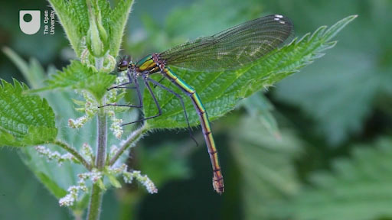

Learning how to provide an accurate identification can also open up new avenues of interest to the observer, allowing them, for example, to describe the ecological communities surrounding them and track any changes that may be occurring. At a wider level, each individual record can be of value to communities of observers and they can be combined with other records in the monitoring of biodiversity from local to global scales.
Although accurate identification is essential, with many organisms it is difficult to achieve this as they may look similar or have very different life stages. Organisms need to be carefully identified using methods such as biological keys. Assistance in this task can be found from a range of published material, from field guides to the specialist literature and online resources. Formal identification often depends on the use of dichotomous keys – that is, a series of questions, the answers to which lead to yet more questions until only a single alternative remains. These can be difficult to use, however, and are prone to inaccurate identification, since a single error will lead to the wrong conclusion. They also do not easily support strategies such as confirming or refuting a hunch or deciding between likely alternatives. There are however other types of key where multiple pieces of information can be considered and a likely identification produced without having to make these dichotomous choices.
By the end of this week, you should be able to:
- understand why species identification is important
- use dichotomous, multi-access and Bayesian keys
- recognise the difficulties in distinguishing between species.

1 Why is species identification important?
As highlighted in the Introduction, the accurate identification of organisms is important when measuring the biodiversity of an area. It is also a prerequisite when attempting to find out more about the ecology of a species. And without accurate identification it is impossible to determine how many species exist in a given area.
Identifying organisms is, however, a task fraught with difficulties. A single type of organism may be misidentified as several different species. For example, if the males and females look very different or if the species is very variable, such as the harlequin ladybird (Harmonia axyridis). In some cases, the larval stages of a species may also be mistakenly identified as a different species. (Refer back to Week 2 for more information on what constitutes a species.)
Alternatively, several different types of organism may be lumped together as a single species. This has happened many times, especially with ‘cryptic’ species such as the soprano pipistrelle bat (Pipistrellus pygmaeus). This wasn’t distinguished as a separate species from the morphologically very similar brown pipistrelle (Pipistrellus pipistrellus) until 1999, initially based on differences in echolocation frequencies. There may be large numbers of cryptic species in certain groups of organisms such as fungi.
Over the course of this week you will examine photographs and videos that demonstrate, through examples, common situations in which simply assuming individual species that look somewhat different are actually different could give a substantial over- or underestimate of the number of species.

2 Identifying species
Now you will look at some real world examples highlighting the challenges of identifying species.

Example 1: Damselflies – counting different species
How many different species of damselfly can you see in the following videos? These damselflies are in mating pairs.

Video content is not available in this format.
Video 1 A pair of damselflies.
View transcript - Video 1 A pair of damselflies.

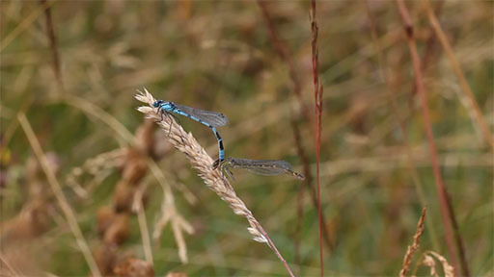

Video content is not available in this format.
Video 2 Video footage of a pair of damselflies.
View transcript - Video 2 Video footage of a pair of damselflies.

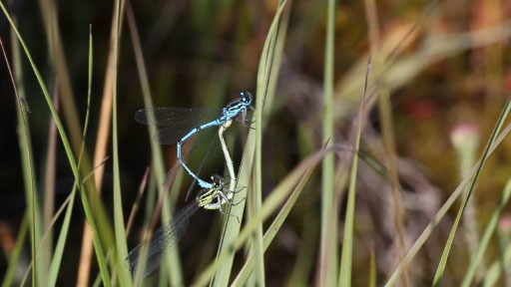

If you don’t look closely, you might easily mistake the male and female for different species, as they have different colours and markings. Had you not seen them paired up like this, you might have thought there were twice as many species as there really are.

2.1 Example 2
Here is another real world example for you to consider.

Example 2 Damselflies – identifying different species
To help us differentiate further, here are videos of male and female demoiselle damselflies (Calopteryx splendens):

Video content is not available in this format.
Video 3 A female demoiselle damselfly.
View transcript - Video 3 A female demoiselle damselfly.

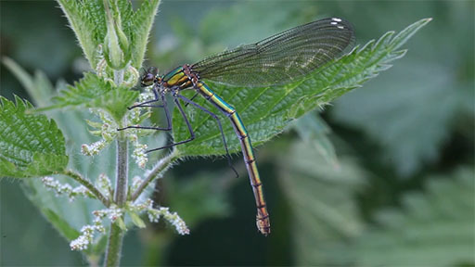

Video content is not available in this format.
Video 4 A male demoiselle damselfly.

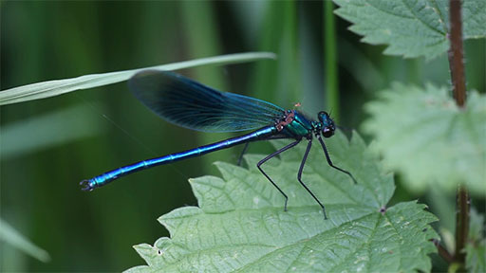

Are these green and blue insects one species or two? The truth is that they are just one species: the banded demoiselle damselfly.
To make identification even more confusing, a few species such as the scarce blue-tailed damselfly (Ischnura pumilio) not only have males and females of somewhat different colour, but also the females change colour markedly during their life from the beautiful orange shown in Video 5 to a green-brown colour scheme.

Video content is not available in this format.
Video 5 A blue-tailed damselfly (Ischnura pumilio).

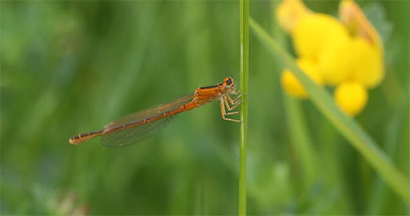

2.2 Example 3
A rather more common situation is where there are several different species that look similar. In this case it is very important to look for small differences to separate the species.

Example 3 Fungi
In the case of fungi, methods of identifying these differences involve the use of chemical tests or microscopic examination.
It is relatively easy to identify the mushrooms in Video 6 as being in the genus Russula due to their bright colour and very fragile flesh. However, identifying them accurately from the large numbers of different Russula species can be much more difficult, even for experts. In fact, the mushroom on the right, with a slightly darker red cap, is of a different species of Russula from the others.

Video content is not available in this format.
Video 6 Red Russulas growing in the wild.
(Source: www.youtube.com)

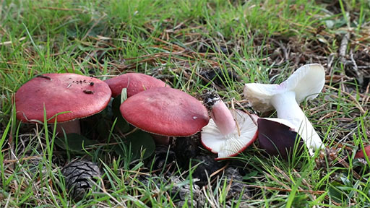

For people who collect mushrooms to eat, identification can be critical. Looking at the fungi in Video 7, you could pose the question, is this mushroom a grey spotted amanita (Amanita excelsa var. spissa), which may be edible, or the very similar panther cap mushroom (Amanita pantherina), which is deadly poisonous? Or perhaps it’s one of the other species of amanita that look rather similar? It is actually a grey spotted amanita.

Video content is not available in this format.
Video 7 An amanita fungus
View transcript - Video 7 An amanita fungus

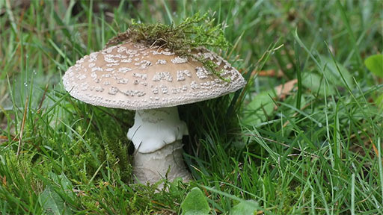

These are just a few examples that demonstrate how important it is to identify species accurately for a whole variety of reasons. Biological keys, which can be books or computer based aids, are one of the most useful tools for carrying out accurate identification of different species.

3 Current estimates of the total number of species
Over 1.8 million species have been described so far in the Catalogue of Life, but estimates of the total number of species on Earth range very widely (Catalogue of Life, 2019).). There have been estimates in the region of 8 million total species on Earth if microorganisms such as bacteria are excluded, rising to 1 trillion( NSF, 2016) or 2 billion if they are included (Brendan et al., 2017). The proportion of species that have so far been described compared with the total global estimate of the number of species varies between groups. For example, almost all mammals, birds and reptiles have been described but only about one in five insects have a description (Chapman, 2009).
Once an organism has been identified as being of a certain species, it is often possible to look up a whole range of ecological information about that species. You will learn more about this in Week 6. There are now many online databases and scientific publications that can provide detailed information on many of the named species. For example, a web search of the harlequin ladybird (Harmonia axyridis) not only shows a very wide range of colours and patterns displayed by this species but also indicates its life history, potential problems caused by its invasive nature, its native and non-native range, and links to many scientific papers on the species.

4 Types of biological key
Given that there is a very large number of species to choose from, how is it possible, when identifying an organism, to narrow down the choices and arrive at a correct identification? The traditional approach is to use a biological key, which uses a series of attributes – usually morphological characters – to separate one species from all the rest.
There are three main types of biological key.
Dichotomous keys consist of a series of questions, each of which has only two mutually exclusive alternative answers, for example (a) twig hairy or (b) twig not hairy. Answers to these questions then lead on to further questions until a definite identification is made. However,with just one mistake it’s possible to take a completely wrong path and arrive at an inaccurate identification.
Multi-access keys consist of characters with their individual states that can be chosen in any order. For example, the character ‘flower colour’ may have states ‘yellow’, ‘red’, ‘blue’ and ‘orange’. Multi-access keys are normally computer-based and give the species that matches all of the character states chosen. Species are dropped from consideration if their characters don’t match. A definite identification is reached when only a single species remains. Multi-access keys allow the user to input only the data that they can observe on the organism at the time. For example, if the plant isn’t in flower then the flower’s characteristics do not have to be entered. Whereas with a dichotomous key it may not be possible to achieve any identification at all without inputting the flower’s characters.
Bayesian multi-access keys (shortened to Bayesian keys) are similar to multi-access keys, but the identification is based on how many characters match. The more characters that match, the more likely the specimen is to be a particular species. This method is based on Bayesian statistics, a branch of statistics that specialises in predictions from limited prior knowledge. One advantage is that, if there are a few species of similar probability being considered, they can all be shown and easily compared.

5 Comparing biological keys
To illustrate how the two types of key differ, Figures 1 and 2 show a traditional dichotomous key and a Bayesian key for the same group of organisms: most of the species of dragonflies and damselflies found in the month of May in the British Isles. Either version can be used to identify the organisms.

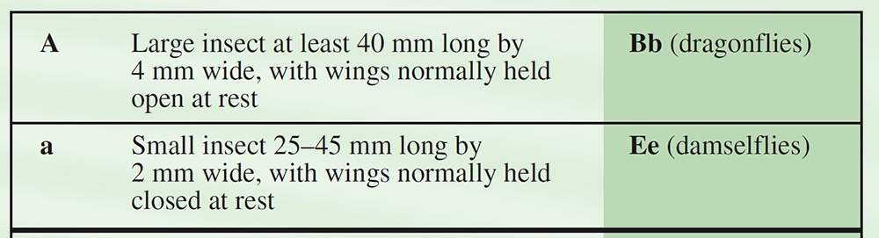
Figure 1 First couplet of the dichotomous dragonfly key

At the beginning of the dragonfly key shown in Figure 1, the user chooses between two alternatives, either (A) a large insect at least 40 mm long by 4 mm wide, with wings normally held open at rest, or (a) a small insect 25–45 mm long by 2 mm wide, with wings normally held closed at rest. Open up the full PDF of the key and refer to this section. Once you have made your choice, you move down the key to the relevant part. For example, if you chose alternative (a) then you move on to couplet Ee (damselflies), where you are asked to choose between insects that are (E) red and black or (e) not red and black. If you choose alternative (E) then you have keyed the insect out as a large red damselfly, but if you choose alternative (e) then you will need to move onto couplet Ff and again make a choice between two alternatives, and so on.

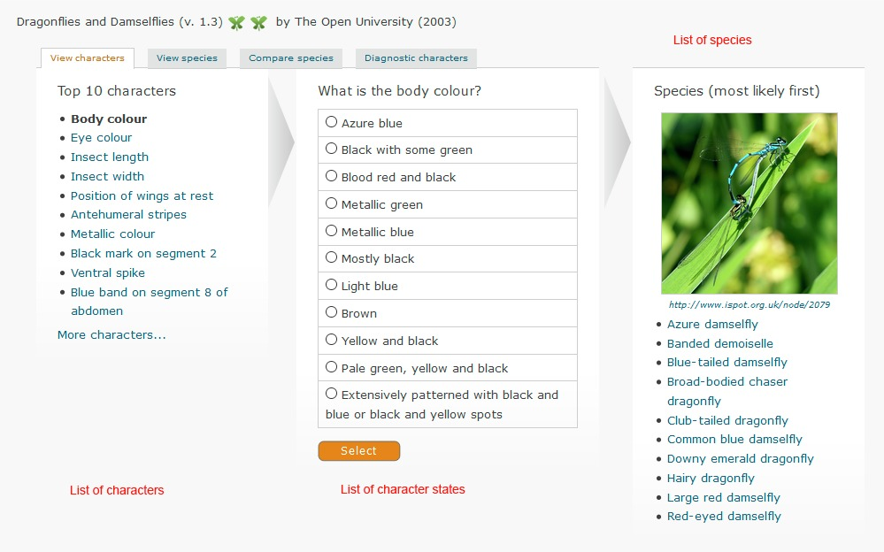
(Source: https://www.ispotnature.org/webkeys/keyintroduction.jsp?selectedKey=webkeys/odonata)
Figure 2 Bayesian key to dragonflies and damselflies.

On the citizen science species-identification platform iSpotnature.org (which will be investigated in thorough detail in Week 6) there is a range of Bayesian keys available. These include a key (see Figure 2) to the same species as used in the dichotomous key shown in Figure 1. Before getting to the first page of the Bayesian key to dragonflies, however, you must first determine whether to use the known distribution and abundance of the species. It’s generally advisable to select the last option presented: ‘Treat all species equally’.
On the first page of the key, the first column shows a list of various characters – for example, body colour or position of wings at rest. These can be selected in any order. Once a particular character is selected, a list showing the possible options for this character appears – for example, the character ‘body colour’ has 11 different colours presented as options.
As each character is selected, the list of species changes to give the most likely species at the top. If an unusual individual is found or a mistake is made in one of the early characters then the most likely species can change considerably, although generally after several characters have been selected the correct species will be at the top. (Note: it is always worth clicking on the species name to see images of that species and a full list of characters in order to check that they match with your species.)

6 Using a biological key
Now it’s your chance to practise using a biological key for identifying species of dragonfly or damselfly.

Activity 1 Working through a dichotomous key
Allow about 15 minutes

In this activity you will need to choose three of the seven dragonfly or damselfly photos shown below and then use the dichotomous key to produce an identification. For each photo you select, record the name of the species that you arrive at using the key.

Interactive content is not available in this format.
Figure 3–9 Options 1-7

Then, with the same photos selected, work your way through the iSpot online Bayesian key. Again, note down the name of the species.
Did you arrive at the same species name using both forms of the key? If not, check all the characters of the species to make sure you are confident which species it is and see if you can find where you made a mistake in the key.

View answer - Untitled part

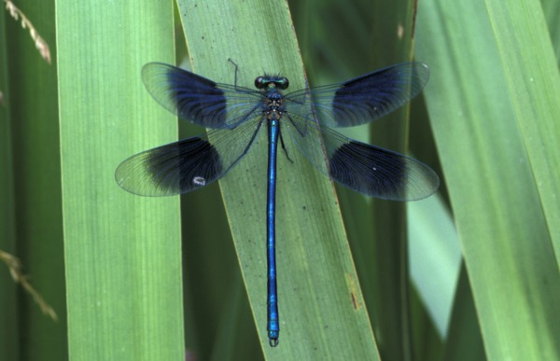
Figure 10 Banded demoiselle (Calopteryx splendens)

Now look at Figure 10 of a banded demoiselle. What is the main difficulty you might have when identifying the species in this image?

View answer - Untitled part

7 Limitations of biological keys
It is important to note the limitations of any key or guide used in species identification. The dichotomous key you used in Activity 1, for instance, is limited in covering only those species of dragonfly and damselfly found in the month of May in the British Isles. (It was initially developed as a dichotomous version for students doing field work on an Open University environment course in mid-May.) There are of course many more species of dragonfly and damselfly that fly later in the year in the British Isles, and globally again there are many more species.
Keys are almost always restricted to a certain group of organisms and often to a certain part of the world. If this wasn’t the case, they would be extremely long and unwieldy. However, these limitations can sometimes lead to problems. For example, mobile species such as dragonflies can sometimes end up far from their normal range and plants can escape from gardens or be transported around the world by humans. In the case of this particular dragonfly key used in Activity 1, climate change over recent years means that there are now additional species turning up more frequently in May that are not covered by the key.

7.1 Other issues using biological keys
When using a key, small details of the species in question have to be noted. These details are often given technical names – for example, stylet for an insect’s piercing mouthparts, such as those of the mosquito. These words are normally explained in a glossary that is used alongside the key. The dragonfly key you used in Activity 1 was deliberately selected because it featured none of these technical terms, as it was to be used by non-experts, as well as for the fact that there were only a few species included in the options. Technical terms can significantly slow down the keying-out of species and can be very off-putting for non-experts. They should be avoided wherever possible if a key is to be used with the general public or in a citizen science context.
When trying to carry out identifications, it is important to know when to stop. Organisms such as dragonflies and damselflies have many characters and character states that can be readily observed and as a result many species are relatively easy to distinguish. However, in other groups of organisms, such as fungi, there can be considerably fewer character differences that are easily observable, and those that are can be shared by a very large number of species.
Figure 11 shows a bright-red mushroom that has very fragile flesh; the gills and stem readily break into small pieces. It is quite easy to key-out this species as belonging to the genus Russula. But still there are well over 100 species of Russula in the UK alone and many times this number worldwide, and most of these are brightly coloured and have fragile flesh. Identifying the species beyond its genus may therefore involve detailed measurements under the microscope, chemical tests and even examining its DNA. It is very important that some people go on to do these tests and distinguish the species, although, for more general users of a key, getting as far as the genus Russula may be enough.

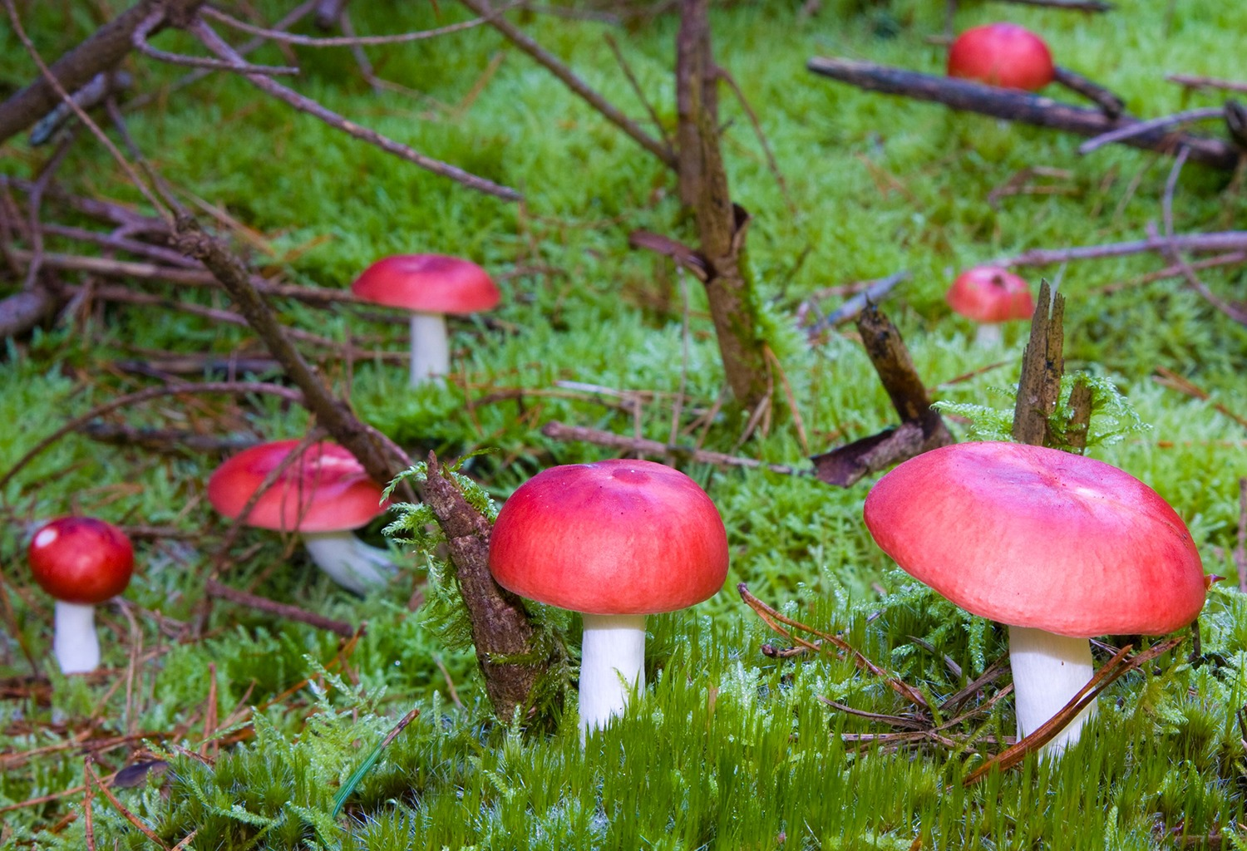
Figure 11 A bright-red species of Russula fungus

8 This week’s quiz
Check what you’ve learned this week by taking the end-of-week quiz.
Week 3 practice quiz
Open the quiz in a new tab or window (by holding ctrl [or cmd on a Mac] when you click the link) and come back here when you are done.

9 Summary of Week 3
The accurate identification of organisms is essential when discussing biodiversity. Without knowing what it is that has been found, observations of animals and plants are of little interest or value. An accurate identification opens up new avenues of knowledge, allowing the description of ecological communities and the tracking of any changes that may be occurring.
However, accurate identification of many organisms is difficult. Fortunately, though, there is a range of published material to help with this, from field guides to specialist literature. Formal identification often depends on the use of dichotomous keys – that is, a series of questions, the answers to which lead to yet more questions until only a single alternative remains. These can be difficult to use, however, and are error-prone since a single mistake will lead to the wrong conclusion. They also do not easily support strategies such as confirming or refuting a hunch or deciding between likely alternatives.
This week you compared using a traditional dichotomous key with using an online iSpot Bayesian key via example images of dragonflies and damselflies. Next week you will look at a case study on monitoring monarch butterflies.
Now that you have a good understanding of how and why we need to make accurate species identifications, next week you will be looking at what types of surveys can be carried out to collect information about species distribution and abundance. This is essential for making an assessment of biodiversity. Such studies require enormous datasets to build up an accurate picture so, once equipped with identification skills, citizen scientists can play an important role in collecting this data.
You can now go to Week 4.

Week 4: Biodiversity recording

Introduction
You are now familiar with some methods of identifying living organisms, and you will learn about advanced identification techniques in Week 5. It is now time to look at how information about biodiversity can be collected and how citizen scientists can help projects which have the message, ‘We need data!’

Video content is not available in this format.
View transcript - Uncaptioned interactive content

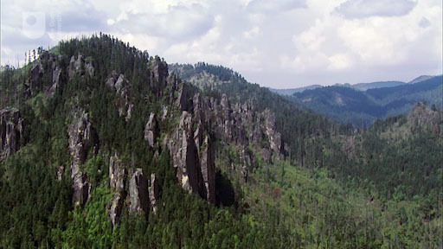

By the end of this week, you should be able to:
- explain the value of monitoring animals and the type of information that may be obtained
- outline the advantages and disadvantages of a given plant survey method
- give examples of how insects can be collected and surveyed
- understand the role of citizen scientists in monitoring and surveying projects.

1 A large-scale project
The video in the Introduction referred to the monarch butterfly, (Danaus plexippus), and its migration routes in North and Central America. Studying the monarchs over such a huge area requires a large number of people, almost all of whom are volunteers. The ways in which scientific information about the butterflies is collected is illustrated in the following case study.

1.1 Case study on monitoring monarch butterflies
Each stage of the life cycle of the monarch butterfly needs to be studied if the threats to its populations are to be understood, yet studying an animal with such a massive geographical range is challenging. In Mexico, the overwintering colonies are in a reserve and monitored by government scientists. In the USA and Canada, information about the butterfly is sourced from a network of citizen science volunteers. They can record sightings by posting details to a website such as Journey North(or take part in a tagging programme such as the one on Monarch Watch, where volunteers can purchase tagging kits with pre-numbered tags along with instructions on how to use them (Figures 1–3). The purpose of the tagging is to determine the pathways taken by migrating butterflies. Obviously, over such a large area it would be unlikely that a marked individual would be sighted and recorded, unless there were thousands of active observers. This type of project can be carried out only on a citizen science basis.

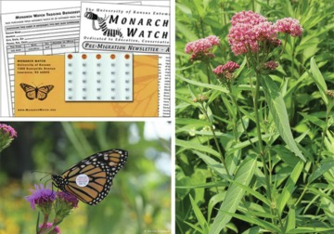
Figure 1 Tagging kit, Figure 2 Tagged butterfly, Figure 3 Food plant Asclepias sp. (milkweed)

Each tag is printed on a polypropylene sheet that has a special adhesive on the back. It is attached to the hind wing of the butterfly, close to its centre of gravity, so as not to impede flight. Downloadable spreadsheets are available to assist with record-keeping and for submitting completed data.

Activity 1 A monarch survey
Allow about 20 minutes

Imagine that you live in North America and have equipped yourself with tagging equipment to monitor adult monarchs from the Monarch Watch Shop. Make a list of what you need to know before you set out, what information you will need to record and what additional observations might be useful.

View answer - Activity 1 A monarch survey

Citizen scientists also take part in other monarch-related projects as well as the tagging one. For example, studying egg-laying sites and the larval stages of their development provides information about their habitat requirements. Surveys are done weekly from the first time they see milkweed in their study area. They record the data they gather online. It is important to survey the occurrence of the food plant for the larvae, milkweed (Asclepias sp.). You will learn about plant survey methods in the next section.

2 Plant surveying

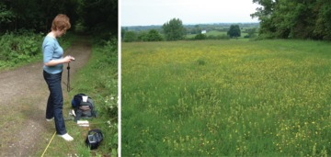
Figures 5 and 6 Preparing to do a plant survey

Many of the problems that arise when surveying animals are caused by their mobility. Plants, of course, don’t present this particular difficulty, but they do present others. The two videos that follow show different sampling methods. As you watch, make notes on the techniques used in each one.

Video content is not available in this format.
Video 1
View transcript - Video 1

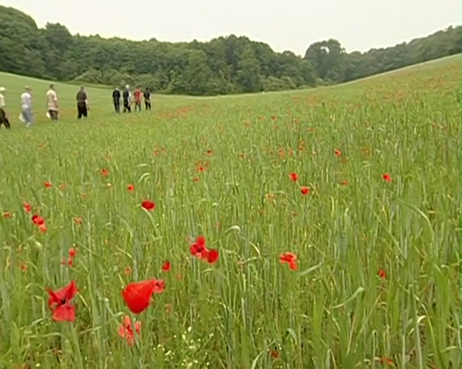

Video content is not available in this format.
Video 2
View transcript - Video 2

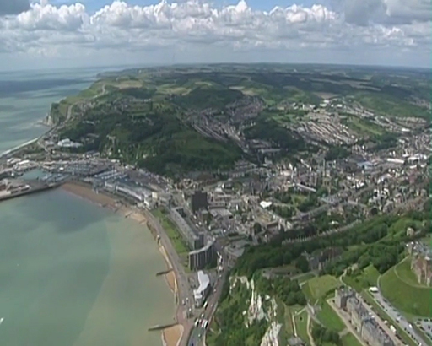

Counting corncockles is similar in principle to recording the numbers of animals (e.g. butterflies) present in a defined area. Surveying the chalk grassland and simply recording the plant species present is a useful way of recording the particular species present.

Activity 2 Assessing diversity
Allow about 5 minutes

What are the limitations of recording the species present in assessing diversity?

View answer - Activity 2 Assessing diversity

The data could be standardised (i.e. to help when comparing them with data from other sites) by using a fixed area to sample and a standard length of time in which to do the recording.

Activity 3 Standardising the sampling area
Allow about 5 minutes

How was standardisation of the sampling area achieved in the surveys shown in the videos?

View answer - Activity 3 Standardising the sampling area

In the corncockle survey it was possible to count directly the number of plants present, but this isn’t always possible so other measures of recording abundance are needed. Two methods that are often used are frequency of occurrence and percentage cover.
Frequency of occurrence is a measure of the chance of finding a particular species within a given sample area. For each square of a grid, the presence or absence of each species is recorded. The frequency of occurrence is the proportion of the total number of squares in which the species occurred.
Percentage cover, is a measure of the area of ground covered by a plant species and requires the use of a grid quadrat. The observer examines each square and makes a visual estimate of whether the square is fully occupied by the species or partly occupied. The partly occupied ones will be combined to give the estimated number of full squares they represent. Adding the number of fully occupied squares to this estimate gives the number of fully occupied squares out of the total number of squares in the grid. Other methods used to get percentage cover in plant surveys include a simple visual estimate of percentage by looking at the whole quadrat, rather than using a grid, and recording the percentage of each species in each sample. There are also various mechanical methods that can be used. For example, a bar with regularly spaced holes in it can be suspended above the area to be surveyed. A needle is put through each hole in turn. Each plant species touched by the needle as it goes through the vegetation is recorded as being present at this point. Photographs, too, can be useful tools in sampling.

Activity 4 Working out percentage cover
Allow about 10 minutes

If a grid was five squares by five squares, nine of which were fully occupied by the target species, what would be the percentage cover for the species being surveyed?

View answer - Activity 4 Working out percentage cover

So quadrats provide a way of formalising survey work. There is however another factor to consider, and that is the decision about where to place the quadrat. It would be very easy to bias your survey by not paying close attention to this criterion. For example, in Video 2 about chalk grasslands, throwing the quadrat on the ground appeared to provide a random approach. But actually there is still a bias at work here since there is a limit to how far you can throw a quadrat; only vegetation within reach is sampled.
Two sampling methods that aim to reduce bias are random and systematic sampling (Figure 8).

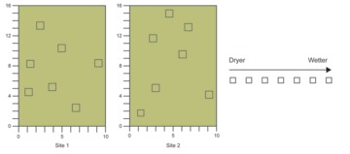
Figure 8 Random (left) and systematic sampling

Random sampling is often used when it’s necessary to compare two or more sites. In this method, equal quadrilateral areas are marked out at each site and two sides of each area are numbered to give a coordinate system. The coordinates of quadrats for sampling are chosen at random. Then, by using a highly accurate differential GPS instrument (these are available for hire if you don’t have one), these randomly generated grid coordinates can be loaded into the machine and set out to centimetre-level accuracy at each site. One advantage of this method is that the same locations can be resurveyed over many years to look at changes over time.
With systematic sampling, instead of randomly placing quadrats, an area is surveyed by placing them at regular intervals, often linearly in an arrangement known as a transect. Transects are often used when surveying to see if there is a change in vegetation with distance.

Activity 5 Transect surveys
Allow about 5 minutes

Can you think of any examples where transect surveys would be useful for surveying animal populations?

View answer - Activity 5 Transect surveys

You will come across other examples of transect use as you read on.

Interactive content is not available in this format.
Video 3

3 Collecting insects
Insects are a very diverse group and can be found in a wide range of habitats. There are many different techniques for collecting and surveying them. This section looks at three examples of insect-collection techniques before moving on to a citizen science case study.
Smaller insects can, of course, be difficult to spot in complex habitats, but your searching will improve with practice. They can be collected using a simple device called a pooter (Figure 12) and then transferred to a tube for later identification.

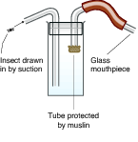
Figure 12 Collecting small insects with a pooter

Activity 6 Survey of larger insects
Allow about 15 minutes

Watch the following video and identify the survey method being used. List some examples (including one you have already encountered) of where this survey method would be useful.

Video content is not available in this format.
Video 4
View transcript - Video 4

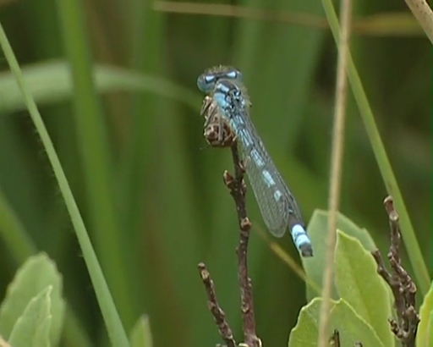

View answer - Activity 6 Survey of larger insects

3.1 Sampling on the soil surface
Insects that move over the ground are sampled with a pitfall trap (Figure 13).

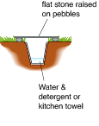
Figure 13 A pitfall trap

This trap is made by simply burying a large yoghurt pot or jam jar in the ground so that the rim of the container is flush with the soil surface. Insects running along the ground fall into the container and cannot climb out. The opening of the trap is covered with a flat stone raised off the surface with pebbles, allowing insects to enter the trap but preventing small mammals from falling into it. To trap live insects, the bottom of the container is filled with dry vegetation or a folded kitchen towel, paper tissues or similar, giving the insects somewhere to settle. Pitfall traps are good for collecting ground beetles (family Carabidae) and wolf spiders (family Lycosidae).
If insects are to be collected for later identification, water with a drop of washing-up liquid or ethylene glycol (antifreeze) should be added to the trap. Identification of many insects can only be done with dead specimens and sometimes dissection is needed. Collecting any living organism for identification has to be done responsibly and for good scientific reasons.

Activity 7 Pitfall traps
Allow about 5 minutes

Can you think of any disadvantages to the live trapping of insects described above? Write your answer in the box below.

Provide your answer...
View answer - Activity 7 Pitfall traps

Now watch the following video which shows a pitfall trap survey.

Video content is not available in this format.
Video 5
View transcript - Video 5

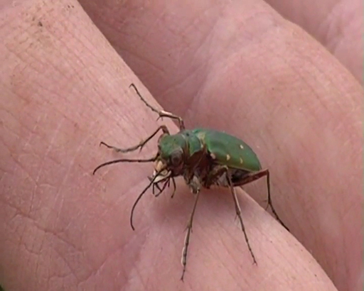

3.2 Sampling flying insects
This video looks at a local volunteer who monitors moths.

Video content is not available in this format.
Video 6
View transcript - Video 6

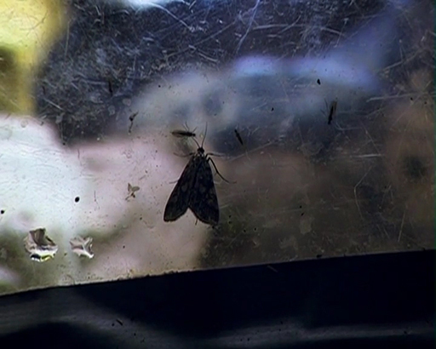

Large day-flying insects such as butterflies may be caught in a butterfly net, identified and released, but since each insect needs to be stalked, these nets are not so useful for sampling. The number of insects caught is more dependent on the skill of the surveyor than on the number of insects in a population. However, where the identification of the insect is possible without capture, a transect method can be used, similar to the survey of dragonflies illustrated in the video at the beginning of this section.
Moths can be monitored using a light trap (Figure 14). Traps of the type used in the previous video can be run throughout the night and checked the following day.

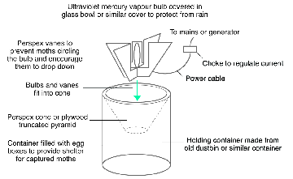
Figure 14 A light trap

Light traps are widely used for surveying night-flying insects. Traps that are run every night can provide species lists for a particular area and, more importantly, show changes in species diversity with the seasons and over the long term as annual records are compared.

3.3 Light traps in the Grand Canyon

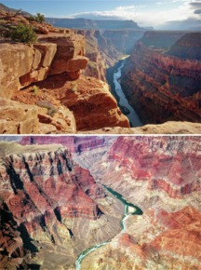
Figure 15 The Grand Canyon and Colorado River, Arizona, USA

The health of a river or stream can be assessed from the diversity of aquatic insects and by the species that are present. For example, some insects can tolerate low oxygen levels, which might arise as a consequence of pollution, whereas others require very clean water so would disappear quickly from fresh water as pollutants arrived.
The United States Geological Survey (USGS) wants to monitor the health of the Colorado River, which flows through the Grand Canyon (Figure 15). Aquatic insects are a key component of this ecosystem, but the small number of professional scientists in the area cannot hope to monitor a 250-mile length of river over long periods of time. So they have recruited people who work on the river to take samples for them all year round (Figure 16).

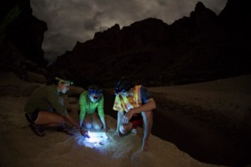
Figure 16 Collecting a light-trap sample of adult aquatic insects in the Grand Canyon

There is a standard procedure to be followed. At dusk, the citizen scientists set out a light trap on the edge of the river. The trap has a fluorescent black lamp which attracts flying insects. Below the lamp is a container of alcohol into which the insects fall. The trap is run for one hour and then the sample is poured into a bottle that can be sent to the USGS labs, where staff can identify and record the insects collected.
From the thousands of samples already collected (and millions of insects identified), it has been possible to show that the abundance and diversity of aquatic insects is influenced by hydro-electric power generation on the river. There are hourly changes in the amount of water discharged from the Glen Canyon Dam, which means that the water level in the river fluctuates, with an intertidal zone between the highest and lowest water levels. The data provided by citizen scientists show that, in regions where low water occurs daily at dusk, the abundance of aquatic insects is three times that of areas where water levels at dusk are high. This difference is attributed to differential mortality of the insect eggs.
But just how important is the survey, which is very labour intensive? The answer to this question lies in the food webs in the ecosystem. Aquatic insects support the entire ecosystem, providing a food source for predators in the water such as fish, terrestrial predators such as lizards and flying predators such as birds and bats. You can find more information about the study on USGS.

4 This week’s quiz
Now it’s time to complete the Week 4 badge quiz. It is similar to previous quizzes, but this time instead of answering five questions there will be fifteen.
Week 4 compulsory badge quiz
Remember, this quiz counts towards your badge. If you’re not successful the first time, you can attempt the quiz again in 24 hours.
Open the quiz in a new tab or window (by holding ctrl [or cmd on a Mac] when you click the link) and come back here when you are done.

5 Summary of Week 4
In previous weeks you explored ways of naming and identifying organisms. This week introduced you to some common survey methods that mostly require the use of simple equipment or even no equipment at all beyond a notebook and pencil. A linear survey of butterflies or dragonflies can be done without equipment, although its accuracy will depend on the identification skills of the observer.
Throughout this course you are encountering examples of citizen science projects, and this week you have been introduced to two examples of projects covering large geographical areas. The work of the citizen scientists in the monarch butterfly survey and the Grand Canyon project contributes enormously, and it is possible that the projects would be impossible without their input of time and interest. In the next two weeks you will explore resources and communities that can help you to engage with other citizen science projects.
You are now halfway through the course. The Open University would really appreciate your feedback and suggestions for future improvement in our optional end-of-course survey, which you will also have an opportunity to complete at the end of Week 8. Participation will be completely confidential and we will not pass on your details to others.
You can now go to Week 5.

Week 5: Advanced species ID techniques

Introduction
We often think of a field guide book, for example, to flowers or birds as a typical accompaniment to a naturalists day out. However, there are many more techniques for identifying species than checking keys and illustrations in the field.

Video content is not available in this format.
View transcript - Uncaptioned interactive content

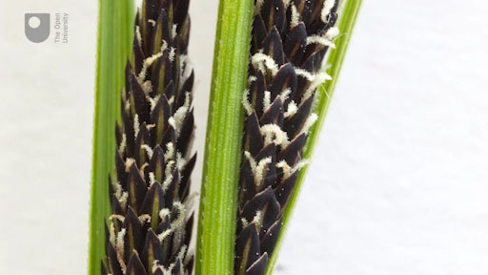

Certain groups of organisms in particular require more detailed examination than is possible with the unaided eye if species are to be identified accurately.
As discussed in Week 3, there are many different species of fungi but they are often difficult to tell apart because they have few easily observed characteristics. For example, globally there are over 700 species of Russula mushroom, most of which look rather similar except for the colour of the cap. Even this one characteristic is not ideal since the colour can change over time and can be affected by rain. In the search for more characteristics to tell species apart, mycologists examine fungi under a microscope to look for aspects of structure that are consistent within a species but differ between species. Examples of these characteristics include the shape of cells on the gill edge and the size, shape and ornamentation of the spores.
By the end of this week, you should be able to:
- understand why a microscope is sometimes required for identifying species
- understand the basis of how DNA barcoding works in general terms
- understand why DNA is sometimes needed instead of using traditional identification techniques
- use an automated species-identification app.

1 Small details are important
When carrying out species identification, it is often the small details that are important to distinguish similar species – for example, whether a sedge flower has two stigmas or three. Details of the flower are possible to see clearly with a hand lens. Yet the characteristics that distinguish separate species of fungi often relate to the shape and size of their spores or other microscopic features, such as cells on the gill edge. Various other groups of organisms also require very close examination in order to identify separate species, such as the two common Bathyporeia amphipods (crustaceans that live on the seashore). These appear identical apart from the presence or absence of a small, backwardly projecting spine which is visible only under a microscope.
Going beyond the microscope, there are species-identification techniques that are based on the chemical composition of the organism, particularly its genetic material – its DNA – which is present in every cell. These techniques can be highly effective at detecting even tiny differences between species. And some of them can also be used to develop molecular phylogenies showing a detailed family tree for each species.
The third technique described here is automated species identification. The computer analyses an image or a sound recording and compares it with a large database of derived information from correctly identified examples of each species. This technique has the potential for rapid species identification and has become increasingly accurate over recent years.

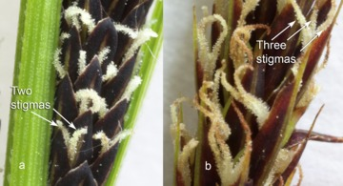
Figures 1 and 2 Carex acuta and C. stigmas

Figures 1 and 2 provide another example of two different species that are almost identical apart from some tiny differences. The images shown are of two very similar species of sedge that often grow in similar conditions and can be separated by the number of their stigmas (the white female part of the flower that collects pollen grains). Figure 1 (a) is a close-up of the slender tufted sedge (Carex acuta), which has pairs of stigmas. While Figure 2 (b) is the lesser pond sedge (C. acutiformis), which has stigmas grouped in threes. The difference is clearly visible with a hand lens.

2 Using microscopes
As discussed in Week 3, there are many different species of fungi but they are often difficult to tell apart because they have few easily observed characteristics. For example, globally there are over 700 species of Russula mushroom, most of which look rather similar except for the colour of the cap, and even this one character is not ideal since the colour can change over time and can be affected by rain. In the search for more characters to tell species apart, mycologists examine fungi under the microscope to look for aspects of structure that are consistent within a species but differ between species. Examples of these characteristics include the shape of cells on the gill edge and the size, shape and ornamentation of the spores.
Now watch nature enthusiast and iSpot user Flaxton explain aspects of fungal identification, firstly just from observations, followed by demonstrations using different types of microscopes.
In Video 1 Flaxton goes through the process of identifying a Boletus luridus fungi, first by noting how to look for the defining characteristics one can spot first from observation, examining the species with the eyes.

Video content is not available in this format.
Video 1
View transcript - Video 1

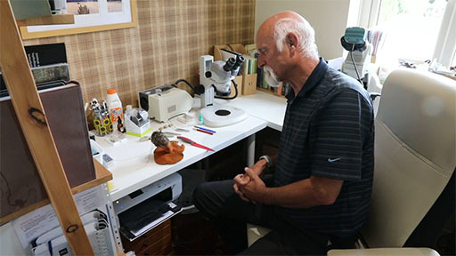

In this video Flaxton demonstrates how to use a binocular microscope to examine a fungi more closely. This type of microscope is often used to prepare sections of fungi or other small specimens, to help to make them more suitable for viewing under a high-power microscope.

Video content is not available in this format.
Video 2

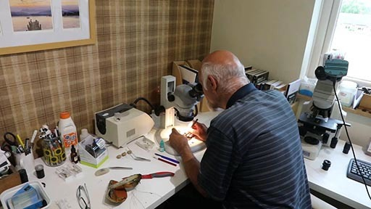

Here we zoom in to better see Flaxton using the binocular microscope as he prepares thin sections of a Russula mushroom cap which is being cut so that cells on the gill edge and spores can be seen.

Video content is not available in this format.
Video 3

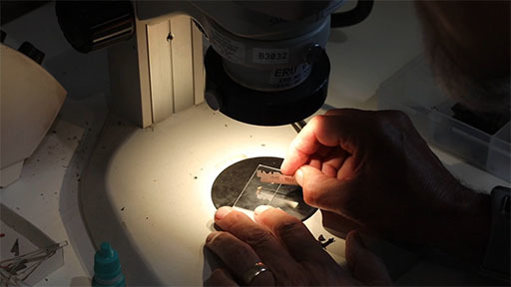

Using a high-power microscope, Flaxton now examine the Russula species that was shown being sectioned under the binocular microscope. Flaxton demonstrates the microscope being focussed by eye and hand. He then places a camera into one of the eyepieces to show the view from the microscope on the computer screen. Flaxton notes that he is concentrating on just one spore from the mushroom and this shows the shape of the spores by switching to the highest power magnification (1000x). At lower magnifications the spore only showed up as a dot in the field of view but as he focusses up and down different parts of the spore become sharp.

Video content is not available in this format.
Video 4
View transcript - Video 4

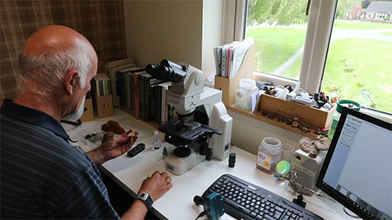

In this final video clip Flaxton wraps up this section by discussing how to use the techniques demonstrated to help identify the characteristic differences and / or similarities of similar species. He looks again at at his earlier identification of a Boletus luridus fungi. And compares it with Boletus mendax. Flaxton shows the spore size and shape on screen while discussing how to differentiate between the two closely related species.

Video content is not available in this format.
Video 5
View transcript - Video 5

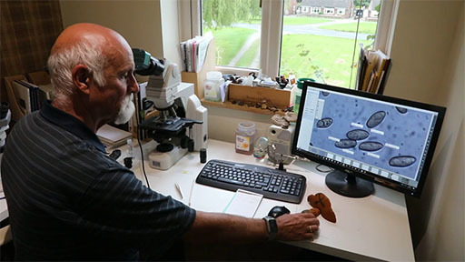

There are various types of optical microscope. You may need to use two in combination, one to dissect and prepare the sample and another to examine the dissected sample at high power (Figure 3). While the wavelength of light limits the useful maximum magnification that can be achieved from an optical microscope, much greater magnification can be obtained with electron microscopes. However, sample preparation for viewing with an electron microscope can be difficult and they are very expensive.

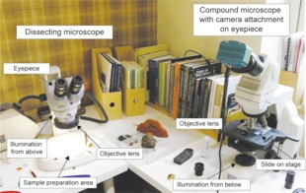
Figure 3 Dissecting and compound microscopes

The dissecting microscope typically offers a range of magnifications, from about 5x to 50x. With this device, illumination is supplied from above, and some models provide a digital output of images in addition to stereo eyepieces. It is suitable for looking at organisms such as mosses and invertebrates and can also be useful for preparing sections of fungus for examination under a higher-powered microscope. As the name suggests, the dissecting microscope is often used when teasing apart tissue with a needle and scalpel so that you can clearly see the fine details of, for example, individual moss leaves.
Another type of microscope – the conventional compound microscope – offers magnifications from around 100x to 1000x. With this device, illumination is usually supplied from below to shine through the specimen. Like the dissecting microscope, it can supply optical or digital output. The higher magnifications (400x–1000x) may require the use of a high-quality oil immersion lens to give a good image. As mentioned earlier, there is a physical limit to amount of magnification that can be obtained using light due to diffraction. The smallest item that can be resolved using a conventional light microscope with high-power lenses is around 0.0002 mm. Fungal spores are in the region of 0.002 mm to 0.01 mm in diameter, so not only are they visible under the microscope but it is also possible to detect surface ornamentation.
It is possible to attach a digital camera to the microscope and view images on-screen. Once calibrated, this can also superimpose a scale or grid on the image.

2.1 USB microscopes
This section looks at the increasingly popular USB microscopes which have become more easily available and accessible over recent years.

USB microscopes and add-on lenses for smartphones
USB microscopes are simple to use and highly portable, offering magnifications of up to about 200x, with built-in LED lighting. However, the quality of images produced by these devices might not be suitable for fungal identification, especially at higher magnifications. This type of microscope is more suitable for studying insects or very small pond life.
It is also possible to use a smartphone equipped with an add-on close-up lens. The magnification obtained with this set-up is less than you would get from a USB microscope but can still be high enough to study species such as mosses. (Bear in mind, though, that the quality and price of close-up lenses for smartphones varies considerably.) See for example the images, which were posted on iSpot, of:
- a sticky mouse-ear (Cerastium glomeratum) (also shown in Figure 7) taken using an iPhone clip-on microscope.
- bryophyte fungus, taken with a dissecting microscope.
- Pilobolus crystallinus (fungus).
- a scarlet elf cup.
- a moss Fissidens exilis(also shown in Figure 4).

Figures 4–7 show a selection of images supplied by iSpot users, taken using various types of conventional microscope to demonstrate their use.

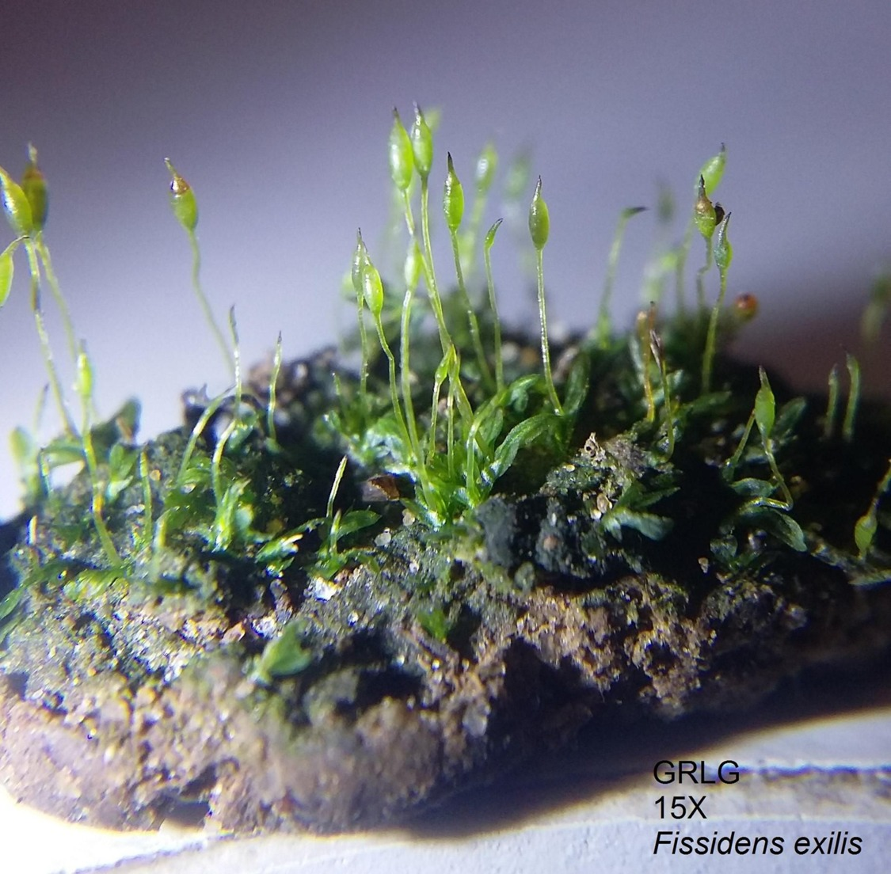
Figure 4 Moss Fissidens exilis seen with a dissecting microscope at 15x magnification

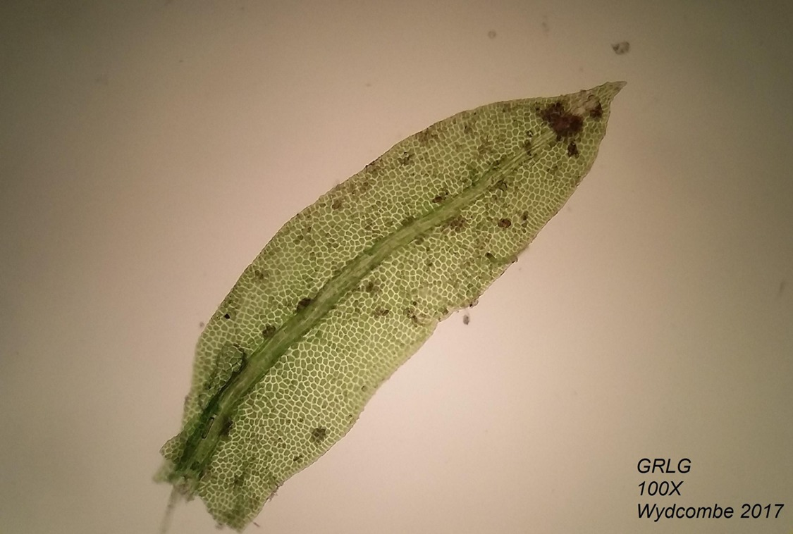
Figure 5 Image of a single leaf taken using a compound microscope at 100x magnification

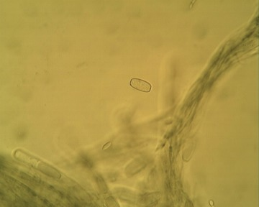
Figure 6 Scarlet elf cup fungus (Sarcoscypha austriaca), taken at 400x magnification, showing characteristic blunt-ended spores and corkscrew hairs on the outside of the cup

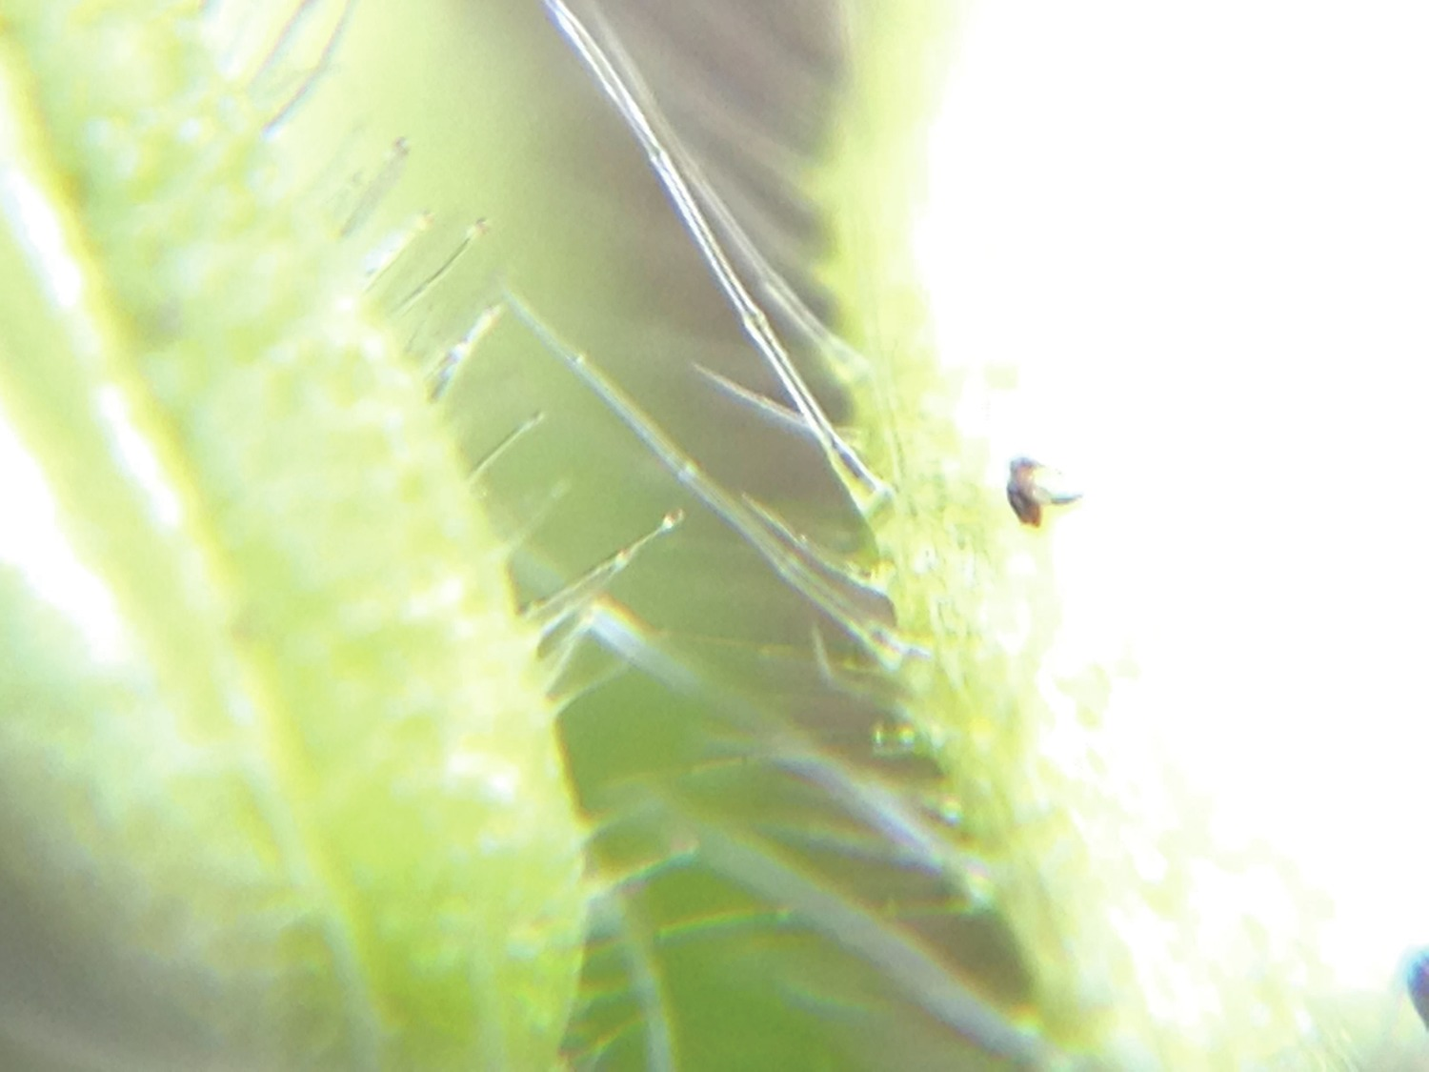
Figure 7 Glandular hairs on a sticky mouse-ear plant (Cerastium glomeratum), taken with a clip-on close-up attachment for a smartphone

3 Examining specimens with a microscope
Some fungal spores can be examined suspended in just water, but others require the use of a staining agent such as Melzer’s solution. This solution contains various chemicals including iodine, which reacts with starch to produce a blue-black colour and shows up the surface characteristics of the spores.
To examine a sample, place a glass slide with a coverslip on the stage of the microscope. Start off by using a relatively low-powered objective lens to focus the image and scan around for suitable spores or other material to examine. Once you’ve selected an area to examine in more detail, switch to using a high-powered lens. (Note: it is particularly important to be careful when focusing high-powered lenses as the depth of focus is tiny and it is very easy to crush the slide by accidentally turning the focusing knob in the wrong direction.)
The size of objects can be measured using an eyepiece graticule, which superimposes a scale on the image. Size is often a very important diagnostic factor in fungal species identification.

Activity 1 Examining specimens with a smartphone
Allow about 5 minutes

Using a smartphone camera, take a photo of a coin, getting as close as you can and using the highest resolution possible. Then zoom in on the resulting image as far as you can. Are there details shown in the image that you are unable to see with the unaided eye? What limits the amount of detail seen?

View answer - Activity 1 Examining specimens with a smartphone

These factors may be very important in the field when trying to use a smartphone to obtain close-up images of mosses or insects. So always take plenty of photos to be sure that you have at least one that is correctly in focus and sharp. Some phone cameras have special modes that take lots of pictures and select only the ones that are sharp. They may even stack the images together by selecting just the in-focus parts of several images and combining these to give an image with increased depth of field. This function can be very useful for analysing small objects, but if you use it be sure to watch out for artefacts creeping in, such as an insect having extra hairs or legs!

4 Using DNA sampling
A variety of techniques has now been developed to identify species, based on their chemical composition rather than their visual appearance. In particular, tiny differences in the DNA molecule can be used to distinguish between species.
There are several different techniques that can be used to distinguish between species from their DNA, one of the most common of which is DNA barcoding. This is a process by which the DNA of a tiny sample is extracted and compared with the DNA of reference samples from known species. The matching between samples is an automated process.
In most groups of organism, there are species that are difficult or impossible to tell apart using traditional techniques. For example, the three large obvious bumblebee species Bombus lucorum, B. cryptarum and B. magnus are very similar and almost impossible to distinguish morphologically (Figure 8). Bees are important pollinators and are often used in citizen science projects. But these three species have to be recorded as just ‘Bombus lucorum complex’ rather than one of the three individual species, making it very difficult to track how each of the individual species is doing (Bossert, 2015).

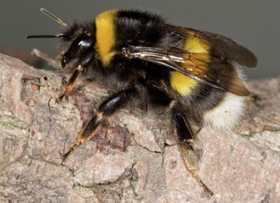
Figure 8 A bumblebee from the Bombus lucorum complex of species

This problem is especially acute in identifying fungi that have visible fruiting bodies for only a short period of the year. Even microscopic examination can sometimes prove inconclusive.

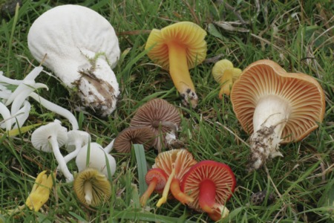
Figure 9 A collection of five types of waxcap fungi and four other species of fungi found in 1 m² of ancient grassland.

The waxcap fungi (genus Hygrocybe, family Hygrophoraceae) are one of the most beautiful and easily recognised groups of fungi (Figure 9). In the UK they are also a target for conservation efforts and statutory designations, since the presence of a high diversity of this group of fungi normally indicates an unfertilised, biocide-free grassland. In 2011, a report from Defra observed the following:

… the level of species diversity within Hygrocybe is substantially greater than that presented in the current guidebooks and scientific treatments. Further research is needed, but we currently believe that at least 96 species are present in the UK (as defined by DNA sequence-based methods), compared with the 51 species (plus 8 varieties) currently accepted. This newly discovered diversity has profound implications for conservation management, and the relevant SSSI [Site of Special Scientific Interest] guidelines based on species numbers will need some reassessment. Bearing in mind the diversity we have uncovered and the knowledge that western European waxcap habitats are considered of high conservation value on a continental scale, it would not be surprising if some of the species were found to be endemic to the British Isles.
(Source: Defra, 2011)

The report goes on to mention that the discovery of cryptic species (i.e. species that look the same and can be distinguished only on examination of their DNA) has implications for fieldworkers and identification books. It is also possible that such cryptic species might be identified by other diagnostic characteristics such as ecological factors or geographic distribution. The report also said that there is still a place for citizen scientists in the monitoring of waxcap habitats.
The use of DNA techniques can give a high degree of confidence in species identification, which can lead to the development of new morphological characters for identification in the field. With the Bombus lucorum complex, a variety of different morphological characters has been tried and checked using DNA methods. This means that it is possible to gauge how confident we can be in using a new identifying morphological character to distinguish between different species, so that the amount of confidence can be assigned to each of the characters.
DNA barcoding can also be used in a number of other circumstances such as identifying species in complex ecosystems, identifying cryptic life stages where morphological features are unknown, the criminal investigation of illegal trading in animals and plants, and analysing food, including determining the origins of foodstuffs intended for human consumption. DNA barcoding is also used increasingly in environmental DNA analysis, where water or some other environmental material is sampled and the organisms present can be detected from traces of their genetic material. Such analysis may also give an indication of their abundance.

5 Automated species identification from images and sounds
Normally, when a photo is uploaded to iSpot or one of the other citizen science biodiversity platforms, a person looks at the photo and tries to give an identification. This might happen very quickly, in just a few minutes, or it might take days or even years if the image is of an obscure organism and a suitable expert visits the site only rarely.
Recently automated species-identification services have become available across a range of taxa, whereby a computer compares an image or a sound recording with information in its database to arrive at an identification. For this to work successfully, the system needs to be initially ‘trained’ by loading it with a large number of correctly identified images of each species. With sound recordings this is also the case. For example, when using automated recognition to identify bat calls, it is very important to include data from correctly identified bat calls from the same part of the world as the recording of the species being identified (Reason et al. 2016).
Such an automated system analyses the images or sounds and derives a database of information that is unique to that species. It then uses this complex derived information to identify any new images. The system does not try to match new images to any of the single specific images that were used to derive the database; instead, it compares them with the derived information from large numbers of images of that species.

Activity 2 Using Pl@ntnet
Allow about 30 minutes

Pl@ntnet is an online tool whereby citizen scientists can contribute to a project on monitoring plant biodiversity. Visit the website at or download the Pl@ntnet app, which is available on Google Play or the App Store. Familiarise yourself with the system by uploading the image of a pasque flower (Pulsatilla vulgaris) in Figure 10.

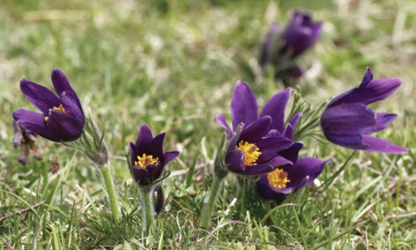
Figure 10 Pasque flower (Pulsatilla vulgaris)

One thing to note with Pl@ntnet is that you need to select the correctproject when you first start, e.g. either ‘Useful Plants’, ‘Western Europe’, ‘USA’ or one of the other projects. If you choose the wrong project, your plant image won’t be compared with the relevant database and might not be found.
Try to identify some plants in your local area and answer the following questions.
- Which species or images work and which have difficulties? Bear in mind that identification is fully automated and performed by a computer program, which might have trouble identifying which part of an image depicts the target sample.
- What information does the app/site ask you? Why?
- Does the app/site give just one identification or does it suggest several alternatives?
- Does the app/site generate any links to other resources that might give more information about the species?

View answer - Activity 2 Using Pl@ntnet

6 This week’s quiz
Check what you’ve learned this week by taking the end-of-week quiz.
Week 5 practice quiz
Open the quiz in a new tab or window (by holding ctrl [or cmd on a Mac] when you click the link) and come back here when you are done.

7 Summary of Week 5
Three very different advanced techniques for species identification were described this week. First, the use of microscopes to resolve the very small details required to distinguish certain groups of organisms. Then DNA barcoding which usually requires a laboratory to perform the analysis but citizen scientists can take suitable samples. Finally, there was an examination of the use of automated image analysis techniques, an area that has grown very rapidly and can be ideal for use in citizen science projects. These techniques are making it easier to distinguish between species, allowing both scientists and citizen scientist to make more accurate identifications. Next week you’ll learn about how to discover more information about an individual species once it has been identified.
You can now go to Week 6.

Week 6: Using web resources

Introduction
This week will be presented as a video diary. Over the course of the week, you will be taken on a learning journey through the stages of how you can use online resources to research the biology of species you record. Your guide will be Open University Lecturer in Ecology and Environmental Science, Dr. Yoseph Araya.

Video content is not available in this format.
View transcript - Uncaptioned interactive content

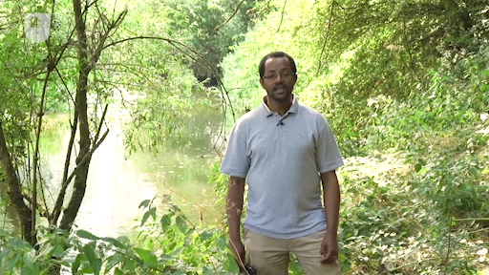

By the end of this week, you should be able to:
- search for further information on identified species, particularly using online resources, and using examples
- understand the value of useful sources of information, using the PROMPT criteria.

1 Online resources supporting species identification
Identifying a species is a challenging but exciting process. You’ve seen in previous weeks that there are lots of different ways of reaching a species identification, each with their strength and weaknesses. For some species, identification is very straightforward – if you’re in the UK and you see a mammal with a black and white striped face, about the size of a medium dog, you can probably very quickly confirm that it’s a badger. However, other species require much closer examination, possibly using a microscope or even DNA techniques to confirm you have correctly identified it.
However, once you know what a species is, whether it’s a bird, tree or fungus, you will no doubt want to know more about it. Particularly if it’s a species that you are not familiar with, you will naturally have lots of questions about it that you will want answering. Luckily, there is a wealth of information available on the internet. In the second part of this week we will be covering how to navigate this information and make judgements about its source and reliability.

1.1 Identifying Katie’s moth
Week 1 told a story about six-year-old Katie from England, who in 2009 discovered an unusual furry moth on her windowsill. Curious to find out what it was, she showed it to her dad, who helped her to post a picture of the moth o iSpot, in order to determine its species identity.
This example provides a useful demonstration of the process of coming to an identification by using a range of support services and resources. The iSpot team were intrigued by Katie’s unusual and distinctive post. The curator of the site suggested that the image might have been that of a euonymus leaf-notcher. But he wasn’t sure of this identification, not least because this species had never been seen before in the UK – nor, indeed, anywhere in Europe.
Within 24 hours, the iSpot curator’s identification had been confirmed within the iSpot online community by an expert at the Natural History Museum in London, with further confirmation coming from an expert from Thailand. The euonymus leaf-notcher is actually native to parts of Southeast Asia, including Thailand, China and Japan. It has been accidentally introduced to a small area of the USA (where it has established itself but does not seem to be spreading much) and then to the UK.
It is unclear how the moth arrived in the UK, but the most likely explanation is that its caterpillars were transported on some of the euonymus plants on which they feed. It is a possible unintended consequence of the global trade in garden plants.
The moth was dead when Katie found it, but the specimen was kept and passed on to the Natural History Museum in London. There it forms part of the long-term record of changes to wildlife in the UK and can be examined by other experts wanting to know about it.

1.2 Searching for species information
The story of Katie’s moth demonstrates the power of discovery, of searching for and finding a species’ identity, as well as the role it plays in biological monitoring and data collection.
There are many ways you can go about getting further information on species. A good source of information is the previously mentioned iSpotnature.org. This will provide you with not only the identity of a sample but also a scientific name or, depending on your location and the species group under investigation, suggestions of other platforms where you can get help with species identification. For example, Natusfera in Spain, Pl@ntnet in France, Artpolaten in Sweden or iNaturalist in the USA.
Another approach would be to use well-known references such as an encyclopedia. The Encyclopedia of Life is an online resource that focuses on species, Wikipedia can also provide general information, although it should be used with caution. It is also possible to search for databases or publications that have a clear link to a reputable academic or conservation organisation – for example, the Global Biodiversity Information Facility (GBIF) biodiversity database – or to a local nature organisation or museum, e.g. the UK’s Natural History Museum or Woodland Trust. You might also choose to follow other types of link that are specifically related to your particular interests, such as ornamental, food sources or scientific journal databases.
In the next section, you will be taken through an example of a search for further information about a particular species.

2 Further research post-identification of the stinging nettle
One weekend, while walking beside a stream in my local park, I came across a ladybird larva feeding on a quite hairy plant, as shown in the video:

Video content is not available in this format.
Video 1
View transcript - Video 1

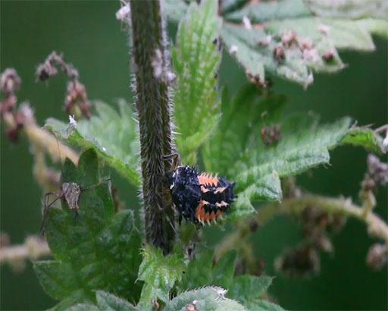

On closer inspection I noticed that the plant had serrated leaves, was of medium height (50 cm) and, to my surprise, had a sharp sting. I was keen to find out what it was and, after taking a picture and searching for similar plants on iSpot, I was able to ascertain it was Urtica dioica, commonly known in England as the stinging nettle. I followed this up with a search of other credible external repositories of both local and international significance.
I then followed this up with a search of other credible external repositories of both local and international significance. I was interested to know if there were reports of any interactions of interest with this plant, which is known for its stinging effect on skin. I also wondered if it had any practical uses and whether it was known outside the UK.

3 Finding out basic information
As a starting point in my quest I visited iSpot, posted my observation and decided to focus on what I could find out about it from iSpot’s species dictionary.
My first point of reference was iSpot’s ‘Taxonomy’ tab for Urtica dioica, which gave me the plant’s scientific classification. It also showed me the family to which the stinging nettle belongs and how it is related to other species. Here’s a link to the species’ Taxonomy page.

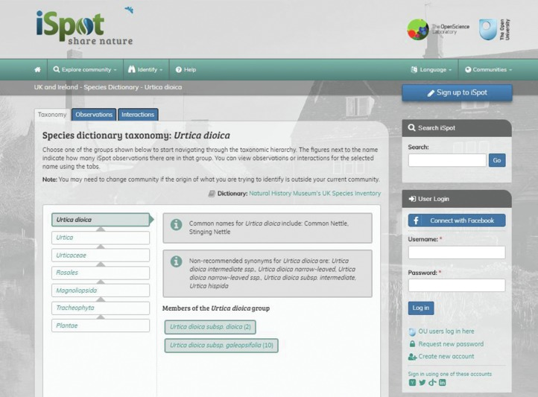
Figure 1 iSpot taxonomy of the stinging nettle (Urtica dioica)

My next step was to look at the ‘Observations’ tab, which led me to a number of other reported observations of the same species across the country made by other users of iSpot (Figure 2). I could see where and when their observations had been posted and other relevant information such as a picture, who posted it and how many people agree with the identification.

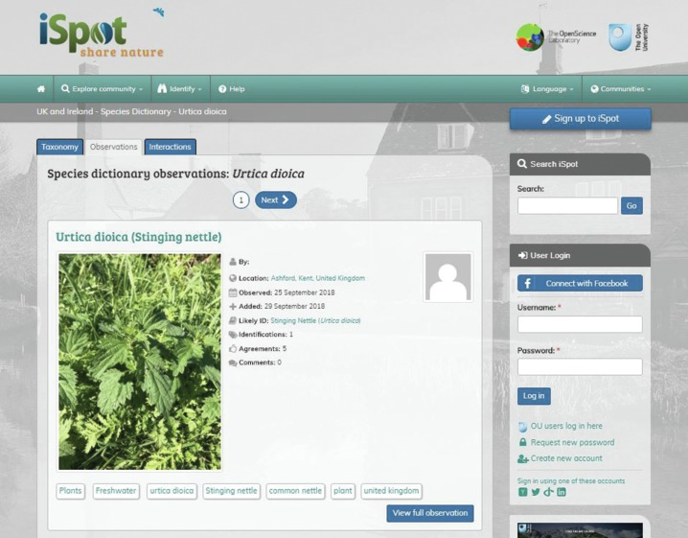
Figure 2 Species dictionary observations

My third stop within iSpot was the ‘Interactions’ tab, which showed me the kinds of creatures that eat or visit nettles (Figure 3).

4 Researching further information about a species
What I have found so far on iSpot is great, and I’m starting to build a picture of the species. I now know more about its taxonomy, where other people have recorded observations of it and which other species it interacts with. But I still have some unanswered questions, and, for that, I’ll need to look elsewhere.

Activity 1 Searching for information and defining your questions
Allow about 10 minutes

Imagine you’re planning to conduct further research on a species whose name you have just confirmed via iSpot.
- What type of questions would you ask in order to learn more about the species?
- What sources of information would you use and how would you use them to search for this information?

View answer - Activity 1 Searching for information and defining your questions

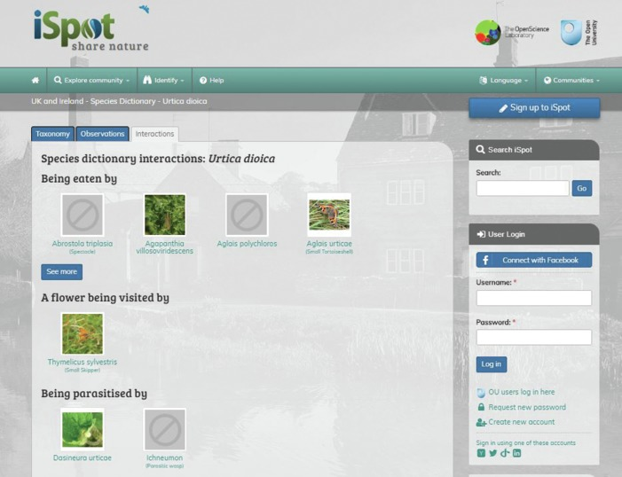
Figure 3 Species dictionary interactions

I was keen to find a more in-depth discussion about the species, especially its description, so I clicked on the link directly under the ‘Likely ID’ in my iSpot observation, which took me to a page on the website of the Encyclopedia of Life, an international publisher of academic work and a project collaborator with iSpot. The page contained a number of interesting facts.

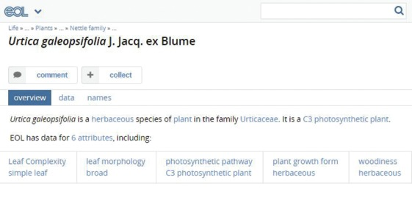
Figure 4 A snapshot of EoL information

Here I found out more about the nettle family – what kinds of habitats it grows in, where in the world it is native and invasive, as well as information about the biology of the plant itself such as the shape of the leaf and the height of the plant. I also checked out the record on another global database – Global Biodiversity Information Facility – which gave me similar information with a world distribution map.
My next stop was the UK’s Natural History Museum’s UK Species Inventory Dictionary, which is one of the dictionaries integrated within iSpot’s species dictionary. As part of the UK’s esteemed Natural History Museum, I thought they would have credible information about the species. The result is shown in Figure 5.

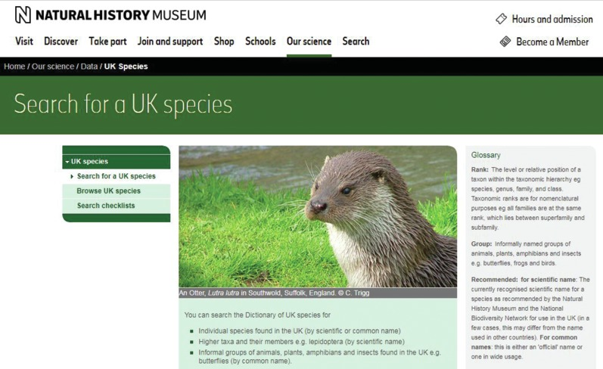
Figure 5 The Natural History Museum’s UK Species Inventory Dictionary.

I then decided to Google search ‘Urtica dioica’ to find out more information about the stinging nettle. This led me to explore Wikipedia, which is a major source of information, although care should be taken when consulting it as it is editable by anyone and mistakes can creep in. Nevertheless, from Wikipedia I was fascinated to learn of the culinary uses of nettles as well as for textiles and gardening.

4.1 More examples
Knowing that anyone can edit Wikipedia, I decided to follow up some links to articles about the use of nettles for textiles. At the bottom of the Wikipedia page (Figure 6), there is a list of references, where you can find out the original source of the information quoted.

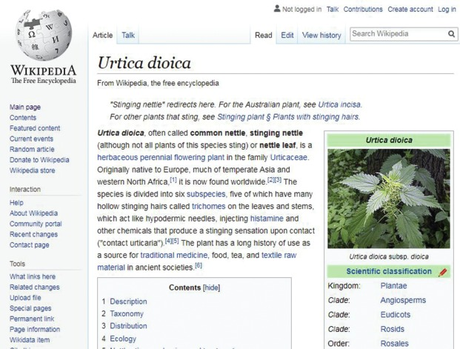
Figure 6 Wikipedia entry for stinging nettle

I clicked on the link to an article in the Guardian newspaper from 2008 claiming that stinging nettles have been historically used to make textiles with, and provide an eco-friendly alternative to cotton: www.theguardian.com/environment/2008/feb/28/ethicalliving.fashion . A search for ‘Urtica dioica textiles’ in Google Scholar (a facility provided by Google to search academic literature including publications in journals and books) reveals many articles about the use of the stinging nettle for making cloth.
Curiosity about how nettles may be used locally, including possible links to food, nutrition and health, led me to explore cookery websites, including the leading food website BBC Good Food, which had a recipe for nettle soup.
However, despite finding all this information, I was still worried about the possible impact of nettle stings. I resolved to find out how the sting works and possible remedies, so consulted the Wilderness & Environmental Medicine Journal, a reputable professional magazine. From its website I learned that nettles have a physical and chemical action that lacerates and then irritates the skin (Figure 8).


Figure 7 Health impact of nettle stings 1

So now I knew the science behind a nettle sting, but is there anything that can be done to treat it? I looked back at the Wikipedia page and found a reference to dock leaves for treating nettle stings. I followed up the link in the references at the bottom of the Wikipedia web page which took me to a primary school activity page about nettle stings and some interesting experiments relating to their treatment (Figure 8).

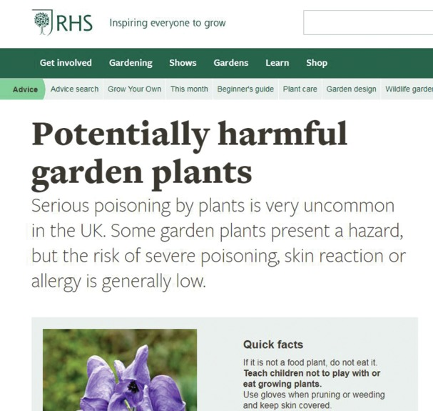
Figure 8 Health impact of nettle stings 2

I also found that the Woodland Trust had some useful information, answering questions about the use of dock leaves to alleviate symptoms. I’m not brave enough to try it right now, but the next time I happen to get stung, I will try using them and share my experience! See the Woodland Trust website for more information on this (Figure 9).

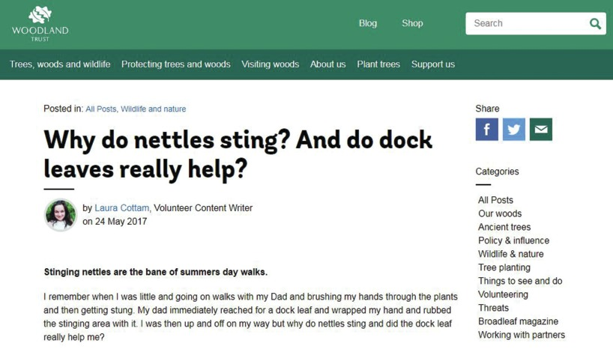
Figure 9 Sting relief?

I then decided to search for ‘nettle sting’ on the NHS (the UK’s National Health Service) website to see what the current medical advice was. There was no mention of dock leaves, but instead it advises that the rash will settle quickly and recommends speaking to a pharmacist about anti-histamine tablets. So it seems that there are potentially some myths around the use of dock leaves, but I wanted to have a final look into this. I went back to the article in the Wilderness & Environmental Medicine Journal to see if there was any mention of dock leaves. They suggest that dock leaves (and other plants) might help with nettle stings by reducing the biochemical impacts, but they can’t do anything to reduce the mechanical impacts of a nettle sting on the skin.

Activity 2 Doing your own search
Allow about 15 minutes

Having read the example search given in this section, do your own search by first selecting one of the following species:
- Bewick’s swan (Cygnus columbianus)
- Hedgehog mushroom (Hydnum repandum)
- Brown trout (Salmo trutta)
Attempt to answer the following questions by doing similar searches to those described in this section. Where possible, also explore the interactions of the species with others.
- Where does the species live? Can you find a distribution map showing which parts of the world the species is found in, and does it live there all year round?
- Do people eat the species and, if so, in which parts of the world is it commonly eaten?
- To which family does the species belong?

View answer - Activity 2 Doing your own search

Of course, you might want to go beyond this suggested activity and find answers to other questions you have about your chosen species. Often the more answers you find, the more questions you have!

5 Time for reflection
I think now is a good time to look back at all the things I’ve found out about stinging nettles and to reflect on both the process and reliability of the sources. In this video I take you through the search steps and the sources of information that I used, which gives you a chance to reflect on the choice of sources. Before choosing a source of information, it is important to subject it to critical analysis. The quality of information obtained can vary greatly from one source to another, depending on their credibility.

Video content is not available in this format.
Video 2
View transcript - Video 2

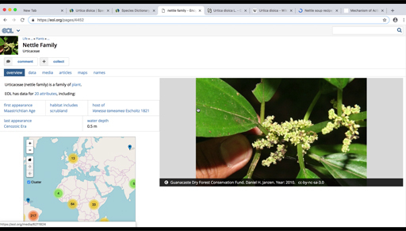

In general, though, any source of information should be evaluated in terms of its presentation (e.g. how well it is presented and is accessible), its relevance to the research being undertaken, its objectivity, its method of data collection, its provenance and its timeliness. The acronym used by The Open University to summarise these criteria is PROMPT (defined below) and you can visit The Open University’s Library Services where you can find out more about evaluating sources of information.

The PROMPT criteria
- Presentation: poor presentation and inappropriate or confusing use of language can hinder your use of content. Try not to let poor presentation stop you from using what might otherwise be good quality, relevant information.
- Relevance: this is not a property of the information itself, but rather of its relationship to the need you have identified. Consider geography, level and the emphasis of the content.
- Objectivity: all information is presented from a position of interest, although this may not be intentional. You need to be aware of possible bias in what you read, and to take account of this when you interpret the information.
- Method (research reports only): do not assume that because a research report has been accepted for publication, it is error free. You need to assess the accuracy of information produced as a result of using particular methods.
- Provenance: The ‘credentials’ of a piece of information support its status and perceived value. It is important to be able to identify the author, sponsoring body or source of your information.
- Timeliness: this is an aspect of relevance. You need to be aware of the date of production or publication, and assess whether this has been superseded, or is still useful to your needs.

Activity 3 How reliable is the source information?
Allow about 10 minutes

Look back at a source of information, either one given in the activities for this week, or one that you have found while doing your own research. Write down some reasons you think it is, or isn’t, a useful source of information.

Provide your answer...

Use Google Scholar to look for scientific articles where you know the provenance is likely to be credible. You could look at the methods section to find out how a study has been carried out to check they have followed a sensible protocol. Always remember to look at the relevance and timeliness of what you find. For example, if you are interested in an oak tree you have spotted in London, would it be useful to know the evolution of oak trees in Africa?

5.1 What if there isn’t an answer to my question?
Once you start examining species, your answers often reveal more questions. There is a wealth of information available online, and you now have a good idea about where to find it and how to think about its reliability. But sometimes this doesn’t give you all the answers you seek. If you’ve still got questions, try asking them on a forum, like iSpot, or get in touch with your local natural history society. Don’t be shy – remember that someone else might be thinking the same question as you. Also remember, as with everything you read online, not to forget to think about the reliability of any information you get. A good way is to ask for the original source of any facts or figures you receive. Then you can follow it up and make your own judgement.

6 This week’s quiz
Check what you’ve learned this week by taking the end-of-week quiz.
Week 6 practice quiz
Open the quiz in a new tab or window (by holding ctrl [or cmd on a Mac] when you click the link) and come back here when you are done.

7 Summary of Week 6
Once you’ve identified the name of a species, it is possible to find out much more information about it using online resources. Knowing the correct name of an organism is key to learning about it. And being able to share accurate observations about it with other people helps to contribute to the body of scientific knowledge.
In this week, you were introduced to a range of resources available to help build an understanding of biodiversity and species identification skills. A number of online resources were introduced, including the Encyclopedia of Life, the Global Biodiversity Information Facility and local and national sources such as the UK’s Natural History Museum, ) and scientific journal databases. You also looked at some other sources of information, such as Wikipedia, newspaper articles and forums and thought about how reliable these sources of information are. This week’s study demonstrated the power of discovery, searching for and finding a species’ identification, as well as the role it plays in biological monitoring and data collection.
Next week you’ll put into practice what you have been learning and become an iSpot citizen scientist. You’ll explore the iSpot website and learn how to add your own observations if you wish. You’ll see how iSpot is more than just a collection of records – it’s also a community of enthusiasts and provides you with opportunities to further your learning and create projects.
You can now go to Week 7.

Week 7: Joining an online citizen science community

Introduction
This week of the course focuses on how you can learn more about the wildlife and habitats around you; build your species identification skills while joining an online citizen science community; and participating through iSpotnature.org. It outlines five ways to participe and learning about biodiversity through using iSpot: explore, identify, contribute, personalise and recognition. This week of the course takes you step-by-step through the process of joining an online citizen science community and using iSpot: browsing, registering, adding an observation, including a species name to an identification, using the iSpot Species Browser and iSpot keys, understanding taxonomic hierarchy, as well as personalising and customising your iSpot experience.

Video content is not available in this format.
View transcript - Uncaptioned interactive content

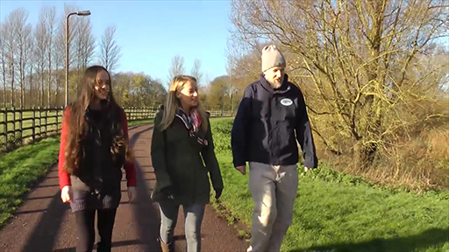

By the end of this week, you should be able to:
- understand the process of how to use iSpot to make observations, post comments, develop projects and customise it with filters
- recognise the value of rewards for species identification via iSpot’s Reputation system
- use a citizen science platform that recognises and values learning, e.g. iSpot quizzes
- understand what it means to be part of an active citizen science community.

1 Overview of iSpot
As you are by now aware, iSpot is a website aimed at helping anyone to identify anything found in nature. It is a platform designed to enable people to upload their observations of wildlife, help each other to identify species, and share and discuss their findings. In this regard, iSpot is a social networking website for biodiversity.
iSpot encourages people to share information about the wildlife they see. In doing so, it is anticipated that they will develop their scientific knowledge, increasing their species and taxonomic identification skills. In this regard, it is effectively a tool for crowdsourcing the identification of species and the recording of biological data. It seeks to:
- lower barriers to identification by providing free, open-access web and mobile software
- be open to all
- create a social network around crowdsourcing biodiversity
- connect beginners with experts
- create a new generation of naturalists.
(Source: Ansine, 2013)
iSpot fits within the model of co-created citizen science projects discussed in Week 1. It has with content contributed almost entirely by the community of diverse enthusiasts and professionals, with contributor skill levels ranging from people new to wildlife identification all the way up to nationally and internationally renowned taxonomic experts (Roy et al, 2012). iSpot provides an online space that links novices with experts, with the idea that this can increase efficiency in identification while spreading taxonomic knowledge.
Developed as a platform with a user-friendly interface, iSpot provides multiple ways for users to participate, as outlined by the following five-step method (Figure 1):
- EXPLORE: Browse the over 30,000 species identified so far and see what other people are spotting.
- IDENTIFY: Want to identify something you’ve seen? Register, join the community, add observations and get help.
- CONTRIBUTE: iSpot motivates and encourages as you contribute through the multi-dimensional reputation system, which awards badges based on species groups.
- PERSONALISE: View and use iSpot in your own way; take part in and create citizen science challenges by designing projects and building filters.
- RECOGNITION: With iSpot you can receive recognition as you learn and participate in quizzes that build and test knowledge as skills increase. There are also free online resources and iSpot has also been integrated into formalised learning such as OU modules and this course.
(Source: Ansine et al., 2017)

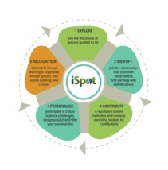
Figure 1 iSpot’s five-step participation method (adapted from Ansine et al., 2017)

2 Using iSpot
Anyone can browse iSpot, but you will need to register before you can start contributing. After joining, you can upload observations of any plant, animal, fungus or other living organism. iSpot picks up the GPS information recorded by any camera or phone with this function activated; tools such as integrated species dictionaries can help to home in on the name of the species; and other comments can be included, such as distinguishing features. Other ways to participate include identifying or commenting on observations from other users; using tools such as the iSpot Identification Keys or demonstrating your skills by doing an iSpot Quiz. Experiences can also be personalised by creating specialised filters and groups of observations, and there is also a range of help and FAQ guides available on the site.
This week takes a look at how you can start your journey towards discovering more about wildlife supported by an online citizen science platform such as iSpot. Your own experience on the site will help you to understand and appreciate the benefits of being part of an active citizen science community.

3 Browsing iSpot
When using iSpot for the first time, a good place to start feeling your way around the site is to take a look at some of the latest observations. As mentioned in Section 2, anyone can see what’s on the site without registering by going to the home page (Figure 2). Then click on the photos of latest observations that are shown in the first carousel of images with latest observations, as well as observations that are not yet identified. If you have registered and logged in, you will also see a live feed of other people logged on to the site.

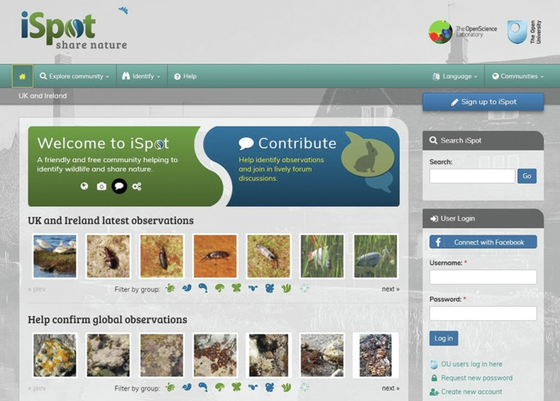
Figure 2 iSpotnature.org homepage

You will notice that, in addition to the main global view of the site, iSpot has other, localised page views, called ‘communities’ (Figure 3). These are currently broken down into the following: Global, UK and Ireland, Chile, Southern Africa, and Hong Kong. Depending on your location, you may choose to navigate to one of these. Your browser will remember your selected community the next time you visit, and you can switch to any of the communities at any time.


Figure 3 Selecting a community in iSpot from the Taskbar

There is a wide range of wildlife posted on the site. In order to navigate through this you can filter through the species groups to find the one you are interested or filter out those unconnected with the species you would like identified. To do this, under the ‘Latest observations’ carousel look for ‘Filter by group’ and select the icon representing the iSpot species group you are interested in. There are nine categories to choose from: amphibians and reptiles, birds, fish, fungi and lichens, invertebrates, mammals, other organisms, plants, and all species (see Figure 4).

Figure 4 iSpot species group icons

4 Registering on iSpot
As mentioned in Section 2, before you can contribute to iSpot by submitting your own observations, commenting on other people’s contributions, creating projects, etc., you will need to register to the site. This is absolutely free and easy to do. First, you will need to click on the ‘Sign up to iSpot’ button on the top right-hand side of the home page (Figure 5).


Figure 5 Registering on iSpot

You will then be prompted to provide details, including a user name, an email address and a password, as shown in Figure 6. You may also register via other social media accounts you might have, such as Facebook.

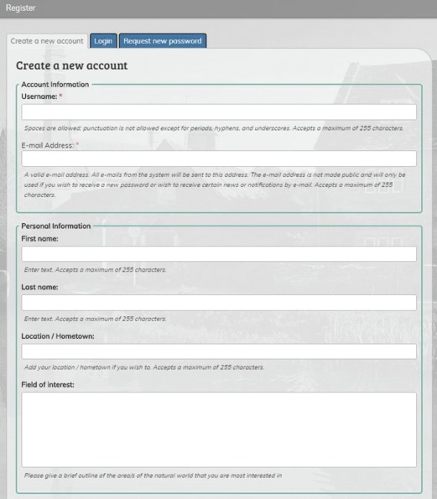
Figure 6 iSpot registration page

Once you have included all the information requested, an activation email will be sent to the email address you supplied. Make sure you read this and follow the instructions provided in it to activate your account.
Once you have registered, the next thing to do is get outside and make some observations. Wherever possible, take a digital photograph of your observation to upload to the site and to share with other people what you’ve seen. You might also want to record notes about your observations: what you saw, where you saw it, when you saw it, etc.

Activity 1: Becoming familiar with iSpot
Allow about 10 minutes

Following the guidelines in Sections 3 and 4, have a look around the iSpot website to familiarise yourself with its features, and register and set up your iSpot account. If you already have an account, or as soon as you’ve set up a new one, log into it. The next section will describe how to add an observation.

5 Adding an observation
Adding your own observations to iSpot allows you to get the most out of using iSpot and to participate fully. When logged in, you can post observations simply by clicking on the ‘Add observation’ button, or by clicking on the ‘Add’ tab in the taskbar at the top of the home page, as shown in Figure 7.

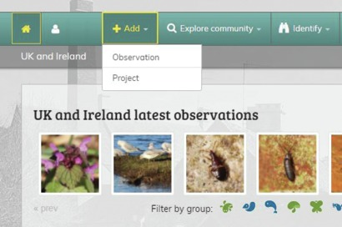
Figure 7 Adding observations on iSpot

Once you’ve arrived at the Add observation page (Figure 8), just fill in the details requested there (e.g. location, date, habitat). Note that you don’t have to complete every box on the page, only those marked with a red asterisk.
Help on the individual sections is available wherever you see the small green question-mark symbol shown in Figure 9.

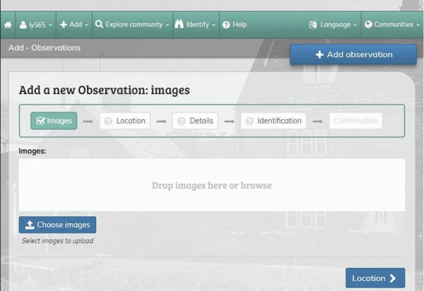
Figure 8 Adding an observation on iSpot


Figure 9 iSpot ‘Help’ icon

Activity 2: Adding an observation in iSpot
Allow about 30 minutes

First, log into your iSpot account. Make sure you have any photos and notes you took about your observation ready. Then follow this six-stage process of creating an observation:

Upload a photo
Add one or more images to your observation. You can select them by browsing through your files or simply drag and drop them directly onto the page. You can add several photos of the same plant, animal, etc.
If you don’t have a photograph but would still like to post an observation, just describe what you saw in as much detail as possible, including size, colour, behaviour, etc.

Add a location
As part of making an observation, you need to provide the location of where you saw it. There are several ways to do this:
- The location may be added automatically when you upload a photo if you took it using a camera with GPS functionality.
- You can add a new location manually by entering a place name, postcode or grid reference, or simply by navigating to the location on the map. When you have found the target area on the map, click on the exact location. You will also need to provide a location name.
Note that when you set up the location, you can choose to hide its precise point on the map. If you tick the option for ‘Hide precise location’, iSpot will display only a 1 km grid square and other users won’t be able to see the precise location of your observation. This can be useful if you do not want to disclose an exact location and would like to ensure it remains private.

Other details
Now is the time for you to provide as much detail as you can to describe what you saw. Add a title and the date of your observation, and select the type of habitat in which you observed your species.

Tag your observation
Tagging helps to group observations together and works in the same way as using hashtags in Twitter. To tag an observation, simply add some descriptive words as a reference for any activity (Figure 10). For example, to make it easier to share your observations with fellow learners on this course, entering the tag ‘#BOC CitizenScience’ in the ‘Descriptive tags’ box will make sure that all contributions containing this tag will be grouped together.

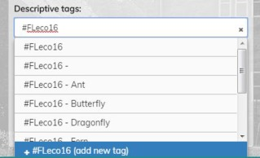
Figure 10 Adding descriptive tags

Identification – what did you see?
Next, click on the ‘Identification’ button to go to the next stage of the process: adding an identification. If you don’t know the name of your species, that’s fine; just leave the boxes blank and other users on iSpot might be able to help. However, if you do know the name of the species you have observed, you can add it in here, either by entering either its scientific name or its common name. Wherever possible, it is advisable to choose a name from the drop-down list that appears when you start typing in these boxes. (Taxonomy and species dictionaries will be discussed in more detail later this week.)
Once you have filled in a name, select an option from the drop-down menu under the heading ‘How sure are you?’ to indicate your level of certainty about your observation. Then add any relevant notes you’ve recorded in the box under the heading ‘ID notes’.

Confirmation!
Simply click on the ‘Confirmation’ button to post your observation to the community.
It’s that simple. And if you’d like to add other observations, simply repeat the steps above.

Seeing your contribution – iSpot’s reputation system
If you want to see all of the observations you’ve made on iSpot so far, simply click on the ‘Profile’ button on the menu bar and then select ‘Your iSpot’ from the drop-down menu that appears. Then select the ‘Observations’ tab from the next page to see any activity or changes associated with your posts.
If you have contributed observations, or have some knowledge of any species group, you can now go ahead and assist other users (including your fellow learners ) by agreeing with or adding identifications to their observations.
iSpot rewards you as you contribute, scoring your activity on the site with badges for each of the species groups represented: birds, fish, amphibians and reptiles, invertebrates, mammals, plants, fungi and lichens and other organisms. Points (shown by an icon representing each group) are awarded based on ‘the weighted agreements given by other participants for identifications’ (Silvertown et al., 2015, p. 133). These ‘reputation points’ demonstrate your skills and knowledge and can be earned when you propose an ID that is then confirmed by others in the community. The number of points is weighted in proportion to the reputation scores of the individuals who support your identification.

6 Adding species names to identifications
This section takes a look at the three ways you can get help with species identification on iSpot: via the Species Browser, iSpot ID keys and the hierarchical tree.
- The Species Browser is a tool for showing links between the thousands of species that have been observed on iSpot, with the most frequently seen species in each group migrating to the top of the list.
- Identification keys are designed to help you work out what type of wildlife you have seen. With iSpot keys, answer as many questions as you can, and the key will help you by sorting through the list of species it knows and suggesting which is most likely.
- When posting an observation, iSpot uses the taxonomic hierarchy from integrated species dictionaries to help you check and attach scientific and common names to the species you are trying to identify.

6.1 Using the Species Browser
The Species Browser is designed to provide a fun and quick way to explore the species recorded in iSpot and can help you to identify your own observations. To find the browser, click on the ‘Explore community’ button in the taskbar at the top of the page (Figure 11). Then select ‘Species browser’ from the drop-down menu or by clicking on the ‘Identify’ button and selecting ‘By browsing species’ from that drop-down menu (Figure 12).

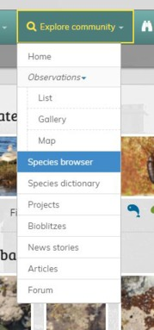
Figure 11 Selecting the iSpot Species Browser from the ‘Explore community’ drop-down menu

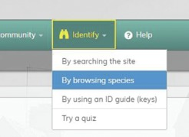
Figure 12 Selecting the iSpot Species Browser from the ‘Identify’ drop-down menu

The Species Browser page opens with a gallery view which allows you to select from 14 groups such as birds, mammals, reptiles, insects, etc. (Figure 13). Simply click on the group you want to explore and you will be shown examples of the most frequently seen species in that group, broken down into taxonomic sub-groups. For example, if you click on ‘Mammals’, you will see a set of images divided into sub-groups for rodents, carnivores, artiodactyls (deer, etc.), and so on, ranked in order of descending frequency of observation.

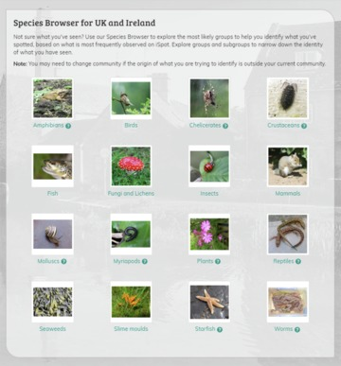
Figure 13 iSpot’s Species Browser – main page

If a sub-group is a particularly large one, you can browse within it by clicking on the ‘See more examples of this group’ link at the bottom of the group images, as you will see in Activity 3.

Activity 3: Searching in the Species Browser
Allow about 20 minutes

For this activity, first make sure you have selected the ‘UK and Ireland’ community, then go to the Species Browser and select ‘Insects’ (Figure 14).

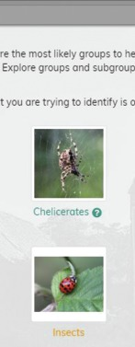
Figure 14 Selecting Insects in the iSpot Species Browser

A page should appear showing groups of all the most frequently observed insects on iSpot, as shown in Figure 15.

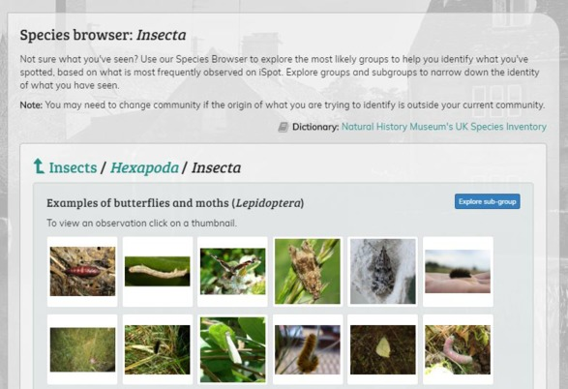
Figure 15 ‘Insects’ group in the iSpot Species Browser with ‘Explore sub-group’ button highlighted

By clicking on the ‘Explore sub-group’ button shown in Figure 15 you’ll be taken to a page where the insects are separated into sub-groups of butterflies and moths, flies, beetles etc. (Be patient here as the site filters hundreds of thousands of observations, so the page might take a little time to load as you scroll down.)
You can click on an observation thumbnail image at any point to see a preview of the observation for that species. To have a go at this, under ‘Examples of butterflies and moths’, find the observation of a peacock butterfly shown in Figure 16.

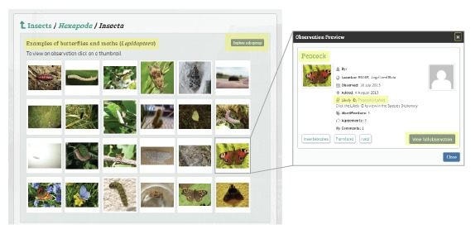
Figure 16 Selecting a peacock butterfly observation

From the preview of the peacock butterfly, first click on the ‘View full observation’ button, then click on the link after ‘Likely ID’ to navigate to a page showing the taxonomy links for this species.

Now that you’ve become familiar with the iSpot Species Browser, it’s time to move on to the next section, reflecting as you do so on the steps you have just gone through.

6.2 The Species Browser and taxonomy
The Species Browser is organised using the taxonomic hierarchies (‘trees of life’) in the species dictionaries that iSpot uses. There is more on this later in this section. There are two main species dictionaries integrated in iSpot: the UK Natural History Museum’s Species Inventory in UK and Ireland, and the Catalogue of Life in the Global community. You can find out which one is being used for the community you’ve selected by clicking on the ‘Explore community’ button in the menu bar and selecting ‘Species dictionary’ from the drop-down menu. The dictionary for that community is listed on the next page. To select another dictionary, go to the ‘Communities’ menu, select a different area and navigate back to the same page.
The Species Browser is a good tool for finding out the most frequently observed species in each group, and it might help you to recognise a species that you’ve seen yourself. There are, however, more formal identification keys on iSpot for many groups as well.

iSpot Species Browser versus species dictionaries

What is the difference between the Species Browser and the ‘Taxonomy’ links/species dictionary pages?
The Species Browser always shows species (or genera, families, etc.) ranked in descending frequency of observation, while the species dictionary pages (you can navigate to these from the Taxonomy links) show the observations ranked in the order that they were added, with the most recent appearing first in the list. Also, the Species Browser view makes it easier to compare images of different but related species or groups on the same page, unlike the species dictionary pages. In Activity 3 you learned how to navigate to a species dictionary page from Species Browser images.

How does iSpot choose which image represents a species?
The image shown for each species is the one that has been identified with the greatest combined reputation score, which is an aggregate value taking into account the reputations of the identifier and all the people who have supported the observation. In many cases, this process selects images that are particularly good examples of the species, showing the identification features clearly, although they might not be the best-looking images on iSpot!

6.3 Using iSpot keys
Identification keys are designed to help you work out what type of wildlife you’ve seen by requiring you to answer a series of questions about the species you’ve observed. The identification keys on iSpot have been designed using a novel approach based on Bayesian statistics and may, therefore, be different from other identification keys you might have encountered.
When using iSpot’s identification keys, simply describe your specimen by answering as many questions as you can and iSpot will comb through its selected dictionary and suggest which species most accurately matches the details you have provided. When a species is starred, it means you have a good match, so you should check the description to confirm your identification and follow the links for more information. Unlike a traditional branching (i.e. dichotomous) key, you don’t have to answer questions in a fixed order; instead, iSpot’s identification keys use probabilities. Put simply, the more evidence you can provide, the more definite your identification will be.
iSpot’s identification keys cover a range of different species groups (lichens, trees, minibeasts, earthworms for example), including several that can help if you are carrying out the surveys run by Open Air Laboratories (OPAL). Go to the iSpot page for keys and for more information go to iSpot keys for beginners.

6.4 Using the taxonomic hierarchy (‘tree of life’)
On iSpot, scientific and common names are checked automatically against the UK species dictionary for UK species and the Catalogue of Life for others. Valid names provide links to species maps on the National Biodiversity Network (NBN) Atlas (for the UK and Ireland only), Wikipedia and the Encyclopedia of Life. (These sites were explored in Week 6.)
As soon as a species name is attached to your observation, you should see a taxonomy list under its photo that will allow you to browse up or down the taxonomic tree. For example, looking at the peacock butterfly you found via the Species Browser earlier (Figure 17), the scientific name is Aglais. If you remember, you used the taxonomy links in the Species Browser to move up through the hierarchy. From here, you can see if there are other species in the family Nymphalidae, look at all the members of the genus Aglais, and so on.

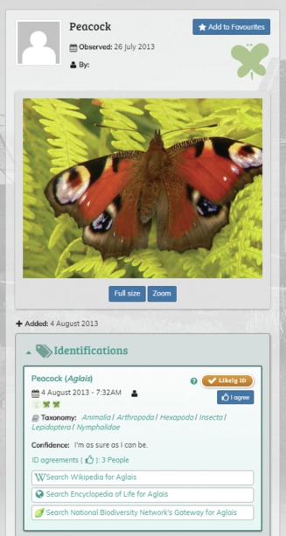
Figure 17 Using taxonomy links in the iSpot Species Browser

The taxonomy links also appear if you click on any of the species names in the identifications on iSpot. These are live links to a species dictionary page that includes the taxonomic tree (shown as a series of links towards the top of the page) as well as any ecological links that have been made with other species (towards the bottom of the page).
To make all of these links work, make sure that, when typing in an English or a scientific species name, you always pick a name off the drop-down list, if you can. And remember to click on the ‘Get recommended’ button, to check that it is the name recommended by the UK Species Inventory (in iSpot’s ‘UK and Ireland’ community) or by the Species 2000 & ITIS Catalogue of Life: Annual Checklist (in the other communities).

Adding species names with help from the species dictionary
When you add an identification and start to type in a species name on iSpot, you should see a drop-down list appear that will provide names that match the one you’re typing in as closely as possible. iSpot works best if you can choose a name from the list whenever possible (although if you need to use a name that isn’t in the list then you have the option of just typing it in).
Find more information about iSpot’s use of species dictionaries.

Why is this important?

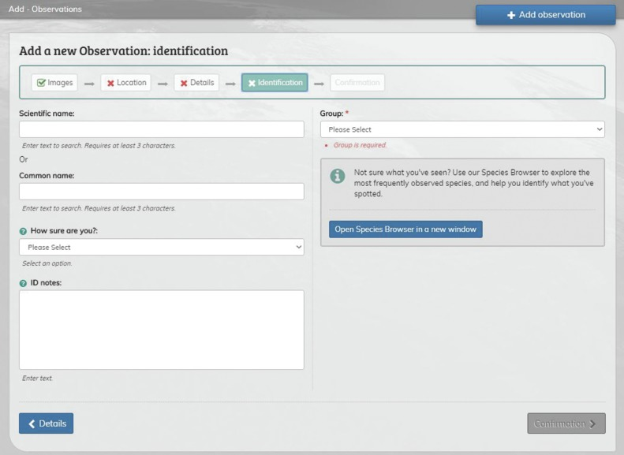
Figure 18 Revising species information

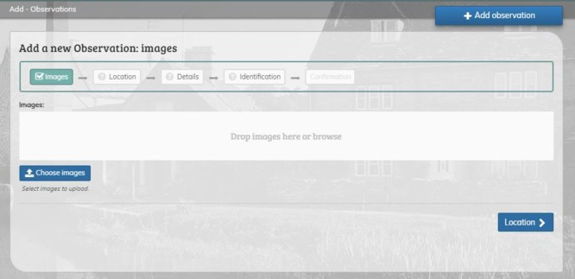
Figure 19 Adding species information

When adding an observation, filling in as much information about the species as you can is very important, including the species group, common or scientific name. Using a name selected from the drop-down list gives iSpot the best chance of linking correctly to other information about the species on both iSpot itself and the external sites that it links to. You can click and open the Species Browser if you would like to look for other examples within a particular species group or sub-group. If you are not sure, just say so from the drop-down menu provided. If you want to revise the information provided after you have posted the observation, you can. Go to it and click the ‘Add a revised identification’ button.
Within iSpot, the use of a recommended name allows your species observation to be linked in to the taxonomic hierarchy feature, so that you can see how your observation fits in to the scientific classification of species and which other species are most closely related.
It also means that the observations on iSpot can be passed on to the recording schemes (such as those badged on iSpot) that collate species records. The site can send the record to the correct recording scheme only if it has been identified with a name that links to a species dictionary.
(Source: adapted from iSpot, 2018)

7 Personalising and customising iSpot
As a platform, iSpot collects your observations, provides a space to collect and share biological recording data and, while doing so, stores location information on what is spotted, where and when. This additional data enables participants to personalise and customise their experience, supported by functionality that creates filters to view the site the way an individual, a group or an organisation prefers.

7.1 Customising your activity – iSpot Projects
iSpot Projects allows you to set up a page that filters out observations for a particular place, time, or species group etc. This page is visible to other iSpotters and enables you to share a particular interest from among the hundreds of observations that are contributed to iSpot each month.
Projects on iSpot have mostly been developed by participants, based on their interests, while others have been developed by the iSpot project team to support learning for an OU course or based on a request from an organisation. A project can be set to filter groups of observations from an area (e.g. a single site or region); by taxonomic rank (e.g. by a family, an order or a single species); or by a selected tag (like the one for this course), habitat or time period. It can be filtered by a combination of any or all of these categories and viewed as a map, picture gallery or summary description.
iSpot project filters are able to capture new observations that have been posted as well as group together historic observations. This makes it easier to access, pick up relevant trends and other information, thereby providing a useful structure for observing and learning.

Activity 4: Working with the online community using iSpot Projects
Allow about 30 minutes

All observations added to iSpot by students and tagged with the course tag ‘CSGBproject’ will be collated in the project connected with this course. Go to the project developed for the course on iSpot. Adding a tag to your contribution will allow you to connect with and see observations made by others on this course.
This activity will give you an opportunity to discuss observations that you and other learners have made on this course and what you have deduced from the identifications made. Here is what you must do to complete this activity:
- Browse the observations posted by you and other learners on the course tagged to the project.
- Find at least two observations that have received a likely ID.
- Find two observations with comments from other users.
- Find and view the reputation scores of at least two other iSpot users who commented on learners’ observations.
- Determine whether or not your observations have been identified by other users.
- Make comments on or identify other people’s observations.

7.2 Customising your view of iSpot – community filters
To see a map of iSpot observations, click on the ‘Explore community’ button on the taskbar at the top of the home page and select ‘Observations > Map’ from the drop-down menu. This will take you to a page showing the latest 1,000 observations from the iSpot community to which you are linked. If you want to see more than 2,000 observations on the map, click on ‘Show more observations’, but note that, the more observations you add to your map, the longer it will take to load. If you are interested in only a particular geographic area, zoom into that area first before you start adding records to the map.
You can also filter the observations shown on this page to see only those of interest to you. Click on ‘Filter community observations’ and you will see a window that allows you to choose a range of options (Figure 19): There are filters for:
- species groups (filter by group)
- species names (filter by taxonomy)
- date (observed or submitted)
- whether or not the observations have a likely ID (e.g. you can choose to look at observations without a likely ID to see if you can help to identify them).

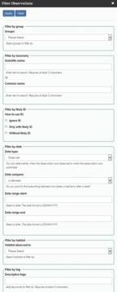
Figure 19 Using iSpot filters

Note: you can add as many filters as you wish. Simply click on ‘Apply filter’ to see the resulting map from the options selected.

8 This week’s quiz
Check what you’ve learned this week by taking the end-of-week quiz.
Week 7 practice quiz
Open the quiz in a new tab or window (by holding ctrl [or cmd on a Mac] when you click the link) and come back here when you are done.

9 Summary of Week 7
In this week, you explored the iSpot website and discovered how you can browse the collections, and even contribute to the collection, by first registering and subsequently adding your observations. Alongside learning how to engage with the website, you had the opportunity to develop your own learning by identifying species from existing information (e.g. images) and associated databases.
You also had the opportunity to engage with the wider online community to confirm the observations of other people and enter into constructive discussion with other users. You were also introduced to iSpot’s advanced tools, designed to create filters for new projects and to customise your presence on iSpot.
Through participating in this week and completing the activities, you should now be able, as a global citizen scientist, to enrich your own learning and, at the same time, contribute to the learning of other people and the progress of science.
The final week of this course looks at the scope of existing citizen science projects, and the value of data sets.
You can now go to Week 8.

Week 8: Citizen science community

Introduction
There are two themes to the final week. The first theme is case studies of citizen science projects from around the world that illustrate how the data collected by participants in the example projects contributed to scientific knowledge. The second theme is reflections on the contributions that citizen science and, more particularly, citizen scientists themselves can make to the advancement of our understanding of global diversity in a connected world. This introductory video features a discussion between two of the course authors – Janice Ansine and David Robinson – about how their interest in citizen science was stimulated and what projects particularly excited them from the examples described in the course.

Video content is not available in this format.
View transcript - Uncaptioned interactive content



By the end of this week, you should be able to:
- use online resources to find and participate in citizen science projects
- understand the scope of existing citizen science projects
- understand the value of data sets and be able to quote examples
- recognise and give examples of the value of technology in enhancing citizen science projects.

1 Ecosystems
Ecosystems provide a number of services to the human population, and the health of these ecosystems is underpinned by their biodiversity. Loss of biodiversity damages ecosystems and also damages ecosystem services and the benefits that we humans derive from them.
According to a United Nations report, it is possible to divide ecosystem services to the human populations into four categories:
- provisioning
- regulating
- supporting
- cultural

Activity 1 Ecosystem services
Allow about 20 minutes

Make a short list of ecosystem services that map onto the four categories listed above. If you are unsure what each category means, think back to the diagram of links in the woodland ecosystem which you produced in Week 2.

View answer - Activity 1 Ecosystem services

Having considered the range of ecosystem services for the human population, you should begin to understand why recording biodiversity is more than a natural-history undertaking: it has a global significance for all humans. Such global significance demands global studies of biodiversity, and the sheer scale of the studies needed is possible only with massive groups of competent observers and recorders. This is the rationale behind the implementation of citizen science initiatives.
The case studies that follow illustrate the diversity and global nature of citizen science projects.

2 Image analysis

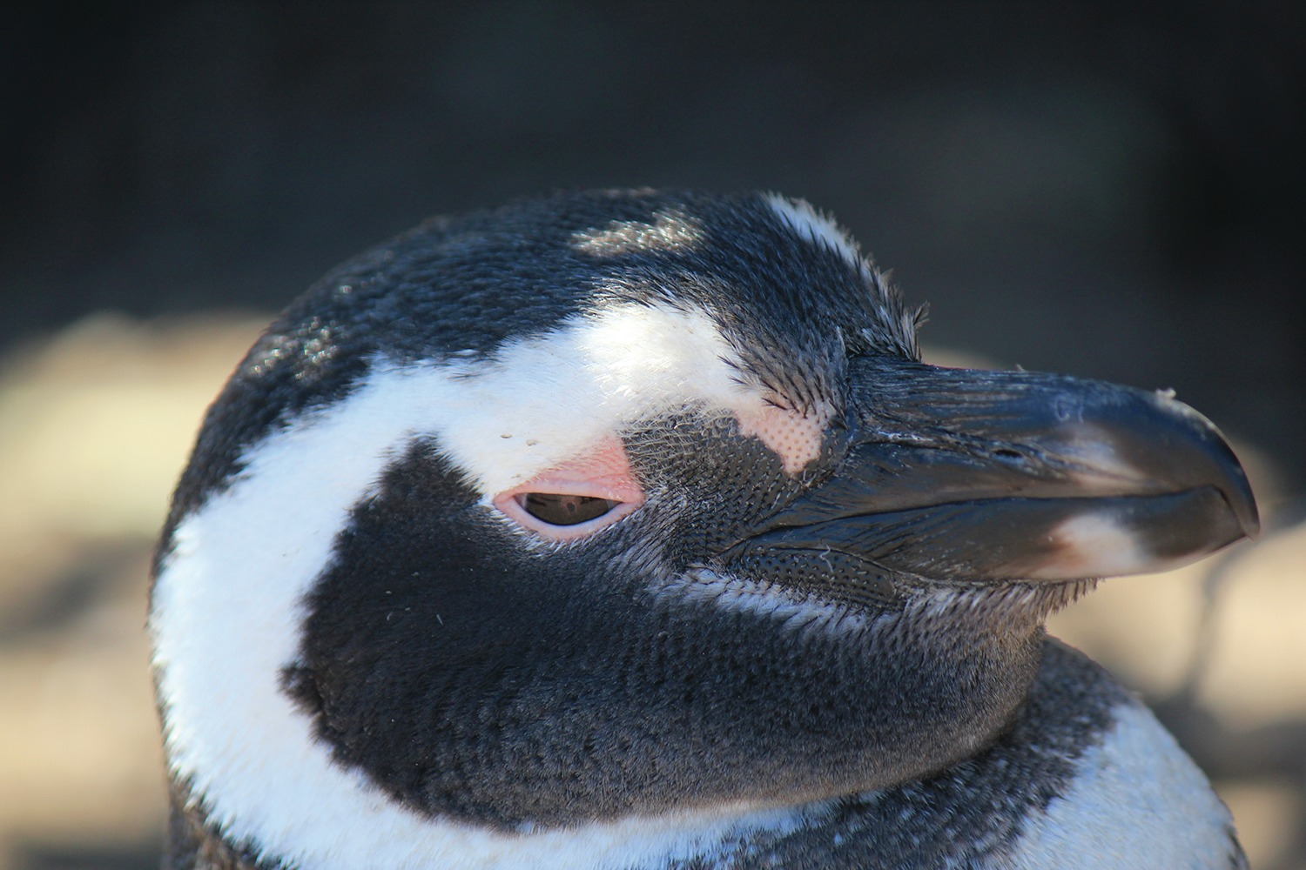
Figure 1 A Magellanic penguin (Spheniscus magellanicus) from a colony in Patagonia, South America

Birds are widely distributed, are often highly visible and vocal, and readily attract our interest (Figure 1). As a consequence, data sets on bird diversity are generally much more comprehensive than those for other animals. Surveys of birds usually collect five pieces of data: species identity, where the bird was seen, the date on which it was seen, what it was doing and how many others of the same species were seen at the time of observation.
There are also five common surveying techniques: territory mapping, transects, point counts, flock or roost counting, and remote sensing such as satellite imaging.
Many of the examples of citizen science that you have encountered so far have involved observations or collections made in the field. However, there are projects that harness the observational skills of citizen scientists in the analysis of photographs, video recordings and live camera feeds. Here is a look at one such bird-related study.
Penguin colonies are found around the Southern Ocean and, as penguins are predators, the health of these colonies is an important indicator of the state of the marine ecosystem. Their geographical range is huge and the habitats they occupy are challenging for observers. PenguinWatch is a citizen science project that has set up a network of cameras on South Atlantic islands and the Antarctic peninsula to monitor penguin colonies all year round. The health of the colonies can be assessed by looking at survival rates of chicks and overall numbers in each colony. Extracting data from the cameras is a time-consuming process, which will eventually be automatic, but at present it is done by over 47,000 volunteers who access the camera images online, marking the adults, chicks and eggs they observe in each image with different-coloured circles. In the image shown in Figure 2, the adults are marked with an orange circle, the chicks with green and the eggs with yellow. There are only six species that might be encountered in the images, but other animals are sometimes visible, so species identification skills are required.

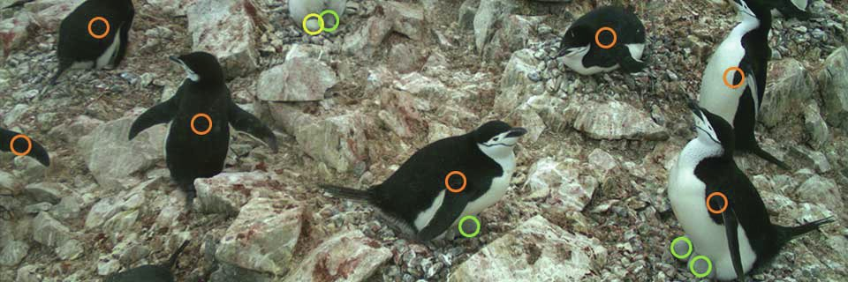
Figure 2: A chinstrap penguin (Pygoscelis antarcticus) colony annotated by online observers.

Activity 2 Using image analysis
Allow about 40 minutes

Now it’s time to try image analysis for yourself. First, go to the PenguinWatch website and click on ‘Get started’. You will then be able to view the short tutorial, after which you will be presented with your first image. (Be prepared to encounter images that are devoid of animal life or obscured by weather.) When you have a feel for the process, think about what information might be extracted from the data set that is being accumulated.

View answer - Activity 2 Using image analysis

3 Big data

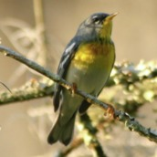
Figure 3 Setophaga americana, the northern parula, is a New World warbler

As the PenguinWatch project has shown you, big citizen science projects have the capacity to produce very large data sets. Cornell University in the USA has been collecting data on birds since 1966. About 400,000 people contribute each year, and an average of 7.5 million observations are recorded on their eBird site each month.
As an example of the value of big data sets, the bird checklists on the eBird site have been used to investigate the synchronisation of the arrival of migratory birds to the greening of trees as leaves appear (Mayor et al., 2017). As the leaves appear, the caterpillars that feed on them also develop, and caterpillars are a vital food source for the birds to feed to their young. Optimal timing is essential for the birds as they must avoid the cold but not arrive so late that they miss the glut of new caterpillars. The eBird database provided the dates on which 48 migratory bird species were observed, which enabled researchers to obtain an average arrival date for the population. The northern parula (Figure 3) is one migratory bird that is falling out of synchronisation. On average, the 48 species investigated were falling out of synchronisation by five days per decade, although some species were falling out by triple that rate. Many of the species were adapting their arrival date to cope with the change in greening of trees but were often not changing fast enough.
It can be seen by such studies that climate change threatens bird species. This particular study shows that migratory birds are adapting to rising temperature, but often not as fast as the climate is changing, the implication being that there will be an impact on species richness.

4 Technology provides opportunities

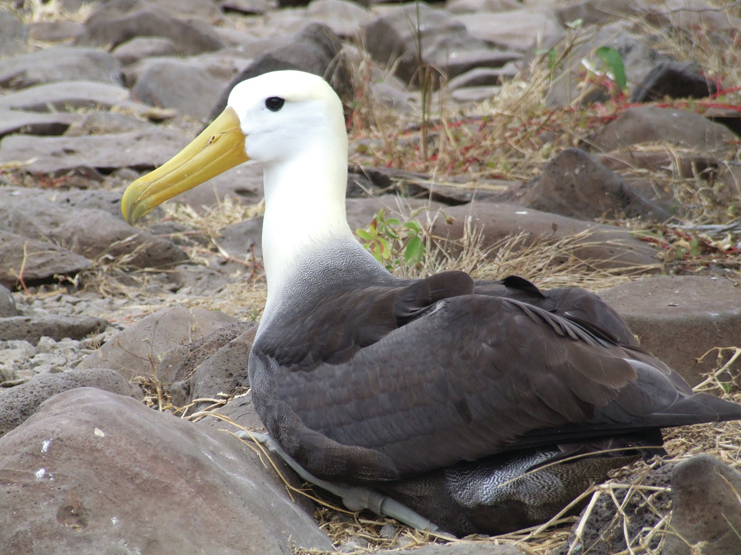
Figure 4 The critically endangered waved albatross (Phoebastria irrorata)

Technology advances rapidly and offers new ways to make observations of animals. The eMammal project run by the Smithsonian Institution links scientists and citizen scientists by using digital cameras, called camera traps, to monitor and record wildlife (Figure 5). There are many different designs of camera trap, but the basic mode of operation is that a weatherproof camera is set up in an area likely to have wildlife present and a motion sensor triggers a photograph (or a burst of photographs) whenever there is sufficient movement that could indicate the presence of an animal. The sensitivity of the motion sensor is usually adjustable, and the camera may use infrared light to illuminate the animal without disturbing it with flash photography. Clearly, these automatic cameras have the potential for generating large data sets.
So far, there are 18 countries in which projects are running, with 64 projects in total covering 1950 species. One such project is the Museums Connect eMammal International project, which links museums in the USA, India and Mexico with local schools, helping them to run camera traps from their classrooms. The data that they collect are used to help to understand how mammals respond to human influences in both wild and urban environments. It is hoped that the involvement of schools in this type of project will hopefully encourage an interest in wildlife and conservation in their students. But also that it will promote the idea that citizens can make a substantial contribution to data collection on an international scale.

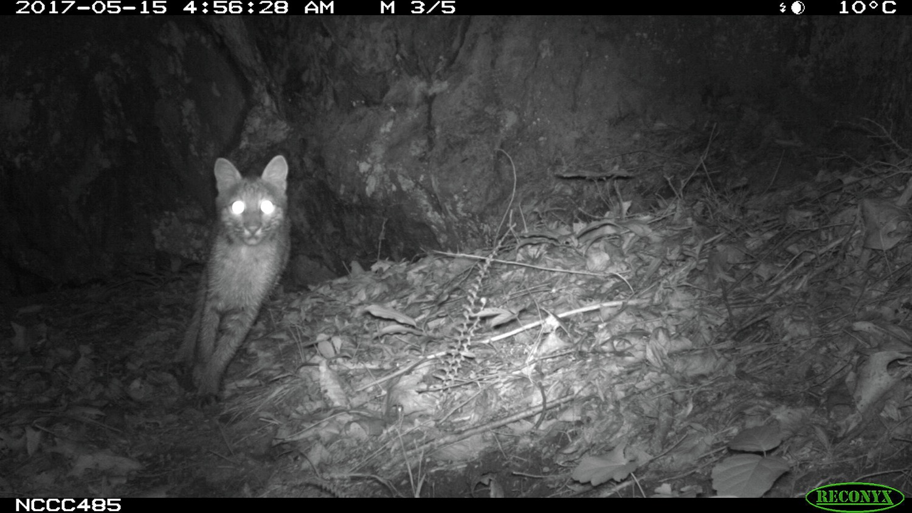
Figure 5 Camera-trap image of a bobcat (Lynx rufus) taken in Madison County, North Carolina, USA, using infrared light

Figure 5 shows how a large-scale camera-trap survey has been used to validate data produced by non-expert citizen science volunteers. However, it sometimes proves necessary to convince sceptical scientists that reliable data can be produced by non-experts. Here is the abstract of a report produced by another survey (Swanson et al, 2016).
Citizen science has the potential to expand the scope and scale of research in ecology and conservation, but many professional researchers remain skeptical of data produced by nonexperts. We devised an approach for producing accurate, reliable data from untrained, nonexpert volunteers. On the citizen science website Snapshot Serengeti, more than 28,000 volunteers classified 1.51 million images taken in a large-scale camera-trap survey in Serengeti National Park, Tanzania. Each image was circulated to, on average, 27 volunteers, and their classifications were aggregated using a simple plurality algorithm. We validated the aggregated answers against a data set of 3829 images verified by experts and calculated 3 certainty metrics – level of agreement among classifications (evenness), fraction of classifications supporting the aggregated answer (fraction support), and fraction of classifiers who reported ‘nothing here’ for an image that was ultimately classified as containing an animal (fraction blank) – to measure confidence that an aggregated answer was correct.
Overall, aggregated volunteer answers agreed with the expert-verified data on 98% of images, but accuracy differed by species commonness such that rare species had higher rates of false positives and false negatives. Easily calculated analysis of variance and post-hoc Tukey statistical tests indicated that the certainty metrics were significant indicators of whether each image was correctly classified or classifiable. Thus, the certainty metrics can be used to identify images for expert review. Bootstrapping analyses further indicated that 90% of images were correctly classified with just 5 volunteers per image. Species classifications based on the plurality vote of multiple citizen scientists can provide a reliable foundation for large-scale monitoring of African wildlife.
(Source: Swanson et al., 2016)

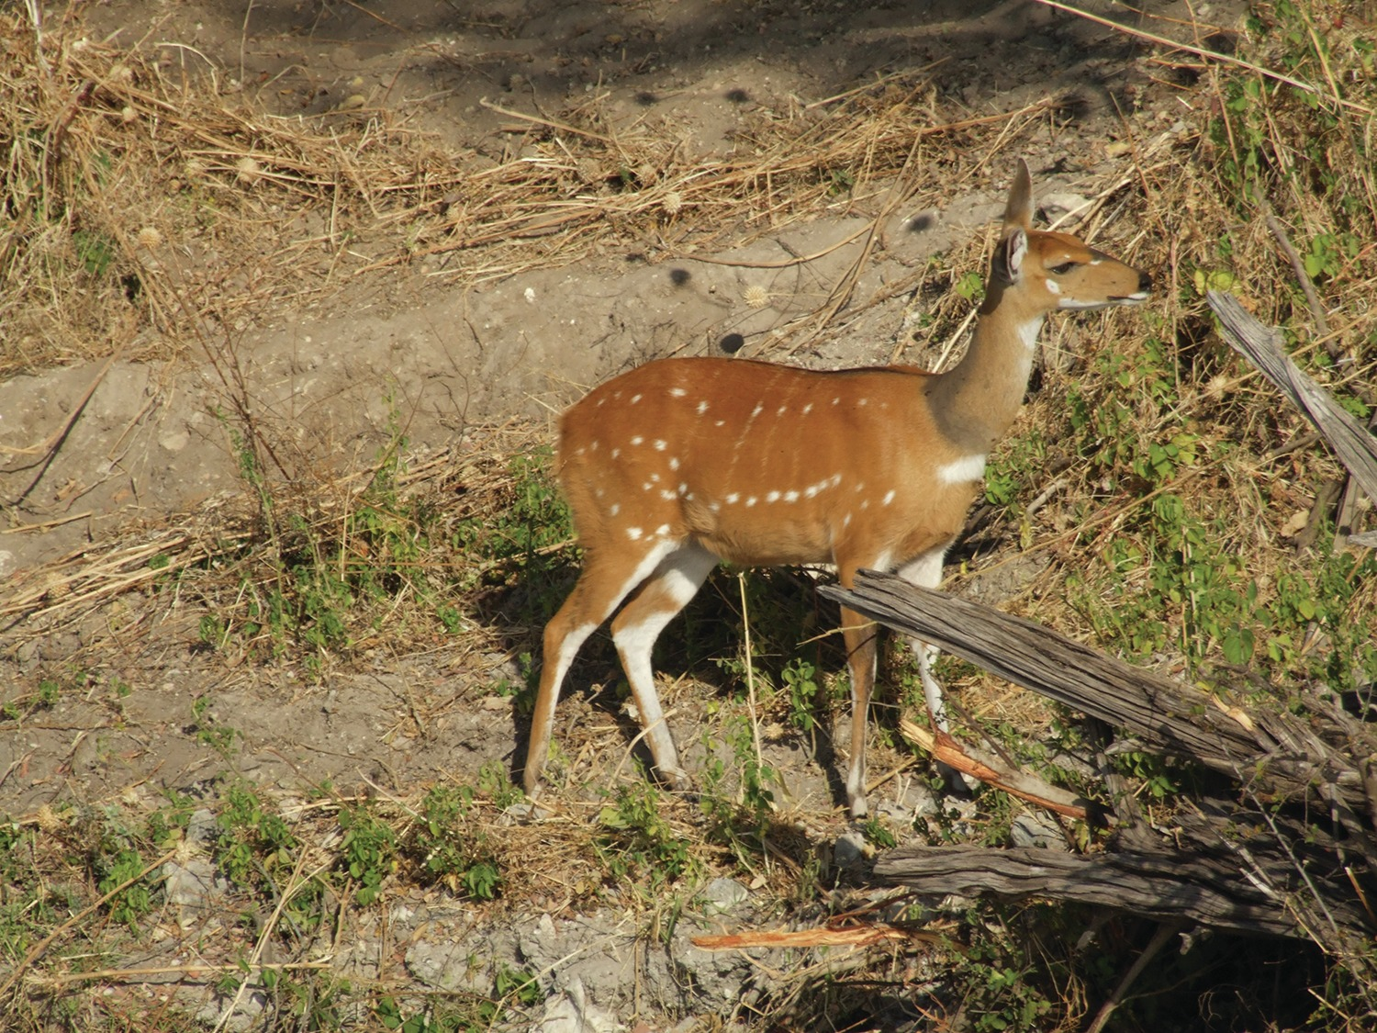
Figure 6 The marsh buck or sitatunga (Tragelaphus spekii) occurs across Central Africa. This photograph was taken in Namibia. The pattern of dots and stripes, although variable between individuals, acts as a visible means of identification in images.

Activity 3 Reliability
Allow about 40 minutes

Having read the previous abstract, think about the sources of variation in the classification of an image and make a list of them. You might find it useful to look at the Snapshot Serengeti website. You could take the tutorial to see how identification is handled, together with collection of other observations such as number of animals present.

View answer - Activity 3 Reliability

4.1 Satellites – the next big advance in citizen science?

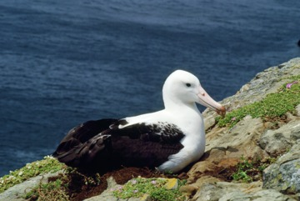
Figure 7 A northern royal albatross (Diomedea sanfordi) incubating eggs

The definition available in satellite images has recently increased to the point where large animals such as albatrosses are visible as individuals. The northern royal albatross shown in Figure 7, for example, is one of the world’s largest birds, with a wingspan of 3.2 m, and its size makes it just visible on satellite images. Each of the white dots in the WorldView-3 images of an albatross colony in Figure 8 appears to be a single bird.

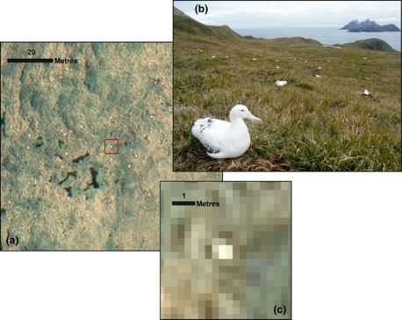
Figure 8 WorldView-3 satellite images of the Chatham Islands, New Zealand, from February 2016, showing white dots assumed to be northern royal albatrosses (Fretwell et al., 2017)

Activity 4 Satellite pros and cons
Allow 20 minutes

Now that you are nearly at the end of this course, take the albatross example as a guide and then consider the problems that might arise when setting up a citizen science project to estimate the population size in a hypothetical species of light-coloured animal using satellite imaging. Think about how you might maximise the accuracy of the data gathered and about whether there is any way to check that the data derived from photographs is a true reflection of the real population.

View answer - Activity 4 Satellite pros and cons

You will realise from the albatross study that aerial imaging has great potential and that the technique is likely to be applied to other populations. The photographs produced by this study were assessed manually, but in future it seems reasonable to expect that fully automated counting will be possible, although doubtless at some cost. Where large amounts of data are being collected, however, there is a role for volunteer citizen scientists, and the role they play – the role you could play – will develop alongside the application of technology.

5 Reflections

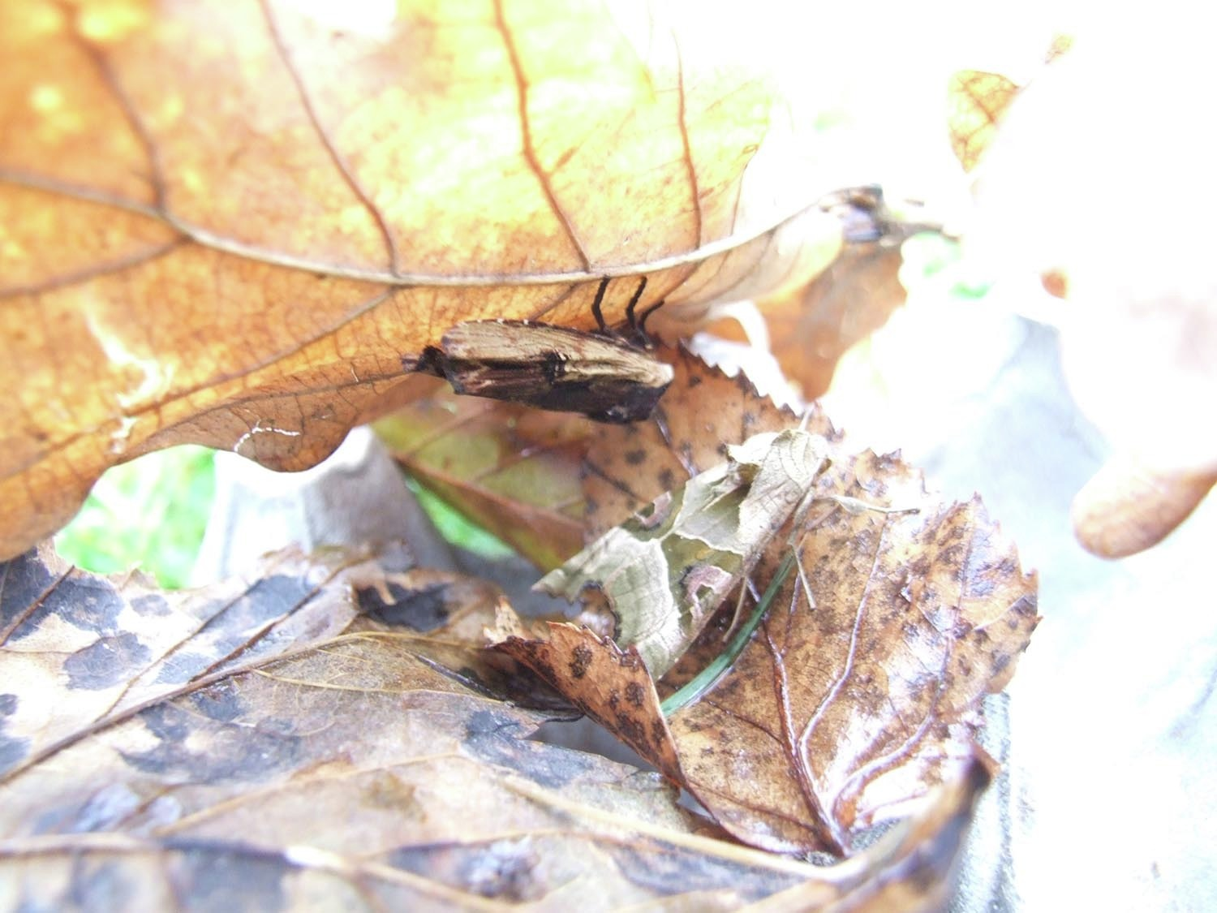
Figure 9 Identifying moths

The term citizen science describes an activity that has been going on since the nineteenth century, although the use of that description is a much more recent innovation. Through studying this course you have encountered a number of examples of existing projects and by now you should be able to appreciate the wide range that they cover. Some projects involve simple observation, with little background knowledge required, while others need a certain amount of skill, such as the light-trapping project along the Colorado River (Week 4, Section 3.3). All of the projects offer stimulating ways to get involved with the study of the natural world. And, as there are rapidly increasing numbers of citizen science projects, so there are plenty of opportunities to get involved (Figure 10).

Activity 5 Definition
Allow about 5 minutes

What working definition has been used here for the term citizen science?

View answer - Activity 5 Definition

Over the previous eight weeks, you have learned about citizen science under three broad headings:
- the scope of citizen science projects
- the development of skills required for the identification and use of online resources
- the contribution of projects to assessing biodiversity and the state of the planet.

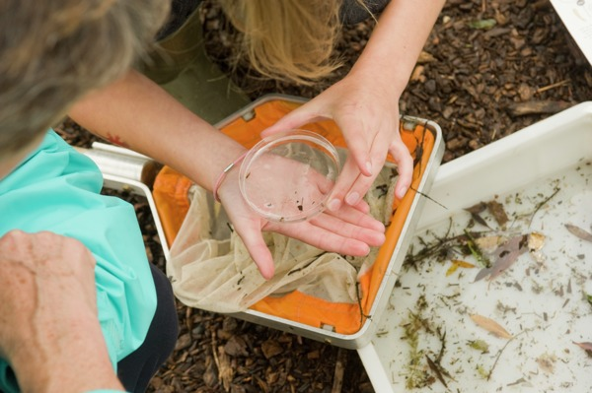
Figure 10 Citizen scientists’doing a stream survey

5.1 The scope of citizen science projects
There has been a range of projects featured over the weeks of this course. The breadth of projects is matched by the breadth of motivations for individuals to get involved.

Activity 6 Scope and motivation

Take a few minutes to review the examples in the course. Select two that illustrate the wide scope of citizen science projects and also the two broad categories of motivation.

View answer - Activity 6 Scope and motivation

An illustration of how a citizen science project can be constructed – and the reasoning behind it – was provided in the case study on Nature’s Calendar (Week 1, Section 6). The project’s research goals, public engagement, learning, data collection and conclusions from data analysis were all considered. The role of the community in the process of enquiry learning was a feature of this project.
The three main approaches to public participation in science are through contributory projects, collaborative projects and co-created projects, all of which feature interactions between scientists and volunteers. However, anyone can set up a citizen science project. The Zooniverse website() provides a platform for ‘people-powered research’ where anyone can be a researcher by joining a wide-ranging, ever-expanding number of projects. Or, by using the project-building advice on the site, individuals can set up their own project (Figure 11).
Technology can also support citizen science, and the rate of advance in capability is enabling new and more ambitious projects. One example featured in this course has been the uploading of photographs to a website with their associated GPS location information, a practice that is changing the role of the citizen scientist from observer to recorder.

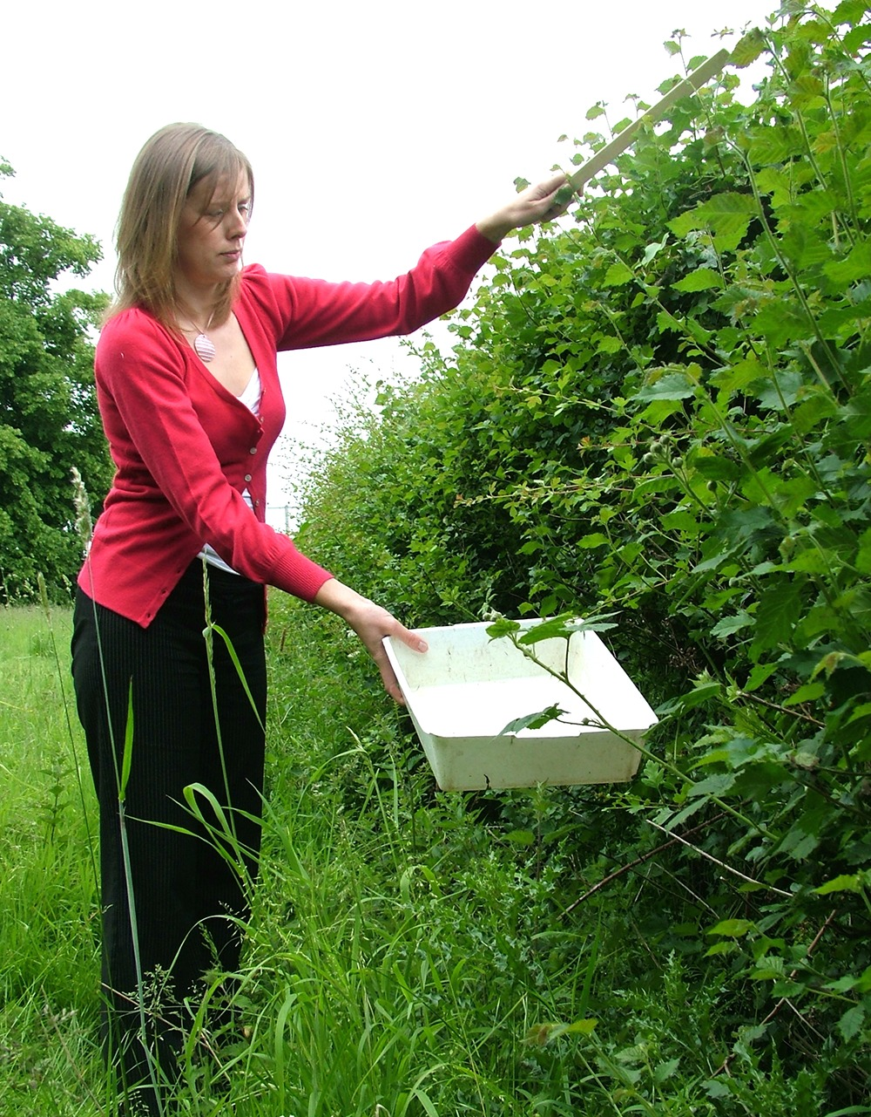
Figure 11 Individual survey work

5.2 The development of skills required for identifying and using online resources
The accurate identification of organisms is crucial when measuring the biodiversity of an area (Figure 12). Without accurate identification, it can be impossible to determine how many species are present. Identification is also an essential prerequisite when attempting to find out more about the ecology of a species, for, once a species has been identified, it is often possible to look up a whole range of ecological information about it. There are now many online databases and scientific publications that provide detailed information about a huge number of named species. Once you have the name of a species, a web search will also indicate its life history, potential problems that it might face or cause, and links to related scientific papers.

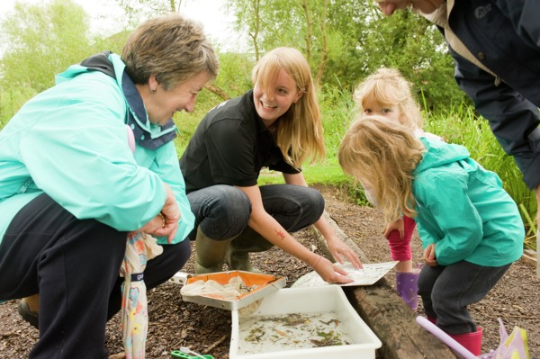
Figure 12 A biodiversity study

Obtaining a species identification is usually possible using a biological key, which uses a series of attributes – usually morphological characters – to guide the user through a series of questions that enable him or her to separate one species from all the rest. The ability to use biological keys is a valuable skill.
There are many ways of finding further information about a species. A good source of information is iSpotnature.org, which will provide you not only with the identity of a species but also with its scientific name. There are also databases and publications available that have a clear link to reputable academic or conservation organisations, such as GBIF’s biodiversity database or local nature organisations and museums.

5.3 The contribution of citizen science projects to assessing biodiversity and the state of the planet
Many of the examples of citizen science projects introduced during this course have had as their aim a contribution to our knowledge of the diversity of life and, perhaps more importantly, the changes in biodiversity that are occurring over time. Other projects, such as the monarch butterfly project, aim to document the lifestyle and population changes of a single species. To support ithis assessment, some observations posted to the iSpot website, once identified and verified, are passed on to national recording organisations. Once projects have been running for a number of years, it is possible to identify trends in populations, and every year citizen scientists’ make observations that will enhance the value of the data sets to which they contribute.

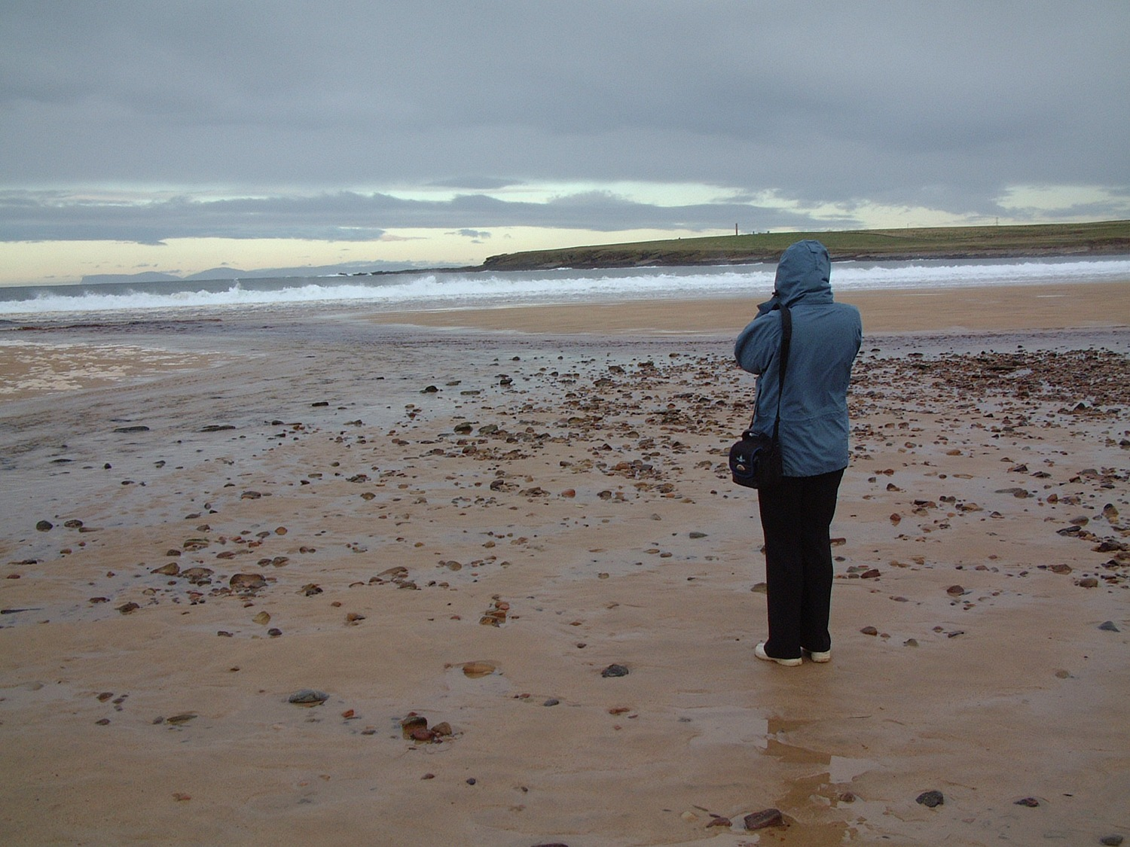
Figure 13 Observing birds on a sandy bay

Over the eight weeks of this course, you have been introduced to the concept of citizen science and a wide range of examples of citizen science projects. As a citizen scientist you might work alone (Figure 13) or as part of a group. While some projects can be carried out at home with a computer, many offer opportunities to work in natural habitats (Figure 14).

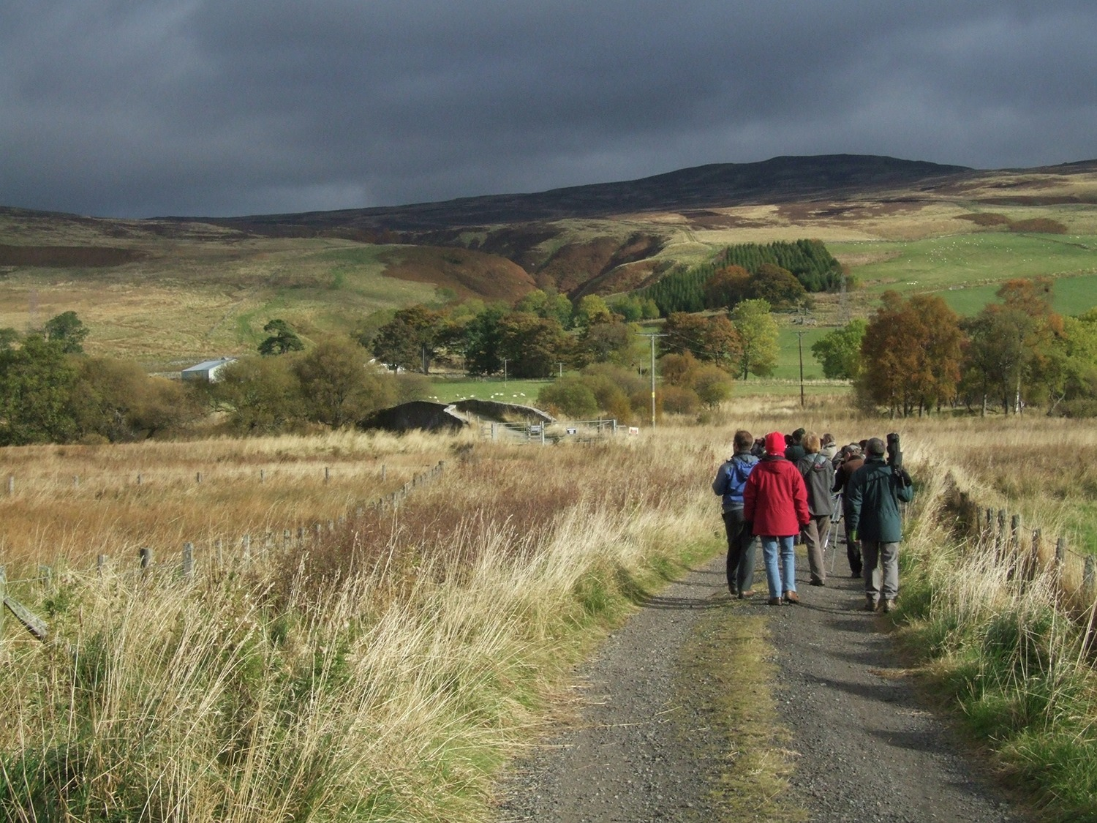
Figure 14 Exploring and recording and enjoying the natural world

You have also been introduced to surveying and identification techniques and have had opportunities to practise them. With this experience, you can join the swelling army of volunteers who, with their badge of ‘citizen scientist’, are making an increasingly important contribution to scientific knowledge – which is something to be proud of.
Finally, here are Janice and David with their concluding thoughts about the course.

Video content is not available in this format.
View transcript - Uncaptioned interactive content

6 This week’s quiz
Now it’s time to complete the Week 8 badge quiz. It is similar to previous quizzes, but this time instead of answering five questions there will be fifteen.
Week 8 compulsory badge quiz
Remember, this quiz counts towards your badge. If you’re not successful the first time, you can attempt the quiz again in 24 hours.
Open the quiz in a new tab or window then come back here when you’ve finished.

Where next?
If you have enjoyed this course you can find more free resources and courses on OpenLearn.
And you might be specifically interested in the following:
- Introducing the environment: Ecology and ecosystems
- Neighbourhood nature
- Nature matters in conversation
- Managing coastal environments
New to University study? Interested in science? Why not explore these courses:
- Questions in science
- Science: concepts and practice
- Science, technology and maths Access module
Currently an OU student? There are also a wide range of Open University courses from environmental studies to biology, technology and education, that integrate elements of citizen science (such as the iSpot and Treezilla platform) within the scope of teaching and learning. Courses are from undergraduate to postgraduate study:
- Environment: responding to change
- The biology of survival
- Developing subject knowledge for the primary years
- Technology-enhanced learning: foundations and futures
Making the decision to study can be a big step and The Open University has over 40 years of experience supporting its students through their chosen learning paths. You can find out more about studying with us by visiting our online prospectus.
Other content from OpenLearn
- The Great British Year – The definitive portrait of the spectacular nature of the country over the course of one year.

Tell us what you think
Now you’ve come to the end of the course, we would appreciate a few minutes of your time to complete this short end-of-course survey (you may have already completed this survey at the end of Week 4).

References
Bonney, R., Ballard, H., Jordan, R., McCallie, E., Phillips, T., Shirk, J., Wilderman, and C.C. (2009) Public Participation in Scientific Research: Defining the field and assessing its potential for informal science education. A CAISE Inquiry Group Report, Washington, Center for Advancement of Informal Science Education [Online]. Available at www.informalscience.org/sites/default/files/PublicParticipationinScientificResearch.pdf (Accessed 7 May 2019).
European Citizen Science Association (ECSA) (2018) Ten Principles of Citizen Science [Online]. Available at dfhttps://ecsa.citizen-science.net/sites/default/files/ecsa_ten_principles_of_citizen_science.pdf (Accessed 7 May 2019).
Geoghegan, H.,. Dyke, A., Pateman, R., West, S. and Everett, G. (2016) Understanding Motivations for Citizen Science. Final report on behalf of the UK Environmental Observation Framework [Online]. Available at www.ukeof.org.uk/resources/citizen-scienceresources/MotivationsforCSREPORTFINALMay2016.pdf (Accessed 24 May 2019).
Irwin, A. (1995) Citizen Science: A Study of People, Expertise and Sustainable Development. Abingdon, Routledge
Silvertown, J., Harvey, M., Greenwood, R., Dodd, M., Rosewell, J., Rebelo, T., Ansine, J. and McConway, K. (2015) ‘Crowdsourcing the identification of organisms: a case-study of iSpot’. ZooKeys, vol. 480, no. 125 [Online]. Available at http://zookeys.pensoft.net/articles.php?id=4633 (Accessed 7 May 2018).
Tweddle, J.C., Robinson, L.D., Pocock, M.J.O. and Roy, H.E (2012) ‘Guide to citizen science:developing, implementing and evaluating citizen science to study biodiversity and the environment in the UK’ [Online]. Natural History Museum and NERC Centre for Ecology and Hydrology for UK-EOF. Available at www.ukeof.org.uk (Accessed 7 May 2019).
Worthington, J. P., Silvertown, J., Cook, L., Cameron, R., Dodd, M., Greenwood, R.M., McConway, K. and Skelton, P. (2011) ‘Evolution MegaLab: a case study in citizen science methods’. Methods in Ecology and Evolution, vol. 3, no. 2, pp. 303–9 [Online]. DOI: 10.1111/j.2041-210X.2011.00164.x (Accessed 7 May 2018).
Science with and for Society (SwafS) (2017) Citizen Science Policies in the European Commission: research agendas towards issues of concern to citizens, Policy Brief, SiS.net [Online]. Available at http://www.sisnetwork.eu/media/sisnet/Policy_brief_Citizen_Science_SiSnet.pdf (Accessed 24 May 2019).
Garg, S., Suyesh, R., Sukesan, S. and Biju S. (2017) ‘Seven new species of Night Frogs (Anura, Nyctibatrachidae) from the Western Ghats Biodiversity Hotspot of India, with remarkably high diversity of diminutive forms’ [Online]. Available at https://peerj.com/articles/3007/ (Accessed 8 May 2019).
Kolbert, E. (2014) The Sixth Extinction: An Unnatural History, London, Bloomsbury Publishing.
Pimm, S.L., Jenkins, C.N., Abell, R., Brooks, T.M., Gittleman, J.L., Joppa, L.N., Raven, P.H., Roberts, C.M. and Sexton, J.O. (2014) ‘The biodiversity of species and their rates of extinction, distribution, and protection’, Science, vol. 344, no. 6187, [Online].. Available at http://science.sciencemag.org/content/344/6187/1246752.long (Accessed 8 May 2019).
Middleton, N. (2013) The Global Casino: An Introduction to Environmental Issues, 5th edn., p. 640, Abingdon, Routledge Publishing.
Myers, N., Mittermeier, R.A., Mittermeier, C.G., da Fonseca, G.A.B. and Kent, J. (2000) ‘Biodiversity hotspots for conservation priorities’, Nature, vol. 403, 853–8.
Wake, D.B. and Vredenburg, V.T. (2008). ‘Are we in the midst of the sixth mass extinction? A view from the world of amphibians’, Proceedings of the National Academy of Sciences, vol. 105, Supplement 1, pp. 11466–73 [Online]. Available at http://www.pnas.org/content/105/Supplement_1/11466.abstract (Accessed 15 July 2019).
Catalogue of Life (2019) Annual Checklist [Online]. Available at www.catalogueoflife.org/annual-checklist/2016/info/ac%20 (Accessed 8 May 2019).
National Science Foundation (NSF) (2016) ‘Researchers find that Earth may be home to 1 trillion species’, News release 16-052 [Online]. Available at https://www.nsf.gov/news/news_summ.jsp?cntn_id=138446 (Accessed 8 May 2019).
Chapman, A. D. (2009) Numbers of Living Species in Australia and the World, 2nd edn, Toowoomba, Australian Biodiversity Information Services [Online]. Available at www.environment.gov.au/science/abrs/publications/other/numbers-living-species/contents (Accessed 8 May 2019).
Larsen, B. B., Miller, E. C., Rhodes, M. K. and Wiens, J. J. (2017) ‘Inordinate fondness multiplied and redistributed: the number of species on Earth and the new pie of life. The Quarterly Review of Biology, vol. 92, no. 3, p. 229 [Online]. DOI: 10.1086/693564 (Accessed 15 May 2019).
Monarch butterflies:
http://monarchlab.org/biology-and-research/biology-and-natural-history/migration
www.learner.org/jnorth/sightings/
www.monarchwatch.org/tagmig/tag.htm
The Grand Canyon survey:
www.usgs.gov/centers/sbsc/science/citizen-science-light-trapping-grand-canyon?qt-science_center_objects=0#qt-science_center_objects
Ainsworth, A.M., Cannon, P. and Dentinger, B. (2013) ‘DNA barcoding and morphological studies reveal two new species of waxcap mushrooms (Hygrophoraceae) in Britain’, MycoKeys vol. 7, pp. 45–62 [Online]. Available at https://doi.org/10.3897/mycokeys.7.5860 (Accessed 10 May 2019).
Bossert, S. (2015) ‘Recognition and identification of bumblebee species in the Bombus lucorum-complex (Hymenoptera, Apidae) – A review and outlook’ Deutsche Entomologische Zeitschrift, no. 62, (vol/1), pp. 19–28 [Online]. Available at https://doi.org/10.3897/dez.62.9000 (Accessed 10 May 2019).
Brock, P.M., Döring, H. and Bidartondo, M.I. (2009) ‘How to know unknown fungi: the role of a herbarium’, New Phytologist, vol. 181, no. 3 pp. 719–24 [Online]. DOI: 10.1111/j.1469-8137.2008.02703.x (Accessed 10 May 2019).
Defra (Department for Environment, Food and Rural Affairs) (2011) ‘Systematics, barcoding and ecology of fungi from waxcap grasslands’, Science and research project WC0787 [Online]. Available at http://randd.defra.gov.uk/Default.aspx?Menu=Menu&Module=More&Location=None&ProjectID=17344&FromSearch=Y&Publisher=1&SearchText=waxcap&SortString=ProjectCode&SortOrder=Asc&Paging=10#Description (Accessed 10 May 2019).
Reason, P.F., Newson, S.E. and Jones, K.E. (2016) ‘Recommendations for using automatic bat identification software with full spectrum recordings’ [Online] Available at http://www.bats.org.uk/data/files/AutomaticID_Recommendations_Version_date_210416.pdf (Accessed 10 May 2019).
Schoch, C.L., Seifert, K.A., Huhndorf, S., Robert, V., Spouge, J.L., Levesque, C.A., Chen, W. and Fungal Barcoding Consortium (2012) ‘Nuclear ribosomal internal transcribed spacer (ITS) region as a universal DNA barcode marker for Fungi’, Proceedings of the National Academy of Sciences of the United States of America. vol 109, no. 16 pp. 6241–6 [Online]. DOI: 10.1073/pnas.1117018109
BBC Good Food (www.bbcgoodfood.com/)
Encyclopedia of Life (http://eol.org/)
Global Biodiversity Information Facility (www.gbif.org/)
iSpotnature.org (www.ispotnature.org/)
National Biodiversity Network, UK (nbn.org.uk/)
National Health Service, UK (www.nhs.uk/pages/home.aspx)
Natural History Museum (www.nhm.ac.uk/)
Web of Science (http://wokinfo.com/)
Wikipedia (https://en.wikipedia.org)
Wilderness & Environmental Medicine Journal (www.wemjournal.org/)
Woodland Trust (www.woodlandtrust.org.uk/)
Ansine, J. (2013) ‘Reaching the public through iSpot: your place to share nature’, Case Study 8.5 in Bowater, L. and Yeoman, K. (eds) Science Communication a practical guide for scientists, Oxford, Wiley Blackwell.
Ansine, J., Dodd, M., Robinson, D. and McAndrew, P. (2017) ‘Exploring citizen science and inquiry learning through iSpotnature.org’, Citizen Inquiry, pp. 83–103, Abingdon, Routledge.
Roy, H. E., Pocock, M. J .O., Preston, C. D., Roy, D. B., Savage, J., Tweddle, J. C. and Robinson, L. D. (2012) ‘Understanding citizen science and environmental monitoring: final report on behalf of UK Environmental Observation Framework’, Wallingford, NERC/Centre for Ecology & Hydrology [Online]. Available at http://nora.nerc.ac.uk/20679/ (Accessed 19 July 2019).
Silvertown, J., Harvey, M., Greenwood, R., Dodd, M., Rosewell, J., Rebelo, T., Ansine, J., and McConway, K. (2015) ‘Crowdsourcing the identification of organisms: a case-study of iSpot’, ZooKeys, (vol. 480), pp. 125–146 [Online]. DOI: 10.3897/zookeys.480.8803 (Accessed 14 May 2019).
Ballard, H. L., Robinson, L.D., Young, A.N., Pauly, G.B., Higgins, L.M., Johnson, R.F. and Tweddle, J.C. (2017) ‘Contributions to conservation outcomes by natural history museum-led citizen science: examining evidence and next steps’. Biological Conservation, vol. 208, pp 87–97 [Online] DOI: 10.1016/j.biocon.2016.08.040 (Accessed 14 May 2019).
Fretwell, P. T., Scofield, P. and Phillips, R.A. (2017) ‘Using super‐high resolution satellite imagery to census threatened albatrosses’. Ibis International Journal of Avian Science, vol. 159, no. 3, pp. 481–490 [Online]. DOI: 10.1111/ibi.12482 (Accessed 14 May 2019).
Mayor, S. J., Guralnick, R.P., Tingley, M.W., Otegui, J., Withey, J.C., Elmendorf, S.C., Andrew, M.E., Leyk, S., Pearse, I.S., Schneider, D.C. (2017) ‘Increasing phenological asynchrony between spring green-up and arrival of migratory birds’, Nature Scientific Reports vol. 7, 1902. [Online] DOI: 10.1038/s41598-017-02045-z (Accessed 14 May 2019).
Swanson, A., Kosmala, M., Lintott, C. and Packer, C. (2016) ‘A generalized approach for producing, quantifying, and validating citizen science data from wildlife images’, Conservation Biology, vol. 30, no. 3, 520–31. [Online]. DOI: 10.1111/cobi.12695. (Accessed 14 May 2019).

Acknowledgements
This course was written by Janice Ansine, David Robinson, Yoseph Araya and Mike Dodd.
This course was first published in August 2019.
Except for third party materials and otherwise stated (see FAQs), this content is made available under a Creative Commons Attribution-NonCommercial-ShareAlike 4.0 Licence.
Course image: © 123foto/iStockphoto.com
Every effort has been made to contact copyright owners. If any have been inadvertently overlooked, the publishers will be pleased to make the necessary arrangements at the first opportunity.

Week 1
Images
Figure 1: getreading
Figures 2, 4, 5, 6, 7 and 8: OPAL (Open Air Laboratories)
Figure 3: PhotosForClass.com;pixabay.com
Figures 10 and 11: naturescalendar.woodlandtrust.org.uk
Audio-visual
Video of citizen science activity: Butterfly-Conservation.org; www.butterfly-conservation.org
Video from the ECSA’s second International Citizen Science Conference, Geneva, 3–5 June 2018: www.science-et-cite.ch

Week 2
Images
Figure 1: Vladimir Wrangel; Shutterstock.com
Figures 2, 5, 6, 7, 8 and 9: courtesy of David Robinson
Figure 3: Franco Folini https://creativecommons.org/licenses/by-sa/3.0/deed.en
Figure 4: Pudding4brains
Figure 10: taken from: http://tchester.org/index.html
Figure 11: Brad Plumer; taken from: https://www.washingtonpost.com/news/wonk/wp/2014/02/11/there-have-been-five-mass-extinctions-in-earths-history-now-were-facing-a-sixth/?utm_term=.5f4f4fac9942
Figure 12: Google Earth
Figure 13: Pamela J. W. Gore
Figure 14: courtesy of Janice Ansine
Figure 15: The Maureen and Mike Mansfield Center Ethics and Public Affairs Program; University of Montana
Figure 16: casadaphoto/Shutterstock.com
Figure 17: Henry Arden;Cultura;Getty Images
Figure 18: taken from: http://www.seafoodwatch.org/ocean-issues/aquaculture; Monterey Bay Aquarium Foundation
Figure 19: taken from: Figure 25.14 in Campbell et al. 'Biology' 8th edition; Pearson Education Inc.
Figure 20: Pancaketom/Dreamstime.com
Figures 21 and 23: International Union for the Conservation of Nature; http://www.iucn.org
Figure 22: National Geographic; https://media.nationalgeographic.org
Figure 24: CarasdelMundo; Moment Open; Getty Images

Week 3
Images
Figures 1, 2, 3, 4, 5, 6, 7, 8, 9, 10 and 11: courtesy of Michael Dodd
Quiz images 1, 2, 3, 4, 5, 6, 7 and 8: courtesy of Michael Dodd
Audio-visual
Videos 1, 2, 3, 4, 5, 6 and 7: courtesy of Michael Dodd

Week 4
Images
Figure 1: Monarch Watch Shop; http://shop.monarchwatch.org/Monarch-Watch-Tagging-Kit/121239.
Figures 2 and 3: Wendy Caldwell, University of Minnesota Monarch Lab.
Figure 4: taken from https://www.welcomewildlife.com; https://creativecommons.org/licenses/by-sa/3.0/.
Figures 5, 6, 9, 10 and 11: courtesy of David Robinson.
Figure 15: (a) sumikophoto; Shutterstock; (b) B&M Noskowski; iStockphoto.com.
Figure 16: USGS/Freshwaters Illustrated. Public domain.

Week 5
Images
Figures 1, 2, 3, 8, 9 and 10: courtesy of Michael Dodd
Figures 4, 5 and 6: Georges Grieff
Figure 7: taken from: iSpotnature.org
Audio-visual
Videos 1, 2, 3, 4 and 5: courtesy of Michael Dodd.

Week 6
Images
Figures 1 and 3: https://www.ispotnature.org; (c) The Open Uniiversity
Figure 2: taken from: iSpotnature.org;(c)The Open University
Figure 4: Encyclopedia of Life; http://eol.org/pages/595063/overview
Figure 5: taken from: http://www.nhm.ac.uk
Figure 6: taken from: https://en.wikipedia.org/wiki/Urtica_dioica
Figure 8: http://www.wemjournal.org
Figure 9: taken from:https://www.nhs.uk/livewell/bites-and-stings/pages/plant-dangers-garden-countryside.aspx; © The Royal Horticultural Society 2019
Figure 10: Woodland Trust; https://www.woodlandtrust.org.uk
Audio-visual
Video 1: courtesy of Michael Dodd

Week 7
Images
Figures 1, 2, 3, 4, 5, 6, 7, 8, 9, 10, 11, 12, 13, 14, 15, 16, 18 and 19: https://www.ispotnature.org; (c) The Open University
Figure 17: taken from:https://www.ispotnature.org; (c) The Open University; image taken by Nick Milsom

Week 8
Images
Figure 1, 4, 6, 9,13 and 14: courtesy of David Robinson
Figure 2: Penguin Watch; https://www.zooniverse.org
Figure 3: Daniel Berganza
Figure 5: Hunter_M_Madison3; https://emammal.si.edu/; https://creativecommons.org/licenses/by-nc-sa/4.0/
Figure 7: Auscape/ardea.com
Figure 8: © 2017 British Ornithologists’ Union and R.A. Philips (photo)
Figures 10, 11 and 12: OPAL (Open Air Laboratories).
Don't miss out
1. Join over 200,000 students, currently studying with The Open University – http://www.open.ac.uk/ choose/ ou/open-content
2. Enjoyed this? Find out more about this topic or browse all our free course materials on OpenLearn – http://www.open.edu/ openlearn/
3. Outside the UK? We have students in over a hundred countries studying online qualifications – http://www.openuniversity.edu/ – including an MBA at our triple accredited Business School.

Activity 1 Energy sources

Answer
For plants, the most obvious sources of energy are sunlight and nutrients from the soil. For animals, energy might be derived from eating plants or from preying on other animals.
Back to Unit 3 Session 2 Activity 1

Activity 2 Genetic diversity

Answer
Across a continent there may be separate populations of the same species. There can be genetic diversity between the populations, arising from adaptations to local conditions.
Back to Unit 3 Session 2 Activity 2

Activity 3 Woodland comparisons

Answer
You might rate the Daintree rain forest in Australia as being the one with greatest diversity because it is tropical. You might then rank the Canadian pine forest as being the least diverse as it is in a cold climate. The European wood, which was also featured in the video in this week’s Introduction, would then come in the middle.
Back to Unit 3 Session 3 Activity 1

Activity 4 Woodland comparison and numerical comparison

Answer
The diversity of species within an ecosystem is made up of two components. The obvious one is simply the number of different species that are present. However, the number of organisms of each species is also important. So the two components are:
species richness
relative abundance
and each can be assigned a numerical value.
Back to Unit 3 Session 3 Activity 2

Activity 5 Diversity through time

Answer
In Figure 11 it is possible to see at least five instances of mass extinction, i.e. the levels where biodiversity shows a downward dip along the y axis (number of families). The most well-known instances and their times (recorded in millions of years ago, or Ma) are:
- the Cretaceous–Palaeogene extinction event at the end of the Cretaceous Period (66 Ma)
- the Triassic–Jurassic extinction event at the end of the Triassic Period (201.3 Ma)
- the Permian–Triassic extinction event at the end of the Permian Period (252 Ma)
- the late-Devonian extinction event (375–360 Ma)
- the extinction events at the end of the Ordovician Period (450–440 Ma)
Note that there could be more extinction events than these and the time scales recorded here are approximate.
Back to Unit 3 Session 4 Activity 1

Activity 6 Species distribution

Answer
You should have collected a series of maps and left a comment on each one regarding your chosen species’ prevalence.
Back to Unit 3 Session 4 Activity 2

Activity 7 Biome characteristics

Answer
Here is the completed table, bearing in mind that the answers for some biomes could vary.

Biome | Temperature | Precipitation | Expected biodiversity
tropical rainforest | hot | very wet | high
taiga | cold | medium wet | low
tundra | very cold | very dry | very low
temperate deciduous forest | medium | medium wet | medium

Back to Unit 3 Session 5 Activity 1

Activity 8 Mass extinctions

Answer
It took around 100 million years for the number of marine families to reach the pre-mass extinction levels. This happened at the start of the Cretaceous Period (C) in the Mesozoic Era.
Back to Unit 3 Session 7 Activity 1

Activity 9 Extinction rates

Answer
The answer is that we do not know. While 1000 species are known to have become extinct over the last 400 years, this figure does not take into account the probably much larger number that became extinct before anybody had discovered and named them.
Back to Unit 3 Session 7 Activity 2

Activity 10 Amphibian diversity

Answer
Factors that impact on species diversity in amphibians are mentioned in the abstract of the paper above. They are defined as habitat loss, climate change and global warming, invasive predator species, disease and pollution.
Back to Unit 3 Session 7 Activity 3

Activity 1 Working through a dichotomous key

Untitled part

Answer
The species are : Figure 3 (Option 1)Brachytron pratense, Figure 4 (Option 2) Calopteryx splendens, Figure 5 (Option 3) Coenagrion puella, Figure 6 (Option 4) Pyrrhosoma nymphula, Figure 7 (Option 5) Ischnura elegans, Figure 8 (Option 6) Cordulia aenea, Figure 9 (Option 7)Libellula depressa.
Back to Unit 4 Session 6 Part 1

Activity 1 Working through a dichotomous key

Untitled part

Answer
The insect has its wings open at rest, but this species is classed as a damselfly in the keys and damselflies are supposed to have their wings closed at rest.
Back to Unit 4 Session 6 Part 2

Activity 1 A monarch survey

Answer
Thinking back to what you read in earlier weeks, before setting out you would need to know the type of environment that monarchs might be found in and, crucially, how to identify the monarch adult butterfly, distinguishing between males and females (Figure 4). You would also need to know how to capture, tag and release the monarchs. The basic data that are essential are when (date and time), where (map reference or GPS coordinates) and how many individuals of each sex at any one time. Additional observations that are:
- what the individual(s) were doing (e.g.feeding, flying, basking, egg-laying)
- whether food plants were available for the larvae and their density
- weather conditions
- any other butterfly species observed.
You might also take photographs, and you probably have other possible observations on your list.

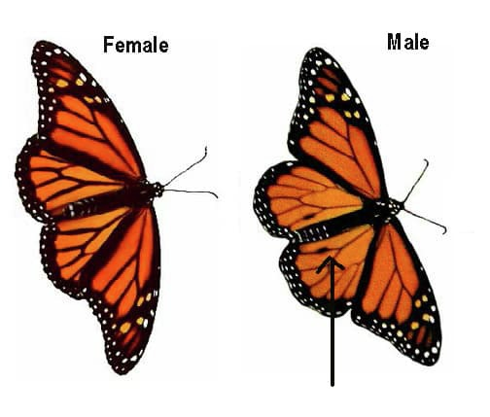
Figure 4 Female (left) and male monarch butterflies. The male has two black spots on the hind wings, which the female lacks, and the female has wider black wing veins than the male.

Back to Unit 5 Session 1 Activity 1

Activity 2 Assessing diversity

Answer
Conspicuous species – maybe those with attractive flowers – are likely to be over-recorded and smaller, less conspicuous species will be frequently overlooked. Other species that might not be recorded are plants that have flowered earlier in the year and then died back. Some species may not yet have appeared and there may be species that are difficult to tell apart.
Back to Unit 5 Session 2 Activity 1

Activity 3 Standardising the sampling area

Answer
The area for sampling was defined by a square called a quadrat. A large quadrat was used in the case of the corncockles, where only one plant was being surveyed, but a much smaller one is needed if accurate sampling of every species present is required.
The quadrat used for the corncockle survey was 5 m x 5 m square. The survey provided an average number of plants in an area of 25 m², which could then be used to estimate the number of corncockles present in the whole field.

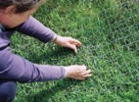
Figure 7 A grid quadrat being used to record the frequency of occurrence

Back to Unit 5 Session 2 Activity 2

Activity 4 Working out percentage cover

Answer
A five-by-five square grid would contain 25 squares. If nine of these were fully occupied, the percentage cover would be nine as a percentage of 25, which is equivalent to 36 out of every 100, i.e. 36%.
Back to Unit 5 Session 2 Activity 3

Activity 5 Transect surveys

Answer
Transects are used to survey animal populations on sandy beaches, where a line of quadrats can be set out from the high-tide mark to the sea edge.
Back to Unit 5 Session 2 Activity 4

Activity 6 Survey of larger insects

Answer
The survey method shown in the video is a linear survey, such as that used to observe plants and animals living on a beach. It could also be used for bird surveys, for example.
Back to Unit 5 Session 3 Activity 1

Activity 7 Pitfall traps

Answer
Yes, there are some disadvantages. One disadvantage of pitfall traps is that they will collect only active animals. Also, spiders and some beetles are predators so may bias your sample by eating other insects in the trap.
Back to Unit 5 Session 3 Activity 2

Activity 1 Examining specimens with a smartphone

Answer
Some coins, such as UK coins, feature very small letters (e.g. below the monarch’s head) or other details that are difficult to read with the unaided eye but may be more visible when examining an image taken with a smartphone. However, the amount of such detail may be limited if you were unable to keep the phone perfectly still when taking the image or if there was a very limited depth of field.
Back to Unit 6 Session 3 Activity 1

Activity 2 Using Pl@ntnet

Answer
- It is likely that images with one clearly defined flower or leaf will work better than those featuring many small objects.
- The app or website might ask which part of the world the plant is from, in order to narrow down its search for suitable species. Or it might ask which part of the plant is featured in the picture in order to narrow down the search to just the characteristics of leaves or flowers, for example.
- Depending on which system you use then it may suggest alternative identifications (with pictures of those various species) and may even attach a probability of accuracy to each alternative.
- There might be a link from the identification to Wikipedia or other resources that might provide more information about the target species.
Back to Unit 6 Session 5 Activity 1

Activity 1 Searching for information and defining your questions

Answer
- Some commonly asked questions include: What species is it? What are its characteristics and does the example recorded fit? What is its distribution in the local area or the world? What are the species’ economic uses, if any? And sometimes, what is its presence in mainstream media?
- Check first to see if any information is available from credible, international, professional organisation databases (websites) such as the UK’s National Biodiversity Network and the Global Biodiversity Information Facility. Scientific literature can be obtained from peer-reviewed publications that are often listed in databases such as Web of Science.
Back to Unit 7 Session 4 Activity 1

Activity 2 Doing your own search

Answer
- Distribution maps for each species:
  - Bewick’s swan (Cygnus columbianus). Note that the Bewick’s swan migrates between the Arctic, where it breeds, and various areas further south, where it escapes the cold winters and lack of food.
  - Hedgehog mushroom (Hydnum repandum).
  - Brown trout (Salmo trutta). Note that there are forms of Salmo trutta that migrate while other forms remain in lakes or rivers.
- The Bewick’s swan (Cygnus columbianus) is shot for food, even though in most of its range it is illegal to kill it. The hedgehog mushroom (Hydnum repandum) is widely eaten in Europe and North America. The brown trout (Salmo trutta) is commonly farmed and is a popular species for recreational fishing.
- The Bewick’s swan (Cygnus columbianus) belongs to the Anatidae family. The hedgehog mushroom (Hydnum repandum) belongs to the Hydnaceae family. The brown trout (Salmo trutta) belongs to the Salmonidae family. Note, however, that taxonomy is in a continuous state of flux and terms relating to family, genus and species may change as new information becomes available.
Back to Unit 7 Session 4 Activity 2

Activity 1 Ecosystem services

Answer
You may have some different examples but here are some well-known ones.
- Provisioning: these are the products obtained from ecosystems, such as food, the supply of water and raw materials. You might also have mentioned genetic resources.
- Regulating: there are benefits from processes that balance climatic variables or break down waste materials.
- Supporting: these are services that underpin others, such as pollination and nutrient cycling, which support food production.
- Cultural: there are lots of examples of cultural services, such as leisure activities, ecotourism and education.
Back to Unit 9 Session 1 Activity 1

Activity 2 Using image analysis

Answer
As the cameras are active all year round, changes in the colony over time – for example, hatching dates – will be observed and can be compared with previous years. Predators will be observed and it will be possible to identify them and work out the rate of predation of chicks and whether predation patterns are changing from year to year. You might also have mentioned arrivals and departures, together with how many penguins, if any, overwinter in the area.
Back to Unit 9 Session 2 Activity 1

Activity 3 Reliability

Answer
Obviously, a major source of variability is species identification, and a photograph might not show an animal from the right angle to see key identifying features. In counting how many animals are visible, there may be one large animal in the foreground and a large number in the far distance, leading to different decisions about which ones to count. Similarly, a herd of deer in the foreground would be almost impossible to count accurately. Some images might not show any identifiable animals at all.
Back to Unit 9 Session 4 Activity 1

Activity 4 Satellite pros and cons

Answer
In the images in Figure 8, each bird is shown as a small, light dot. Asking more than one person to count the number of dots on the photograph by eye and taking the mean value increases the confidence in the data. However, as each animal is just a dot, it is possible to include in the count other species that are light coloured, or even light-coloured patches of rock. Also, it would be impossible to separate breeding and non-breeding individuals via this method.
If the actual site surveyed was accessible, it would be possible to compare a ground survey with a satellite survey of the same area on the same day. However, as you would swiftly appreciate, that is a daunting task, and of course it might be a cloudy day!
Refer to Fretwell et al. (2017) to find out more information about how the albatross survey was carried out.
Back to Unit 9 Session 4 Activity 2

Activity 5 Definition

Answer
It is the collection and analysis of data relating to the natural world by members of the general public, typically as part of a collaborative project with professional scientists.
Back to Unit 9 Session 5 Activity 1

Activity 6 Scope and motivation

Answer
There are a great many examples to choose from, as the scope of citizen science is large. Contributing to the iSpotnature.org website provides an opportunity for individuals both to contribute observations and to learn. This project highlights individual motivation. The survey of insects in the Grand Canyon (Week 4, Section 3.3), requires special skills in the volunteers. The exemplifies organisational motivation, the organisation in this case being the United States Geological Survey.
Back to Unit 9 Session 5 Activity 2

Uncaptioned interactive content

Transcript
JANICE ANSINE
In June 2009, six-year-old Katie from Berkshire, England, saw an unusual furry moth on her windowsill at home. Curious to find out what it was, she showed it to her dad who helped her take a photo and posted it on the then new citizen sized platform, ispotnature.org. Within 24 hours, the iSpot online community confirmed it to be the are the most Leaf Notcher, a species never previously seen in the UK and Europe.
This example of citizen science demonstrates its power. Anyone can get involved, make discoveries, and contribute to scientific knowledge, while at the same time being able to engage with and learn about science. This first week of the course looks at the growth of citizen science and how it contributes to scientific knowledge. I hope you are inspired to get involved.
Back to Unit 2MediaContent 1

Video of citizen science activity

Transcript
[PIANO MUSIC]
NICK BAKER
Butterflies are incredibly sensitive indicators of the health of our environment. Across the UK, most species of butterflies and moths are in some kind of decline. But the good news is you can do something about it. You can help by taking part in Butterfly Conservation's Big Butterfly Count. And by doing so, you'll be able to help them work out how best to help the butterflies.
On top of that, it's a great way of having fun and getting outside. It's not just good for the butterflies, this. Being outside is good for you too. Now how do you take part? All you need is either the Big Butterfly Count app on your phone or tablet. Or, you can print off your recording sheet from the Big Butterfly Count website.
Now what you need to take part in the survey is simply one of those and 15 minutes of your time. That's all it takes, 15 minutes-- preferably, in sunny weather. So head outdoors and set up in a good spot for butterflies. Now this could be your garden, a park, a wood, or a favourite spot that you've got in mind.
So there's the Butterfly Count app. Press on it. It opens up. Take part in the count? It asks me. Yes, please. It's now time to start. So 15 minutes from now, go. And of course, I have to record the maximum number of butterflies of any species I see at any one time.
So that is a Meadow Brown. Meadow Brown is there. Meadow Brown.
[PIANO MUSIC]
Ah-ha, Small Tortoiseshell, finally. There's also sort of this big, dark shape just over there. And I just got myself a Red Admiral. If you're not using an app or on a tablet or a phone, the old-fashioned way is just as good. And it's a simple chart like this. So I can fill in the butterflies I've seen in my 15 minute station. One Small Tortoiseshell. And one Red Admiral.
OK, that's my 15 minutes up. So I can just add a few more little details to the last page. And then press Submit. Now, if you're not using the app, then you now need to go and enter it on the website.
OK, right. Now I'm going to put in the data from my form into the Big Butterfly Count website. Submit Sightings. Meadow Brown. So Submit Sightings. I have some good news. We're all done.
You can also join in with the Big Butterfly Count conversation on social media, to let everyone know what you've seen and what you've learned about the different species you've been counting. Also, remember-- this is quite important-- that the counts where you see nothing still count. So let us know.
Some more good news, you can keep counting. You can complete as many counts in as many different locations as you like. And you don't have to go it alone. Bring your friends and family along for the fun. And they, too, can help towards securing a brighter future for our butterflies. All you need to do to start is visit Butterfly Conservation's Big Butterfly Count website.
Back to Unit 2 Session 3 MediaContent 2

Video 1 Why citizen science?

Transcript
KATEY:
My name is Kate Lewthwaite, I am Citizen and Science Programme Manager at The Woodland Trust.
Why citizen science? I’ve always been passionate about reaching out in science to as many people as possible, and helping them engaging with it. So that is my personal, I suppose my mission statement of my whole career, so that is why I am in the job that I’m in, which is my dream job, which is wonderful.
Why is it important? Because science impacts everywhere, every day in every way, and if all of us were a bit more informed and if we engaged more, then we can make better choices as a society about the way forward and what matters to us.
JAKE MORRIS:
From Defra, I lead on social research for Defra plant health and have worked in citizen science projects now support citizen science, specifically as they relate to tree health - and the question around why citizen and science? For me… erm, there tends to be focus on data, and the gathering and management of data, and using citizen scientists to add temporal and spatial resolution to data, I think it is really important, but I think is less important arguably then what I referred to is the sort of social and cultural development aspects and dimension of citizen science. So good citizen science projects, tend to be very successful at generating benefits for groupings of people and for individuals.
So if you think about people going out to the natural environment, experiencing nature, having positive interaction with nature, and then you participate in initiatives that gather data, to inform policy how better to protect the environment. So that confers on those individuals and those groups a whole set of benefits which I think are the real value around citizen science.
MICHAEL POCOCK:
I’m Doctor Michael Pocock, I’m an ecologist from the Centre for Ecology and Hydrology, so I do research and I’ve become really interested in citizen science because I care about the science that can be done, and by engaging lots of people over a long term, you can do science, over vast scales, across the country and for many, many decades. And it can be sustainable in a way that isn’t sustainable when relying upon professionals. But I am also really interested in citizen science it’s a way that ordinary people, anyone, can be involved.
Back to Unit 2 Session 5 MediaContent 1

Video 2 Why citizen science?

Transcript
JACK SEWELL:
Hi I’m Jack Sewell, from the Marine Biological Association, and I’m involved in several citizen science projects, trying to get schools, volunteers, members of the public involved in the collection of biological data.
I think that is really important to have citizen science, I think it’s a very, very powerful tool for engaging people in science, and for subjects around science. From my point of view, the marine environment and the marine biology, I think it is a very powerful tool for collecting data from a wide area, I’m a strong believer in lots of eyes, ears, and being able to collect large amounts of really useful information and bring it together.
TANIA JENKINS:
My name is Tania Jenkins and I work with Swiss Academy of Natural Sciences I am also one of the founders of an organisation called the EvoKE project and we aim to promote public understanding of evolution and citizen science has a huge role to play in public understanding in evolution. So why citizen science? Well, first of all, why not? Citizen and science is one of the, the ways that you as a citizen can empower and shape science.
The whole scientific process, you can be involved in citizen science by helping us answer the relevant questions.
What is relevant in your community? What is relevant in your garden? And for this there are loads of citizen science projects that you can join. For me, why citizen science, well, citizen science in my opinion, is one route to social empowerment and change and to shape how we view the world around us, and to shape how the scientific process works.
And how science, general can be made better with your help.
DAVID SLAWSON:
I’m David Slawson, I work for OPAL, which is the Open Air Laboratories, at Imperial College London. Why citizen science?
I think it had a broad range of benefits, so often people talk about data, which I think is very, very relevant, but my particular interest is outreach. So citizen science is great for giving people a learning experience, raising there awareness of things and perhaps even changing behaviours.
Back to Unit 2 Session 5 MediaContent 2

Video from the ECSA’s second International Citizen Science Conference, Geneva, 3–5 June 2018.

Transcript
[MUSIC PLAYING]
SUBJECT 1
So one of the main reasons for success from Citizens with Engagement project would be communication, engagement, interaction, and two-way. So for example, when citizens of public are engaged in a project, if they don't have engagement from the organisers on a regular basis-- so basically saying two-way communication-- the project will soon just tip off, and less engagement from the general public. And that's one of the main things that I think is critical to a project.
SUBJECT 2
What I think is important is that citizens can take ownership of the activity.
SUBJECT 3
There are some citizen science project where in a year, you can achieve five year support, just because regular people with no higher education participate in it. So it both benefits science and benefits the people who participate in it.
SUBJECT 4
Quite important that citizens get a hold of what science is about, so they can be aware of all the basis and how science is used by and for, like, politics-- which is the citizen part of citizen science.
SUBJECT 5
Everybody has a right to get involved in science projects. It's part of their cultural life, their everyday life, their learning life.
[MUSIC PLAYING]
SUBJECT 6
Talk about the context in which we are working about eight years ago. And then go through an assortment of projects that have come up since the time of the spill. I have a number of lessons learned from the work that we've done over the years that I'll share. And then I want to dig a bit into the concept of equity and how we can build that as a central component. And really creating science that's centred on people.
SUBJECT 7
So I think the history of citizen science gives us a lot of interesting lessons for today's citizen science. It tells us that what you need is not just reaching out to the public, but you also need educating scientists, scientists who understand the questions and the issues that the public is interested in. And it tells you that it's not enough just to go to the public with technology, but you need to listen to what are the real questions of the communities.
SUBJECT 8
The citizen science dynamic and the science society policies come from the place where we consider that we need to educate people to trust in science. But if we look at the situation from the ground, we make the hypothesis that better public policies design should be embedded and to motivate people to have a research citizen agenda-- not a science citizen agenda, a research citizen agenda. Because citizen science talks about research and not about communication and pedagogy. It's a research agenda that is needed.
[MUSIC PLAYING]
Back to Unit 2 Session 9 MediaContent 1

Uncaptioned interactive content

Transcript
DAVID ROBINSON
In mixed woodlands like this, in high summer, the trees are in leaf, there's the sound of birds and insects, butterflies basking in grass. There's a rich diversity of life.
YOSEPH ARAYA
This is a mixed woodland, and there are a number of trees. There are oak trees which are towering above the hazel, ash, and lime. And they are occupying different zones because of differences in humidity and light. But this is not only about trees. There are a vast number of other species too.
DAVID ROBINSON
And the wood changes with the seasons, unlike tropical forests, where there's very little difference around the year. So come here in autumn, when the leaves are coming off the trees and a new group of organisms makes its appearance-- fungi.
YOSEPH ARAYA
There are many different types of fungi, some quite distinctive to look at, others that you can only tell apart with a microscope. Identity is crucial to making sense of these rich and diverse variety. This makes them an interesting challenge to work with.
Here are some samples collected in one hour by a group of enthusiasts from one wood. And they are tentative identification. Some really can be identified just by appearance. Others need a microscope. You will learn more about identification techniques for fungi later. But remember, knowing them starts with collection and then identification.
DAVID ROBINSON
A large number of species are part of this woodland ecosystem. But how can this diversity, this biodiversity, be quantified? How do we define a species? These are questions for this week's study.
You'll look at examples of life from around the world and a broad range of ecosystem types, which will start with forests and woods.
Back to Unit 3MediaContent 1

Video 1 An example of environmental drivers and diversity, using the Teign Valley, South West UK.

Transcript
NARRATOR
One of the charms of the [? team ?] catchment is that it encompasses a wide-range of natural and semi-natural habitats, tumbling rivers wind their way through wooded valleys. And as the land rises, small lush pastures criss-crossed by wildflower festooned hedge banks give way to bracken-clad upper slopes, while the hilltops may be covered with purple heather moorland or heaths bright with golden gorse.
It's clear to even the most casual observer that animal and plant species are not distributed evenly in space. Some species are widely scattered, while others are only rarely encountered. Furthermore, individuals of a species tend to form clusters that are more or less isolated from one another. So the question arises, what factors determine the spatial distribution and abundance of species?
Back to Unit 3 Session 5 MediaContent 1

Video 2 David Attenborough introduction on human impact

Transcript
[ANIMAL AND BIRD SOUNDS]
Sir David Attenborough: We live in extraordinary times. We're surrounded by more species of animals and plants than has probably ever existed at any one time in the history of the Earth. For nearly 50 years, I've been lucky enough to spend my time travelling around the Earth documenting those animals and those plants. But it's now increasingly apparent that one species-- our own-- has developed the unique ability of so altering its surroundings that it can destroy whole species, indeed, whole environments.
Back to Unit 3 Session 5 MediaContent 2

Uncaptioned interactive content

Transcript
MIKE DODD
We often want to know how many species there are within an area. But it can be tricky to identify the number of species because some are difficult to identify. This week is all about using keys to identify the observation you found. We'll try the traditional branching keys. We'll try multi-access keys. We'll try an innovative type of Bayesian keys where you can put in all the information you found, and it comes up with an answer. And we'll also allow you to compare the different types of key in an activity at the end.
Back to Unit 4MediaContent 1

Video 1 A pair of damselflies.

Transcript
[INSECT BUZZING]
[BIRDS WHISTLING]
[INSECT BUZZING]
Back to Unit 4 Session 2 MediaContent 1

Video 2 Video footage of a pair of damselflies.

Transcript
Back to Unit 4 Session 2 MediaContent 2

Video 3 A female demoiselle damselfly.

Transcript
[BIRDS CHIRPING]
Back to Unit 4 Session 2 MediaContent 3

Video 7 An amanita fungus

Transcript
[BIRDS WHISTLING]
Back to Unit 4 Session 2 MediaContent 7

Uncaptioned interactive content

Transcript
DAVID ROBINSON
The monarch butterflies of North America have an astonishing migration as part of their life cycle. The butterflies are found in the United States and southern Canada. But in the autumn, they fly south to overwinter, some in California, but the majority in the mountains of central Mexico, about 3,000 metres above sea level. And the journey to those overwintering sites may be as much as 3,000 miles.
The butterflies cluster on the branches of fir trees and pass the winter in an inactive state. When the spring arrives, the adults become active again, mate, and start the return journey northwards, the females laying eggs on milkweed plants along the way. None will complete the return journey, and it will be their descendants that reach southern Canada again.
Thanks to the work of thousands of citizen scientists who monitor the butterflies every year, more is being learned about the migration. Some volunteers even tag individual butterflies. This week, you'll learn about a number of survey techniques and you'll get to appreciate how you can contribute to scientific research.
Back to Unit 5MediaContent 1

Video 1

Transcript
NARRATOR
The farm has to monitor the number of corn cockles they have year on year. And that's where the volunteers come in. They're going to start counting.
WOMAN
Good morning. Good morning, everybody. Thanks for coming along on your Sunday. We're going to do some corn cockle counting today.
WOMAN
You count yours first, then on your corner.
WOMAN
One--
NARRATOR
The method is to divide the ground randomly into 5 metre squares. Count the corn cockles, work out the average. And from that, estimate the total in the field--
WOMAN
Good job. You know what I'm doing. So 13. That was 21 then, wasn't it?
NARRATOR
--while trying not to be distracted by the marathon going through the public footpath. And how many corn cockles are there? About 5,000.
Back to Unit 5 Session 2 MediaContent 1

Video 2

Transcript
INTERVIEWEE
Chalk is an amazing rock. It was formed back in the Cretaceous period about 100 million years ago. And how it's formed is by lots and lots of tiny shells of marine algae. And when I say lots, I mean absolutely billions and billions, all crushed down together. And it's actually now a really internationally rare rock, but we've got to everywhere.
KADY LEE-PRESTON
About 6,000 years ago, all of this was forest, which was cleared by Neolithic farmers. They grazed their animals here, and change it to grassland. But this left the area exposed to the elements.
INTERVIEWEE
A lot of the topsoil has been washed off over the years. And it's created a really nutrient-poor surface, nutrient-poor soil.
KADY LEE-PRESTON
It may seem strange, but low fertility soil actually encourages the rarer species. If this soil were rich, it would be overgrown by the boring, old common species you get everywhere. But because it's poor, it gives the uncommon plants a chance. And that's what makes it so rare and so precious.
[MUSIC PLAYING]
And so Western Heights of Dover are home to an enormous number of chalk-loving species. As we can demonstrate with a wooden square, which biologists call a quadrant.
BIOLOGIST
So if we go over here somewhere and just throw the quadrant randomly, we can see the different species that are here. This is rock rose. This one's salad burnet with its cucumberly smelling leaves. This is milkwort. And this is horseshoe vetch, very important for the butterflies. And this is [INAUDIBLE] weed with its lovely little fluffy ear-like leaves. And just in this quadrant alone, there's 40 or 50 different species of chalk [INAUDIBLE] plants.
Back to Unit 5 Session 2 MediaContent 2

Video 4

Transcript
WOMAN
Susan?
SUSAN BRANDES
Yeah?
WOMAN
Here's one here.
SUSAN BRANDES
Oh, yes.
MATT BAKER
Oh, what's that there?
SUSAN BRANDES
That's one of the blue damselflies. Oh, look, it's washing its head.
MATT BAKER
That's amazing. He's a very flexible chap.
SUSAN BRANDES
He is, isn't he?
MATT BAKER
And very striking.
SUSAN BRANDES
Yes. They're very vivid. It's amazing how quickly they can just disappear when they're so bright. They just disappear behind a leaf and they're gone. I'd walk around the reserve about once a week, or once a fortnight on the same route, looking out for dragonflies to see how many have emerged.
Oh, look, there's another one. That's a Four Spot Chaser.
MATT BAKER
A what?
SUSAN BRANDES
A Four Spot Chaser, much bigger than the damselfly.
MATT BAKER
Yeah.
SUSAN BRANDES
So if you look carefully, you could see it's got four spots on its wings. Well, four spots each side. So I suppose it's eight spots, really. 15 years ago, there were only three species on the moss. But now, there are-- 15 have been seen, of which 11 are regular. So that's improved a lot since the moss has been wetted up. And there's more water for the dragonflies.
And dragonflies are an indicator species. If they're there, then lots of other things will be as well.
MATT BAKER
Yeah. And how long have you been looking at dragonflies there?
SUSAN BRANDES
Since 2002. And it's been interesting to learn about them.
MATT BAKER
Did you know anything them before?
SUSAN BRANDES
I knew nothing at all about dragonflies, apart from they were pretty things that flew around.
Back to Unit 5 Session 3 MediaContent 1

Video 5

Transcript
WOMAN
A good way to take a look at bugs and insects is to set a few simple pitfall traps. A coffee cup sunk into the ground and left overnight will soon have passersby dropping in. My guide is entomologist Dave Boyce.
OK, Dave, let's see what we've got.
DAVE BOYCE
OK. All right, now. Let's just pick a few things out. This is my real passion.
WOMAN
Your thing.
DAVE BOYCE
Yeah. And this is a green tiger beetle.
WOMAN
That's a beauty, isn't it?
DAVE BOYCE
He's a day-hunting predator with these very long legs. It means he can run very fast. He's got very big eyes you can see on the front there. So he's finding things. He sees insects from a distance, and he'll either run them down or even fly. Beetles, you don't think of as being good fliers, but tiger beetles are terrific fliers.
WOMAN
The Billy boy of the heathland.
DAVE BOYCE
Very much so, yeah. Right, well, the green tiger beetle is a beautiful animal and lovely to see. But here is the thing that really gets my pulse racing as a beetle twitcher. This is [INAUDIBLE] ground beetle-- beautiful, green-metallic wing cases and this pinky metallic full body. And this is a very, very rare species.
WOMAN
Why is it that some creatures do have such a hard time of it surviving?
DAVE BOYCE
This is a very, very specialised beast in the habitat it requires. It not only needs lowland heath. It needs particular conditions. It likes very open heath and with lots of patches of bare ground. It's very warmth-loving, and the bare ground creates that very, very dry, very hot environment it requires.
And the work the RSPB's been doing here, in terms of opening up areas of heath for this and for a number of other rare invertebrates and other species, is critical to its survival.
[MUSIC PLAYING]
Back to Unit 5 Session 3 MediaContent 2

Video 6

Transcript
HERMIONE COCKBURN
Although there are 2,500 species of moth in Britain, in the last century alone, 62 have disappeared from the UK because of habitat loss. Local naturalist and volunteer John Nola is devoted to preserving them. So John, how did you get into this in the first place?
JOHN NOLA
It was a childhood love. I collected moths in my childhood. But collecting is unacceptable, and now we monitor the species that we catch.
HERMIONE COCKBURN
This is the contraption that you do it all with.
JOHN NOLA
Yes, this works on the same principle as a lobster pot, except that you've got a light bulb instead of bait. The moths are attracted to the light, can't find the way out. The trap's full of egg boxes into which they settle themselves.
HERMIONE COCKBURN
Why do you do this? What do you get out of it?
JOHN NOLA
Well, I get a lot of pleasure out of it. But the importance of it is that moths are very good indicators of the health of the environment.
HERMIONE COCKBURN
So if John records a wide variety of moth species here on the reserve, it's a pretty good sign that the plant communities they depend on are in good health.
So what do we do now it's all set up?
JOHN NOLA
We let the trap do its work and come back and see what it achieves tomorrow morning.
HERMIONE COCKBURN
So how do you fancy a pint?
JOHN NOLA
[LAUGHS] I could murder a pint.
[MUSIC PLAYING]
HERMIONE COCKBURN
It's like a lucky dip, really. You don't quite know what you're going to get. Look at this one. That is amazing.
JOHN NOLA
This is the canary-shouldered thorn.
HERMIONE COCKBURN
Oh, that's a lovely one.
JOHN NOLA
This moth is called a mother of pearl. If you sort of move it, you can see the sheen on its wings that gives it its name.
HERMIONE COCKBURN
Oh, yes. It's quite beautiful. Like a shell.
JOHN NOLA
It's a very common moth. Its caterpillar feeds on stinging nettles.
HERMIONE COCKBURN
Ah. Well, I can see why it would be common 'round here then.
[MUSIC PLAYING]
So with an abundance of moths in the trap, it looks like Loch Lomond Nature Reserve is in good shape.
JOHN NOLA
We have another new species here. This is called the oblique carpet.
HERMIONE COCKBURN
[LAUGHS] They've got some great names.
JOHN NOLA
Uh-huh.
HERMIONE COCKBURN
Oh, another [INAUDIBLE].
JOHN NOLA
Another [INAUDIBLE], two common rustic, and another [INAUDIBLE].
[MUSIC PLAYING]
Back to Unit 5 Session 3 MediaContent 3

Uncaptioned interactive content

Transcript
MIKE DODD
Species identification can be tricky, especially when these species are very closely related to each other. For example, a couple of species of closely related sage may only be told apart when looking at the flower in great detail and seeing whether it has two or three stamens. This can be seen with a hand lens. If you want to go further and use a microscope, you get a greater magnification. Even going beyond microscopes, you may need to use the chemical composition of the plant and look at its DNA.
So this week, you'll look at species which are very closely related to each other and see how you can use the microscope to distinguish between them. You'll also look at DNA barcoding an automated image analysis.
Back to Unit 6MediaContent 1

Video 1

Transcript
FLAXTON
When looking to identify fungus, we need to look for the defining characteristics of each individual species. Some can be fairly straightforward, as this bolete, Boletus luridus, in the fact that it has markings on the stem that are distinctive. And the flesh changes to a deep blue as soon as it is damaged. And I can show you this very easily by just drawing on there, an instant change that gives me a very straightforward identification.
Back to Unit 6 Session 2 MediaContent 1

Video 4

Transcript
FLAXTON
Because this particular Russula was immature, I was, unfortunately, not able to get a spore print. So I've taken a section of the gill and washed some of the spores off with the iodide stain Melzer's reagent. And we will now look under the scope and see what the spore shows.
At 100 magnification the spores are not giving up much detail at all. We can possibly see the shape of them, but that's about it. So it needs higher magnification. So we'll move up to 400. And we now start to see the ornamentation on the spores. The shape of the spore is very obvious. And the ornamentation is there, but not in any great detail. So again, we need to move up to the highest magnification, 1,000.
When you move to 1,000 magnification, it is an oil immersion lens and needs oil between the glass slide and the lens itself. And now we can clearly see individual warts and ridges between some of those warts. And by moving the point of focus, we can also see how deep the warts are, or how tall they are, standing proud of the spore itself.
Using stacking software, we can show all of these features in one slide, rather than having to move between different points of focus.
Back to Unit 6 Session 2 MediaContent 4

Video 5

Transcript
FLAXTON
Boletus luridus has a network down the stem, a relatively common species. But a new species has been found, Boletus mendax. And that has a network part of the way down the stem and not the bottom half of the stem.
I came across a species that I was unsure of, and so needed to check the characteristics. One of the microscopic detail differences is the shape and length and width of the spores.
So taking a spore sample of this particular find, I have put it through the scope, measured the spores, and proved that this particular find is Boletus luridus. The specimen that I found that looked like this new species, mendax, unfortunately also had these shaped and sized spores. So it was just a slight variation on Boletus luridus, and not the new specimen of mendax, unfortunately.
Back to Unit 6 Session 2 MediaContent 5

Uncaptioned interactive content

Transcript
YOSEPH ARAYA
The world wide web is a fascinating resource for looking about nature. There are many videos, pictures you can find from government and social media. However, it's not always easy to find good information from reliable sources. This week, you will look at a video diary which will help you how to use the web to find credible information from trustworthy resources as you study the biology of species you record and observe.
Back to Unit 7MediaContent 1

Video 1

Transcript
[CHIRPING]
I;
[CHATTERING]
[LAUGHING]
[CHIRPING]
[BABY CRYING]
[CHIRPING]
[CLICKING]
[LAUGHING]
[CHIRPING]
Back to Unit 7 Session 2 MediaContent 1

Video 2

Transcript
Finally, it is possible to conclude that by studying the worldwide web we have been able to identify a particular species which is Urtica dioica, or nettles. And then we have been able to look at the nettle family in the Encyclopaedia of Life Science and finding more information about its global location.
But this wasn't just about the species. We could find more interesting information and more names of it in the Natural History Museum website. Although the ones we have seen so far are scientific information, we could also look at publicly available databases like Wikipedia, which could lead us to look at the species more with its uses and also medical issues. We can always support this with further websites, such as, for example, in this case, BBC Goodfood for looking at recipes on how to use nettles. We were also able to look at the medical complications using peer reviewed journals, such as the Journal of Wilderness and Environmental Medicine.
Overall, the worldwide website has provided us with sufficient information to know more about that particular serrated leaf plant I found in my neighbourhood.
Back to Unit 7 Session 5 MediaContent 1

Uncaptioned interactive content

Transcript
JANICE ANSINE
In the UK, many of us are passionate about our natural heritage. But although we enjoy being in our gardens, walking in local parks and green spaces, how much do we really know about the flora and fauna? Being able to recognise and name different species is very important. It is fundamental to biological education, science, and conservation.
Understanding that people like to share this type of knowledge and want to learn more, the Open University created ispotnature.org, a citizen science social networking platform for biodiversity. iSpot supports and engages both beginners and experts through their interest and curiosity about the natural world.
As you are by now aware, iSpot is aimed at helping anyone to identify anything found in nature. It is designed to enable people to upload their observations of wildlife, help each other to identify species, and share and discuss their findings.
In this week, you will be taken through the process of using a citizen science platform that supports species identification.
Back to Unit 8MediaContent 1

Uncaptioned interactive content

Transcript
DAVID ROBINSON
Hello. I'm David Robinson.
JANICE ANSINE
And I'm Janice Ansine.
DAVID ROBINSON
And we're going to introduce you to the final week in which you're going to take a global view and look at some projects in detail. And hopefully, this will encourage you to take part in citizen science projects yourself, if you haven't already done so.
So Janice, what got you interested in citizen science in the first place?
JANICE ANSINE
Well, for me, David, it was just a general interest in nature and caring about the environment. So in the earlier times when I was in Jamaica, I would get involved in beach cleanups and getting involved with the members of the public. And then when I came back to the UK, it actually evolved more with managing projects, but managing projects that I loved to get involved with as well. So it could be going on and observing different species, or going bird watching. But it's having an interest in looking after that flora and fauna that are so important to what we do generally.
DAVID ROBINSON
Well, I got interested because I joined a small group of people who were just interested in rearing insects, in fact, stick insects, which were not very common collections in the country at that stage. And I got an enormous satisfaction working with enthusiastic amateurs. And now that group of people have gone on, they've collected, and they now make major contributions to the scientific literature about stick insects. And so they've become from-- followed a route from being amateurs to, effectively, almost professional citizen scientists. And it's very, very rewarding working with them.
JANICE ANSINE
That really defines what the citizen science is, doesn't it?
DAVID ROBINSON
It does, yes. Well, as you've been through the weeks, looked at a number of examples of citizen science projects, and of course in this week we're going to be considering some more, but which of the ones that we've already looked at did you find most exciting?
JANICE ANSINE
Well, I think for me, the one that really grabbed me-- because, of course, I've been involved with iSpot from day one-- what was the overarching project that got us started, and that is looking at the OPAL Explore Nature. I think that's the one that's resonated because it's one of them that has actually influenced my career and my interest in science over the past number of years.
And it really is one that has impacted in the UK, as it gives people the chance to get involved in science as a scientist, working with scientists, and getting something more out of their experience in a wide number of areas. So you can do a biodiversity survey, you can look at pollinators, you can look at earthworms. So you can get interested in any aspect that interests you.
Which one is the most significant one for you, David?
DAVID ROBINSON
I think it was the one, the long-term study of the monarch butterfly. That I found fascinating because it's been going a long time, more and more people have got involved, and it started to reveal things that we simply didn't know. It's beginning to embrace some new techniques, like bar code use. And I think that that's an excellent example of how people can contribute. And in contributing, they're also learning, and learning both, learning about the natural environment, but also learning the skills they can then apply perhaps in other projects.
Back to Unit 9MediaContent 1

Uncaptioned interactive content

Transcript
DAVID ROBINSON
Well, citizen science projects have blossomed-- I mean, there's more and more opportunities for people to get involved. And the projects are getting, I think, slightly more sophisticated. Partly, this is because technology has enabled people. It's enabled them to communicate and to deal with a very wide scope of projects. Also to deal with data sets that are distributed electronically. I mean, masses of opportunities there. So what advice would you give to people who want to get involved in citizen science projects?
JANICE ANSINE
Well, first of all, don't be daunted by it, that there is a lot out there. But just pick on the thing that interests you the most and explore from there. There are many opportunities out there, if you're not-- if you're not keen on biodiversity, but are really keen about understanding what's happening with the stars, try Zooniverse. If you really want to explore and understand the different flora and fauna, the different insects and plants that you see out there, have a look at iSpot. The key thing is getting involved, do something, our nature needs it.
Back to Unit 9 Session 5 MediaContent 1

